Filed Pursuant to Rule 424(b)(4)

Registration No. 333-250082

PROSPECTUS

15,500,000 Shares


Class A Common Stock

C3.ai, Inc. is offering 15,500,000 shares of our Class A common stock. This is our initial public offering, and prior to this offering, no public market existed for our shares of common stock. The initial public offering price is $42.00 per share.

We have two classes of authorized common stock, Class A common stock and Class B common stock. The rights of the holders of Class A common stock and Class B common stock are identical, except with respect to voting and conversion. Each share of Class A common stock is entitled to one vote per share. Each share of Class B common stock is entitled to 50 votes per share and is convertible into one share of Class A common stock.

Each of Spring Creek Capital, LLC, an affiliate of Koch Industries, Inc., and Microsoft Corporation has entered into an agreement with us pursuant to which it has agreed to purchase 2,380,952 and 1,190,476 shares, respectively, of our Class A common stock in a private placement at a price per share equal to the initial public offering price. These transactions are contingent upon, and are scheduled to close immediately subsequent to, the closing of this offering.

Outstanding shares of Class B common stock will represent approximately 65.46% of the voting power of our outstanding capital stock immediately following this offering and the concurrent private placements. Our founder, Chief Executive Officer, and Chairman of the Board, Thomas M. Siebel, will hold or have the ability to control approximately 71.96% of the voting power of our outstanding capital stock immediately following this offering and the concurrent private placements. We believe we are eligible for but do not intend to take advantage of the “controlled company” exemption to the corporate governance rules for New York Stock Exchange-listed companies.

We have been approved to list our Class A common stock on the New York Stock Exchange under the symbol “AI.”

We are an “emerging growth company” as defined under the federal securities laws. Investing in our Class A common stock involves risks. See the section titled “Risk Factors” beginning on page 16.

 | PRICE $42.00 A SHARE
 |  |  |  | Price to |  | Underwriting |  | Proceeds to
 |  |  |  |  |  | Discounts and |  | Proceeds to
 |  |  |  | Public |  | Commissions⁽¹⁾ |  | C3.ai, Inc.
Per Share |  |  | $42.00 |  |  | $2.625 |  | $39.375
Total |  |  | $651,000,000 |  |  | $40,687,500 |  | $610,312,500
__________________
(1) See the section titled “Underwriters” for a description of the compensation payable to the underwriters.

At our request, the underwriters have reserved up to 5% of the shares offered by this prospectus for sale at the initial public offering price through a directed share program to certain individuals identified by our officers and directors who have expressed an interest in purchasing common stock in this offering. For additional information, see the section titled “Underwriters.”

We have granted the underwriters the right to purchase up to an additional 2,325,000 shares of Class A common stock.

Certain funds and accounts managed by subsidiaries of BlackRock, Inc., or the BlackRock Funds, and one or more entities affiliated with Capital Research Global Investors, have each separately indicated an interest in purchasing shares of Class A common stock at the initial public offering price, representing up to 20% of the shares of Class A common stock offered in this offering on a combined basis. These indications of interest are not binding agreements or commitments to purchase. As a result, either the BlackRock Funds, Capital Research Global Investors, or both could determine to purchase more, less or no shares in this offering, or the underwriters could determine to sell more, fewer or no shares to the BlackRock Funds or to Capital Research Global Investors. The underwriters would receive the same discount on any of the shares sold to the BlackRock Funds or to Capital Research Global Investors as they would from any other shares sold to the public in the offering.

The Securities and Exchange Commission and state securities regulators have not approved or disapproved of these securities, or determined if this prospectus is truthful or complete. Any representation to the contrary is a criminal offense.

The underwriters expect to deliver the shares of Class A common stock to purchasers on or about December 11, 2020 .

MORGAN STANLEY J.P. MORGAN BofA SECURITIES

DEUTSCHE BANK SECURITIES

CANACCORD GENUITY JMP SECURITIES KEYBANC CAPITAL MARKETS NEEDHAM & COMPANY PIPER SANDLER WEDBUSH SECURITIES

December 8 , 2020

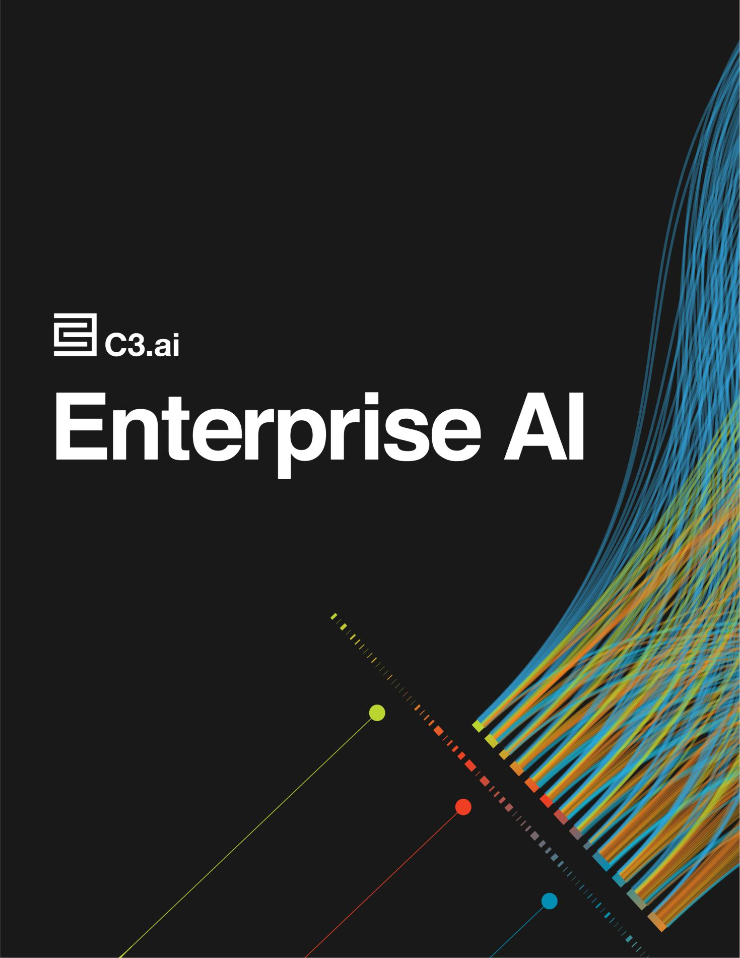

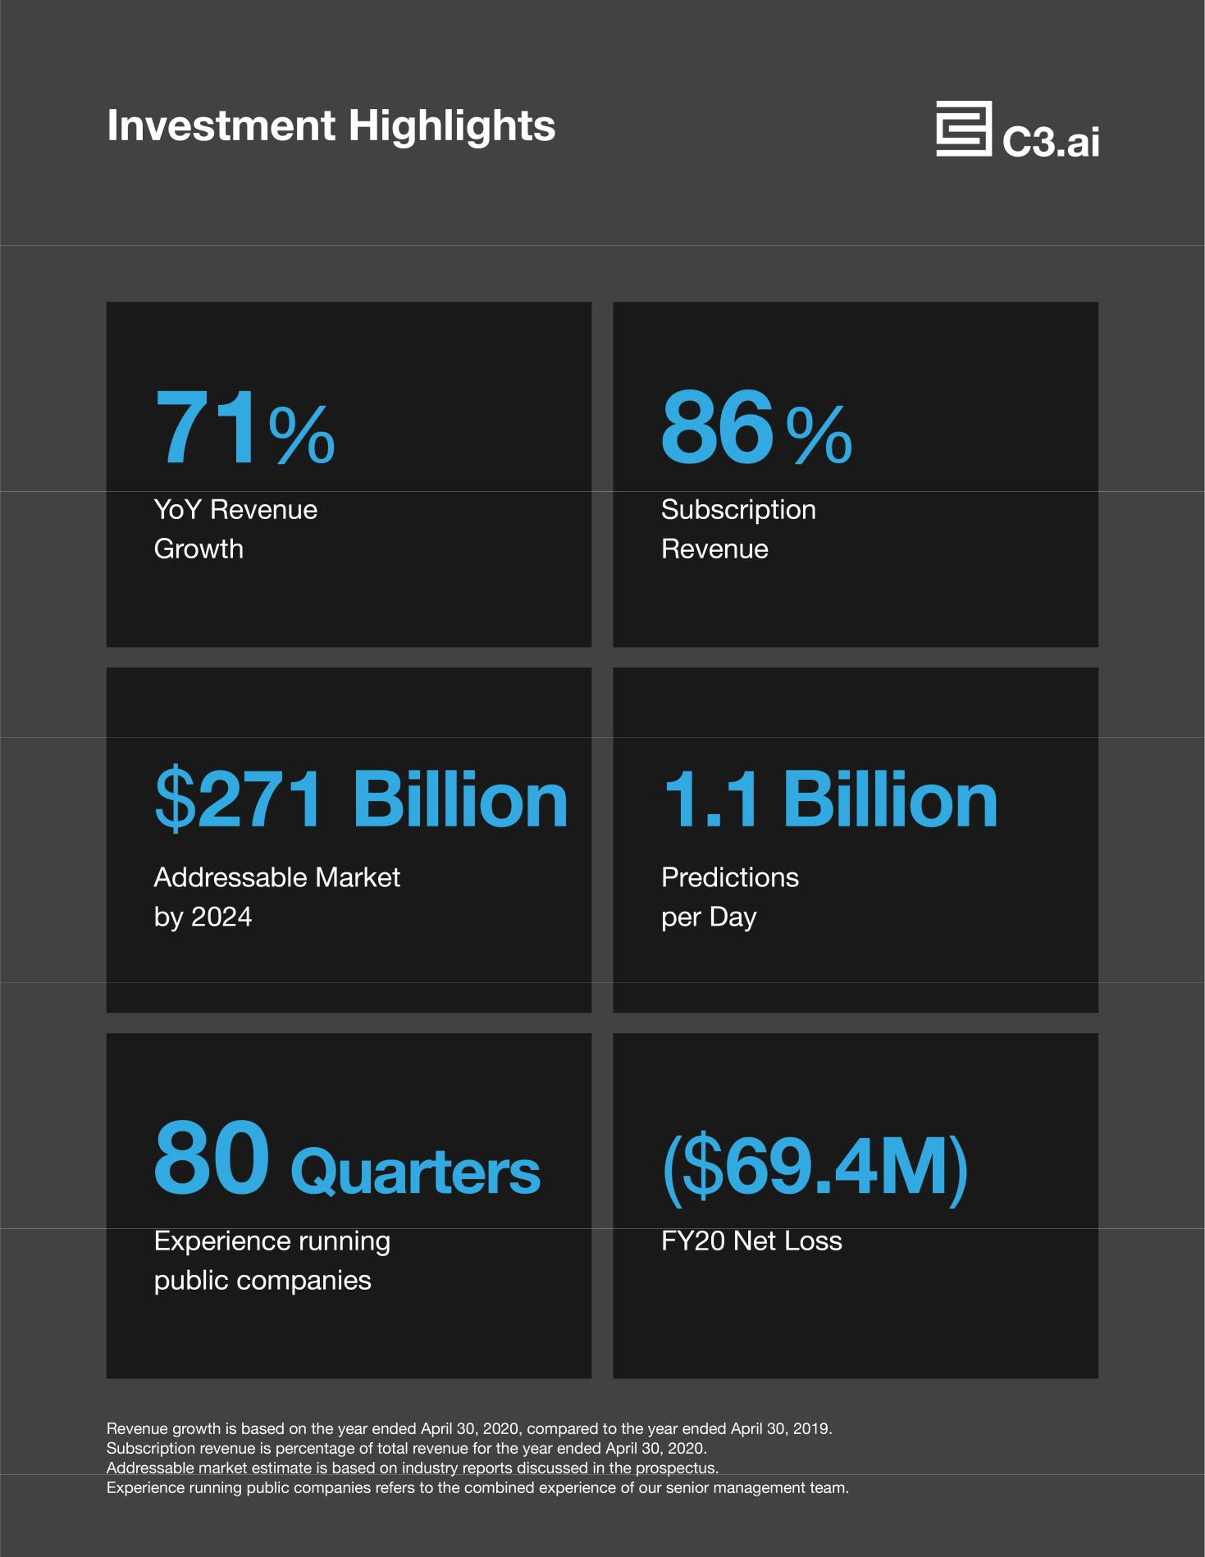

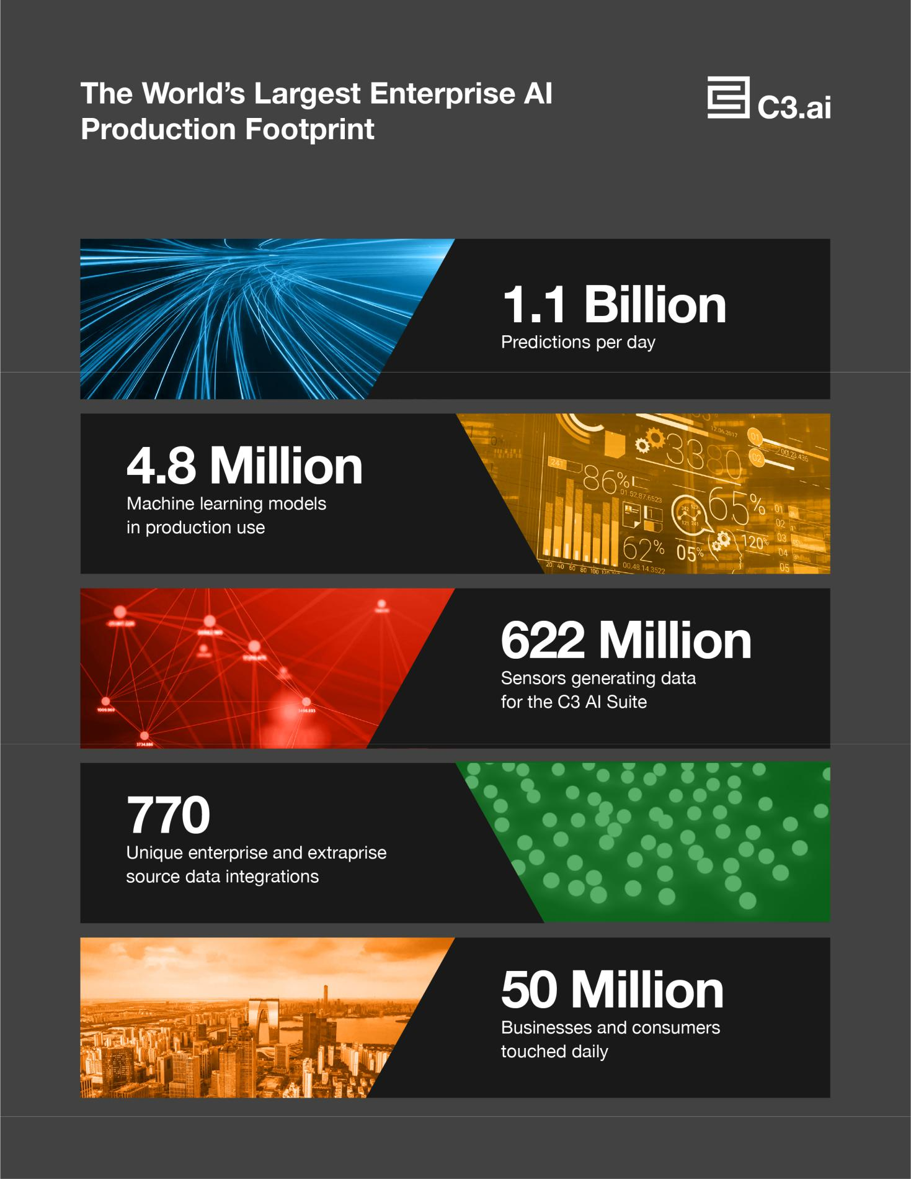

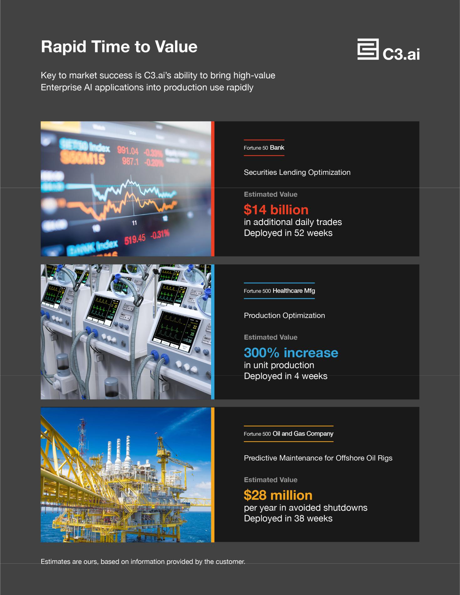

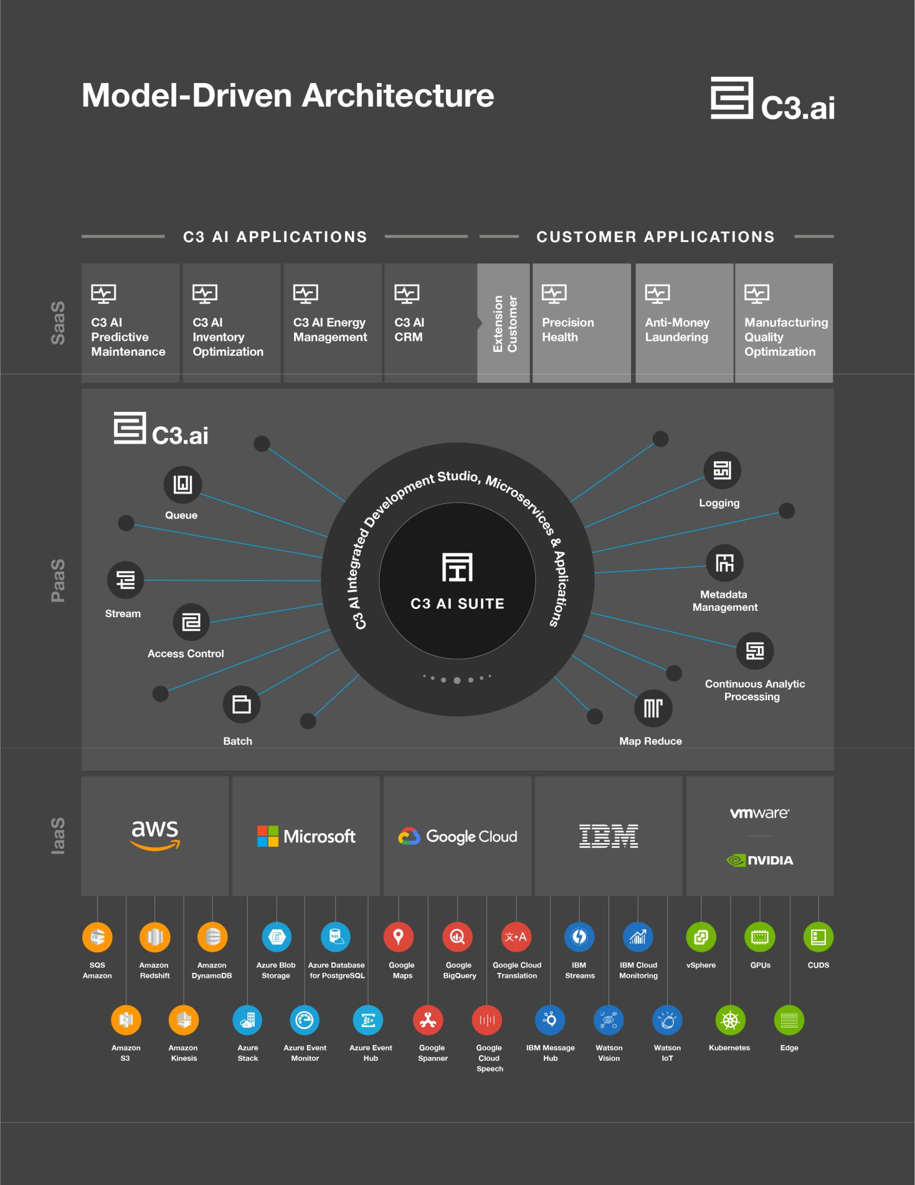

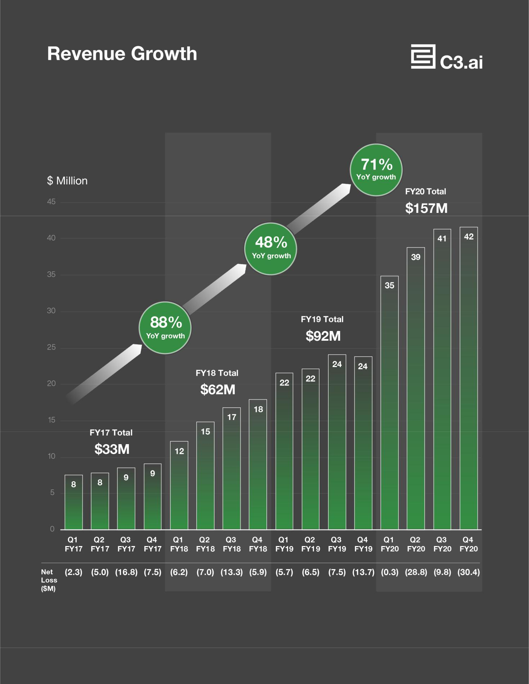

C3.ai, Inc.

Letter from the Chief Executive Officer

This is my fourth decade in the information technology industry.

After completing my graduate work in Computer Science, specifically relational database theory, I was recruited to the then start-up Oracle. The relational database market was nascent when I joined Larry Ellison and Bob Miner at Oracle in 1983. The global market for information technology was $224 billion, and, as I recall, the RDBMS market was less than $20 million. I was satisfied that the fundamental economics of application development and information processing assured the ascendance of RDBMS. That turned out to be a pretty good bet.

A decade later, Oracle grew to exceed $1 billion in revenue. The information technology market had grown to exceed $510 billion. We established a clear market leadership position in the RDBMS market.

In the mid-1990s, the industry experienced a step function of innovative information technology that proved to dramatically accelerate IT market growth. This included graphical user interface technology, popularized by Microsoft Windows 95, nomadic laptop computers, first introduced by Compaq, broad bandwidth communications, and the post-Mosaic browser ubiquitous internet.

As of 1993, as an industry we had successfully applied information technology to automate many business processes including accounting, manufacturing automation, and general office productivity. And yet the business processes of sales, marketing, and customer service were still analog and manual, largely untouched by information technology.

In July of 1993, convinced that this presented a huge unserved market opportunity, I founded Siebel Systems, a computer software company committed to successfully applying this new step function of information and communications technology to the business processes of sales, marketing, and customer service. That too turned out to be a good idea.

Six years later, Siebel Systems exceeded $2 billion in revenue with 8,000 employees in 29 countries, becoming one of the fastest growing enterprise software companies in history. At Siebel Systems, I believe we invented the CRM market as you know it today, and established a clear global market leading position in that market. Siebel Systems merged with Oracle in 2006. The CRM market is now a $60+ billion software industry.

From 1983 through 2006, we saw one wave after another of new technologies: mainframes, minicomputers, personal computers, the internet, relational database technology, enterprise application software, and client-server computing. Each technology breakthrough represented a replacement market for its predecessor, fueling a $1.3 trillion industry by 2006.

Assessing the IT landscape at the beginning of the 21st century, it became apparent that a new set of technologies was destined to constitute another step function that would change everything about the information processing world, dramatically accelerating the growth of IT markets. This step function of technologies – substantially more impactful than anything we had seen before – included: elastic cloud computing, big data, the internet of things, and AI or predictive analytics. Today, at the confluence of these technology vectors we find the phenomenon of Enterprise AI and Digital Transformation, mandates that are rising to the top of every CEO’s agenda. The global IT market exceeds $2.3 trillion today.

These technologies were largely nascent in January 2009 when we founded C3.ai with the goal of developing a comprehensive unified software development and enterprise applications solution designed to enable organizations to exploit these new technologies.

We succeeded at that task. And in the process, we developed a set of inventions we believe are fundamental to any enterprise AI application, and that are proprietary and patented. We succeeded at deploying high-value Enterprise AI applications at small scale, at medium scale, and at the largest industrial scale. We succeeded across a diverse range of industries and across a wide range of AI use cases.

We serve a large and rapidly growing market, estimated to be $174 billion in 2020, growing to $271 billion in 2024. Our goal is to establish a global market-leading position in this market as we did at Oracle and at Siebel Systems. The difference being that this market is an order of magnitude larger than either of those opportunities.

I believe we are well-positioned to succeed. The market is large and rapidly growing. We have succeeded at developing a highly differentiated and efficacious AI development platform and an associated family of AI applications. We have

manageable competitive risk compared to others, including – (1) companies attempting to build the application from scratch – with little to no success – and (2) a plethora of AI point solutions each of which addresses a small slice of the problem.

It boils down to execution risk. Does the C3.ai team have the skills and experience to succeed? Can they manage a rapidly growing business? Can they successfully implement mission critical extraprise application deployments? Can they attract, retain, and motivate the top people in the industry? Can they establish rewarding strategic partnerships with customers and market partners? Can they effectively scale and manage business sales, marketing, and support infrastructures globally? Can they accelerate and maintain technology leadership? I believe that the strength and experience of management and human capital at C3.ai is our strongest asset. This is unquestionably the most talented and experienced team that I have worked with in my career.

I believe C3.ai is uniquely qualified to tackle these challenges. But clearly, as an investor, you will need to resolve these questions to your satisfaction.

You can expect us to operate a highly disciplined, professional business that is engineered to become structurally profitable and structurally cash-positive in the long term. We will focus on maintaining continuing technology leadership. We will strive to attract, retain, and motivate high performance teams. We will focus on top-line growth to establish market leadership. We will work to establish and enhance brand equity and thought leadership. We will strive to assure that each and every one of our customers is delighted. We will focus on building a high-performance corporate culture known for excellence in execution. We will strive for high levels of predictability in our technology roadmap, our customer engagements, and our financial results.

We have seen many changes in the information technology markets in the past few decades: Disruptive technologies. The diversity and motivation of human capital. Increased accountability. Increased regulatory rigor. The expectations – indeed the demands – of customers, markets, employees, investors, and regulators have been in a constant state of change. I expect the rate of change in such expectations will only accelerate in the coming decades. We are here to serve our stakeholders and to be a good member of the communities in which we operate. You can expect that as these expectations of stakeholders continue to change in the coming years, we will be attentive to those changes and modify our business practices accordingly.

Our singular focus is to leverage our technology leadership, first-mover advantage, and management leadership to establish and maintain a global leadership position in Enterprise AI. Should we succeed at that objective, we will have built C3.ai into one of the world’s great software companies.

Sincerely,

Thomas M. Siebel

Founder and CEO

TABLE OF CONTENTS

 |  |  |  |  |  |  |  | Page |  |  |  |  |  |  |  |  | Page
PROSPECTUS SUMMARY |  |  |  |  |  |  |  |  | CERTAIN RELATIONSHIPS AND RELATED PARTY
 |  |  |  |  |  |  |  | 1
RISK FACTORS |  |  |  |  |  |  |  | 16 |  | TRANSACTIONS |  |  |  |  |  |  | 150
 |  |  |  |  |  |  |  | 16 | PRINCIPAL STOCKHOLDERS |  |  |  |  |  |  |  | 153
SPECIAL NOTE REGARDING FORWARD-LOOKING
 |  |  |  |  |  |  |  |  | DESCRIPTION OF CAPITAL STOCK |  |  |  |  |  |  |  | 156
 | STATEMENTS |  |  |  |  |  |  | 52
 |  |  |  |  |  |  |  |  | SHARES ELIGIBLE FOR FUTURE SALE |  |  |  |  |  |  |  | 162
MARKET, INDUSTRY, AND OTHER DATA |  |  |  |  |  |  |  | 53
USE OF PROCEEDS |  |  |  |  |  |  |  | 54 | MATERIAL U.S. FEDERAL INCOME TAX
DIVIDEND POLICY |  |  |  |  |  |  |  | 55 |  | CONSEQUENCES TO NON-U.S. HOLDERS OF OUR
 |  |  |  |  |  |  |  | 55 |  | CLASS A COMMON STOCK |  |  |  |  |  |  | 165
CAPITALIZATION |  |  |  |  |  |  |  | 56
 |  |  |  |  |  |  |  | 56 | UNDERWRITERS |  |  |  |  |  |  |  | 169
DILUTION |  |  |  |  |  |  |  | 59
 |  |  |  |  |  |  |  | 59 | CONCURRENT PRIVATE PLACEMENTS |  |  |  |  |  |  |  | 179
SELECTED CONSOLIDATED FINANCIAL AND OTHER
 |  |  |  |  |  |  |  |  | LEGAL MATTERS |  |  |  |  |  |  |  | 180
 | DATA |  |  |  |  |  |  | 61
 |  |  |  |  |  |  |  | 61 | EXPERTS |  |  |  |  |  |  |  | 180
MANAGEMENT’S DISCUSSION AND ANALYSIS OF
 |  |  |  |  |  |  |  |  | WHERE YOU CAN FIND MORE INFORMATION |  |  |  |  |  |  |  | 180
 | FINANCIAL CONDITION AND RESULTS OF
 | OPERATIONS |  |  |  |  |  |  | 63 | INDEX TO CONSOLIDATED FINANCIAL STATEMENTS |  |  |  |  |  |  |  |  | F-1
BUSINESS |  |  |  |  |  |  |  | 88
MANAGEMENT |  |  |  |  |  |  |  | 129
EXECUTIVE COMPENSATION |  |  |  |  |  |  |  | 137

_________________

Neither we, nor any of the underwriters have authorized anyone to provide you with any information or to make any representations other than those contained in this prospectus or in any free writing prospectuses we have prepared. Neither we, nor any of the underwriters take any responsibility for, and can provide no assurance as to the reliability of, any other information that others may give you. We are offering to sell, and seeking offers to buy, shares of our Class A common stock only in jurisdictions where offers and sales are permitted. The information contained in this prospectus is accurate only as of the date of this prospectus, regardless of the time of delivery of this prospectus or of any sale of our Class A common stock. Our business, financial condition, results of operations, and future growth prospects may have changed since that date.

Through and including January 2, 2021 (the 25th day after the date of this prospectus), all dealers effecting transactions in these securities, whether or not participating in this offering, may be required to deliver a prospectus. This is in addition to a dealer’s obligation to deliver a prospectus when acting as an underwriter and with respect to an unsold allotment or subscription.

For investors outside the United States: Neither we, nor any of the underwriters have done anything that would permit this offering or possession or distribution of this prospectus in any jurisdiction where action for that purpose is required, other than in the United States. Persons outside of the United States who come into possession of this prospectus must inform themselves about, and observe any restrictions relating to, the offering of the shares of our Class A common stock and the distribution of this prospectus outside of the United States.


PROSPECTUS SUMMARY

This summary highlights selected information contained elsewhere in this prospectus. This summary does not contain all of the information you should consider before investing in our Class A common stock. You should read this entire prospectus carefully, including the sections titled “Risk Factors” and “Management’s Discussion and Analysis of Financial Condition and Results of Operations,” and our consolidated financial statements and the related notes included elsewhere in this prospectus, before making an investment decision. Our fiscal year ends on April 30. Unless the context otherwise requires, all references in this prospectus to “we,” “us,” “our,” “our company,” and “C3.ai” refer to C3.ai, Inc. and its subsidiaries. Unless otherwise indicated, references to our “common stock” include our Class A common stock and Class B common stock.

OVERVIEW

C3.ai

C3.ai is an Enterprise AI software company.

We provide software-as-a-service, or SaaS, applications that enable the rapid deployment of enterprise-scale AI applications of extraordinary scale and complexity that offer significant social and economic benefit.

All C3.ai software applications can be deployed on Azure, Amazon Web Services, or AWS, the IBM Cloud, Google Cloud Platform, or on-premise.

Enterprise AI Software Solutions

We provide three primary families of software solutions:

- The C3 AI Suite, our core technology, is a comprehensive application development and runtime environment that is designed to allow our customers to rapidly design, develop, and deploy Enterprise AI applications of any type.

- C3 AI Applications, built using the C3 AI Suite, include a large and growing family of industry-specific and application-specific turnkey AI solutions that can be immediately installed and deployed.

- C3.ai Ex Machina, our no-code solution that provides secure, easy access to analysis-ready data, and enables business analysts without data science training to rapidly perform data science tasks such as building, configuring, and training AI models.

Large Total Addressable Market

We serve a large and rapidly growing market, estimated to be $174 billion in 2020, growing to $271 billion in 2024, a 12% compound annual growth rate, or CAGR. Our solutions address use cases across:

- Enterprise AI Software. $18 billion in 2020, $44 billion in 2024, a 24% CAGR.¹

- Enterprise Infrastructure Software. Application Development, Infrastructure, and Middleware; Data Integration and Quality Tools, and Master Data Management Products: $63 billion in 2020, $82 billion in 2024, a 7% CAGR.²

- Enterprise Applications. Analytics, Business Intelligence and Customer Relationship Management, or CRM: $93 billion in 2020, $145 billion in 2024, a 12% CAGR.³

By any standards, this is a large and rapidly growing addressable market opportunity.

First-Mover Advantage

We believe we enjoy a significant first-mover advantage in Enterprise AI, based on our significant investment in our products and technology over the last decade of development. We are not aware of others who have made as much progress as we have in this space. We believe that we have the world’s most extensive Enterprise AI production footprint. Our goal is

- Source: IDC, Worldwide Artificial Intelligence Systems Spending Guide, September 2019
- Source: Gartner, Forecast: Enterprise Infrastructure Software, Worldwide, 2018-2024, 3Q20 Update

³ Source: Gartner, Forecast: Enterprise Application Software, Worldwide, 2018-2024, 3Q20 Update

1

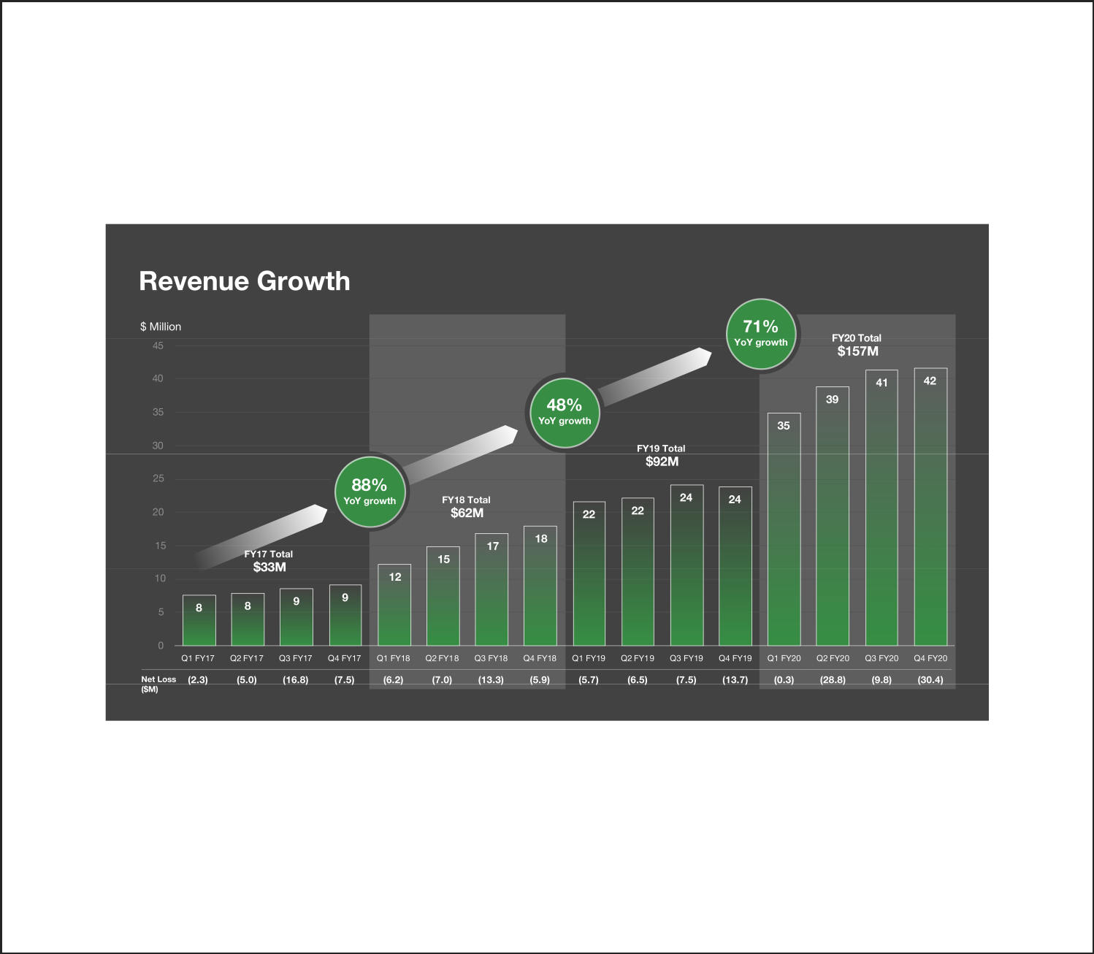
to establish and maintain a global leadership position in Enterprise AI across all market segments including large enterprises, small and medium businesses, and government entities.

Rapid Revenue Growth

We are growing rapidly, with total revenue of $156.7 million in the fiscal year ended April 30, 2020 compared to $91.6 million in the fiscal year ended April 30, 2019, representing year-over-year growth of 71%. Over the same period, our subscription revenue grew to $135.4 million from $77.5 million, a 75% increase. The bulk of our revenue accrues from subscription software, accounting for roughly 86% of our total revenue. We incurred net losses of $69.4 million and $33.3 million in the fiscal years ended April 30, 2020 and 2019, respectively.

Lighthouse Customers

Our market-entry strategy has been to establish high-value customer engagements with large global early adopters, or lighthouse customers, in Europe, Asia, and the United States across a range of industries. These lighthouse customers serve as proof points for other potential customers in their particular industries. We have established strategic relationships with our customers that include many of the world’s iconic organizations, demonstrating the utility of our Enterprise AI software solutions across geographies, cultures, vertical markets, and a wide range of use-cases at small, medium, and even the largest industrial scale. We work to replicate those deployments across similar companies within each vertical market.

2

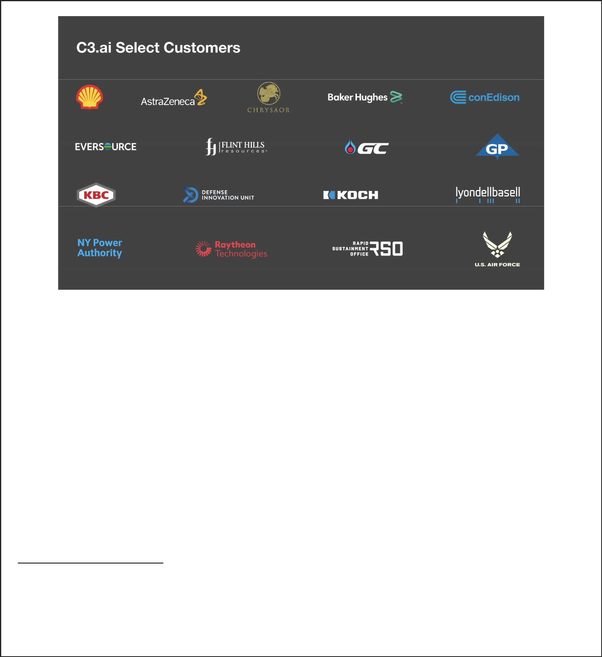

High-Value Outcomes

We are enabling the digital transformation of many of the world’s leading organizations and, in the process, helping them to attain short time-to-value and exceptionally high economic returns. At some companies, based on feedback from our customers, we estimate our solutions have resulted in hundreds of millions of dollars in annual economic benefit.⁴ We estimate, based on our production C3.ai roadmaps, that we may enable billions of dollars in annual economic benefit for our customers.⁵

Rapid Time to Value

The key to our market success to date, and our primary competitive differentiator, is our ability to leverage the C3 AI Suite and C3 AI Applications to bring high-value Enterprise AI applications into production use rapidly. We have deployed Enterprise AI applications into production use in as little as four weeks.

Outsized Average Total Subscription Contract Value

As a result of the high-value outcomes that we enable, we enjoy uncommonly high total contract values for software subscriptions. Our average total subscription contract value for contracts entered into in fiscal years 2016, 2017, 2018, 2019, and 2020 was $1.2 million, $11.7 million, $10.8 million, $16.2 million, and $12.1 million, respectively. We believe this is a high-water mark for the applications software industry.⁶ We are able to drive these extraordinary subscription contract values because of the high-value outcomes we provide to our customers—we enable some of the largest companies in the world to succeed in their most mission-critical digital transformation projects.

Total contract value is the sum of total subscription contract value plus paid trials, contractual increases of less than 12 months in duration, and monthly actual usage-based fees. Our average total contract value for contracts entered into in fiscal

- Management estimates based on results from trials or deployments using customer data from more than 20 projects across 15 customers. Data and feedback were collected from
2016 to 2020. See the section titled “Market, Industry, and Other Data” for additional information.
- Based on actual results achieved in trials or deployments using actual customer data and business processes as provided by our customers. These estimates are limited by the scaling
factors of extrapolating these results from the specific project scope of each trial or deployment across the customer’s entire business. These estimates are based on more than 20 projects across 15 customers, and the data and feedback were collected from customer engagements occurring in the years 2016 to 2020.

- Based on our review of the estimated contract values of approximately 100 representative applications software companies from publicly available sources. See the section titled “Market, Industry, and Other Data” for additional information.

3

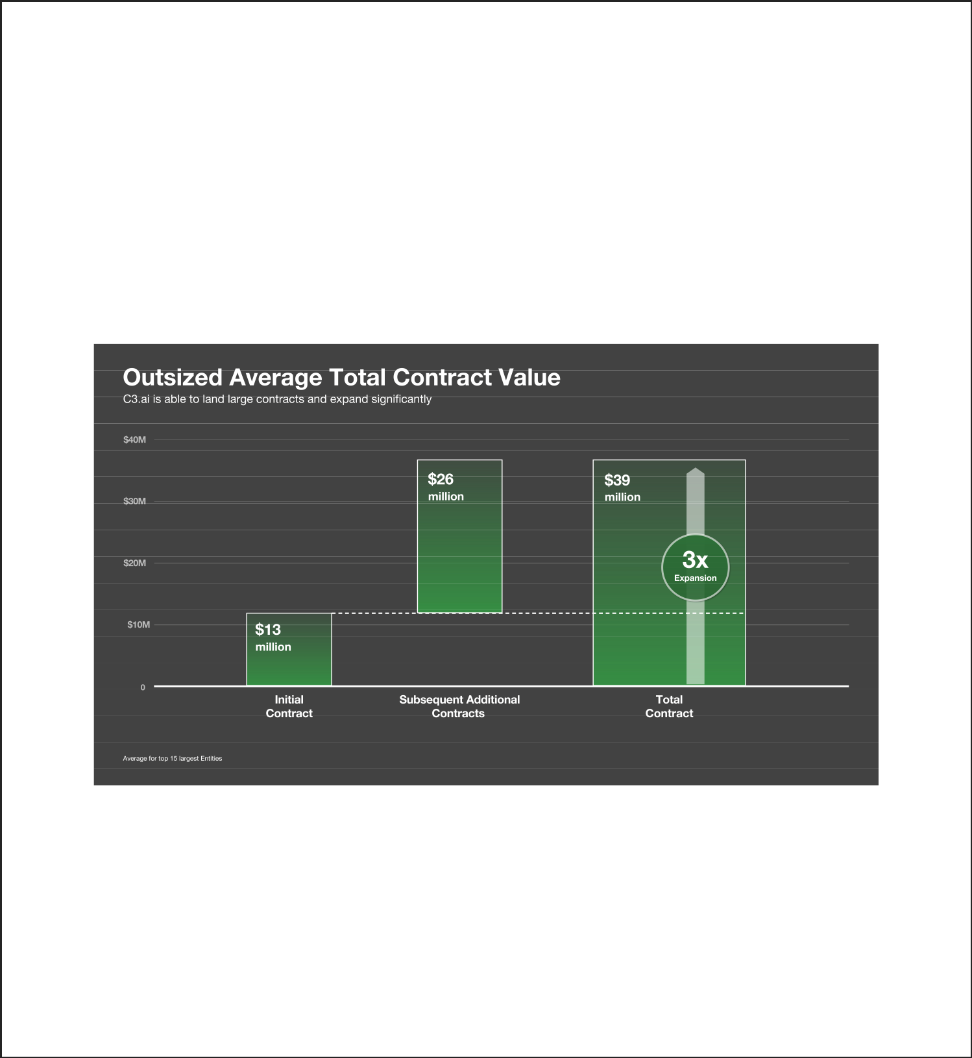
years 2016, 2017, 2018, 2019, 2020, and the six months ended October 31, 2020 was $0.6 million, $2.6 million, $1.2 million, $1.4 million, $1.3 million, and $1.7 million, respectively.

The average total subscription contract value is decreasing and we expect it to continue to decrease as we have restructured our sales organization and expanded our market-partner ecosystem to effectively address small, medium, and large enterprise sales opportunities. We have seen significant progress to date in this regard. Our average total subscription contract value for the six months ended October 31, 2020 was $7.7 million.

Land and Expand

After their initial contract with us, our customers tend to expand the use of our products and, as a result, may purchase additional applications, additional developer seats, additional software products, additional runtime usage, and additional services. We define an Entity as a separate buying entity that has an active contract to deploy the C3 AI Suite or one or more C3 AI Applications. We often provide our software to a distinct department, business unit, or group within such single buying entity and define a customer as each distinct department, unit, or group within an Entity. The average initial subscription contract value with our largest 15 Entities from 2010 to date is $12.8 million. On average, each of these Entities has purchased an additional $26.1 million in product subscriptions and services from us since their initial subscription contract to date as they expanded existing use cases and added additional use cases to their roadmaps.

Extensive Partner Ecosystem

We have established strategic relationships with technology leaders including AWS, Baker Hughes, Fidelity National Information Services, or FIS, Google, IBM, Microsoft, and Raytheon. These world-leading technology companies can marshal tens of thousands of talented resources to establish and serve small, medium, and large C3.ai customer relationships at global scale.

Leveraged Go-to-Market Model

Our market entry growth strategy has been to employ a direct sales organization organized in a traditional geographic/industry market matrix, partnered with C3.ai technical experts in our forward deployed engineering organization, to establish and expand customer relationships with large lighthouse customers with a diversity of AI use cases across a range of industry segments. Our sales and engagement efforts are frequently closely coordinated with our marketing partners including AWS, Baker Hughes, FIS, Google, IBM, and Microsoft.

4


Having established the scalability of our product offerings and their utility across a wide range of AI use cases at large-enterprise scale, we are now (1) expanding those same use cases across similar companies, (2) establishing middle market sales organizations, including telesales and online sales, and (3) leveraging our marketing partners as enterprise and mid-market distribution channels.

Revenue Model

The bulk of our revenue is generated from subscriptions to our software, accounting for roughly 86% of our total revenue. We currently have four primary revenue sources:

- Term subscriptions of the C3 AI Suite, usually three years in duration.

- Term subscriptions of C3 AI Applications, usually three years in duration.

- Monthly runtime fees of the C3 AI Applications and customer-developed applications built using the C3 AI Suite, usage-based upon CPU-hour consumption.

- Professional services fees associated with training and assisting our customers.

Recognized AI-Industry Leadership

We have won many industry recognitions, including CNBC Disruptor 50 (2020, 2019, 2018), BloombergNEF Pioneer (2020), Forbes Cloud 100 (2020, 2019, 2018, 2017), Deloitte Technology Fast 500 (2019), and EY Entrepreneur of the Year (2018, 2017), and have been named a leader by Forrester Wave: Industrial IoT Software Platforms (2019, 2018).

Our Secret Sauce: C3.ai Model-Driven Architecture

The C3 AI Suite, with its proprietary model-driven architecture, addresses the requirements for the digital transformation software stack, providing a low-code/no-code AI and Internet of Things, or IoT, platform that accelerates software development, reduces cost and risk, and delivers applications that are flexible enough to meet evolving needs.

We believe Enterprise AI applications require a new digital transformation software stack. The traditional approach to developing AI and IoT enterprise software—i.e., using structured programming to build applications by assembling and integrating various open source components and cloud services—can be slow, costly, and ineffective. Due to daunting technical requirements, among other reasons, a recent study has shown that 84% of Enterprise AI deployments have not scaled.

Enabled by our proprietary model-driven architecture, the C3 AI Suite and C3 AI Applications allow organizations to dramatically simplify and accelerate Enterprise AI adoption. Compared to the structured programming approach that most organizations typically attempt, we estimate that our model-driven architecture speeds development by a factor of 26, while reducing the amount of code that must be written by up to 99%.

We enjoy a rich patent portfolio that presents a substantial competitive advantage in the Enterprise AI market—most notably, our recently issued U.S. patents (No. 10,817,530 and No. 10,824,634) which were granted for systems, methods, and devices for an enterprise AI and internet-of-things platform.

The C3 AI Suite enables us to rapidly and successfully deploy functionally rich, high-value Enterprise AI applications even at the largest enterprise scale.

Competition

Our primary competition is largely do-it-yourself, custom-developed, company-specific AI platforms and applications. These tend to be very costly complex software engineering projects, often fail, and, if successful, usually require many years to realize economic return.

We are unaware of any end-to-end Enterprise AI development platforms that are directly competitive with the C3 AI Suite.

5


Sales Alliances

Strategic partnerships are core to our growth strategy with market-leading companies offering highly leveraged distribution channels to various markets.

To date, we have established such a partnership with Baker Hughes to address the needs of the global oil and gas market, with FIS to address needs in the financial services market, with Raytheon to serve the U.S. defense and intelligence communities, and with Microsoft and Adobe to address the next generation of CRM.

In addition, we have announced global alliances with AWS, IBM, Intel, and Microsoft to jointly market, sell, and service our combined solutions across industry verticals.

In the majority of our sales opportunities we are aligned with one or more of these partners.

Thought Leadership

Our Chief Executive Officer, Tom Siebel, and our Chief Technology Officer, Ed Abbo, are recognized leaders in information technology, facilitating broad market validation by media, analysts, and industry groups. Their decades of technology leadership in enterprise software position them well to engage strategically with the executive leadership of leading corporations and government entities.

University Relations: C3.ai Digital Transformation Institute

Established in February 2020, the C3.ai Digital Transformation Institute, or C3.ai DTI, is a research consortium dedicated to accelerating the benefits of artificial intelligence for business, government, and society. C3.ai DTI engages the world’s leading scientists to conduct research and train practitioners in the new Science of Digital Transformation, which operates at the intersection of artificial intelligence, machine learning, cloud computing, internet of things, big data analytics, organizational behavior, public policy, and ethics.

C3.ai DTI is a coalition of some of the world’s leading research institutions including Princeton, Carnegie Mellon, MIT, University of Illinois at Urbana-Champaign, University of Chicago, UC Berkeley, Stanford, the National Center for Supercomputing Applications, and Lawrence Berkeley Labs, in partnership with Microsoft and C3.ai.

C3.ai DTI provides organization and funding for wide-ranging fundamental research to develop advanced AI techniques, methods, and processes to accelerate the Science of Digital Transformation. Funding, computing resources, Azure resources, and unlimited use of the C3 AI Suite are being provided to these researchers and institutions as the AI research platform. C3.ai DTI has initially funded 26 research projects to develop new AI techniques to address the challenges of the COVID-19 pandemic.

In addition to contributing to the public good, C3.ai DTI exposes the capabilities of our AI Suite and AI Applications to potentially thousands of researchers, undergraduates, and graduate students at these world-renowned institutions. This helps to further build the community of C3.ai users and to establish C3.ai as the standard for developing and deploying large-scale Enterprise AI applications to solve the world’s hardest problems.

Growth Strategy

We are substantially investing in the expansion of our direct enterprise sales and service organization both geographically and across vertical markets to expand the use of C3.ai solutions within existing customers and establish new customer relationships.

We will continue to focus on the success of our customers to increase penetration of our existing customer base.

We will continue to expand our major account sales organization to focus on large enterprise software agreements.

We will continue to expand our enterprise sales organization globally, focused on divisions of Fortune 500 companies as well as with smaller and medium-sized businesses.

We will expand our leveraged distribution channel with additional strategic partners like Baker Hughes, FIS, Microsoft, and Raytheon.

6


We will continue to develop high volume distribution channels including digital marketing, telesales, and strategic distributors, particularly to address the needs of small and medium businesses.

We are bringing new product families to market that we believe will develop into substantial recurring revenue streams for C3.ai.

We expect to enter into additional strategic development and distribution agreements, like those we have in place with Baker Hughes, FIS, Microsoft, and Raytheon, that we expect will provide us highly leveraged access to other vertical and horizontal markets.

Rich Human Capital

Our strongest asset is unquestionably the human capital we have been able to attract, retain, and motivate. We have won the Glassdoor Best Place to Work award, were named a WayUp Top 100 Internship Program, and are consistently ranked amongst the best places to work. We attract exceptionally talented, highly educated, experienced, motivated employees. We hired 214 new employees in the past year. We received approximately 52,000 applications for those positions. Approximately 10,000 of those were engaged in rigorous skill evaluation and interview cycles for a final selection of 214. Fifty-seven percent of our employees have advanced degrees, many from the world’s most prestigious institutions.

Veteran Disciplined Management

Our executive leadership team, led by our CEO, Tom Siebel, has individually and collectively managed some of the world’s most successful and rapidly growing software companies, including Oracle and Siebel Systems. This is a team that has created markets and has a demonstrated history of responsible management and commitment to employees, customers, and investors. We enjoy exceptional levels of experience, discipline and rigor in our management practices that transcend market cycles and market bubbles. We are focused on building a rapidly growing, professional, structurally cash-positive, and structurally profitable company in the long term with the singular focus of establishing a global leadership position in Enterprise AI with a long trail of satisfied customers.

Our CEO, Tom Siebel, is a seasoned software innovator who has and continues to receive broad industry recognition for his leadership. A sample of his honors and awards include:

- Entrepreneur of the Year – EY, 2018

- Glassdoor Top CEO – 2018

- Honorary Ph.D. – Politecnico di Torino, 2018

- Entrepreneur of the Year – EY, 2017

- Best Places to Work, 100% CEO approval rating – Glassdoor, 2017

- Most Admired CEO Lifetime Achievement Award – San Francisco Business Times, 2016

- Academy of Arts and Sciences, Elected Member – April 2013

- #3 of the World’s Top 25 Philanthropists – Barron’s, November 2010

- Woodrow Wilson Award for Corporate Citizenship

- Engineering at Illinois Hall of Fame – University of Illinois at Urbana-Champaign, 2010

- #5 of the World’s Top 25 Philanthropists – Barron’s, 2009

- Top 50 Philanthropists – BusinessWeek 2007, 2008

- Honorary Ph.D. Engineering – University of Illinois at Urbana-Champaign, 2006

- Thomas M. Siebel, Master Entrepreneur of the Year – Ernst & Young, 2003

- Entrepreneurial Company of the Year – Harvard Business School, 2003

7

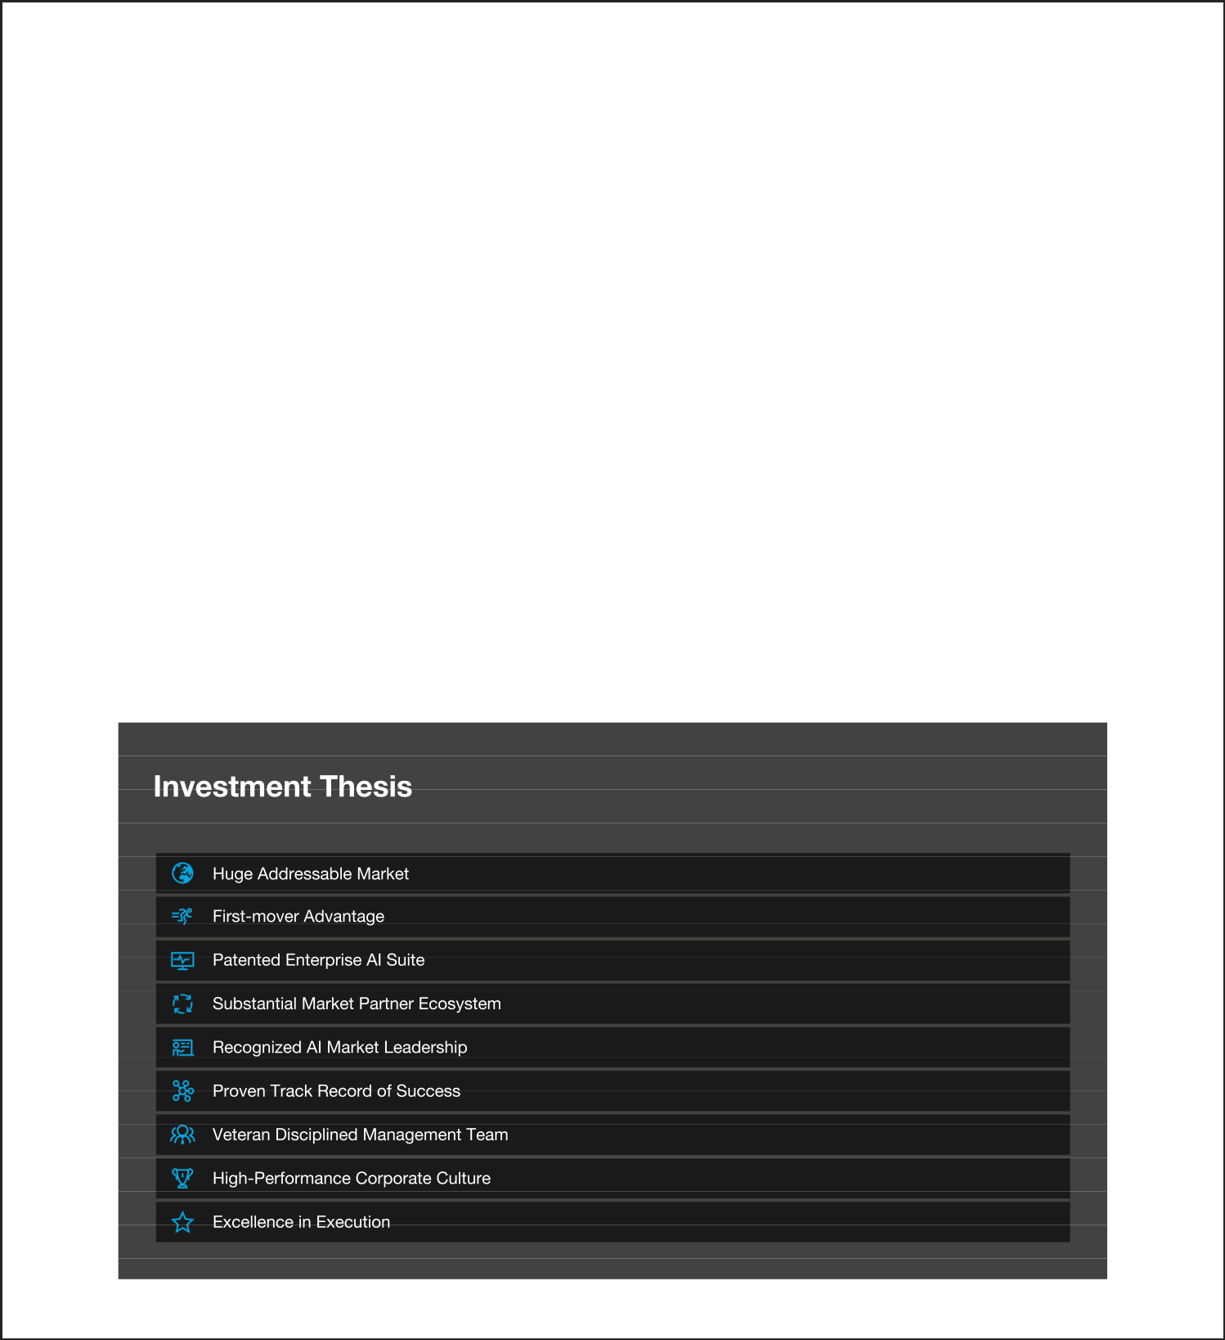
- Hall of Fame – CRM Magazine, 2003

- CEO of the Year – Industry Week, 2002

- Top 25 Managers in Global Business – BusinessWeek, 1999 to 2002

- Top 10 CEOs of 2000 – Investor’s Business Daily, 2000

- The World’s Most Influential Software Company – BusinessWeek, 2000

- The Most Influential Company in IT – Intelligent Enterprise, 2000

- Fastest Growing Technology Company – Deloitte & Touche, 1999

- Fastest Growing Company in America – Fortune, 1999

C3.ai Investment Thesis

Enterprise AI is a huge addressable market.

We have a highly experienced CEO and management team with an established track record of identifying large technology markets in their nascent stage, developing innovative, superior solutions to meet the needs of those markets, assembling and organizing high-performance organizations, and building rapidly growing, financially sound, cash-positive, profitable, professionally managed, market-leading companies that accrue substantial value to customers, employees, partners, and investors.

We have developed a patented Enterprise AI suite enabling the successful digital transformation of leading corporations and government entities. First-mover advantage. Technology leadership. Substantial market eco-system. Recognized Enterprise AI market leadership. A high-performance corporate culture. Focused on excellence in execution.

We are in this for the long run, with the singular focus of establishing and maintaining recognized technology innovation and global market leadership in the Enterprise AI application software market.

8


RISK FACTORS

Investing in our Class A common stock involves a high degree of risk because our business is subject to numerous risks and uncertainties, as fully described in the section titled “Risk Factors” immediately following this summary. These risks include, but are not limited to, the following:

- we have a limited operating history, which makes it difficult to evaluate our prospects and future results of operations;

- historically, a limited number of customers have accounted for a substantial portion of our revenue. If existing customers do not renew their contracts with us, or if our relationships with our largest customers are impaired or terminated, our revenue could decline, and our results of operations would be adversely impacted;

- our business depends on our ability to attract new customers and on our existing customers purchasing additional subscriptions from us and renewing their subscriptions;

- we have a history of operating losses and may not achieve or sustain profitability in the future;

- we face intense competition and could lose market share to our competitors, which could adversely affect our business, financial condition and results of operations;

- our sales cycles can be long and unpredictable, particularly with respect to large subscriptions, and our sales efforts require considerable time and expense;

- if the market for our AI Suite and AI Applications fails to grow as we expect, or if businesses fail to adopt our AI Suite and AI Applications, our business, operating results, and financial condition could be adversely affected;

- if we fail to respond to rapid technological changes, extend our AI Suite and AI Applications or develop new features and functionality, our ability to remain competitive could be impaired;

- if we were to lose the services of our Chief Executive Officer or other members of our senior management team, we may not be able to execute our business strategy; and

- the COVID-19 pandemic could have an adverse impact on our business, operations, and the markets and communities in which we, our partners, and customers operate.

Corporate Information

We were initially formed in 2009 as C3, LLC, a Delaware limited liability company. In June 2012, we incorporated under the laws of the state of Delaware under the name C3, Inc. In July 2016, we changed our name to C3 IoT, Inc., and, in June 2019, we changed our name to C3.ai, Inc. Our principal executive offices are located at 1300 Seaport Blvd, Suite 500, Redwood City, California 94063. Our telephone number is (650) 503-2200. Our website address is C3.ai. Information contained on, or that can be accessed through, our website is not incorporated by reference into this prospectus, and you should not consider information on our website to be part of this prospectus.

The C3.ai design logo, “C3.ai,” and our other registered or common law trademarks, service marks or trade names appearing in this prospectus are the property of C3.ai, Inc. Other trade names, trademarks, and service marks used in this prospectus are the property of their respective owners.

We believe we are eligible for but do not intend to take advantage of the “controlled company” exemption to the corporate governance rules for New York Stock Exchange-listed companies.

Implications of Being an Emerging Growth Company

As a company with less than $1.07 billion in revenue during our last fiscal year, we qualify as an “emerging growth company” as defined in the Jumpstart Our Business Startups Act, or the JOBS Act, enacted in April 2012. An emerging growth company may take advantage of certain exemptions from various public company reporting requirements. These provisions include, but are not limited to:

- not being required to comply for a certain period of time with the auditor attestation requirements of Section 404 of the Sarbanes-Oxley Act of 2002, as amended, or the Sarbanes-Oxley Act;

9


- reduced disclosure obligations regarding executive compensation in our periodic reports, proxy statements, and registration statements; and

- exemptions from the requirements of holding a stockholder advisory vote on executive compensation and any golden parachute payments not previously approved.

We may take advantage of these provisions until the last day of our fiscal year following the fifth anniversary of the date of the first sale of our Class A common stock in this offering. However, if certain events occur prior to the end of such five-year period, including if (1) we become a “large accelerated filer,” with at least $700 million of equity securities held by non-affiliates; (2) our annual gross revenue exceeds $1.07 billion; or (3) we issue more than $1.0 billion of non-convertible debt in any three-year period, we will cease to be an emerging growth company prior to the end of such five-year period.

We have elected to take advantage of certain of the reduced disclosure obligations in the registration statement of which this prospectus is a part and may elect to take advantage of other reduced reporting requirements in future filings. As a result, the information that we provide to our stockholders may be different than you might receive from other public reporting companies in which you hold equity interests.

In addition, the JOBS Act provides that an “emerging growth company” can take advantage of an extended transition period for complying with new or revised accounting standards. This provision allows an emerging growth company to delay the adoption of some accounting standards until those standards would otherwise apply to private companies. We have elected to use the extended transition period under the JOBS Act. Accordingly, our financial statements may not be comparable to the financial statements of public companies that comply with such new or revised accounting standards.

10


THE OFFERING

Class A common stock offered by us

Class A common stock to be outstanding after this offering and the concurrent private placements

Class B common stock to be outstanding after this offering and the concurrent private placements

Option to purchase additional shares of Class A common stock offered by us
Class A common stock sold by us in the concurrent private placements

15,500,000 shares

92,348,010 shares

3,499,992 shares

2,325,000 shares

Immediately subsequent to the closing of this offering, and subject to certain conditions of closing as described in the section titled “Concurrent Private Placements,” each of Spring Creek Capital LLC, an affiliate of Koch Industries, Inc., and Microsoft Corporation will purchase from us in a private placement $100.0 million and $50.0 million, respectively, of our Class A common stock at a price per share equal to the initial public offering price. Based on the initial public offering price of $42.00 per share, this will be 2,380,952 and 1,190,476 shares, respectively. We will receive the full proceeds and will not pay any underwriting discounts or commissions with respect to the shares that are sold in the private placements. The sale of the shares in the private placements is contingent upon the completion of this offering. The sale of these shares to Spring Creek Capital LLC and Microsoft Corporation will not be registered in this offering and will be subject to a market standoff agreement with us for a period of up to 365 days after the date of this prospectus and lock-up agreement with the underwriters for a period of up to 180 days after the date of this prospectus. See “Shares Eligible for Future Sale—Lock-Up Agreements and Market Standoff Provisions” for additional information regarding such restrictions. We refer to the private placements of these shares of Class A common stock as the concurrent private placements.

Total Class A and Class B common stock to be outstanding after 95,848,002 shares (or approximately 98,173,002 shares if the underwriters
this offering and the concurrent private placements option to purchase additional shares of our Class A common stock is
exercised in full).

11

Voting rights

We have two classes of authorized common stock, Class A common stock and Class B common stock. The rights of the holders of Class A common stock and Class B common stock are identical, except with respect to voting and conversion. The holders of Class A common stock are entitled to one vote per share and the holders of Class B common stock are entitled to 50 votes per share on all matters that are subject to stockholder vote. Each share of Class B common stock may be converted into one share of Class A common stock at the option of the holder thereof, and will be converted into one share of Class A common stock upon transfer thereof, subject to certain exceptions.


The holders of our outstanding Class B common stock will hold 65.46% of the voting power of our outstanding capital stock following this offering and the concurrent private placements, with our directors, executive officers and 5% stockholders and their respective affiliates beneficially holding 83.49% of our voting power in the aggregate. These holders will have the ability to control the outcome of matters submitted to our stockholders for approval, including the election of our directors and the approval of any change of control transaction. See the section titled “Description of Capital Stock” for additional information.

Use of proceeds

We estimate that our net proceeds from the sale of our Class A common stock that we are offering and the concurrent private placements will be approximately $752.8 million (or approximately $844.4 million if the underwriters option to purchase additional shares of our Class A common stock is exercised in full), based upon the initial public offering price of $42.00 per share, and after deducting underwriting discounts and commissions and estimated offering expenses.

The principal purposes of this offering and the concurrent private placements are to increase our capitalization and financial flexibility, and create a public market for our Class A common stock. As of the date of this prospectus, we cannot specify with certainty all of the particular uses for the net proceeds to us from this offering and the concurrent private placements. However, we currently intend to use the net proceeds we receive from this offering and the concurrent private placements for general corporate purposes, including working capital, operating expenses and capital expenditures. We may also use a portion of the net proceeds to acquire complementary businesses, products, services or technologies. However, we do not have agreements or commitments to enter into any acquisitions at this time. See the section titled “Use of Proceeds” for additional information.

Directed share program

At our request, the underwriters have reserved up to 5% of the shares offered by this prospectus for sale at the initial public offering price to certain individuals identified by our officers and directors who have expressed an interest in purchasing common stock in this offering. For additional information, see the section titled “Underwriters.”

New York Stock Exchange symbol

We have been approved to list our Class A common stock on the New York Stock Exchange under the symbol “AI.”

Risk factors

See the section titled “Risk Factors” and the other information included in this prospectus for a discussion of factors you should carefully consider before deciding to invest in our Class A common stock.

The number of shares of our common stock that will be outstanding after this offering and the concurrent private placements is based on 73,276,582 shares of our Class A common stock (including preferred stock, other than the Series A*

12


Preferred Stock, on an as-converted basis) and 3,499,992 shares of our Class B common stock (including the Series A* Preferred Stock on an as-converted basis) outstanding as of October 31, 2020 and excludes:

- 42,661,167 shares of our Class A common stock issuable upon the exercise of options to purchase shares of our Class A common stock issued under our Amended and Restated 2012 Equity Incentive Plan, or the 2012 Plan, outstanding as of October 31, 2020, with a weighted-average exercise price of $5.5665 per share;

- 414,314 shares of our Class A common stock issuable upon the exercise of options to purchase shares of our Class A common stock issued under our 2012 Plan after October 31, 2020, with a weighted-average exercise price of $27.03 per share;

- 3,395,944 shares of our Class A common stock reserved for future issuance under our 2012 Plan, which shares ceased to be available for issuance at the time our 2020 Equity Incentive Plan, or the 2020 Plan, became effective;

- 22,000,000 shares of our Class A common stock reserved for future issuance under our 2020 Plan, which includes an annual evergreen increase and became effective in connection with this offering; and

- 3,000,000 shares of our Class A common stock reserved for future issuance under our 2020 Employee Stock Purchase Plan, or the ESPP, which includes an annual evergreen increase and became effective in connection with this offering.

Upon the execution and delivery of the underwriting agreement related to this offering, any remaining shares available for issuance under our 2012 Plan will become reserved for future issuance as Class A common stock under our 2020 Plan, and we will cease granting awards under our 2012 Plan. See the section titled “Executive Compensation—Employee Benefit and Stock Plans” for additional information.

Unless otherwise indicated, the information in this prospectus assumes:

- a 6-for-1 reverse stock split of our common and preferred stock that became effective on November 25, 2020;

- the filing and effectiveness of our amended and restated certificate of incorporation and the effectiveness of our amended and restated bylaws, each of which will occur upon the completion of this offering;

- the issuance of an aggregate of 3,571,428 shares of our Class A common stock to Spring Creek Capital, LLC, an affiliate of Koch Industries, Inc., and Microsoft Corporation upon the closing of the concurrent private placements, at the initial public offering price of $42.00 per share;

- the automatic conversion immediately prior to the completion of this offering of all 33,628,776 outstanding shares of our redeemable convertible preferred stock as of October 31, 2020, except our Series A* Preferred Stock, into an aggregate of 33,628,776 shares of our Class A common stock;

- the conversion of all 3,499,992 outstanding shares of our Series A* Preferred Stock as of October 31, 2020, into 3,499,992 shares of our Class B common stock, which will occur immediately prior to the completion of this offering;

- the conversion of all 6,666,665 outstanding shares of our redeemable convertible Class A-1 common stock as of October 31, 2020, into an aggregate of 6,666,665 shares of our Class A common stock;

- no exercise of the outstanding options described above; and

- no exercise of the underwriters’ option to purchase up to an additional 2,325,000 shares of Class A common stock in this offering.

13


SUMMARY CONSOLIDATED FINANCIAL DATA

The summary consolidated statements of operations data for the years ended April 30, 2019 and 2020 have been derived from our audited consolidated financial statements included elsewhere in this prospectus. The summary consolidated statements of operations data for the six months ended October 31, 2019 and 2020 and the consolidated balance sheet data as of October 31, 2020 are derived from our unaudited interim consolidated financial statements that are included elsewhere in this prospectus. We have prepared the unaudited interim consolidated financial statements on the same basis as the audited consolidated financial statements. We have included, in our opinion, all adjustments necessary to state fairly our financial position as of October 31, 2020 and the results of operations for the six months ended October 31, 2019 and 2020. Our historical results are not necessarily indicative of the results to be expected for any other period in the future and the results of operations for the six months ended October 31, 2020 are not necessarily indicative of the results to be expected for any other period in the future. You should read the consolidated financial data set forth below in conjunction with our consolidated financial statements and the accompanying notes, the information in “Management’s Discussion and Analysis of Financial Condition and Results of Operations,” and other financial information contained elsewhere in this prospectus.

 |  | Fiscal Year Ended April 30, |  |  |  |  |  | Six Months Ended October 31,
 |  | 2019 |  |  | 2020 |  |  | 2019 |  |  | 2020
 |  |  |  |  | (in thousands, except per share data)
Consolidated Statements of Operations Data:
Revenue
Subscription | $ | 77,472 |  | $ | 135,394 | $ |  | 63,998 |  | $ | 71,549
Professional services |  | 14,133 |  |  | 21,272 |  |  | 9,767 |  |  | 10,275
Total revenue |  | 91,605 |  |  | 156,666 |  |  | 73,765 |  |  | 81,824
Cost of revenue
Subscription(1) |  | 24,560 |  |  | 31,479 |  |  | 14,630 |  |  | 15,671
Professional services(1) |  | 5,826 |  |  | 7,308 |  |  | 3,716 |  |  | 4,909
Total cost of revenue |  | 30,386 |  |  | 38,787 |  |  | 18,346 |  |  | 20,580
Gross profit |  | 61,219 |  |  | 117,879 |  |  | 55,419 |  |  | 61,244
Operating expenses
Sales and marketing(1) |  | 37,882 |  |  | 94,974 |  |  | 37,224 |  |  | 36,446
Research and development(1) |  | 37,318 |  |  | 64,548 |  |  | 34,791 |  |  | 29,398
General and administrative(1) |  | 22,061 |  |  | 29,854 |  |  | 14,250 |  |  | 13,249
Total operating expenses |  | 97,261 |  |  | 189,376 |  |  | 86,265 |  |  | 79,093
Loss from operations |  | (36,042) |  |  | (71,497) |  |  | (30,846) |  |  | (17,849)
Interest income |  | 3,508 |  |  | 4,251 |  |  | 1,979 |  |  | 868
Other (expense) income, net |  | (546) |  |  | (1,752) |  |  | (96) |  |  | 2,440
Net loss before provision for income taxes |  | (33,080) |  |  | (68,998) |  |  | (28,963) |  |  | (14,541)
Provision for income taxes |  | 266 |  |  | 380 |  |  | 185 |  |  | 253
Net loss | $ | (33,346) |  | $ | (69,378) | $ |  | (29,148) |  | $ | (14,794)
Net loss per share attributable to common stockholders, basic and
 | $ | (1.32) |  | $ | (1.94) | $ |  | (0.85) |  | $ | (0.39)
diluted(2) | $ | (1.32) |  |  |  |  |  |  |  | $ | (0.39)
Weighted-average shares used in computing net loss per share |  | 25,329 |  |  | 35,800 |  |  | 34,380 |  |  | 37,673
attributable to common stockholders, basic and diluted(2) |  | 25,329 |  |  | 35,800 |  |  | 34,380 |  |  | 37,673
Pro forma net loss per share, basic and diluted(2) |  |  |  | $ | (0.97) |  |  |  |  | $ | (0.20)
Weighted-average shares used in computing pro forma net loss |  |  |  |  | 71,192 |  |  |  |  |  | 73,550
per share, basic and diluted(2) |  |  |  |  | 71,192 |  |  |  |  |  | 73,550

14


________________

(1) Includes stock-based compensation expense as follows:

 | Fiscal Year Ended April 30, |  |  |  |  |  |  | Six Months Ended October 31,
 | 2019 |  |  | 2020 |  |  |  | 2019 |  |  | 2020
 |  |  |  |  | (in thousands)
Cost of subscription | $ | 149 |  | $ | 370 |  | $ | 142 |  | $ | 343
Cost of professional services |  | 69 |  |  | 122 |  |  | 63 |  |  | 137
Sales and marketing |  | 1,739 |  |  | 3,074 |  |  | 1,281 |  |  | 3,045
Research and development |  | 781 |  |  | 1,223 |  |  | 602 |  |  | 1,106
General and administrative |  | 1,529 |  |  | 3,521 |  |  | 1,275 |  |  | 3,050
Total stock-based compensation expense | $ | 4,267 |  | $ | 8,310 |  | $ | 3,363 |  | $ | 7,681

- See Note 10 to our consolidated financial statements included elsewhere in this prospectus for an explanation of the method used to calculate our basic and diluted net loss per share attributable to common stockholders, basic and diluted pro forma net loss per share attributable to common stockholders and the weighted-average number of shares used in the computation of the per share amounts.

 |  |  | As of October 31, 2020
 |  |  |  |  |  |  |  | Pro
 |  |  |  |  |  |  |  | Forma As
 |  | Actual |  |  | Pro Forma(1) |  |  | Adjusted(2)
 |  |  |  |  | (in thousands)
Consolidated Balance Sheet Data:
Cash and cash equivalents | $ | 114,603 | $ |  | 114,603 |  | $ | 869,740
Short-term investments |  | 175,841 |  |  | 175,841 |  |  | 175,841
Working capital(3) |  | 222,779 |  |  | 222,779 |  |  | 980,910
Total assets |  | 355,600 |  |  | 355,600 |  |  | 1,105,419
Deferred revenue, current and non-current |  | 81,956 |  |  | 81,956 |  |  | 81,956
Redeemable convertible preferred stock |  | 399,753 |  |  | 0 |  |  | —
Redeemable convertible Class A-1 common stock |  | 18,800 |  |  | 0 |  |  | —
Class A common stock |  | 33 |  |  | 73 |  |  | 92
Class B common stock |  | — |  |  | 3 |  |  | 3
Additional paid-in capital |  | 124,009 |  |  | 542,518 |  |  | 1,295,312
Accumulated deficit |  | (308,431) |  |  | (308,431) |  |  | (308,431)
Total stockholders’ (deficit) equity | $ | (184,327) | $ |  | 234,226 |  | $ | 987,038

__________________

- Reflects (i) the automatic conversion of all 33,628,776 outstanding shares of our redeemable convertible preferred stock as of October 31, 2020, except our Series A* Preferred Stock, into an aggregate of 33,628,776 shares of our Class A common stock, (ii) the automatic conversion of all 3,499,992 outstanding shares of our Series A* Preferred Stock as of October 31, 2020, into an aggregate of 3,499,992 shares of our Class B common stock, (iii) the automatic conversion of all 6,666,665 outstanding shares of our redeemable convertible Class A-1 common stock as of October 31, 2020 into an aggregate of 6,666,665 shares of our Class A common stock, and (iv) the filing and effectiveness of our amended and restated certificate of incorporation upon the completion of this offering.

- Reflects (a) the pro forma items described in the immediately preceding footnote and (b) our issuance and sale of shares of Class A common stock in this offering and the concurrent private placement based upon the initial public offering price of $42.00 per share, after deducting the underwriting discounts and commissions and estimated offering expenses payable by us.

- Working capital is defined as current assets less current liabilities.

15

RISK FACTORS

Investing in our Class A common stock involves a high degree of risk. You should consider carefully the risks and uncertainties described below, together with all of the other information in this prospectus, including the section titled “Management’s Discussion and Analysis of Financial Condition and Results of Operations” and our consolidated financial statements and related notes, before making a decision to invest in our Class A common stock. Our business, results of operations, financial condition and prospects could also be harmed by risks and uncertainties that are not presently known to us or that we currently believe are not material. If any of the risks actually occur, our business, results of operations, financial condition and prospects could be materially and adversely affected. Unless otherwise indicated, references to our business being harmed in these risk factors will include harm to our business, AI Suite, applications, reputation, brand, financial condition, results of operations and future prospects. In such event, the market price of our Class A common stock could decline, and you could lose all or part of your investment.

Summary Risk Factor

Investing in our Class A common stock involves a high degree of risk because our business is subject to numerous risks and uncertainties, as fully described below. The principal factors and uncertainties that make investing in our Class A common stock risky include, among others:

- we have a limited operating history, which makes it difficult to evaluate our prospects and future results of operations;

- historically, a limited number of customers have accounted for a substantial portion of our revenue. If existing customers do not renew their contracts with us, or if our relationships with our largest customers are impaired or terminated, our revenue could decline, and our results of operations would be adversely impacted;

- our business depends on our ability to attract new customers and on our existing customers purchasing additional subscriptions from us and renewing their subscriptions;

- we have a history of operating losses and may not achieve or sustain profitability in the future;

- we face intense competition and could lose market share to our competitors, which could adversely affect our business, financial condition and results of operations;

- our sales cycles can be long and unpredictable, particularly with respect to large subscriptions, and our sales efforts require considerable time and expense;

- if the market for our AI Suite and AI Applications fails to grow as we expect, or if businesses fail to adopt our AI Suite and AI Applications, our business, operating results, and financial condition could be adversely affected;

- we may not be able to respond to rapid technological changes, extend our AI Suite and AI Applications or develop new features and functionality;

- if we were to lose the services of our Chief Executive Officer or other members of our senior management team, we may not be able to execute our business strategy; and

- the COVID-19 pandemic could have an adverse impact on our business, operations, and the markets and communities in which we, our partners, and customers operate.

Risks Related to Our Business and Our Industry

We have a limited operating history, which makes it difficult to evaluate our prospects and future results of operations.

We were founded in 2009. As a result of our limited operating history, our ability to forecast our future results of operations is limited and subject to a number of uncertainties, including our ability to plan for and model future growth. Our historical revenue growth should not be considered indicative of our future performance. Further, in future periods, we expect our revenue growth to slow. A number of factors could cause our growth rate to be adversely impacted, including any reduction in demand for our AI Suite and AI Applications, increased competition, contraction of our overall market, our inability to accurately forecast demand for our AI Suite and AI Applications, or our failure, for any reason, to capitalize on growth opportunities. We have encountered and will encounter risks and uncertainties frequently experienced by growing companies in rapidly changing industries, such as the risks and uncertainties described herein. If our assumptions regarding

16

these risks and uncertainties, which we use to plan our business, are incorrect or change, or if we do not address these risks successfully, our business would be harmed.

Historically, a limited number of customers have accounted for a substantial portion of our revenue. If existing customers do not renew their contracts with us, or if our relationships with our largest customers are impaired or terminated, our revenue could decline, and our results of operations would be adversely impacted.

We derive a significant portion of our revenue from a limited number of existing customers. Our top three Entities together accounted for 34% and 44% of our revenue for the years ended April 30, 2019 and 2020, respectively. Our top three Entities by revenue for the year ended April 30, 2020, have been with us for an average of 3.3 years. Each of ENGIE Information et Technologie, or Engie, and Caterpillar, Inc. accounted for greater than 10% of our revenue for the year ended April 30, 2019, and each of Baker Hughes Company, or Baker Hughes, and Engie each accounted for greater than 10% of our revenue for the year ended April 30, 2020. In June 2016, we entered into a master license and services agreement with Engie whereby Engie partners with us to support their digital transformation with a non-exclusive, worldwide license to our AI Suite and certain AI Applications. This arrangement was revised in June 2019 to extend the term by an additional three years for a total of six years. Our master license and services agreement with Engie is terminable by either party upon 30 days’ written notice if the other party materially breaches the agreement or applicable order form and does not cure such breach prior to the end of that 30 day period, and under certain circumstances in connection with a change of control of either party. In April 2019, we entered into a professional services agreement with Engie pursuant to which we develop a customized application for Engie on our AI Suite. This arrangement has a three year term and permits Engie to terminate the contract at the start of the third year subject to a wind down fee of approximately €2.5 million payable by Engie. Certain of our customers, including customers that, at the time, represented a significant portion of our business, have in the past reduced their spend with us or decided to not renew their subscriptions with us, which has reduced our anticipated future payments or revenue from these customers. It is not possible for us to predict the future level of demand from our larger customers for our AI Suite and AI Applications. In addition, our average total subscription contract value is decreasing and we expect it to continue to decrease as we expand our customer base beyond a small number of large customers to a larger number of smaller customers.

Our commercial customers typically purchase three-year subscriptions which generally do not provide for a right to terminate the subscription for convenience. Our customers generally have no obligation to renew, upgrade, or expand their subscriptions with us after the terms of their existing subscriptions expire. In addition, our customers may opt to decrease their usage of our AI Suite and AI Applications. As a result, we cannot provide assurance that our customers will renew, upgrade, or expand their subscriptions with us, if they renew at all. If one or more of our customers elect not to renew their subscriptions with us, or if our customers renew their subscriptions with us for shorter time periods, or if our customers decrease their usage of our AI Suite and AI Applications, or if our customers otherwise seek to renegotiate terms of their existing agreements on terms less favorable to us, our business and results of operations would be adversely affected. This adverse impact would be even more pronounced for customers that represent a material portion of our revenue or business operations.

Our business depends on our ability to attract new customers and on our existing customers purchasing additional subscriptions from us and renewing their subscriptions.

To increase our revenue, we must continue to attract new customers. Our success will depend to a substantial extent on the widespread adoption of our AI Suite and AI Applications. Although demand for data management, machine learning, analytics, and artificial intelligence platforms and applications has grown in recent years, the market for these platforms and applications continues to evolve. Numerous factors may impede our ability to add new customers, including but not limited to, our failure to compete effectively against alternative products or services, failure to attract and effectively train new sales and marketing personnel, failure to develop or expand relationships with partners and resellers, failure to successfully innovate and deploy new applications and other solutions, failure to provide a quality customer experience and customer support, or failure to ensure the effectiveness of our marketing programs. If we are not able to attract new customers, it will have an adverse effect on our business, financial condition and results of operations.

In addition, our future success depends on our ability to sell additional subscriptions for our AI Suite and AI Applications to our existing customers, and our customers renewing their subscriptions when the contract term expires. Our customers typically purchase three-year subscriptions which generally do not provide for a right to terminate the subscription for convenience. Our customers generally have no contractual obligation to renew, upgrade, or expand their subscriptions after the terms of their existing subscriptions expire. In addition, our customers may opt to decrease their usage of our AI Suite and AI Applications. Given our limited operating history, we may not be able to accurately predict customer renewal

17

rates. Our customers’ renewal and/or expansion commitments may decline or fluctuate as a result of a number of factors, including, but not limited to, their satisfaction with our AI Suite, applications and our customer support, the frequency and severity of software and implementation errors or other reliability issues, the pricing of our subscriptions or competing solutions, changes in their IT budget, the effects of global economic conditions, and our customers’ financial circumstances, including their ability to maintain or expand their spending levels or continue their operations. In order for us to maintain or improve our results of operations, it is important that our customers renew or expand their subscriptions with us. If our customers do not purchase additional subscriptions or seats or increase their usage or our customers do not renew their subscriptions, our business, financial condition, and results of operations may be harmed.

We have limited historical experience with supporting or selling to smaller, non-enterprise customers. We intend to grow our customer base and further contribute to our overall growth by introducing product offerings with a lower entry price point, such as our no-code offering C3 AI Ex Machina. If we are able to broaden our customer base, if at all, to include smaller or mid-size customers pursuant to C3 AI Ex Machina or similar offerings, we will be faced with risks that may not be present or that are present to a lesser extent with respect to sales to large organizations. Because of our limited experience in supporting or selling to smaller, non-enterprise customers, we cannot assure you that we will be successful in our efforts to broaden our customer base or in getting future smaller customers to renew or expand their subscriptions to our offerings. If such customers do not renew their agreements or renew on less favorable terms or for less usage, our revenue may grow more slowly than expected or decline our business, financial condition, and results of operations may be harmed.

Achieving renewal or expansion of usage and subscriptions may require us to engage increasingly in sophisticated and costly sales and support efforts that may not result in additional sales. In addition, the rate at which our customers expand the deployment of our AI Suite and AI Applications depends on a number of factors. If our efforts to expand penetration within our customers are not successful, our business, financial condition, and results of operations may be harmed.

Because we derive substantially all of our revenue from our AI Suite and AI Applications, failure of Enterprise AI solutions in general and our AI Suite and AI Applications in particular to satisfy customer demands or to achieve increased market acceptance would adversely affect our business, results of operations, financial condition, and growth prospects.

We derive and expect to continue to derive substantially all of our revenue from our AI Suite and AI Applications. As such, the market acceptance of Enterprise AI solutions in general, and our AI Suite in particular, are critical to our continued success. Market acceptance of an Enterprise AI solution depends in part on market awareness of the benefits that Enterprise AI can provide over legacy products, emerging point products, and manual processes. In addition, in order for cloud-based Enterprise AI solutions to be widely accepted, organizations must overcome any concerns with placing sensitive information on a cloud-based platform. In addition, demand for our platform in particular is affected by a number of other factors, some of which are beyond our control. These factors include continued market acceptance of our AI Suite, the pace at which existing customers realize benefits from the use of our platform and decide to expand deployment of our platform across their business, the timing of development and release of new products by our competitors, technological change, reliability and security, the pace at which enterprises undergo digital transformation, and developments in data privacy regulations. In addition, we expect that the needs of our customers will continue to rapidly change and increase in complexity. We will need to improve the functionality and performance of our platform continually to meet those rapidly changing, complex demands. If we are unable to continue to meet customer demands or to achieve more widespread market acceptance of Enterprise AI solutions in general or our platform in particular, our business operations, financial results, and growth prospects will be materially and adversely affected.

We have a history of operating losses and may not achieve or sustain profitability in the future.

We incurred net losses in each period since our founding in 2009. We generated net losses of approximately $33.3 million and $69.4 million for the fiscal years ended April 30, 2019 and April 30, 2020, respectively, and expect to continue to incur net losses for the foreseeable future. As a result, we had an accumulated deficit of $293.6 million as of April 30, 2020. These losses and accumulated deficit reflect the substantial investments we made to acquire new customers, commercialize our AI Suite and AI Applications, and continue to develop our AI Suite and AI Applications. While we have experienced revenue growth in recent periods, we do not know whether or when we will generate sufficient revenue to sustain or increase our growth or achieve or maintain profitability in the future. We also expect our costs and expenses to increase in future

18

periods, which could negatively affect our future results of operations if our revenue does not increase. In particular, we intend to continue to expend significant funds to further develop our AI Suite and AI Applications and business, including:

- investments in our research and development team and in the development of new features and enhancements of our AI Suite and AI Applications, including the hiring of additional development staff, and fees paid to third parties for related enhancements;

- investments in sales, marketing, and services, including expanding our sales force and our customer service team, increasing our customer base, increasing market awareness of our AI Suite and AI Applications, and development of new technologies;

- expanding our operations and infrastructure; and

- hiring additional employees.

We will also face increased compliance costs associated with growth, the expansion of our customer base, and being a public company. Our efforts to grow our business may be costlier than we expect, our revenue growth may be slower than we expect, and we may not be able to increase our revenue enough to offset our increased operating expenses. We may incur significant losses in the future for a number of reasons, including the other risks described herein, and unforeseen expenses, difficulties, complications or delays, and other unknown events. If we are unable to achieve and sustain profitability, the value of our business and Class A common stock may significantly decrease.

We face intense competition and could lose market share to our competitors, which could adversely affect our business, financial condition and results of operations.

The market for our products is intensely competitive and characterized by rapid changes in technology, customer requirements, industry standards, and frequent new platform and application introductions and improvements. We anticipate continued competitive challenges from current competitors who address different aspects of our offerings, and in many cases, these competitors are more established and enjoy greater resources than we do. We also expect competitive challenges from new entrants into the industry. If we are unable to anticipate or effectively react to these competitive challenges, our competitive position could weaken, and we could experience a decline in our growth rate and revenue that could adversely affect our business and results of operations.

Our main sources of current and potential competition fall into several categories:

- internal IT organizations that develop internal solutions and provide self‑support for their enterprises;

- commercial enterprise and point solution software providers;

- open source software providers with data management, machine learning, and analytics offerings;

- public cloud providers offering discrete tools and micro-services with data management, machine learning, and analytics functionality;

- system integrators that develop and provide custom software solutions;

- legacy data management product providers; and

- strategic and technology partners who may also offer our competitors’ technology or otherwise partner with them, including our strategic partners who may offer a substantially similar solution based on a competitor’s technology or internally developed technology that is competitive with ours.

Many of our existing competitors have, and some of our potential competitors could have, substantial competitive advantages such as:

- greater name recognition, longer operating histories, and larger customer bases;

- larger sales and marketing budgets and resources and the capacity to leverage their sales efforts and marketing expenditures across a broader portfolio of products;

19

- broader, deeper, or otherwise more established relationships with technology, channel, and distribution partners and customers;

- wider geographic presence or greater access to larger customer bases;

- greater focus in specific geographies or industries;

- lower labor and research and development costs;

- larger and more mature intellectual property portfolios; and

- substantially greater financial, technical, and other resources to provide support, to make acquisitions, hire talent, and to develop and introduce new products.

In addition, some of our larger competitors have substantially broader and more diverse platform and application offerings and may be able to leverage their relationships with distribution partners and customers based on other products or incorporate functionality into existing products to gain business in a manner that discourages potential customers from subscribing to our AI Suite and AI Applications, including by selling at zero or negative margins, bundling with other offerings, or offering closed technology platforms. Potential customers may also prefer to purchase from their existing suppliers rather than a new supplier regardless of platform or application performance or features. As a result, even if the features of our AI Suite and AI Applications are superior, potential customers may not purchase our offerings. These larger competitors often have broader product lines and market focus or greater resources and may therefore not be as susceptible to economic downturns or other significant reductions in capital spending by customers. If we are unable to sufficiently differentiate our solutions from the integrated or bundled products of our competitors, such as by offering enhanced functionality, performance or value, we may see a decrease in demand for our offerings, which could adversely affect our business, operating results, and financial condition.

Moreover, new innovative start‑up companies, and larger companies that are making significant investments in research and development, may introduce products that have greater performance or functionality, are easier to implement or use, or incorporate technological advances that we have not yet developed or implemented, or may invent similar or superior technologies that compete with ours. Our current and potential competitors may also establish cooperative relationships among themselves or with third parties that may further enhance their resources.

Some of our competitors have made or could make acquisitions of businesses that allow them to offer more competitive and comprehensive solutions. As a result of such acquisitions, our current or potential competitors may be able to accelerate the adoption of new technologies that better address customer needs, devote greater resources to bring these platforms and applications to market, initiate or withstand substantial price competition, or develop and expand their product and service offerings more quickly than we can. These competitive pressures in our market or our failure to compete effectively may result in fewer orders, reduced revenue and gross margins, and loss of market share. In addition, it is possible that industry consolidation may impact customers’ perceptions of the viability of smaller or even mid‑size software firms and consequently customers’ willingness to purchase from such firms.

We may not compete successfully against our current or potential competitors. If we are unable to compete successfully, or if competing successfully requires us to take costly actions in response to the actions of our competitors, our business, financial condition, and results of operations could be adversely affected. In addition, companies competing with us may have an entirely different pricing or distribution model. Increased competition could result in fewer customer orders, price reductions, reduced operating margins, and loss of market share. Further, we may be required to make substantial additional investments in research, development, marketing, and sales in order to respond to such competitive threats, and we cannot assure you that we will be able to compete successfully in the future.

Our sales cycles can be long and unpredictable, particularly with respect to large subscriptions, and our sales efforts require considerable time and expense.

Our results of operations may fluctuate, in part, because of the complexity of customer problems that our AI Suite and AI Applications address, the resource‑intensive nature of our sales efforts, the length and variability of the sales cycle for our AI Suite and AI Applications, and the difficulty in making short‑term adjustments to our operating expenses. The timing of our sales is difficult to predict. The length of our sales cycle, from initial evaluation to payment for our subscriptions is generally six to nine months but can vary substantially from customer to customer and can extend over a number of years for some customers. Our sales efforts involve educating our customers about the use, technical capabilities, and benefits of our AI

20

Suite and AI Applications. Customers often undertake a prolonged evaluation process, which frequently involves not only our AI Suite and AI Applications but also those of other companies. In addition, the size of potential customers may lead to longer sales cycles. For instance, we invest resources into sales to large organizations and large organizations typically undertake a significant evaluation and negotiation process due to their leverage, size, organizational structure and approval requirements, all of which can lengthen our sales cycle. We may also face unexpected deployment challenges with large organizations or more complicated deployment of our AI Suite and AI Applications. Large organizations may demand additional features, support services, and pricing concessions or require additional security management or control features. Some organizations may also require an on-premise solution rather than a cloud solution, which potentially requires additional implementation time and potentially a longer sales cycle. We may spend substantial time, effort and money on sales efforts to large organizations without any assurance that our efforts will produce any sales or that these customers will deploy our AI Suite and AI Applications widely enough across their organization to justify our substantial upfront investment. As a result, it is difficult to predict exactly when, or even if, we will make a sale to a potential customer or if we can increase sales to our existing customers.

Individual sales tend to be large as a proportion of our overall sales, which impacts our ability to plan and manage cash flows and margins. These large individual sales have, in some cases, occurred in quarters subsequent to those we anticipated, or have not occurred at all. If our sales cycle lengthens or our substantial upfront investments do not result in sufficient revenue to justify our investments, our operating results could be adversely affected. In addition, within each quarter, it is difficult to project which month a deal will close. Therefore, it is difficult to determine whether we are achieving our quarterly expectations until near the end of the quarter, and whether we will achieve annual expectations. Most of our expenses are relatively fixed or require time to adjust. Therefore, if expectations for our business are not accurate, we may not be able to adjust our cost structure on a timely basis, and our margins and cash flows may differ from expectations.

Certain revenue metrics such as net dollar-based retention rate or annual recurring revenue may not be accurate indicators of our future financial results.

Other subscription-based software companies often report on metrics such as net dollar-based revenue retention rate, annual recurring revenue or other revenue metrics, and investors and analysts sometimes look to these metrics as indicators of business activity in a period for businesses such as ours. However, given our large average subscription contract value and our dependence on a small number of high-value customer contracts, these metrics are not accurate indicators of future revenue for any given period of time because the gain or loss of even a single high-value customer contract could cause significant volatility in these metrics. If investors and analysts view our business through these metrics, the trading price of our Class A common stock may be adversely affected.

Changes in our subscription or pricing models could adversely affect our operating results.

As the markets for our subscriptions grow, as new competitors introduce new products or services that compete with ours or as we enter into new international markets, we may be unable to attract new customers at the same price or based on the same pricing model as we have historically used. Regardless of pricing model used, large customers may demand higher price discounts than in the past. As a result, we may be required to reduce our prices, offer shorter contract durations or offer alternative pricing models, which could adversely affect our revenue, gross margin, profitability, financial position, and cash flow.

We have limited experience with respect to determining the optimal prices for subscriptions for our AI Suite and AI Applications. In the past, we have been able to increase our prices for our AI Suite and AI Applications but we may choose not to introduce or be unsuccessful in implementing future price increases. Our competitors may introduce new products that compete with ours or reduce their prices, or we may be unable to attract new customers or retain existing customers based on our historical subscription and pricing models. Given our limited operating history and limited experience with our historical subscription and pricing models, we may not be able to accurately predict customer renewal or retention rates. As a result, we may be required or choose to reduce our prices or change our pricing model, which could harm our business, results of operations, and financial condition.

Our revenue growth depends in part on the success of our strategic relationships with third parties, including channel partners, and if we are unable to establish and maintain successful relationships with them, our business, operating results, and financial condition could be adversely affected.

We seek to grow our partner ecosystem as a way to grow our business. We anticipate that we will continue to establish and maintain relationships with third parties, such as channel partners, resellers, OEMs, system integrators, independent software and hardware vendors, and platform and cloud service providers. For example, in June 2019, we entered into a

21

strategic collaboration with Baker Hughes whereby Baker Hughes operates as the exclusive channel partner and reseller of our AI Suite and AI Applications in the oil and gas industry and a non-exclusive reseller in other industries. This arrangement was revised in June 2020 to extend the term by an additional two years for a total of five years, with an expiration date in the fiscal year ending April 30, 2024. We also have strategic relationships with Fidelity National Information Services, or FIS, IBM, Microsoft, and Raytheon.

We plan to continue to establish and maintain similar strategic relationships in certain industry verticals and otherwise, and we expect our channel partners to become an increasingly important aspect of our business. However, these strategic relationships could limit our ability in the future to compete in certain industry verticals and, depending on the success of our third-party partners and the industries that those partners operate in generally, may negatively impact our business because of the nature of strategic alliances, exclusivity provisions, or otherwise. We work closely with select vendors to design solutions to specifically address the needs of certain industry verticals or use cases within those verticals. As our agreements with strategic partners terminate or expire, we may be unable to renew or replace these agreements on comparable terms, or at all. For instance, our AI Suite and AI Applications are marketed in the oil and gas industry on a co-branded basis with Baker Hughes. In the event of any termination, expiration, or renegotiation of the arrangement with Baker Hughes, we may lose the right to continue to co-brand our products in this industry, and it may be difficult for us to arrange for another channel partner to sell our AI Suite and AI Applications in the oil and gas industry in a timely manner, and we could lose brand awareness and sales opportunities during the transition.

Our future growth in revenue and ability to achieve and sustain profitability depends in part on our ability to identify, establish, and retain successful strategic partner relationships in the United States and internationally, which will take significant time and resources and involve significant risk. To the extent we do identify such partners, we will need to negotiate the terms of a commercial agreement with them under which the partner would distribute our AI Suite and AI Applications. We cannot be certain that we will be able to negotiate commercially attractive terms with any strategic partner, if at all. In addition, all channel partners must be trained to distribute our AI Suite and AI Applications. In order to develop and expand our distribution channel, we must develop and improve our processes for channel partner introduction and training. If we do not succeed in identifying suitable strategic partners or maintain our relationships with such partners, our business, operating results, and financial condition may be adversely affected.

Moreover, we cannot guarantee that the partners with whom we have strategic relationships will continue to devote the resources necessary to expand our reach and increase our distribution. In addition, customer satisfaction with services and other support from our strategic partners may be less than anticipated, negatively impacting anticipated revenue growth and results of operations. We cannot be certain that these partners will prioritize or provide adequate resources to selling our AI Suite and AI Applications. Further, some of our strategic partners offer competing platforms and applications or also work with our competitors. As a result of these factors, many of the companies with whom we have strategic alliances may choose to pursue alternative technologies and develop alternative platforms and applications in addition to or in lieu of our AI Suite and AI Applications, either on their own or in collaboration with others, including our competitors. We cannot assure you that our strategic partners will continue to cooperate with us. In addition, actions taken or omitted to be taken by such parties may adversely affect us. Moreover, we rely on our channel partners to operate in accordance with the terms of their contractual agreements with us. For example, our agreements with our channel partners limit the terms and conditions pursuant to which they are authorized to resell or distribute our AI Suite and AI Applications and offer technical support and related services. If we are unsuccessful in establishing or maintaining our relationships with third parties, or if our strategic partners do not comply with their contractual obligations to us, our business, operating results, and financial condition may be adversely affected. Even if we are successful in establishing and maintaining these relationships with third parties, we cannot assure you that these relationships will result in increased customer usage of our AI Suite and AI Applications or increased revenue to us.

In addition, some of our sales to government entities have been made, and in the future may be made, indirectly through our channel partners. Government entities may have statutory, contractual, or other legal rights to terminate contracts with our channel partners for convenience or due to a default, and, in the future, if the portion of government contracts that are subject to renegotiation or termination at the election of the government entity are material, any such termination or renegotiation may adversely impact our future operating results. In the event of such termination, it may be difficult for us to arrange for another channel partner to sell our AI Suite and AI Applications to these government entities in a timely manner, and we could lose sales opportunities during the transition. Government entities routinely investigate and audit government contractors’ administrative processes, and any unfavorable audit could result in the government entity refusing to renew its subscription to our AI Suite and AI Applications, a reduction of revenue, or fines or civil or criminal liability if the audit uncovers improper or illegal activities.

22

If the market for our AI Suite and AI Applications fails to grow as we expect, or if businesses fail to adopt our AI Suite and AI Applications, our business, operating results, and financial condition could be adversely affected.

It is difficult to predict customer adoption rates and demand for our AI Suite and AI Applications, the entry of competitive platforms, or the future growth rate and size of the cloud-based software and software-as-a-service, or SaaS, business software markets. A substantial majority of our revenue has come from sales of our subscription-based software products, which we expect to continue for the foreseeable future. Although demand for data management, machine learning, and analytics platforms and applications has grown in recent years, the market for these platforms and applications continues to evolve. We cannot be sure that this market will continue to grow or, even if it does grow, that businesses will adopt our AI Suite and AI Applications. Our future success will depend in large part on our ability to further penetrate the existing market for Enterprise AI software, as well as the continued growth and expansion of what we believe to be an emerging market for Enterprise AI platforms and applications that are faster, easier to adopt, and easier to use. Our ability to further penetrate the Enterprise AI market depends on a number of factors, including the cost, performance, and perceived value associated with our AI Suite and AI Applications, as well as customers’ willingness to adopt a different approach to data analysis. We have spent, and intend to keep spending, considerable resources to educate potential customers about digital transformation, artificial intelligence, and machine learning in general and our AI Suite and AI Applications in particular. However, we cannot be sure that these expenditures will help our AI Suite and AI Applications achieve any additional market acceptance. Furthermore, potential customers may have made significant investments in legacy analytics software systems and may be unwilling to invest in new platforms and applications. If the market fails to grow or grows more slowly than we currently expect or businesses fail to adopt our AI Suite and AI Applications, our business, operating results, and financial condition could be adversely affected.

If we fail to respond to rapid technological changes, extend our AI Suite and AI Applications or develop new features and functionality, our ability to remain competitive could be impaired.

The market for our AI Suite and AI Applications is characterized by rapid technological change and frequent new platform and application introductions and enhancements, changing customer demands, and evolving industry standards. The introduction of platforms and applications embodying new technologies can quickly make existing platforms and applications obsolete and unmarketable. Data management, machine learning, and analytics platforms and applications are inherently complex, and it can take a long time and require significant research and development expenditures to develop and test new or enhanced platforms and applications. The success of any enhancements or improvements to our existing AI Suite and AI Applications or any new applications depends on several factors, including timely completion, competitive pricing, adequate quality testing, integration with existing technologies, and overall market acceptance.

Our ability to grow our customer base and generate revenue from customers will depend heavily on our ability to enhance and improve our AI Suite and AI Applications, to develop additional functionality and use cases, introduce new features and applications and interoperate across an increasing range of devices, operating systems, and third-party applications. Our customers may require features and capabilities that our current AI Suite and AI Applications do not have or may face use cases that our current AI Suite and AI Applications do not address. We invest significantly in research and development, and our goal is to focus our spending on measures that improve quality and ease of adoption and create organic customer demand for our AI Suite and AI Applications. When we develop a new enhancement or improvement to our AI suite or applications, we typically incur expenses and expend resources upfront to develop, market and promote the new enhancement and improvement. Therefore, when we develop and introduce new enhancements and improvements to our AI Suite and AI Applications, they must achieve high levels of market acceptance in order to justify the amount of our investment in developing and bringing them to market. There is no assurance that our enhancements to our AI Suite and AI Applications or our new application experiences, functionality, use cases, features, or capabilities will be compelling to our customers or gain market acceptance. If our research and development investments do not accurately anticipate customer demand, or if we fail to develop our AI Suite and AI Applications in a manner that satisfies customer preferences in a secure, timely and cost-effective manner, we may fail to retain our existing customers or increase demand for our AI Suite and AI Applications.

Moreover, even if we introduce new C3 AI Suite capabilities and C3 AI Applications, we may experience a decline in revenue from sales of our existing AI Suite and AI Applications that is not offset by revenue from the new C3 AI Suite capabilities or applications. For example, customers may delay ordering subscriptions of new AI Suite capabilities or applications to permit them to make a more thorough evaluation of the C3 AI Suite and AI Applications or until industry and marketplace reviews become widely available. Some customers may hesitate to migrate to new C3 AI Suite and AI Applications due to concerns regarding the complexity of migration and suite or application infancy issues on performance. In addition, we may lose existing customers who choose a competitor’s AI platforms and applications rather than migrate to

23

our new AI Suite capabilities and applications. This could result in a temporary or permanent revenue shortfall and adversely affect our business.

Any failure of our AI Suite and AI Applications to operate effectively with future infrastructure platforms and technologies could reduce the demand for our AI Suite and AI Applications. If we are unable to respond to these changes in a timely and cost-effective manner, our AI Suite and AI Applications may become less marketable, less competitive, or obsolete, and our operating results may be adversely affected.

The introduction of new AI platforms and applications by competitors or the development of entirely new technologies to replace existing offerings could make our AI Suite and AI Applications obsolete or adversely affect our business, results of operations, and financial condition. We may experience difficulties with software development, design, or marketing that could delay or prevent our development, introduction, or implementation of new C3 AI Suite or application experiences, features, or capabilities. We have in the past experienced delays in our internally planned release dates of new features and capabilities, and there can be no assurance that new C3 AI Suite or application features or capabilities will be released according to schedule. Any delays could result in adverse publicity, loss of revenue or market acceptance, or claims by customers brought against us, all of which could harm our business. Moreover, new productivity features for our AI Suite and AI Applications may require substantial investment, and we have no assurance that such investments will be successful. If customers do not widely adopt our new AI Suite and AI Application features and capabilities, we may not be able to realize a return on our investment. If we are unable to develop, license, or acquire new features and capabilities to our AI Suite and AI Applications on a timely and cost-effective basis, or if such enhancements do not achieve market acceptance, our business could be harmed.

If we were to lose the services of our CEO or other members of our senior management team, we may not be able to execute our business strategy.

Our success depends in a large part upon the continued service of key members of our senior management team. In particular, our founder and CEO, Thomas M. Siebel, is critical to our overall management, as well as the continued development of our AI Suite and AI Applications, our sales strategy, our culture, our strategic direction, engineering, and operations. All of our executive officers are at-will employees, and we do not maintain any key person life insurance policies. The loss of any member of our senior management team could make it more difficult to execute our business strategy and, therefore, harm our business.

The failure to effectively develop and expand our marketing and sales capabilities could harm our ability to increase our customer base and achieve broader market acceptance of our AI Suite and AI Applications.

Our ability to expand our customer base and achieve broader market acceptance of our AI Suite and AI Applications depends to a significant extent on our ability to continue to expand our marketing and sales operations and the ultimate effectiveness of those operations. We plan to continue expanding our sales force and strategic partners, both domestically and internationally.

Identifying and recruiting qualified sales representatives and training them is time consuming and resource intensive, and they may not be fully trained and productive for a significant amount of time. Our AI Suite and AI Applications are complicated and, as such, our sales force and operations require significant time and investment for proper recruitment, onboarding, and training in order for our sales operations to be productive. In addition, as we enter into new markets, expand the capabilities of our AI Suite and offer new applications, we may need to identify and recruit additional sales and marketing efforts specific to such strategic expansion. Our efforts to do so may be increasingly resource intensive, time consuming, and ultimately unsuccessful. We also dedicate significant resources to sales and marketing programs, including internet and other online advertising. All of these efforts require us to invest significant financial and other resources. In addition, the cost to acquire customers is high due to these marketing and sales efforts. Our business will be harmed if our efforts do not generate a correspondingly significant increase in revenue. We will not achieve anticipated revenue growth from expanding our sales force if we are unable to hire, develop, and retain talented sales personnel, if our new sales personnel are unable to achieve desired productivity levels in a reasonable period of time, or if our sales and marketing programs are not effective.

In addition, our business would be adversely affected if our marketing and sales efforts are not successful and generate increases in revenue that are smaller than anticipated. If our marketing and sales efforts are not effective, our sales and revenue may grow more slowly than expected or materially decline, and our business may be significantly harmed.

24

If we fail to develop, maintain, and enhance our brand and reputation cost-effectively, our business and financial condition may be adversely affected.

We believe that developing, maintaining, and enhancing awareness and integrity of our brand and reputation in a cost-effective manner are important to achieving widespread acceptance of our AI Suite and AI Applications and are important elements in attracting new customers and maintaining existing customers. We believe that the importance of our brand and reputation will increase as competition in our market further intensifies. Successful promotion of our brand depends on the effectiveness of our marketing efforts, our ability to provide a reliable and useful AI Suite and AI Applications at competitive prices, the perceived value of our AI Suite and AI Applications, our ability to maintain our customers’ trust, our ability to continue to develop additional functionality and use cases and our ability to differentiate our AI Suite and AI Applications and capabilities from competitive offerings. Brand promotion activities may not yield increased revenue, and even if they do, the increased revenue may not offset the expenses we incur in building and maintaining our brand and reputation. We also rely on our customer base in a variety of ways, including to give us feedback on our AI Suite and AI Applications. If we fail to promote and maintain our brand successfully or to maintain loyalty among our customers, or if we incur substantial expenses in an unsuccessful attempt to promote and maintain our brand, we may fail to attract new customers and partners or retain our existing customers and partners and our business and financial condition may be adversely affected. Any negative publicity relating to our employees, partners, or others associated with these parties, may also tarnish our own reputation simply by association and may reduce the value of our brand. Damage to our brand and reputation may result in reduced demand for our AI Suite and AI Applications and increased risk of losing market share to our competitors. Any efforts to restore the value of our brand and rebuild our reputation may be costly and may not be successful.

We also enter into strategic relationships in which we co-brand our products. If these relationships terminate, it may have an adverse effect on our brand. For example, our AI Suite and AI Applications are marketed in the oil and gas industry on a co-branded basis with Baker Hughes. In the event of any termination or expiration of the arrangement with Baker Hughes, we may lose the right to continue using the co-brand to market and sell our AI Suite and AI Applications in the oil and gas industry, and it may be difficult for us to arrange for another channel partner to sell our AI Suite and AI Applications in the oil and gas industry in a timely manner, and we could lose brand awareness and sales opportunities during the transition, which could potentially harm our business.

We may not successfully manage our growth or plan for future growth.

Since our founding in 2009, we have experienced rapid growth. For example, our headcount has grown to 482 full-time employees as of October 31, 2020, with employees located both in the United States and internationally. The growth and expansion of our business places a continuous and significant strain on our management, operational, and financial resources. Further growth of our operations to support our customer base, our expanding third-party relationships, our information technology systems, and our internal controls and procedures may not be adequate to support our operations. Managing our growth will also require significant expenditures and allocation of valuable management resource, including the challenges of integrating, developing, and motivating a rapidly growing employee base in various countries around the world. Certain members of our management have not previously worked together for an extended period of time, and some do not have experience managing a public company, which may affect how they manage our growth.

In addition, our rapid growth may make it difficult to evaluate our future prospects. Our ability to forecast our future results of operations is subject to a number of uncertainties, including our ability to effectively plan for and model future growth. We have encountered in the past, and may encounter in the future, risks and uncertainties frequently experienced by growing companies in rapidly changing industries. If we fail to achieve the necessary level of efficiency in our organization as it grows, or if we are not able to accurately forecast future growth, our business would be harmed.

If we are unable to ensure that our AI Suite and AI Applications interoperate with a variety of software applications that are developed by others, including our partners, we may become less competitive and our results of operations may be harmed.

Our AI Suite and AI Applications must integrate with a variety of hardware and software platforms, and we need to continuously modify and enhance our AI Suite and AI Applications to adapt to changes in hardware and software technologies. In particular, we have developed our AI Suite and AI Applications to be able to easily integrate with key third-party applications, including the applications of software providers that compete with us as well as our partners. We are typically subject to standard terms and conditions of such providers, which govern the distribution, operation, and fees of

25

such software systems, and which are subject to change by such providers from time to time. Our business will be harmed if any provider of such software systems:

- discontinues or limits our access to its software;

- modifies its terms of service or other policies, including fees charged to, or other restrictions on us, or other platform and application developers;

- changes how information is accessed by us or our customers;

- establishes more favorable relationships with one or more of our competitors; or

- develops or otherwise favors its own competitive offerings over our AI Suite and AI Applications.

Third-party services and products are constantly evolving, and we may not be able to modify our AI Suite and AI Applications to assure their compatibility with that of other third parties as they continue to develop or emerge in the future or we may not be able to make such modifications in a timely and cost-effective manner. In addition, some of our competitors may be able to disrupt the operations or compatibility of our AI Suite and AI Applications with their products or services, or exert strong business influence on our ability to, and terms on which we, operate our AI Suite. Should any of our competitors modify their products or standards in a manner that degrades the functionality of our AI Suite and AI Applications or gives preferential treatment to our competitors or competitive products, whether to enhance their competitive position or for any other reason, the interoperability of our AI Suite and AI Applications with these products could decrease and our business, results of operations, and financial condition would be harmed. If we are not permitted or able to integrate with these and other third-party applications in the future, our business, results of operations, and financial condition would be harmed.

Our ability to sell subscriptions to our AI Suite and AI Applications could be harmed by real or perceived material defects or errors in our AI Suite and AI Applications.

The software technology underlying our AI Suite and AI Applications is inherently complex and may contain material defects or errors, particularly when new applications are first introduced, when new features or capabilities are released, or when integrated with new or updated third-party hardware or software. There can be no assurance that our existing AI Suite and AI Applications and new applications will not contain defects or errors. Any real or perceived errors, failures, vulnerabilities, or bugs in our AI Suite and AI Applications could result in negative publicity or lead to data security, access, retention, or other performance issues, all of which could harm our business. Correcting such defects or errors may be costly and time-consuming and could harm our business. Moreover, the harm to our reputation and legal liability related to such defects or errors may be substantial and would harm our business.

The failure to attract and retain additional qualified personnel or to maintain our company culture could harm our business and culture and prevent us from executing our business strategy.

To execute our business strategy, we must attract and retain highly qualified personnel. Competition for executives, data scientists, engineers, software developers, sales personnel, and other key employees in our industry is intense. In particular, we compete with many other companies for employees with high levels of expertise in designing, developing and managing platforms and applications for data management, machine learning, and analytics technologies, as well as for skilled data scientists, sales, and operations professionals. In addition, we are extremely selective in our hiring process which requires significant investment of time and resources from internal stakeholders and management. At times, we have experienced, and we may continue to experience, difficulty in hiring personnel who meet the demands of our selection process and with appropriate qualifications, experience, or expertise, and we may not be able to fill positions as quickly as desired.

Many of the companies with which we compete for experienced personnel have greater resources than we have, and some of these companies may offer more attractive compensation packages. Particularly in the San Francisco Bay Area, job candidates and existing employees carefully consider the value of the equity awards they receive in connection with their employment. If the perceived value of our equity awards declines, or if the mix of equity and cash compensation that we offer is unattractive, it may adversely affect our ability to recruit and retain highly skilled employees. Job candidates may also be threatened with legal action under agreements with their existing employers if we attempt to hire them, which could impact hiring and result in a diversion of our time and resources. Additionally, laws and regulations, such as restrictive immigration laws, or export control laws, may limit our ability to recruit internationally. We must also continue to retain and motivate existing employees through our compensation practices, company culture, and career development opportunities.

26

We believe that a critical component to our success and our ability to retain our best people is our culture. As we continue to grow and develop a public company infrastructure, we may find it difficult to maintain our company culture.

In addition, many of our employees may be able to receive significant proceeds from sales of our equity in the public markets after our initial public offering, which may reduce their motivation to continue to work for us. Moreover, this offering could create disparities in wealth among our employees, which may harm our culture and relations among employees and our business.

If we fail to attract new personnel or to retain our current personnel, our business would be harmed.

Our quarterly results and key metrics are likely to fluctuate significantly and may not fully reflect the underlying performance of our business.

Our quarterly results of operations and key metrics may vary significantly in the future as they have in the past, particularly in light of our dependence on a limited number of high-value customer contracts, and period-to-period comparisons of our results of operations and key metrics may not be meaningful. Accordingly, the results of any one quarter should not be relied upon as an indication of future performance. Our quarterly results of operations and key metrics may fluctuate as a result of a variety of factors, many of which are outside of our control, and as a result, may not fully reflect the underlying performance of our business. Fluctuation in quarterly results may negatively impact the value of our securities. Factors that may cause fluctuations in our quarterly results of operations and key metrics include, without limitation, those listed elsewhere in this Risk Factors section and those listed below:

- our ability to generate significant revenue from new offerings;

- our ability to expand our number of partners and distribution of our AI Suite and AI Applications;

- our ability to hire and retain employees, in particular those responsible for the selling or marketing of our AI Suite and AI Applications;

- our ability to develop and retain talented sales personnel who are able to achieve desired productivity levels in a reasonable period of time and provide sales leadership in areas in which we are expanding our sales and marketing efforts;

- changes in the way we organize and compensate our sales teams;

- the timing of expenses and recognition of revenue;

- our ability to increase sales to large organizations as well as increase sales to a larger number of smaller customers;

- the length of sales cycles and seasonal purchasing patterns of our customers;

- the amount and timing of operating expenses related to the maintenance and expansion of our business, operations, and infrastructure, as well as international expansion and entry into operating leases;

- timing and effectiveness of new sales and marketing initiatives;

- changes in our pricing policies or those of our competitors;

- the timing and success of new platforms, applications, features, and functionality by us or our competitors;

- failures or breaches of security or privacy, and the costs associated with remediating any such failures or breaches;

- changes in the competitive dynamics of our industry, including consolidation among competitors;

- changes in laws and regulations that impact our business;

- any large indemnification payments to our users or other third parties;

- the timing of expenses related to any future acquisitions;

- health epidemics or pandemics, such as the coronavirus, or COVID-19, pandemic;

27

- civil unrest and geopolitical instability; and

- general political, economic, and market conditions.

We recognize revenue from subscriptions to our AI Suite and AI Applications over the terms of these subscriptions. Consequently, increases or decreases in new sales may not be immediately reflected in our results of operations and may be difficult to discern.

We recognize revenue from subscriptions to our AI Suite and AI Applications over the terms of these subscriptions, which is typically three years. As a result, a portion of the revenue we report in each quarter is derived from the recognition of deferred revenue relating to subscriptions entered into during previous quarters. Consequently, a decline in new or renewed subscriptions in any single quarter may only have a small impact on the revenue that we recognize for that quarter. However, such a decline will negatively affect our revenue in future quarters. Accordingly, the effect of significant downturns in sales and potential changes in our pricing policies or rate of customer expansion or retention may not be fully reflected in our results of operations until future periods. In addition, a significant portion of our costs are expensed as incurred. As a result, growth in the number of new customers could continue to result in our recognition of higher costs and lower revenue in the earlier periods of our subscriptions. Finally, our subscription-based revenue model also makes it difficult for us to rapidly increase our revenue through additional sales in any period, as revenue from new customers or from existing customers that increase their use of our AI Suite and AI Applications must be recognized over the applicable subscription term. These risks are further exacerbated by our dependence on high-value customer contracts.

Any failure to offer high-quality maintenance and support services for our customers may harm our relationships with our customers and, consequently, our business.

Once our AI Suite and AI Applications are deployed, our customers depend on our maintenance and support teams to resolve technical and operational issues relating to our AI Suite and AI Applications. Our ability to provide effective customer maintenance and support is largely dependent on our ability to attract, train, and retain qualified personnel with experience in supporting customers with our AI Suite and AI applications such as ours and maintaining the same. The number of our customers has grown significantly and that has and will continue to put additional pressure on our customer maintenance and support teams. We may be unable to respond quickly enough to accommodate short-term increases in customer demand for technical support or maintenance assistance. We also may be unable to modify the future, scope, and delivery of our maintenance services and technical support to compete with changes in the technical services provided by our competitors. Increased customer demand for maintenance and support services, without corresponding revenue, could increase costs and negatively affect our operating results. In addition, if we experience increased customer demand for support and maintenance, we may face increased costs that may harm our results of operations. Further, as we continue to grow our operations and support our global customer base, we need to be able to continue to provide efficient support and effective maintenance that meets our customers’ needs globally at scale. Customers receive additional maintenance and support features, and the number of our customers has grown significantly, which will put additional pressure on our organization. If we are unable to provide efficient customer maintenance and support globally at scale or if we need to hire additional maintenance and support personnel, our business may be harmed. Our ability to attract new customers is highly dependent on our business reputation and on positive recommendations from our existing customers. Any failure to maintain high-quality maintenance and support services, a failure of channel parties to maintain high-quality maintenance and support services or a market perception that we do not maintain high-quality maintenance and support services for our customers, would harm our business.

The COVID-19 pandemic had and could continue to have an adverse impact on our business, operations, and the markets and communities in which we, our partners, and customers operate.

The COVID-19 pandemic has caused general business disruption worldwide beginning in January 2020. The potential impact and duration of the

COVID-19 pandemic on the global economy and our business are difficult to assess or predict. Potential impacts include:

- our customer prospects and our existing customers may experience slowdowns in their businesses, which in turn may result in reduced demand for our AI Suite and AI Applications, lengthening of sales cycles, loss of customers, and difficulties in collections;

- our employees are working from home significantly more frequently than they have historically, which may result in decreased employee productivity and morale, with increased unwanted employee attrition in addition to the increased risk of a cyberattack;

28

- we continue to incur fixed costs, particularly for real estate, and are deriving reduced or no benefit from those costs;

- we may continue to experience disruptions to our growth planning, such as for facilities and international expansion;

- we anticipate incurring costs in returning to work from our facilities around the world, including changes to the workplace, such as space planning, food service, and amenities;

- we may be subject to legal liability for safe workplace claims;

- our critical vendors or third-party partners could go out of business;

- in-person marketing events, including industry conferences, have been canceled and we may continue to experience prolonged delays in our ability to reschedule or conduct in-person marketing events and other sales and marketing activities; and

- our marketing, sales, professional services, and support organizations are accustomed to extensive face-to-face customer and partner interactions, and conducting business virtually is unproven.

The impact of any of the foregoing, individually or collectively, could adversely affect our business, financial condition, and results of operations.

As a result of the COVID-19 pandemic, we temporarily closed our headquarters and other offices, required our employees and contractors to work remotely, and implemented travel restrictions, all of which represented a significant change in how we operate our business. The operations of our partners and customers have likewise been altered. As a result of global business disruption, the COVID-19 pandemic had a significant adverse impact on our conclusion of new and additional business agreements in the first half of calendar year 2020. While the duration and extent of the COVID-19 pandemic depends on future developments that cannot be accurately predicted at this time, such as the extent and effectiveness of containment actions, it has already had an adverse effect on the global economy and the ultimate societal and economic impact of the COVID-19 pandemic remains unknown. In particular, the conditions caused by this pandemic are likely to affect the rate of global IT spending and, despite the measures we have taken to limit or mitigate the impact, it could continue to have an adverse effect on the demand for our AI Suite and AI Applications, lengthen our sales cycles, reduce the value or duration of subscriptions, reduce the level of subscription renewals, negatively impact collections of accounts receivable, reduce expected spending from new customers, cause some of our paying customers to go out of business, limit the ability of our direct sales force to travel to customers and potential customers, and affect contraction or attrition rates of our paying customers, all of which could adversely affect our business, results of operations, and financial condition during fiscal 2021 and future periods.

Moreover, to the extent the COVID-19 pandemic adversely affects our business, financial condition, and results of operations, it may also have the effect of heightening many of the other risks described in this “Risk Factors” section, including but not limited to, those related to our ability to increase sales to existing and new customers, develop and deploy new offerings and applications and maintain effective marketing and sales capabilities.

Our actual or perceived failure to comply with privacy, data protection and information security laws, regulations, and obligations could harm our business.

We are subject to numerous federal, state, local, and international laws and regulations regarding privacy, data protection, information security and the storing, sharing, use, processing, transfer, disclosure, and protection of personal information and other content, the scope of which is changing, subject to differing interpretations and may be inconsistent among countries, or conflict with other rules. We are also subject to the terms of our privacy policies and obligations to third parties related to privacy, data protection, and information security. We strive to comply with applicable laws, regulations, policies, and other legal obligations relating to privacy, data protection, and information security to the extent possible. However, the regulatory framework for privacy and data protection worldwide is, and is likely to remain, uncertain for the foreseeable future, and it is possible that these or other actual or alleged obligations may be interpreted and applied in a manner that is inconsistent from one jurisdiction to another and may conflict with other rules or our practices.

We also expect that there will continue to be new laws, regulations, and industry standards concerning privacy, data protection, and information security proposed and enacted in various jurisdictions. For example, in May 2018, the General Data Protection Regulation, or GDPR, went into effect in the European Union, or EU. The GDPR imposed more stringent data protection requirements and provides greater penalties for noncompliance than previous data protection laws, including potential penalties of up to €20 million or 4% of annual global revenue.

29

Although there are legal mechanisms to allow for the transfer of personal data from the United Kingdom, the European Economic Area, or EEA, and Switzerland to the United States, uncertainty about compliance with such data protection laws remains and such mechanisms may not be available or applicable with respect to the personal data processing activities necessary to research, develop and market our AI Suite and AI Applications. For example, legal challenges in Europe to the mechanisms allowing companies to transfer personal data from the EEA to the United States could result in further limitations on the ability to transfer personal data across borders, particularly if governments are unable or unwilling to reach agreement on or maintain existing mechanisms designed to support cross-border data transfers, such as the EU-U.S. and Swiss-U.S. Privacy Shield Frameworks, or the Privacy Shield Frameworks. Specifically, on July 16, 2020, the Court of Justice of the European Union invalidated Decision 2016/1250 which had deemed the protection provided by the EU-U.S. Privacy Shield Framework adequate under EU privacy law, specifically under the GDPR. To the extent that we or any of our vendors, contractors, or consultants have been relying on the EU-U.S. Privacy Shield Framework, we will not be able to do so in the future, which could increase our costs and may limit our ability to process personal data from the EU. The same decision also cast doubt on the ability to use one of the primary alternatives to the Privacy Shield Frameworks, namely, the European Commission’s Standard Contractual Clauses, to lawfully transfer personal data from Europe to the United States and most other countries. At present, there are few if any viable alternatives to the Privacy Shield Frameworks and the Standard Contractual Clauses for the foregoing purposes. On September 8, 2020, Switzerland’s Federal Data Protection and Information Commissioner similarly invalidated the use of the Privacy Shield as a vehicle for lawful data transfers from those countries to the United States and authorities in the United Kingdom may likewise invalidate use of the Privacy Shield as a mechanism for lawful data transfers to the United States. As such, our processing of personal data from Europe may not comply with European data protection law, may increase our exposure to the GDPR’s heightened sanctions for violations of its cross-border data transfer restrictions and may reduce demand for our services from companies subject to European data protection laws. Loss of our ability to import personal data from Europe may also require us to increase our data processing capabilities in Europe at significant expense. Additionally, other countries outside of Europe have enacted or are considering enacting similar cross-border data transfer restrictions and laws requiring local data residency, which could increase the cost and complexity of delivering our services and operating our business.

Further, following a referendum in June 2016 in which voters in the United Kingdom approved an exit from the EU, the United Kingdom government has initiated a process to leave the EU, known as Brexit. Brexit has created uncertainty with regard to the regulation of data protection in the United Kingdom. In particular, while the Data Protection Act of 2018, which implements and complements the GDPR achieved Royal Assent on May 23, 2018 and is now effective in the United Kingdom, it is still unclear whether transfer of data from the EEA to the United Kingdom will remain lawful under the GDPR. During the period of “transition” (i.e., until December 31, 2020), EU law will continue to apply in the United Kingdom, including the GDPR, after which the Data Protection Act will substantially convert the requirements of the GDPR into United Kingdom law. However, we cannot fully predict how the Data Protection Act and other United Kingdom data protection laws or regulations may develop in the medium to longer term, affecting how data transfers to and from the United Kingdom will be regulated. We continue to monitor and review the impact of any resulting changes to EU or United Kingdom law that could affect our operations. Beginning in 2021, the United Kingdom will be a “third country” under the GDPR. We may, however, incur liabilities, expenses, costs, and other operational losses under the GDPR and privacy laws of the applicable EU Member States and the United Kingdom in connection with any measures we take to comply with them.

California also recently enacted legislation, the California Consumer Privacy Act of 2018, or CCPA, which affords consumers expanded privacy protections as of January 1, 2020. The potential effects of this legislation are far reaching and may require us to modify our data processing practices and policies and to incur substantial costs and expenses in an effort to comply. For example, the CCPA gives California residents expanded rights to access and require deletion of their personal information, opt out of certain personal information sharing and receive detailed information about how their personal information is used. The CCPA also provides for civil penalties for violations, as well as a private right of action for data breaches that may increase data breach litigation. In addition, the CCPA has prompted a number of proposals for new federal and state privacy legislation that, if passed, could increase our potential liability, increase our compliance costs and adversely affect our business. Additionally, a new privacy law, the California Privacy Rights Act, or CPRA, was passed by voters in California as part of the November 3, 2020 election. The CPRA is expected to significantly modify the CCPA, potentially resulting in further uncertainty and requiring us to incur additional costs and expenses in an effort to comply. The enactment of the CCPA is prompting a wave of similar legislative developments in other states in the United States, which could create the potential for a patchwork of overlapping but different state laws. Some countries also are considering or have passed legislation requiring local storage and processing of data, or similar requirements, which could increase the cost and complexity of operating our AI Suite and AI Applications and other aspects of our business.

30

With laws and regulations such as the GDPR in the EU and the CCPA in the United States imposing new and relatively burdensome obligations, and with substantial uncertainty over the interpretation and application of these and other laws and regulations, there is a risk that the requirements of these laws and regulations, or of contractual or other obligations relating to privacy, data protection, or information security, are interpreted or applied in a manner that is, or is alleged to be, inconsistent with our management and processing practices, our policies or procedures, or the features of our AI Suite and AI Applications. We may face challenges in addressing their requirements and making necessary changes to our policies and practices, and may incur significant costs and expenses in an effort to do so. Although we endeavor to comply with our published policies, certifications, and documentation, we may at times fail to do so or may be perceived to have failed to do so. Moreover, despite our efforts, we may not be successful in achieving compliance if our employees or vendors to comply with our published policies and documentation. Any failure or perceived failure by us to comply with our privacy policies, our privacy-, data protection-, or information security-related obligations to customers or other third parties or any of our other legal obligations relating to privacy, data protection, or information security may result in governmental investigations or enforcement actions, litigation, claims, or public statements against us by consumer advocacy groups or others, and could result in significant liability or cause our customers to lose trust in us, which could have an adverse effect on our reputation and business. Furthermore, the costs of compliance with, and other burdens imposed by, the laws, regulations, and policies that are applicable to the businesses of our customers may limit the adoption and use of, and reduce the overall demand for, our AI Suite and AI Applications.

Additionally, if third parties we work with, such as vendors or developers, violate applicable laws or regulations or our policies, such violations may also put our customers’ content at risk and could in turn have an adverse effect on our business. Any significant change to applicable laws, regulations or industry practices regarding the collection, use, retention, security, or disclosure of our customers’ content, or regarding the manner in which the express or implied consent of customers for the collection, use, retention, or disclosure of such content is obtained, could increase our costs and require us to modify our AI Suite and AI Applications, possibly in a material manner, which we may be unable to complete and may limit our ability to store and process customer data or develop new applications and features.

Our application for a PPP Loan could in the future be determined to have been impermissible which could result in damage to our reputation or adversely impact our business.

In May 2020, given the uncertainty caused by COVID-19 and related events we applied for and received proceeds of approximately $6.3 million from a loan under the Paycheck Protection Program, or the PPP Loan, of the Coronavirus Aid, Relief, and Economic Security Act, or the CARES Act. The PPP Loan had a term of two years, was unsecured, and was guaranteed by the U. S. Small Business Administration, or the SBA. The PPP Loan carried a fixed interest rate of 1.00% per annum, with the first six months of interest deferred. Under the CARES Act, we may have been eligible to apply for forgiveness of all loan proceeds used to pay payroll costs, rent, utilities, and other qualifying expenses, provided that we retained a certain number of employees and maintain compensation within certain regulatory parameters of the Paycheck Protection Program. However, we repaid the entire balance of the PPP Loan in August 2020.

In applying for the PPP Loan, we were required to certify, among other things, that the then-current economic uncertainty made the PPP Loan necessary to support our ongoing operations and that we did not, together with our affiliates, then employ more than 500 employees. We made these certifications in good faith after analyzing, among other things, economic uncertainties created by the COVID-19 pandemic, including its impact on our customers and prospects and the global economic at large, and the potential impact on our business activity. We repaid the entire balance of the PPP Loan in August 2020.

We believe that we satisfied all eligibility criteria for the PPP Loan, and that our receipt of the PPP Loan was consistent with the objectives of the PPP of the CARES Act. The certification regarding necessity described above did not at the time contain any objective criteria and continues to be subject to interpretation. If, despite our good-faith belief that we satisfied all eligibility requirements for the PPP Loan, we are later determined to have violated any of the laws or governmental regulations that apply to us in connection with the PPP Loan, such as the False Claims Act, or it is otherwise determined that we were ineligible to receive the PPP Loan, we may be subject to civil, criminal, and administrative penalties, despite the fact that we elected not to use any of the PPP Loan proceeds and repaid the entire balance of the PPP Loan in August 2020. Any violations or alleged violations may result in adverse publicity and damage to our reputation, a review or audit by the SBA or other government entity, or claims under the False Claims Act. These events could consume significant financial and management resources and could have a material adverse effect on our business, results of operations, and financial condition.

31

We rely on third-party service providers to host and deliver our AI Suite and AI Applications, and any interruptions or delays in these services could impair our AI Suite and AI Applications and harm our business.

We currently serve our customers from third-party data center hosting facilities located in the United States, Asia, and Europe. Our operations depend, in part, on our third-party facility providers’ ability to protect these facilities against damage or interruption from natural disasters, power or telecommunications failures, criminal acts, and similar events. In the event that our data center arrangements are terminated, or if there are any lapses of service or damage to a center, we could experience lengthy interruptions in our AI Suite and AI Applications as well as delays and additional expenses in making new arrangements.

We designed our system infrastructure and procure and own or lease the computer hardware used for our AI Suite and AI Applications. Design and mechanical errors, spikes in usage volume, and failure to follow system protocols and procedures could cause our systems to fail, resulting in interruptions in our AI Suite and AI Applications. Any interruptions or delays in our service, whether as a result of third-party error, our own error, natural disasters, or security breaches, whether accidental or willful, could harm our relationships with our customers and cause our revenue to decrease and/or our expenses to increase. Also, in the event of damage or interruption, our insurance policies may not adequately compensate us for any losses that we may incur. These factors in turn could further reduce our revenue, subject us to liability and cause us to issue credits or cause customers to fail to renew their subscriptions, any of which could materially adversely affect our business.

We may face exposure to foreign currency exchange rate fluctuations.

We sell to customers globally and have international operations primarily in Europe. As we continue to expand our international operations, we will become more exposed to the effects of fluctuations in currency exchange rates. Although the majority of our cash generated from revenue is denominated in U.S. dollars, a small amount is denominated in foreign currencies, and our expenses are generally denominated in the currencies of the jurisdictions in which we conduct our operations. For the fiscal year ended April 30, 2020, 20% of our revenue and 9% of our expenses were denominated in currencies other than U.S. dollars. Because we conduct business in currencies other than U.S. dollars but report our results of operations in U.S. dollars, we also face remeasurement exposure to fluctuations in currency exchange rates, which could hinder our ability to predict our future results and earnings and could materially impact our results of operations. Therefore, increases in the value of the U.S. dollar and decreases in the value of foreign currencies could result in the dollar equivalent of our revenue being lower. We do not currently maintain a program to hedge exposures to non-U.S. dollar currencies.

Our current AI Suite and AI Applications, as well as applications, features, and functionality that we may introduce in the future, may not be widely accepted by our customers or may receive negative attention or may require us to compensate or reimburse third parties, any of which may lower our margins and harm our business.

Our ability to engage, retain, and increase our base of customers and to increase our revenue will depend on our ability to successfully create new applications, features, and functionality, both independently and together with third parties. We may introduce significant changes to our existing AI Suite and AI Applications or develop and introduce new and unproven applications, including technologies with which we have little or no prior development or operating experience. These new applications and updates may fail to engage, retain, and increase our base of customers or may create lag in adoption of such new applications. New applications may initially suffer from performance and quality issues that may negatively impact our ability to market and sell such applications to new and existing customers. The short- and long-term impact of any major change to our AI Suite and AI Applications, or the introduction of new applications, is particularly difficult to predict. If new or enhanced applications fail to engage, retain, and increase our base of customers, we may fail to generate sufficient revenue, operating margin, or other value to justify our investments in such applications, any of which may harm our business in the short term, long term, or both.

In addition, our current AI Suite and AI Applications, as well as applications, features, and functionality that we may introduce in the future, may require us to compensate or reimburse third parties. In addition, new applications that we introduce in the future may similarly require us to compensate or reimburse third parties, all of which would lower our profit margins for any such new applications. If this trend continues with our new and existing AI Suite and AI Applications, it could harm our business.

Sales to government entities and highly regulated organizations are subject to a number of challenges and risks.

We have sold and may sell to U.S. federal, state, and local, as well as foreign, governmental agency customers, as well as to customers in highly regulated industries such as financial services, telecommunications, and healthcare. Sales to such entities are subject to a number of challenges and risks. Selling to such entities can be highly competitive, expensive, and

32

time consuming, often requiring significant upfront time and expense without any assurance that these efforts will generate a sale. Government contracting requirements may change and in doing so restrict our ability to sell into the government sector. Government demand and payment for our AI Suite and AI Applications are affected by public sector budgetary cycles and funding authorizations, with funding reductions or delays adversely affecting public sector demand for our AI Suite and AI Applications.

Further, governmental and highly regulated entities may demand contract terms that differ from our standard arrangements and may be less favorable than terms agreed with private sector customers. In our experience, government entities often require shorter term subscriptions than our private sector customers due to budget cycles, making one-year subscriptions not uncommon. Government entities and highly regulated organizations typically have longer implementation cycles, sometimes require acceptance provisions that can lead to a delay in revenue recognition, can have more complex IT and data environments, and may expect greater payment flexibility from vendors.

Contracts with governmental entities may also include preferential pricing terms, including, but not limited to, “most favored customer” pricing. In the event that we are successful in being awarded a government contract, such award may be subject to appeals, disputes, or litigation, including but not limited to bid protests by unsuccessful bidders.

As a government contractor or subcontractor, we must comply with laws, regulations, and contractual provisions relating to the formation, administration, and performance of government contracts and inclusion on government contract vehicles, which affect how we and our partners do business with government agencies. As a result of actual or perceived noncompliance with government contracting laws, regulations, or contractual provisions, we may be subject to non-ordinary course audits and internal investigations which may prove costly to our business financially, divert management time, or limit our ability to continue selling our products and services to our government customers. These laws and regulations may impose other added costs on our business, and failure to comply with these or other applicable regulations and requirements, including non-compliance in the past, could lead to claims for damages from our channel partners, downward contract price adjustments or refund obligations, civil or criminal penalties, and termination of contracts and suspension or debarment from government contracting for a period of time with government agencies. Any such damages, penalties, disruption, or limitation in our ability to do business with a government would adversely impact, and could have a material adverse effect on, our business, results of operations, financial condition, public perception and growth prospects.

Governmental and highly regulated entities may have statutory, contractual, or other legal rights to terminate contracts with us or our partners for convenience or for other reasons. Any such termination may adversely affect our ability to contract with other government customers as well as our reputation, business, financial condition, and results of operations. All these factors can add further risk to business conducted with these customers. If sales expected from a government entity or highly regulated organization for a particular quarter are not realized in that quarter or at all, our business, financial condition, results of operations, and growth prospects could be materially and adversely affected.

Our business could be adversely affected if our employees cannot obtain and maintain required security clearances, we cannot obtain and maintain a required facility security clearance, or we do not comply with legal and regulatory obligations regarding the safeguarding of classified information.

One of our U.S. government contracts requires our employees to maintain security clearances, and also requires us to comply with U.S. Department of Defense, or DoD, security rules and regulations. The DoD has strict security clearance requirements for personnel who perform work in support of classified programs. In general, access to classified information, technology, facilities, or programs are subject to additional contract oversight and potential liability. In the event of a security incident involving classified information, technology, facilities, or programs, or personnel holding clearances, we may be subject to legal, financial, operational and reputational harm. Obtaining and maintaining security clearances for employees involves a lengthy process, and it is difficult to identify, recruit, and retain employees who already hold security clearances. If our employees are unable to obtain security clearances in a timely manner, or at all, or if our employees who hold security clearances are unable to maintain their clearances or terminate employment with us, then a customer requiring classified work could terminate an existing contract or decide not to renew the contract upon its expiration. To the extent we are not able to obtain or maintain a facility security clearance, we may not be able to bid on or win new classified contracts, and our existing contract (and any future contracts we may subsequently obtain) requiring a facility security clearance could be terminated.

If we are unable to achieve and sustain a level of liquidity sufficient to support our operations and fulfill our obligations, our business, operating results and financial position could be adversely affected.

We actively monitor and manage our cash and cash equivalents so that sufficient liquidity is available to fund our operations and other corporate purposes. In the future, increased levels of liquidity may be required to adequately support our

33

operations and initiatives and to mitigate the effects of business challenges or unforeseen circumstances. If we are unable to achieve and sustain such increased levels of liquidity, we may suffer adverse consequences including reduced investment in our AI Suite and AI Applications, difficulties in executing our business plan and fulfilling our obligations, and other operational challenges. Any of these developments could adversely affect our business, operating results and financial position.

We may need additional capital, and we cannot be certain that additional financing will be available on favorable terms, or at all.

Historically, we have funded our operations and capital expenditures primarily through equity issuances and cash generated from our operations. Although we currently anticipate that our existing cash and cash equivalents and cash flow from operations will be sufficient to meet our cash needs for the foreseeable future, we may require additional financing. We evaluate financing opportunities from time to time, and our ability to obtain financing will depend, among other things, on our development efforts, business plans, operating performance, and condition of the capital markets at the time we seek financing. Future sales and issuances of our capital stock or rights to purchase our capital stock could result in substantial dilution to our existing stockholders. We may sell Class A common stock, convertible securities, and other equity securities in one or more transactions at prices and in a manner as we may determine from time to time. If we sell any such securities in subsequent transactions, investors may be materially diluted. New investors in such subsequent transactions could gain rights, preferences, and privileges senior to those of holders of our Class A common stock. Any debt financing that we may secure in the future could involve restrictive covenants relating to our capital raising activities and other financial and operational matters, which may make it more difficult for us to obtain additional capital and to pursue business opportunities. We cannot assure you that additional financing will be available to us on favorable terms when required, or at all. If we are unable to obtain adequate financing or financing on terms satisfactory to us when we require it, our ability to continue to support our business growth, development efforts and to respond to business challenges could be significantly impaired, and our business, operating results and financial condition may be adversely affected.

We may acquire other businesses or receive offers to be acquired, which could require significant management attention, disrupt our business or dilute stockholder value.

We have in the past made, and may in the future make, acquisitions of other companies, products, and technologies. We have limited experience in acquisitions. We may not be able to find suitable acquisition candidates and we may not be able to complete acquisitions on favorable terms, if at all. If we do complete acquisitions, we may not ultimately strengthen our competitive position or achieve our goals, and any acquisitions we complete could be viewed negatively by customers, developers, or investors. In addition, we may not be able to integrate acquired businesses successfully or effectively manage the combined company following an acquisition. If we fail to successfully integrate our acquisitions, or the people or technologies associated with those acquisitions, into our company, the results of operations of the combined company could be adversely affected. Any integration process will require significant time and resources, require significant attention from management and disrupt the ordinary functioning of our business, and we may not be able to manage the process successfully, which could harm our business. In addition, we may not successfully evaluate or utilize the acquired technology and accurately forecast the financial impact of an acquisition transaction, including accounting charges.

We may have to pay cash, incur debt, or issue equity securities to pay for any such acquisition, each of which could affect our financial condition or the value of our capital stock. The sale of equity to finance any such acquisitions could result in dilution to our stockholders. If we incur more debt, it would result in increased fixed obligations and could also subject us to covenants or other restrictions that would impede our ability to flexibly operate our business.

We have business and customer relationships with certain entities who are stockholders or are affiliated with our directors, or both, and conflicts of interest may arise because of such relationships.

Some of our customers and other business partners are affiliated with certain of our directors or hold shares of our capital stock, or both. For example, in June 2019, we entered into a strategic collaboration agreement with Baker Hughes whereby Baker Hughes had a right to appoint a director. Our director, Lorenzo Simonelli, is an employee of Baker Hughes, and Baker Hughes is a stockholder. We believe that the transactions and agreements that we have entered into with related parties are on terms that are at least as favorable as could reasonably have been obtained at such time from third parties. However, these relationships could create, or appear to create, potential conflicts of interest when our board of directors is faced with decisions that could have different implications for us and these other parties or their affiliates. In addition, conflicts of interest may arise between us and these other parties and their affiliates. The appearance of conflicts, even if such conflicts do not materialize, might adversely affect the public’s perception of us, as well as our relationship with other companies and our

34

ability to enter into new relationships in the future, including with competitors of such related parties, which could harm our business and results of operations.

If we or our third-party service providers experience a security breach or unauthorized parties otherwise obtain access to our customers’ data, our data, or our AI Suite, our AI Suite may be perceived as not being secure, our reputation may be harmed, demand for our platform may be reduced, and we may incur significant liabilities.

Our AI Suite and AI Applications process, store, and transmit our customers’ proprietary and sensitive data, potentially including personal information, protected health information, and financial data. Our AI Suite and AI Applications are built to be available on the infrastructure of third-party public cloud providers such as Amazon Web Services, or AWS, Azure, and Google Cloud Platform. We also use third-party service providers to help us deliver services to our customers. These vendors may store or process personal information, protected health information, or other confidential information of our employees, our partners or our customers. We collect such information from individuals located both in the United States and abroad and may store or process such information outside the country in which it was collected. While we and our third-party service providers have implemented security measures designed to protect against security breaches, these measures could fail or may be insufficient, resulting in the unauthorized disclosure, modification, misuse, unavailability, destruction, or loss of our or our customers’ data or other sensitive information. Any security breach of our AI Suite, our applications, our operational systems, physical facilities, or the systems of our third-party partners, or the perception that one has occurred, could result in litigation, indemnity obligations, regulatory enforcement actions, investigations, fines, penalties, mitigation and remediation costs, disputes, reputational harm, diversion of management’s attention, and other liabilities and damage to our business. Even though we do not control the security measures of third parties, we may be responsible for any breach of such measures or suffer reputational harm even where we do not have recourse to the third party that caused the breach. In addition, any failure by our partners to comply with applicable law or regulations could result in proceedings against us by governmental entities or others.

Cyberattacks, denial-of-service attacks, ransomware attacks, business email compromises, computer malware, viruses, social engineering (including phishing) and other malicious internet-based activity are prevalent in our industry and our customers’ industries and continue to increase. In addition, we may experience attacks, unavailable systems, unauthorized access or disclosure due to employee or other theft or misuse, denial-of-service attacks, sophisticated attacks by nation-state and nation-state supported actors, and advanced persistent threat intrusions. We cannot guarantee that our security measures will be sufficient to protect against unauthorized access to or other compromise of the personal information and/or other confidential information of our partners, our customers and our customers’ end-users. The techniques used to sabotage, disrupt or to obtain unauthorized access to our AI Suite, applications, systems, networks, or physical facilities in which data is stored or through which data is transmitted change frequently, and we may be unable to implement adequate preventative measures or stop security breaches while they are occurring. The recovery systems, security protocols, network protection mechanisms and other security measures that we have integrated into our AI Suite, applications, systems, networks and physical facilities, which are designed to protect against, detect and minimize security breaches, may not be adequate to prevent or detect service interruption, system failure or data loss. Our AI Suite, applications, systems, networks, and physical facilities could be breached or personal information could be otherwise compromised due to employee error or malfeasance, if, for example, third parties attempt to fraudulently induce our employees or our customers to disclose information or user names and/or passwords, or otherwise compromise the security of our AI Suite, networks, systems and/or physical facilities. Third parties may also exploit vulnerabilities in, or obtain unauthorized access to, platforms, applications, systems, networks and/or physical facilities utilized by our vendors. We have previously been, and may in the future become, the target of cyber-attacks by third parties seeking unauthorized access to our or our customers’ data or to disrupt our operations or ability to provide our services. While we have been successful in preventing such unauthorized access and disruption in the past, we may not continue to be successful against these or other attacks in the future.

We have contractual and legal obligations to notify relevant stakeholders of security breaches. Most jurisdictions have enacted laws requiring companies to notify individuals, regulatory authorities, and others of security breaches involving certain types of data. In addition, our agreements with certain customers and partners may require us to notify them in the event of a security breach involving customer or partner data on our systems or those of subcontractors processing customer or partner data on our behalf. Such mandatory disclosures are costly, could lead to negative publicity, may cause our customers to lose confidence in the effectiveness of our security measures, and require us to expend significant capital and other resources to respond to or alleviate problems caused by the actual or perceived security breach may cause us to breach customer contracts. Depending on the facts and circumstances of such an incident, these damages, penalties and costs could be significant and may not be covered by insurance or could exceed our applicable insurance coverage limits. Such an event also could harm our reputation and result in litigation against us. Any of these results could materially adversely affect our financial performance. Our agreements with certain customers may require us to use industry-standard, reasonable, or other

35

specified measures to safeguard sensitive personal information or confidential information, and any actual or perceived breach of such measures may increase the likelihood and frequency of customer audits under our agreements, which is likely to increase the costs of doing business. An actual or perceived security breach could lead to claims by our customers, or other relevant stakeholders that we have failed to comply with such legal or contractual obligations. As a result, we could be subject to legal action or our customers could end their relationships with us. There can be no assurance that any limitations of liability in our contracts, which we have in certain agreements, would be enforceable or adequate or would otherwise protect us from liabilities or damages.

Litigation resulting from security breaches may adversely affect our business. Unauthorized access to our AI Suite, applications, systems, networks, or physical facilities could result in litigation with our customers or other relevant stakeholders. These proceedings could force us to spend money in defense or settlement, divert management’s time and attention, increase our costs of doing business, or adversely affect our reputation. We could be required to fundamentally change our business activities and practices or modify our AI Suite capabilities in response to such litigation, which could have an adverse effect on our business. If a security breach were to occur, and the confidentiality, integrity or availability of our data or the data of our partners or our customers was disrupted, we could incur significant liability, or our AI Suite, applications, systems, or networks may be perceived as less desirable, which could negatively affect our business and damage our reputation.

If we fail to detect or remediate a security breach in a timely manner, or a breach otherwise affects a large amount of data of one or more customers, or if we suffer a cyberattack that impacts our ability to operate our AI Suite and AI Applications, we may suffer material damage to our reputation, business, financial condition, and results of operations. Further, our insurance coverage may not be adequate for data security, indemnification obligations, or other liabilities. Depending on the facts and circumstances of such an incident, the damages, penalties and costs could be significant and may not be covered by insurance or could exceed our applicable insurance coverage limits. In addition, we cannot be sure that our existing insurance coverage and coverage for errors and omissions will continue to be available on acceptable terms or that our insurers will not deny coverage as to any future claim. Our risks are likely to increase as we continue to expand our AI Suite and AI Applications, grow our customer base, and process, store, and transmit increasingly large amounts of proprietary and sensitive data.

We could suffer disruptions, outages, defects, and other performance and quality problems with our AI Suite or with the public cloud and internet infrastructure on which it relies.

Our business depends on our AI Suite and AI Applications to be available without disruption. We have experienced, and may in the future experience, disruptions, outages, defects, and other performance and quality problems with our AI Suite and AI Applications. We have also experienced, and may in the future experience, disruptions, outages, defects, and other performance and quality problems with the public cloud and internet infrastructure on which our AI Suite and AI Applications rely. These problems can be caused by a variety of factors, including introductions of new functionality, vulnerabilities and defects in proprietary and open source software, human error or misconduct, capacity constraints, design limitations, as well as from internal and external security breaches, malware and viruses, ransomware, cyber events, denial or degradation of service attacks or other security-related incidents.

Further, if our contractual and other business relationships with our public cloud providers are terminated, suspended, or suffer a material change to which we are unable to adapt, such as the elimination of services or features on which we depend, we could be unable to provide our AI Suite and AI Applications and could experience significant delays and incur additional expense in transitioning customers to a different public cloud provider.

Any disruptions, outages, defects, and other security performance and quality problems with our AI Suite and AI Applications or with the public cloud and internet infrastructure on which it relies, or any material change in our contractual and other business relationships with our public cloud providers, could result in reduced use of our AI Suite and AI Applications, increased expenses, including significant, unplanned capital investments and/or service credit obligations, and harm to our brand and reputation, any of which could have a material adverse effect on our business, financial condition, and results of operations.

36

Risks Related to Our International Operations

We are continuing to expand our operations outside the United States, where we may be subject to increased business and economic risks that could harm our business.

We have customers in over 10 countries, and 22% of our revenue in the fiscal year ended April 30, 2020 was generated from customers outside of North America. As of October 31, 2020, we had nine international sales locations, and we plan to add local sales support in further select international markets over time. We expect to continue to expand our international operations, which may include opening offices in new jurisdictions and providing our AI Suite and AI Applications in additional languages. Any new markets or countries into which we attempt to sell subscriptions to our AI Suite and AI Applications may not be receptive. For example, we may not be able to expand further in some markets if we are not able to satisfy certain government-and industry-specific requirements. In addition, our ability to manage our business and conduct our operations internationally in the future may require considerable management attention and resources and is subject to the particular challenges of supporting a rapidly growing business in an environment of multiple languages, cultures, customs, legal and regulatory systems, alternative dispute systems, and commercial markets. Future international expansion will require investment of significant funds and other resources. Operating internationally subjects us to new risks and may increase risks that we currently face, including risks associated with:

- recruiting and retaining talented and capable employees outside the United States and maintaining our company culture across all of our offices;

- potentially different pricing environments, longer sales cycles, and longer accounts receivable payment cycles and collections issues;

- compliance with applicable international laws and regulations, including laws and regulations with respect to privacy, data protection, and consumer protection, and the risk of penalties to us and individual members of management or employees if our practices are deemed to be out of compliance;

- management of an employee base in jurisdictions that may not give us the same employment and retention flexibility as does the United States;

- operating in jurisdictions that do not protect intellectual property rights to the same extent as does the United States and the practical enforcement of such intellectual property rights outside of the United States;

- foreign government interference with our intellectual property that resides outside of the United States, such as the risk of changes in foreign laws that could restrict our ability to use our intellectual property;

- integration with partners outside of the United States;

- securing our locally operated systems and our data and the data of our customers and partners accessible from such jurisdictions;

- compliance by us and our business partners with anti-corruption laws, import and export control laws, tariffs, trade barriers, economic sanctions, anti-money laundering laws and other regulatory limitations on our ability to provide our AI Suite and AI Applications in certain international markets;

- foreign exchange controls that might require significant lead time in setting up operations in certain geographic territories and might prevent us from repatriating cash earned outside the United States;

- political and economic instability;

- COVID-19 or any other pandemics or epidemics that could result in decreased economic activity in certain markets, decreased use of our AI Suite and AI Applications, or in our decreased ability to import, export, or sell our AI Suite and AI Applications to existing or new customers in international markets;

- changes in diplomatic and trade relationships, including the imposition of new trade restrictions, trade protection measures, import or export requirements, trade embargoes, and other trade barriers;

- generally longer payment cycles and greater difficulty in collecting accounts receivable;

37

- double taxation of our international earnings and potentially adverse tax consequences due to changes in the income and other tax laws of the United States or the international jurisdictions in which we operate; and

- higher costs of doing business internationally, including increased accounting, travel, infrastructure, and legal compliance costs.

Some of our business partners also have international operations and are subject to the risks described above. Even if we are able to successfully manage the risks of international operations, our business may be adversely affected if our business partners are not able to successfully manage these risks.

Compliance with laws and regulations applicable to our global operations substantially increases our cost of doing business in international jurisdictions. We may be unable to keep current with changes in laws and regulations as they occur. Although we have implemented policies and procedures designed to support compliance with these laws and regulations, there can be no assurance that we will always maintain compliance or that all of our employees, contractors, partners, and agents will comply. Any violations could result in enforcement actions, fines, civil and criminal penalties, damages, injunctions, or reputational harm. If we are unable to comply with these laws and regulations or manage the complexity of our global operations successfully, we may need to relocate or cease operations in certain foreign jurisdictions.

We are subject to governmental export and import controls that could impair our ability to compete in international markets or subject us to liability if we are not in compliance with applicable laws.

Our AI Suite and AI Applications are subject to various restrictions under U.S. export control and trade and economic sanctions laws and regulations, including the U.S. Department of Commerce’s Export Administration Regulations, or EAR, and various economic and trade sanctions regulations administered by the U.S. Department of the Treasury’s Office of Foreign Assets Control, or OFAC. U.S. export control and economic sanctions laws and regulations include restrictions or prohibitions on the sale or supply of certain AI platform and applications, services and technologies to U.S. embargoed or sanctioned countries, governments, persons, and entities. Further, U.S. export laws and regulations include broad licensing requirements, including requiring authorization for the export of certain items. In addition, various countries regulate the import of certain items, including through import permitting and licensing requirements and have enacted or could enact laws that could limit our ability to distribute our AI Suite and AI Applications or could limit our customers’ ability to implement our AI Suite and AI Applications in those countries.

Changes in our AI Suite and AI Applications and, if required, obtaining the necessary export license or other authorization for a particular sale, or changes in export, sanctions, and import laws, may result in the delay or loss of sales opportunities, delay the introduction and sale of subscriptions to our AI Suite and AI Applications in international markets, prevent our customers with international operations from using our AI Suite and AI Applications or, in some cases, prevent the access or use of our AI Suite and AI Applications to and from certain countries, governments, persons, or entities altogether. Further, any change in export or import regulations, economic sanctions or related laws, shift in the enforcement or scope of existing regulations or change in the countries, governments, persons, or technologies targeted by such regulations could result in decreased use of our AI Suite and AI Applications or in our decreased ability to export or sell our AI Suite and AI Applications to existing or potential customers with international operations. Any decreased use of our AI Suite and AI Applications or limitation on our ability to export or sell our AI Suite and AI Applications would likely harm our business.

In addition, if our channel partners fail to obtain appropriate import, export, or re-export licenses or permits, we may also be adversely affected through reputational harm, as well as other negative consequences, including government investigations and penalties.

Even though we take precautions to ensure that we and our channel partners comply with all relevant regulations, any failure by us or our channel partners to comply with U.S. export control and economic sanctions laws and regulations or other laws could have negative consequences, including reputational harm, government investigations and substantial civil and criminal penalties (e.g., fines, incarceration for responsible employees and managers, and the possible loss of export or import privileges).

38

We are subject to the U.S. Foreign Corruption Practices Act, or FCPA, and similar anti-corruption, anti-bribery, and similar laws, and non-compliance with such laws can subject us to criminal or civil liability and harm our business, financial condition and results of operations.

We are subject to the FCPA, U.S. domestic bribery laws, the UK Bribery Act, and other anti-corruption and similar laws in the countries in which we conduct activities. Anti-corruption and anti-bribery laws have been enforced aggressively in recent years and are interpreted broadly to generally prohibit companies, their employees, and their third-party business partners or intermediaries, representatives, and agents from authorizing, offering, or providing, directly or indirectly, improper payments or other benefits, directly or indirectly, to government officials or others in the private sector in order to influence official action, direct business to any person, gain any improper advantage, or obtain or retain business. As we increase our international sales and business, our risks under these laws may increase.

As we increase our international sales and business and sales to the public sector, we may engage with third-party business partners and intermediaries to market our AI Suite and AI Applications and to obtain necessary permits, licenses, and other regulatory approvals. In addition, we or our third-party business partners or intermediaries may have direct or indirect interactions with officials and employees of government agencies or state-owned or affiliated entities. We can be held liable for the corrupt or other illegal activities of our third-party business partners or intermediaries, our employees, representatives, contractors, and agents, even if we do not explicitly authorize such activities.

These laws also require that we keep accurate books and records and maintain internal controls and compliance procedures designed to prevent any such actions. While we have policies and procedures to address compliance with such laws, we cannot assure you that our third-party business partners or intermediaries, employees, representatives, contractors, and agents will not take actions in violation of our policies and applicable law, for which we may be ultimately held responsible.

Detecting, investigating, and resolving actual or alleged violations of anti-corruption laws can require a significant diversion of time, resources, and attention from senior management, as well as significant defense costs and other professional fees. In addition, noncompliance with anti-corruption, or anti-bribery could subject us to whistleblower complaints, investigations, sanctions, settlements, prosecution, enforcement actions, fines, damages, other civil or criminal penalties or injunctions against us, our officers, or our employees, disgorgement of profits, suspension or debarment from contracting with the U.S. government or other persons, reputational harm, adverse media coverage, and other collateral consequences. If any subpoenas or investigations are launched, or governmental or other sanctions are imposed, or if we do not prevail in any possible civil or criminal proceeding, our reputation, business, stock price, financial condition, prospects and results of operations could be harmed.

Risks Related to Taxes

Our results of operations may be harmed if we are required to collect sales or other related taxes for our subscriptions in jurisdictions where we have not historically done so.

We collect sales tax in a number of jurisdictions. One or more states or countries may seek to impose incremental or new sales, use, or other tax collection obligations on us. A successful assertion by a state, country, or other jurisdiction that we should have been or should be collecting additional sales, use, or other taxes could, among other things, result in substantial tax payments, create significant administrative burdens for us, discourage potential customers from subscribing to our AI Suite and AI Applications due to the incremental cost of any such sales or other related taxes, or otherwise harm our business.

We may be subject to liabilities on past sales for taxes, surcharges, and fees.

We currently collect and remit applicable sales tax in jurisdictions where we, through our employees, have a presence and where we have determined, based on legal precedents in the jurisdiction, that sales of our AI Suite and AI Applications are classified as taxable. We do not currently collect and remit other state and local excise, utility, user, and ad valorem taxes, fees or surcharges that may apply to our customers. We believe that we are not otherwise subject to, or required to collect, any additional taxes, fees or surcharges imposed by state and local jurisdictions because we do not have a sufficient physical presence or “nexus” in the relevant taxing jurisdiction or such taxes, fees, or surcharges do not apply to sales of our AI Suite and AI Applications in the relevant taxing jurisdiction. However, there is uncertainty as to what constitutes sufficient physical presence or nexus for a state or local jurisdiction to levy taxes, fees, and surcharges for sales made over the internet, and there is also uncertainty as to whether our characterization of our AI Suite and AI Applications as not taxable in certain jurisdictions will be accepted by state and local taxing authorities. Additionally, we have not historically collected value-added tax, or VAT, or goods and services tax, or GST, on sales of our AI Suite and AI Applications, generally, because we

39

make almost all of our sales through our office in the United States, and we believe, based on information provided to us by our customers, that most of our sales are made to business customers.

Taxing authorities may challenge our position that we do not have sufficient nexus in a taxing jurisdiction or that our AI Suite and AI Applications use, telecommunications, VAT, GST, and other taxes, which could result in increased tax liabilities for us or our customers, which could harm our business.

The application of indirect taxes (such as sales and use tax, VAT, GST, business tax, and gross receipt tax) to businesses that transact online, such as ours, is a complex and evolving area. Following the recent U.S. Supreme Court decision in South Dakota v. Wayfair, Inc., states are now free to levy taxes on sales of goods and services based on an “economic nexus,” regardless of whether the seller has a physical presence in the state. As a result, it may be necessary to reevaluate whether our activities give rise to sales, use, and other indirect taxes as a result of any nexus in those states in which we are not currently registered to collect and remit taxes. Additionally, we may need to assess our potential tax collection and remittance liabilities based on existing economic nexus laws’ dollar and transaction thresholds. We continue to analyze our exposure for such taxes and liabilities. The application of existing, new, or future laws, whether in the United States or internationally, could harm our business. There have been, and will continue to be, substantial ongoing costs associated with complying with the various indirect tax requirements in the numerous markets in which we conduct or will conduct business.

We may have exposure to greater than anticipated tax liabilities, which could harm our business.

While to date we have not incurred significant income taxes in operating our business, we are subject to income taxes in the United States and various jurisdictions outside of the United States. Our effective tax rate could fluctuate due to changes in the proportion of our earnings and losses in countries with differing statutory tax rates. Our tax expense could also be impacted by changes in non-deductible expenses, changes in excess tax benefits of stock-based or other compensation, changes in the valuation of, or our ability to use, deferred tax assets and liabilities, the applicability of withholding taxes, and effects from acquisitions.

The provision for taxes on our financial statements could also be impacted by changes in accounting principles, changes in U.S. federal, state, or international tax laws applicable to corporate multinationals such as the recent legislation enacted in the United States, other fundamental changes in law currently being considered by many countries and changes in taxing jurisdictions’ administrative interpretations, decisions, policies and positions.

We are subject to review and audit by U.S. federal, state, local, and foreign tax authorities. Such tax authorities may disagree with tax positions we take, and if any such tax authority were to successfully challenge any such position, our business could be harmed. We may also be subject to additional tax liabilities due to changes in non-income based taxes resulting from changes in federal, state, or international tax laws, changes in taxing jurisdictions’ administrative interpretations, decisions, policies, and positions, results of tax examinations, settlements, or judicial decisions, changes in accounting principles, changes to our business operations, including acquisitions, as well as the evaluation of new information that results in a change to a tax position taken in a prior period.

Our ability to use our net operating losses and certain other tax attributes to offset future taxable income or taxes may be subject to certain limitations.

As of April 30, 2020, we had net operating loss carryforwards, or NOL, for U.S. federal, state, and foreign purposes of $168.6 million, $73.2 million and $0 million, respectively, which may be available to offset taxable income in the future, and portions of which expire in various years beginning in 2032. A lack of future taxable income would adversely affect our ability to utilize these NOLs before they expire. Under the Tax Cuts and Jobs Act of 2017, or the Tax Act, as modified by the CARES Act, federal NOLs incurred in tax years beginning after December 31, 2017 may be carried forward indefinitely, but the deductibility of such federal NOLs in tax years beginning after December 31, 2020 is limited to 80% of taxable income. It is uncertain if and to what extent various states will conform to the Tax Act or the CARES Act. In addition, under Section 382 of the Internal Revenue Code of 1986, as amended, or the Code, a corporation that undergoes an “ownership change” (as defined under Sections 382 and 383 of the Code and applicable Treasury Regulations) is subject to limitations on its ability to utilize its pre-change NOLs and certain other tax attributes to offset post-change taxable income or taxes. We may experience a future ownership change (including, potentially, in connection with this offering and the concurrent private placement) under Section 382 of the Code that could affect our ability to utilize our NOLs to offset our income. Furthermore, our ability to utilize NOLs of companies that we have acquired or may acquire in the future may be subject to limitations. In addition, at the state level, there may be periods during which the use of NOLs is suspended or otherwise limited, which could accelerate or permanently increase state taxes owed. For example, on June 29, 2020, the Governor of California signed into law the 2020 Budget Act which temporarily suspends the utilization of NOLs and limits the utilization of research credits to $5.0

40

million annually for 2020, 2021, and 2022. For these reasons, we may not be able to utilize a material portion of the NOLs reflected on our balance sheet, even if we attain profitability, which could potentially result in increased future tax liability to us and could adversely affect our operating results and financial condition.

Risks Related to Our Intellectual Property

We are currently, and may be in the future, party to intellectual property rights claims and other litigation matters, which, if resolved adversely, could harm our business.

We primarily rely and expect to continue to rely on a combination of patent, patent licenses, trade secret, domain name protection, trademark, and copyright laws, as well as confidentiality and license agreements with our employees, consultants, and third parties, to protect our intellectual property and proprietary rights. From time to time, are subject to litigation based on allegations of infringement, misappropriation, or other violations of intellectual property or other rights. As we face increasing competition and gain an increasingly high profile, the possibility of intellectual property rights claims, commercial claims, and other assertions against us grows. We have in the past been, and may from time to time in the future become, a party to litigation and disputes related to our intellectual property, our business practices, and our AI Suite and AI Applications. While we intend to defend any lawsuit vigorously, litigation can be costly and time consuming, divert the attention of our management and key personnel from our business operations, and dissuade potential customers from subscribing to our AI Suite and AI Applications, which would harm our business. Furthermore, with respect to lawsuits, there can be no assurances that favorable outcomes will be obtained. We may need to settle litigation and disputes on terms that are unfavorable to us, or we may be subject to an unfavorable judgment that may not be reversible upon appeal. The terms of any settlement or judgment may require us to cease some or all of our operations or pay substantial amounts to the other party. In addition, our agreements with customers or partners typically include certain provisions for indemnifying them against liabilities if our AI Suite and AI Applications infringe a third party’s intellectual property rights, including in the third-party open source software components included in our AI Suite and AI Applications, which indemnification obligations could require us to make payments to our customers. During the course of any litigation or dispute, we may make announcements regarding the results of hearings and motions and other interim developments. If securities analysts and investors regard these announcements as negative, the market price of our Class A common stock may decline. With respect to any intellectual property rights claim, we may have to seek a license to continue practices found to be in violation of third-party rights, which may not be available on reasonable terms and may significantly increase our operating expenses. A license to continue such practices may not be available to us at all, and we may be required to develop alternative non-infringing technology or practices or discontinue the practices. The development of alternative, non-infringing technology or practices could require significant effort and expense. Our business could be harmed as a result.

Indemnity provisions in various agreements potentially expose us to substantial liability for intellectual property infringement and other losses.

Our agreements with customers and other third parties generally include indemnification provisions under which we agree to indemnify them for losses suffered or incurred as a result of claims of intellectual property infringement, or other liabilities relating to or arising from our software, services, or other contractual obligations. Large indemnity payments could harm our business, results of operations, and financial condition. Although we normally contractually limit our liability with respect to such indemnity obligations, generally, those limitations may not be fully enforceable in all situations, and we may still incur substantial liability under those agreements. Any dispute with a customer with respect to such obligations could have adverse effects on our relationship with that customer and other existing customers and new customers and harm our business and results of operations.

Our failure to protect our intellectual property rights and proprietary information could diminish our brand and other intangible assets.

As of November 23, 2020, we have six issued patents in the United States, five issued patents in a number of international jurisdictions, 11 patent applications (including two applications that have been allowed and one provisional application) pending in the United States, and 26 patent applications pending internationally. Our issued patents expire between February 23, 2033 and April 17, 2037. Other than the two allowed applications, which are in process of finalization and issuance, the pending patent applications are presently undergoing examination or expected to undergo examination in the near future. These patents and patent applications seek to protect our proprietary inventions relevant to our business, in addition to other proprietary technologies which are maintained as trade secrets. We intend to pursue additional intellectual property protection to the extent we believe it would be beneficial and cost-effective. We make business decisions about when to seek patent protection for a particular technology and when to rely upon copyright or trade secret protection, and the

41

approach we select may ultimately prove to be inadequate. Even in cases where we seek patent protection, there is no assurance that the resulting patents will effectively protect every significant feature of our AI Suite and AI Applications. In addition, we believe that the protection of our trademark rights is an important factor in AI platform and application recognition, protecting our brand and maintaining goodwill. If we do not adequately protect our rights in our trademarks from infringement and unauthorized use, any goodwill that we have developed in those trademarks could be lost or impaired, which could harm our brand and our business. Third parties may knowingly or unknowingly infringe our proprietary rights, third parties may challenge our proprietary rights, pending and future patent, trademark and copyright applications may not be approved, and we may not be able to prevent infringement without incurring substantial expense. We have also devoted substantial resources to the development of our proprietary technologies and related processes. In order to protect our proprietary technologies and processes, we rely in part on trade secret laws and confidentiality agreements with our employees, consultants, and third parties. These agreements may not effectively prevent unauthorized disclosure of confidential information and may not provide an adequate remedy in the event of unauthorized disclosure of confidential information. In addition, others may independently discover our trade secrets, in which case we would not be able to assert trade secret rights or develop similar technologies and processes. Further, laws in certain jurisdictions may afford little or no trade secret protection, and any changes in, or unexpected interpretations of, the intellectual property laws in any country in which we operate may compromise our ability to enforce our intellectual property rights. Costly and time-consuming litigation could be necessary to enforce and determine the scope of our proprietary rights. If the protection of our proprietary rights is inadequate to prevent use or appropriation by third parties, the value of our AI Suite and AI applications, brand, and other intangible assets may be diminished, and competitors may be able to more effectively replicate our AI Suite and AI Applications. Any of these events would harm our business.

Our use of third-party open source software could negatively affect our ability to offer and sell subscriptions to our AI Suite and AI Applications and subject us to possible litigation.

A portion of the technologies we use incorporates third-party open source software, and we may incorporate third-party open source software in our solutions in the future. Open source software is generally licensed by its authors or other third parties under open source licenses. From time to time, companies that use third-party open source software have faced claims challenging the use of such open source software and requesting compliance with the open source software license terms. Accordingly, we may be subject to suits by parties claiming ownership of what we believe to be open source software or claiming non-compliance with the applicable open source licensing terms. Some open source software licenses require end users who use, distribute or make available across a network software and services that include open source software to offer aspects of the technology that incorporates the open source software for no cost. We may also be required to make publicly available source code (which in some circumstances could include valuable proprietary code) for modifications or derivative works we create based upon, incorporating or using the open source software and/or to license such modifications or derivative works under the terms of the particular open source license. Additionally, if a third-party software provider has incorporated open source software into software that we license from such provider, we could be required to disclose any of our source code that incorporates or is a modification of our licensed software. While we employ practices designed to monitor our compliance with the licenses of third-party open source software and protect our valuable proprietary source code, we may inadvertently use third-party open source software in a manner that exposes us to claims of non-compliance with the terms of their licenses, including claims of intellectual property rights infringement or for breach of contract. Furthermore, there exists today an increasing number of types of open source software licenses, almost none of which have been tested in courts of law to provide guidance of their proper legal interpretations. If we were to receive a claim of non-compliance with the terms of any of these open source licenses, we could be required to incur significant legal expenses defending against those allegations and could be subject to significant damages, enjoined from offering or selling our solutions that contained the open source software, and required to comply with the foregoing conditions, and we may be required to publicly release certain portions of our proprietary source code. We could also be required to expend substantial time and resources to re-engineer some of our software. Any of the foregoing could disrupt and harm our business.

In addition, the use of third-party open source software typically exposes us to greater risks than the use of third-party commercial software because open source licensors generally do not provide warranties or controls on the functionality or origin of the software. Use of open source software may also present additional security risks because the public availability of such software may make it easier for hackers and other third parties to determine how to compromise our AI Suite and AI Applications. Any of the foregoing could harm our business and could help our competitors develop platforms and applications that are similar to or better than ours.

42

Because of the characteristics of open source software, there may be fewer technology barriers to entry by new competitors and it may be relatively easy for new and existing competitors with greater resources than we have to compete with us.

One of the characteristics of open source software is that the governing license terms generally allow liberal modifications of the code and distribution thereof to a wide group of companies and/or individuals. As a result, others could easily develop new platforms and applications based upon those open source programs that compete with existing open source software that we support and incorporate into our AI Suite and AI Applications. Such competition with use of the open source projects that we utilize can materialize without the same degree of overhead and lead time required by us, particularly if the customers do not value the differentiation of our proprietary components. It is possible for new and existing competitors with greater resources than ours to develop their own open source software or hybrid proprietary and open source software offerings, potentially reducing the demand for, and putting price pressure on, our AI Suite and AI Applications. In addition, some competitors make open source software available for free download and use or may position competing open source software as a loss leader. We cannot guarantee that we will be able to compete successfully against current and future competitors or that competitive pressure and/or the availability of open source software will not result in price reductions, reduced operating margins and loss of market share, any one of which could seriously harm our business.

If open source software programmers, many of whom we do not employ, or our own internal programmers do not continue to develop and enhance open source technologies, we may be unable to develop new technologies, adequately enhance our existing technologies or meet customer requirements for innovation, quality and price.

We rely to a significant degree on a number of open source software programmers, or committers and contributors, to develop and enhance components of our AI Suite and AI Applications. Additionally, members of the corresponding Apache Software Foundation Project Management Committees, or PMCs, many of whom are not employed by us, are primarily responsible for the oversight and evolution of the codebases of important components of the open source data management ecosystem. If the open source data management committees and contributors fail to adequately further develop and enhance open source technologies, or if the PMCs fail to oversee and guide the evolution of open source data management technologies in the manner that we believe is appropriate to maximize the market potential of our solutions, then we would have to rely on other parties, or we would need to expend additional resources, to develop and enhance our AI Suite and AI Applications. We also must devote adequate resources to our own internal programmers to support their continued development and enhancement of open source technologies, and if we do not do so, we may have to turn to third parties or experience delays in developing or enhancing open source technologies. We cannot predict whether further developments and enhancements to these technologies would be available from reliable alternative sources. In either event, we may incur additional development expenses and experience delays in technology release and upgrade. Delays in developing, completing, or delivering new or enhanced components to our AI Suite and AI Applications could cause our offerings to be less competitive, impair customer acceptance of our solutions, and result in delayed or reduced revenue for our solutions.

Our software development and licensing model could be negatively impacted if the Apache License, Version 2.0 is not enforceable or is modified so as to become incompatible with other open source licenses.

Components of our AI Suite and AI Applications have been provided under the Apache License 2.0. This license states that any work of authorship licensed under it, and any derivative work thereof, may be reproduced and distributed provided that certain conditions are met. It is possible that a court would hold this license to be unenforceable or that someone could assert a claim for proprietary rights in a program developed and distributed under it. Any ruling by a court that this license is not enforceable, or that we may not reproduce or distribute those open source software components as part of our AI Suite and AI Applications, may negatively impact our distribution or development of all or a portion of our solutions. In addition, at some time in the future it is possible that the license terms under which important components of the open source projects in our AI Suite and AI Applications are distributed may be modified, which could, among other consequences, negatively impact our continuing development or distribution of the software code subject to the new or modified license.

Further, full utilization of our AI Suite and AI Applications may depend on software, applications, hardware and services from various third parties, and these items may not be compatible with our AI Suite and AI Applications and their development or available to us or our customers on commercially reasonable terms, or at all, which could harm our business.

43

Risks Related to Ownership of Our Class A Common Stock

An active trading market for our Class A common stock may never develop or be sustained.

We have been approved to list our Class A common stock on the New York Stock Exchange under the symbol “AI.” However, we cannot assure you that an active trading market for our Class A common stock will develop on that exchange or elsewhere or, if developed, that any market will be sustained. Accordingly, we cannot assure you of the likelihood that an active trading market for our Class A common stock will develop or be maintained, your ability to sell your shares of our Class A common stock when desired or the prices that you may obtain for your shares.

The trading price of our Class A common stock may be volatile, and you could lose all or part of your investment.

Prior to this offering, there was no public market for shares of our Class A common stock. The initial public offering price of our Class A common stock was determined through negotiation between us and the underwriters. This price does not necessarily reflect the price at which investors in the market will be willing to buy and sell shares of our Class A common stock following this offering. In addition, the trading price of our Class A common stock following this offering is likely to be volatile and could be subject to fluctuations in response to various factors, some of which are beyond our control. These fluctuations could cause you to lose all or part of your investment in our Class A common stock as you might be unable to sell your shares at or above the price you paid in this offering. Factors that could cause fluctuations in the trading price of our Class A common stock include the risk factors set forth in this section as well as the following:

- price and volume fluctuations in the overall stock market from time to time;

- volatility in the trading prices and trading volumes of technology stocks;

- changes in operating performance and stock market valuations of other technology companies generally, or those in our industry in particular;

- sales of shares of our Class A common stock by us or our stockholders;

- failure of securities analysts to maintain coverage of us, changes in financial estimates by securities analysts who follow our company, or our failure to meet these estimates or the expectations of investors, particularly in light of the significant portion of our revenue derived from a limited number of customers;

- changes in our financial, operating or other metrics, regardless of whether we consider those metrics as reflective of the current state or long-term prospects of our business, and how those results compare to securities analyst expectations, including whether those results fail to meet, exceed, or significantly exceed securities analyst expectations, particularly in light of the significant portion of our revenue derived from a limited number of customers;

- announcements by us or our competitors of new products, applications, features, or services;

- the public’s reaction to our press releases, other public announcements, and filings with the SEC;

- rumors and market speculation involving us or other companies in our industry;

- actual or anticipated changes in our results of operations or fluctuations in our results of operations;

- actual or anticipated developments in our business, our competitors’ businesses or the competitive landscape generally;

- litigation involving us, our industry, or both, or investigations by regulators into our operations or those of our competitors;

- actual or perceived privacy or data security incidents;

- developments or disputes concerning our intellectual property or other proprietary rights;

- announced or completed acquisitions of businesses, applications, products, services, or technologies by us or our competitors;

- new laws or regulations or new interpretations of existing laws or regulations applicable to our business;

44

- changes in accounting standards, policies, guidelines, interpretations, or principles;

- any significant change in our management; and

- general political and economic conditions and slow or negative growth of our markets.

In addition, in the past, following periods of volatility in the overall market and in the market price of a particular company’s securities, securities class action litigation has often been instituted against these companies. This litigation, if instituted against us, could result in substantial costs and a diversion of our management’s attention and resources.

The dual class structure of our common stock as contained in our amended and restated certificate of incorporation has the effect of concentrating voting control with those stockholders who held our stock prior to this offering and the concurrent private placements, including our executive officers, employees and directors and their affiliates, limiting your ability to influence corporate matters.

Our Class B common stock has 50 votes per share, and our Class A common stock, which is the stock we are offering in this initial public offering and the concurrent private placements, has one vote per share. Mr. Siebel and related entities will control the voting power of all of the outstanding Class B common stock immediately following this offering and will beneficially hold approximately 33.29% of our outstanding capital stock but will control approximately 71.96% of the voting power of our outstanding capital stock following the completion of this offering and the concurrent private placements. Therefore, Mr. Siebel will have control over our management and affairs and over all matters requiring stockholder approval, including election of directors and significant corporate transactions, such as a merger or other sale of us or our assets, for the foreseeable future. We believe we are eligible for but do not intend to take advantage of the “controlled company” exemption to the corporate governance rules for New York Stock Exchange-listed companies.

In addition, the holders of Class B common stock collectively will continue to be able to control all matters submitted to our stockholders for approval even if their stock holdings represent less than a majority of the outstanding shares of our common stock. This concentrated control will limit your ability to influence corporate matters for the foreseeable future, and, as a result, the market price of our Class A common stock could be adversely affected.

Each share of Class B common stock will be automatically converted into one share of Class A common stock upon the earliest of (1) the date that is six months following the death or incapacity of Mr. Siebel, (2) the date that is six months following the date that Mr. Siebel is no longer providing services to us as an officer, employee, director, or consultant, (3) the 20-year anniversary of the date of the closing of our initial public offering, and (4) the date specified by the holders of a majority of the then outstanding shares of Class B common stock, voting as a separate class. Future transfers by holders of Class B common stock will generally result in those shares converting to Class A common stock, which will have the effect, over time, of increasing the relative voting power of those holders of Class B common stock who retain their shares in the long term. If, for example, Mr. Siebel retains a significant portion of his holdings of Class B common stock for an extended period of time, he could, in the future, control a majority of the combined voting power of our Class A and Class B common stock. As a board member, Mr. Siebel owes a fiduciary duty to our stockholders and must act in good faith in a manner he reasonably believes to be in the best interests of our stockholders. As a stockholder, even a controlling stockholder, Mr. Siebel is entitled to vote his shares in his own interests, which may not always be in the interests of our stockholders generally.

FTSE Russell and Standard & Poor’s does not allow most newly public companies utilizing dual or multi-class capital structures to be included in their indices. Affected indices include the Russell 2000 and the S&P 500, S&P MidCap 400 and S&P SmallCap 600, which together make up the S&P Composite 1500. Also in 2017, MSCI, a leading stock index provider, opened public consultations on their treatment of no-vote and multi-class structures and temporarily barred new multi-class listings from certain of its indices; however, in October 2018, MSCI announced its decision to include equity securities “with unequal voting structures” in its indices and to launch a new index that specifically includes voting rights in its eligibility criteria. Under the announced policies, our dual class capital structure would make us ineligible for inclusion in certain indices, and as a result, mutual funds, exchange-traded funds and other investment vehicles that attempt to passively track these indices will not be investing in our stock. In addition, we cannot assure you that other stock indices will not take similar actions. Given the sustained flow of investment funds into passive strategies that seek to track certain indices, exclusion from certain stock indices would likely preclude investment by many of these funds and would make our Class A common stock less attractive to other investors. As a result, the trading price and volume of our Class A common stock could be adversely affected.

45

We cannot predict the impact our dual class structure may have on the market price of our Class A common stock.

We cannot predict whether our dual class structure, combined with the concentrated control of our stockholders who held our capital stock prior to the completion of this offering, including our executive officers, employees, and directors and their affiliates, will result in a lower or more volatile market price of our Class A common stock or in adverse publicity or other adverse consequences. For example, as mentioned above certain index providers have announced restrictions on including companies with multiple class share structures in certain of their indices. Under the announced policies, our dual class capital structure would make us ineligible for inclusion in many indices. Given the sustained flow of investment funds into passive strategies that seek to track certain indexes, exclusion from stock indexes would likely preclude investment by many of these funds and could make our Class A common stock less attractive to other investors. As a result, the market price of our Class A common stock could be adversely affected

We will have broad discretion in the use of net proceeds from this offering and the concurrent private placements and may invest or spend the proceeds in ways with which you do not agree and in ways that may not yield a return.

We cannot specify with any certainty the particular uses of the net proceeds that we will receive from this offering and the concurrent private placements. Our management will have broad discretion over the use of net proceeds from this offering and the concurrent private placements, including for any of the purposes described in “Use of Proceeds,” and you will not have the opportunity as part of your investment decision to assess whether the net proceeds are being used appropriately. Investors may not agree with our decisions, and our use of the proceeds may not yield any return on your investment. Because of the number and variability of factors that will determine our use of the net proceeds from this offering and the concurrent private placements, their ultimate use may vary substantially from their currently intended use. Our failure to apply the net proceeds of this offering and the concurrent private placements effectively could impair our ability to pursue our growth strategy or could require us to raise additional capital.

Substantial future sales of shares of our Class A common stock and Class B common stock could cause the market price of our Class A common stock to decline.

Sales of a substantial number of shares of our Class A common stock and Class B common stock (after automatically converting to Class A common stock) in the public market following the completion of this offering, or the perception that these sales might occur, could depress the market price of our Class A common stock and could impair our ability to raise capital through the sale of additional equity securities. Many of our existing equity holders have substantial unrecognized gains on the value of the equity they hold based upon the price of this offering, and therefore they may take steps to sell their shares or otherwise secure the unrecognized gains on those shares.

The shares of Class A common stock purchased in the concurrent private placements will be subject to a market standoff agreement with us for a period of up to 365 days after the date of this prospectus.

Based on shares outstanding as of October 31, 2020, upon the completion of this offering and the concurrent private placements, we will have outstanding a total of 92,348,010 shares of Class A common stock and 3,499,992 shares of Class B common stock, assuming no exercise of the underwriters’ option to purchase additional shares (94,673,010 shares of Class A common stock assuming exercise of the underwriters’ option to purchase additional shares in full) and no exercise of outstanding options, after giving effect to the conversion of all outstanding shares of our preferred stock into shares of Class B common stock immediately prior to the completion of this offering. Of these shares, only the shares of Class A common stock sold in this offering will be freely tradable, without restriction, in the public market immediately after the offering. All of our executive officers and directors and the holders of substantially all the shares of our capital stock and securities convertible into or exchangeable for our capital stock have entered into market standoff agreements with us or have entered or will enter into lock-up agreements with the underwriters that restrict their ability to transfer shares of our capital stock during the period ending on, and including, the 180th day after the date of this prospectus, subject to specified exceptions; provided that such restricted period will end with respect to 20% of the shares subject to each lock-up agreement if at any time beginning 90 days after the date of this prospectus (1) we have issued a quarterly earnings release announced by press release through a major news service, or on a report on Form 8-K and (2) the last reported closing price of our Class A common stock is at least 33% greater than the initial public offering price of our Class A common stock for 10 out of any 15 consecutive trading days, including the last day, ending on or after the 90th day after the date of this prospectus; and provided further that, if 90 days after the date of this prospectus occurs within five trading days of a trading black-out period, the above referenced early expiration period will be the sixth trading day immediately preceding the commencement of the trading black-out period. In addition, with respect to shares not released as a result of such early release, if the 180th day after the date of this prospectus occurs within five trading days of a trading black-out period, the lock-up period will expire on the

46

sixth trading day immediately preceding the commencement of the trading black-out period. Morgan Stanley & Co. LLC and J.P. Morgan Securities LLC may permit our stockholders who are subject to these lock-up agreements to sell shares prior to the expiration of the lock-up agreements, subject to applicable notice requirements. If not earlier released, all of the shares of Class A common stock sold in this offering will become eligible for sale upon expiration of the 180-day lock-up period, except for any shares held by our affiliates as defined in Rule 144 under the Securities Act.

In addition, as of October 31, 2020, there were 42,661,167 shares of Class A common stock subject to outstanding options under our Amended and Restated 2012 Equity Incentive Plan, or the 2012 Plan. We intend to register all of the shares of Class A common stock issuable upon conversion of the shares of Class B common stock issuable upon exercise of outstanding options and upon exercise or settlement of any options or other equity incentives we may grant in the future for public resale under the Securities Act. Accordingly, these shares will become eligible for sale in the public market to the extent such options are exercised, subject to the market standoff and lock-up agreements described above and compliance with applicable securities laws.

As of October 31, 2020, holders of 55,057,773 shares of our Class A common stock, including shares issuable upon the conversion of outstanding shares of preferred stock, have rights, subject to some conditions, to require us to file registration statements for the public resale of the Class A common stock issuable upon conversion of such shares or to include such shares in registration statements that we may file on our behalf or for other stockholders. See the sections titled “Shares Eligible for Future Sale” and “Underwriters.”

Provisions in our corporate charter documents and under Delaware law may prevent or frustrate attempts by our stockholders to change our management or hinder efforts to acquire a controlling interest in us, and the market price of our Class A common stock may be lower as a result.

There are provisions in our certificate of incorporation and bylaws, as they will be in effect following this offering, that may make it difficult for a third party to acquire, or attempt to acquire, control of our company, even if a change in control was considered favorable by our stockholders.

Our charter documents will also contain other provisions that could have an anti-takeover effect, such as:

- establishing a classified board of directors so that not all members of our board of directors are elected at one time;

- permitting the board of directors to establish the number of directors and fill any vacancies and newly created directorships;

- providing that directors may only be removed for cause;

- prohibiting cumulative voting for directors;

- requiring super-majority voting to amend some provisions in our certificate of incorporation and bylaws;

- authorizing the issuance of “blank check” preferred stock that our board of directors could use to implement a stockholder rights plan;

- eliminating the ability of stockholders to call special meetings of stockholders;

- prohibiting stockholder action by written consent, which requires all stockholder actions to be taken at a meeting of our stockholders; and

- our dual class common stock structure as described above.

Moreover, because we are incorporated in Delaware, we are governed by the provisions of Section 203 of the Delaware General Corporation Law, which prohibit a person who owns 15% or more of our outstanding voting stock from merging or combining with us for a period of three years after the date of the transaction in which the person acquired in excess of 15% of our outstanding voting stock, unless the merger or combination is approved in a prescribed manner. Any provision in our certificate of incorporation or our bylaws or Delaware law that has the effect of delaying or deterring a change in control could limit the opportunity for our stockholders to receive a premium for their shares of our Class A common stock and could also affect the price that some investors are willing to pay for our Class A common stock.

Our amended and restated certificate of incorporation will designate the Court of Chancery of the State of Delaware and, to the extent enforceable, the federal district courts of the United States of America as the exclusive forums for certain

47

disputes between us and our stockholders, which could limit our stockholders’ ability to choose the judicial forum for disputes with us or our directors, officers or employees.

Our amended and restated certificate of incorporation which will become effective upon the completion of this offering will provide that, unless we consent in writing to the selection of an alternative forum, the sole and exclusive forum for the following types of actions or proceedings under Delaware statutory or common law: (1) any derivative action or proceeding brought on our behalf, (2) any action asserting a claim of breach of a fiduciary duty owed by any of our directors, officers, or other employees to us or our stockholders, (3) any action arising pursuant to any provision of the Delaware General Corporation Law, or the certificate of incorporation or the amended and restated bylaws or (4) any other action asserting a claim that is governed by the internal affairs doctrine shall be the Court of Chancery of the State of Delaware (or, if the Court of Chancery does not have jurisdiction, the federal district court for the District of Delaware), in all cases subject to the court having jurisdiction over indispensable parties named as defendants. This provision would not apply to suits brought to enforce a duty or liability created by the Exchange Act. In addition, to prevent having to litigate claims in multiple jurisdictions and the threat of inconsistent or contrary rulings by different courts, among other considerations, our amended and restated certificate of incorporation will further provide that the U.S. federal district courts will be the exclusive forum for resolving any complaint asserting a cause of action arising under the Securities Act. However, as Section 22 of the Securities Act creates concurrent jurisdiction for federal and state courts over all suits brought to enforce any duty or liability created by the Securities Act, and an investor cannot waive compliance with the federal securities laws and the rules and regulations thereunder, there is uncertainty as to whether a court would enforce such a provision. While the Delaware courts have determined that such choice of forum provisions are facially valid, a stockholder may nevertheless seek to bring a claim in a venue other than those designated in the exclusive forum provisions. In such instance, we would expect to vigorously assert the validity and enforceability of the exclusive forum provisions of our amended and restated certificate of incorporation. This may require significant additional costs associated with resolving such action in other jurisdictions and there can be no assurance that the provisions will be enforced by a court in those other jurisdictions.

These exclusive forum provisions may limit a stockholder’s ability to bring a claim in a judicial forum that it finds favorable for disputes with us or our directors, officers, or other employees, which may discourage lawsuits against us and our directors, officers and other employees. If a court were to find either exclusive-forum provision in our amended and restated certificate of incorporation to be inapplicable or unenforceable in an action, we may incur further significant additional costs associated with resolving the dispute in other jurisdictions, all of which could seriously harm our business.

Our Class A common stock market price and trading volume could decline if securities or industry analysts do not publish research or publish inaccurate or unfavorable research about our business.

The trading market for our Class A common stock will depend in part on the research and reports that securities or industry analysts publish about us or our business. The analysts’ estimates are based upon their own opinions and are often different from our estimates or expectations. If one or more of the analysts who cover us downgrade our Class A common stock or publish inaccurate or unfavorable research about our business, the price of our securities would likely decline. If few securities analysts commence coverage of us, or if one or more of these analysts cease coverage of us or fail to publish reports on us regularly, demand for our securities could decrease, which might cause the price and trading volume of our Class A common stock to decline.

We will incur costs and demands upon management as a result of complying with the laws and regulations affecting public companies in the United States, which may harm our business.

As a public company listed in the United States, we will incur significant additional legal, accounting, and other expenses. In addition, changing laws, regulations, and standards relating to corporate governance and public disclosure, including regulations implemented by the SEC and the New York Stock Exchange, may increase legal and financial compliance costs and make some activities more time consuming. These laws, regulations and standards are subject to varying interpretations, and as a result, their application in practice may evolve over time as new guidance is provided by regulatory and governing bodies. We intend to invest resources to comply with evolving laws, regulations, and standards, and this investment may result in increased general and administrative expenses and a diversion of management’s time and attention from revenue-generating activities to compliance activities. If, notwithstanding our efforts, we fail to comply with new laws, regulations, and standards, regulatory authorities may initiate legal proceedings against us and our business may be harmed.

Failure to comply with these rules might also make it more difficult for us to obtain certain types of insurance, including director and officer liability insurance, and we might be forced to accept reduced policy limits and coverage or incur

48

substantially higher costs to obtain the same or similar coverage. The impact of these events would also make it more difficult for us to attract and retain qualified persons to serve on our board of directors, on committees of our board of directors, or as members of senior management.

We are an “emerging growth company,” and we intend to comply only with reduced disclosure requirements applicable to emerging growth companies.

As a result, our Class A common stock could be less attractive to investors.

We are an “emerging growth company,” as defined in the Jumpstart Our Business Startups Act, and for as long as we continue to be an emerging growth company, we may choose to take advantage of exemptions from various reporting requirements applicable to other public companies but not to emerging growth companies, including not being required to comply with the auditor attestation requirements of Section 404 of the Sarbanes-Oxley Act of 2002, or the Sarbanes-Oxley Act, reduced disclosure obligations regarding executive compensation in our periodic reports and proxy statements, and exemptions from the requirements of holding a nonbinding advisory vote on executive compensation and stockholder approval of any golden parachute payments not previously approved. We will remain an emerging growth company until the earlier of (1) the last day of the fiscal year (a) following the fifth anniversary of the completion of this offering, (b) in which we have total annual gross revenue of over $1.07 billion or (c) in which we are deemed to be a large accelerated filer, which means the market value of our common stock held by non-affiliates exceeds $700 million as of the prior October 31 and (2) the date on which we have issued more than $1.0 billion in non-convertible debt during the prior three-year period. We cannot predict if investors will find our Class A common stock less attractive if we choose to rely on these exemptions. If some investors find our Class A common stock less attractive as a result of any choices to reduce future disclosure, there may be a less active trading market for our Class A common stock, and our stock price may be more volatile.

General Risks

If we fail to maintain an effective system of disclosure controls and internal control over financial reporting, our ability to produce timely and accurate financial statements or comply with applicable regulations could be impaired.

As a public company, we will be subject to the reporting requirements of the Securities Exchange Act of 1934, as amended, or the Exchange Act, the Sarbanes-Oxley Act, and the rules and regulations of the applicable listing standards of the New York Stock Exchange. We expect that the requirements of these rules and regulations will continue to increase our legal, accounting, and financial compliance costs, make some activities more difficult, time consuming, and costly, and place significant strain on our personnel, systems, and resources.

The Sarbanes-Oxley Act requires, among other things, that we maintain effective disclosure controls and procedures and internal control over financial reporting. We are continuing to develop and refine our disclosure controls and other procedures that are designed to ensure that information required to be disclosed by us in the reports that we will file with the SEC is recorded, processed, summarized, and reported within the time periods specified in SEC rules and forms and that information required to be disclosed in reports under the Exchange Act is accumulated and communicated to our principal executive and financial officers. We are also continuing to improve our internal control over financial reporting. In order to maintain and improve the effectiveness of our disclosure controls and procedures and internal control over financial reporting, we have expended, and anticipate that we will continue to expend, significant resources, including accounting-related costs and significant management oversight.

Our current controls and any new controls that we develop may become inadequate because of changes in conditions in our business. In addition, changes in accounting principles or interpretations could also challenge our internal controls and require that we establish new business processes, systems, and controls to accommodate such changes. We have limited experience with implementing the systems and controls that will be necessary to operate as a public company, as well as adopting changes in accounting principles or interpretations mandated by the relevant regulatory bodies. Additionally, if these new systems, controls, or standards and the associated process changes do not give rise to the benefits that we expect or do not operate as intended, it could adversely affect our financial reporting systems and processes, our ability to produce timely and accurate financial reports or the effectiveness of internal control over financial reporting. Moreover, our business may be harmed if we experience problems with any new systems and controls that result in delays in their implementation or increased costs to correct any post-implementation issues that may arise.

Further, weaknesses in our disclosure controls and internal control over financial reporting may be discovered in the future. Any failure to develop or maintain effective controls or any difficulties encountered in their implementation or improvement could harm our business or cause us to fail to meet our reporting obligations and may result in a restatement of our financial statements for prior periods. Any failure to implement and maintain effective internal control over financial reporting also could adversely affect the results of periodic management evaluations and annual independent registered public

49

accounting firm attestation reports regarding the effectiveness of our internal control over financial reporting that we will eventually be required to include in our periodic reports that will be filed with the SEC. Ineffective disclosure controls and procedures and internal control over financial reporting could also cause investors to lose confidence in our reported financial and other information, which would likely have a negative effect on the trading price of our Class A common stock. In addition, if we are unable to continue to meet these requirements, we may not be able to remain listed on the New York Stock Exchange. We are not currently required to comply with the SEC rules that implement Section 404 of the Sarbanes-Oxley Act and are therefore not required to make a formal assessment of the effectiveness of our internal control over financial reporting for that purpose. As a public company, we will be required to provide an annual management report on the effectiveness of our internal control over financial reporting commencing with our second Annual Report on Form 10-K.

Our independent registered public accounting firm is not required to formally attest to the effectiveness of our internal control over financial reporting until our first annual report filed with the SEC where we are an accelerated filer or a large accelerated filer. At such time, our independent registered public accounting firm may issue a report that is adverse in the event it is not satisfied with the level at which our internal control over financial reporting is documented, designed or operating. Any failure to maintain effective disclosure controls and internal control over financial reporting could harm our business and could cause a decline in the trading price of our Class A common stock.

Any future litigation against us could be costly and time-consuming to defend.

We have in the past and may in the future become subject to legal proceedings and claims that arise in the ordinary course of business, such as claims brought by our customers in connection with commercial or intellectual property disputes or employment claims made by our current or former employees. Litigation might result in substantial costs and may divert management’s attention and resources, which might seriously harm our business, financial condition, and results of operations. Insurance might not cover such claims, might not provide sufficient payments to cover all the costs to resolve one or more such claims, and might not continue to be available on terms acceptable to us (including premium increases or the imposition of large deductible or co-insurance requirements). A claim brought against us that is uninsured or underinsured could result in unanticipated costs, potentially harming our business, financial position, and results of operations. In addition, we cannot be sure that our existing insurance coverage and coverage for errors and omissions will continue to be available on acceptable terms or that our insurers will not deny coverage as to any future claim.

The estimates of market opportunity and forecasts of market growth included in this prospectus may prove to be inaccurate, and even if the market in which we compete achieves the forecasted growth, our business could fail to grow at similar rates, if at all.

Market opportunity estimates and growth forecasts included in this prospectus, including those we have generated ourselves, are subject to significant uncertainty and are based on assumptions and estimates that may not prove to be accurate. Not every organization covered by our market opportunity estimates will necessarily buy data management, machine learning, and analytics platforms and applications at all, and some or many of those organizations may choose to continue using legacy analytics methods or solutions offered by our competitors. It is impossible to build every platform or application feature that every customer wants, and our competitors may develop and offer features that our AI Suite and AI Applications do not provide. The variables that go into the calculation of our market opportunity are subject to change over time, and there is no guarantee that any particular number or percentage of the organizations covered by our market opportunity estimates will purchase our solutions at all or generate any particular level of revenue for us. Even if the market in which we compete meets the size estimates and growth forecasts in this prospectus, our business could fail to grow for a variety of reasons outside of our control, including competition in our industry. If any of these risks materialize, it could harm our business and prospects. For more information regarding the estimates of market opportunity and the forecasts of market growth included in this prospectus, see the section titled “Market and Industry Data.”

Our business could be disrupted by catastrophic events.

Occurrence of any catastrophic event, including earthquake, fire, flood, tsunami, or other weather event, power loss, telecommunications failure, software or hardware malfunctions, pandemics (such as the COVID-19 pandemic), political unrest, geopolitical instability, cyberattack, war, or terrorist attack, could result in lengthy interruptions in our service. In particular, our U.S. headquarters are located in the San Francisco Bay Area, a region known for seismic activity and wild fires, and our insurance coverage may not compensate us for losses that may occur in the event of an earthquake or other significant natural disaster. In addition, acts of terrorism could cause disruptions to the internet or the economy as a whole. Even with our disaster recovery arrangements, our service could be interrupted. If our systems were to fail or be negatively impacted as a result of a natural disaster or other event, our ability to deliver our AI Suite and AI Applications to our

50

customers would be impaired, or we could lose critical data. If we are unable to develop adequate plans to ensure that our business functions continue to operate during and after a disaster and to execute successfully on those plans in the event of a disaster or emergency, our business would be harmed.

51

SPECIAL NOTE REGARDING FORWARD-LOOKING STATEMENTS

This prospectus contains forward-looking statements about us and our industry that involve substantial risks and uncertainties. All statements other than statements of historical facts contained in this prospectus, including statements regarding our future results of operations or financial condition, business strategy and plans and objectives of management for future operations, including our statements regarding the benefits and timing of the roll-out of new technology, are forward-looking statements. In some cases, you can identify forward-looking statements because they contain words such as “anticipate,” “believe,” “contemplate,” “continue,” “could,” “estimate,” “expect,” “intend,” “may,” “plan,” “potential,” “predict,” “project,” “should,” “target,” “will” or “would” or the negative of these words or other similar terms or expressions. These forward-looking statements include, but are not limited to, statements concerning the following:

- our expectations regarding our revenue, expenses, and other operating results;

- our ability to acquire new customers and successfully retain existing customers;

- our ability to increase usage our AI Suite and AI Applications;

- our ability to achieve or sustain profitability;

- future investments in our business, our anticipated capital expenditures, and our estimates regarding our capital requirements;

- the costs and success of our sales and marketing efforts, and our ability to promote our brand;

- our growth strategies for our AI Suite and AI Applications;

- the estimated addressable market opportunity for our AI Suite and AI Applications;

- our reliance on key personnel and our ability to identify, recruit, and retain skilled personnel;

- our ability to effectively manage our growth, including any international expansion;

- our ability to protect our intellectual property rights and any costs associated therewith;

- the effects of the coronavirus, or COVID-19, pandemic or other public health crises;

- our ability to compete effectively with existing competitors and new market entrants; and

- the growth rates of the markets in which we compete.

You should not rely on forward-looking statements as predictions of future events. We have based the forward-looking statements contained in this prospectus primarily on our current expectations and projections about future events and trends that we believe may affect our business, financial condition and operating results. The outcome of the events described in these forward-looking statements is subject to risks, uncertainties and other factors described in the section titled “Risk Factors” and elsewhere in this prospectus. Moreover, we operate in a very competitive and rapidly changing environment. New risks and uncertainties emerge from time to time, and it is not possible for us to predict all risks and uncertainties that could have an impact on the forward-looking statements contained in this prospectus. The results, events and circumstances reflected in the forward-looking statements may not be achieved or occur, and actual results, events or circumstances could differ materially from those described in the forward-looking statements.

In addition, statements that “we believe” and similar statements reflect our beliefs and opinions on the relevant subject. These statements are based on information available to us as of the date of this prospectus. While we believe that such information provides a reasonable basis for these statements, that information may be limited or incomplete. Our statements should not be read to indicate that we have conducted an exhaustive inquiry into, or review of, all relevant information. These statements are inherently uncertain, and investors are cautioned not to unduly rely on these statements.

The forward-looking statements made in this prospectus relate only to events as of the date on which the statements are made. We undertake no obligation to update any forward-looking statements made in this prospectus to reflect events or circumstances after the date of this prospectus or to reflect new information or the occurrence of unanticipated events, except as required by law. We may not actually achieve the plans, intentions or expectations disclosed in our forward-looking statements, and you should not place undue reliance on our forward-looking statements. Our forward-looking statements do not reflect the potential impact of any future acquisitions, mergers, dispositions, joint ventures or investments.

52

MARKET, INDUSTRY, AND OTHER DATA

This prospectus contains statistical data, estimates, forecasts, and other information concerning our industry, including market position and the size and growth rates of the markets in which we participate, that are based on industry publications and reports. While we believe this information included in this prospectus is reliable and is based on reasonable assumptions, this information involves a number of assumptions and limitations, and you are cautioned not to give undue weight to these estimates. We have not independently verified the accuracy or completeness of the data contained in these industry publications and reports. The industry in which we operate is subject to a high degree of uncertainty and risk due to a variety of factors, including those described in the section titled “Risk Factors.” These and other factors could cause results to differ materially from those expressed in these publications and reports.

Certain information in the text of this prospectus is contained in independent industry publications. None of the industry publications referred to in this prospectus were prepared on our or on our affiliates’ behalf or at our expense. The source of these independent industry publications is provided below:

- IDC, Worldwide Artificial Intelligence Systems Spending Guide, September 2019

- IDC, FutureScape: Worldwide CIO Agenda 2021 Predictions, October 2020

- Gartner, Forecast: Enterprise Infrastructure Software, Worldwide, 2018-2024, 3Q20 Update*

- Gartner, Forecast: Enterprise Application Software, Worldwide, 2018-2024, 3Q20 Update*

Information contained on or accessible through the website(s) referenced above is not a part of this prospectus and the inclusion of the website address referenced above in this prospectus is an inactive textual reference only.

The Gartner content described herein, or the Gartner Content, represent(s) research opinion or viewpoints published, as part of a syndicated subscription service, by Gartner, Inc., or Gartner, and are not representations of fact. Gartner Content speaks as of its original publication date (and not as of the date of this prospectus) and the opinions expressed in the Gartner Content are subject to change without notice.

In this prospectus, we estimated the overall potential economic impact of applying AI and machine learning to a broad range of use cases across a company’s operations. To arrive at these estimates, we gathered publicly available financial and operating data regarding a company in each of the four highlighted industries from annual reports, investor calls, and other financial reporting sources. We then estimated the potential improvement, expressed as a percentage, for each of the relevant financial and operational metrics that might be achieved by applying AI and machine learning to the selected use cases. We based our estimates of the potential improvement from a variety of sources, including industry reports, regulatory filings, publicly available consulting firm and analyst reports, as well as our own experience from trials and deployments. We then calculated the potential economic impact by multiplying each of the selected financial and operating metrics by the estimated potential improvement. These estimates of potential outcomes are based on 2019 financial data, estimates of the potential impact of AI from reports published and projects completed over the past five years, and a future potential value capture period of approximately five years. These projections reflect our estimate of the potential economic benefit to the selected companies; the estimate of the potential impact to other companies would depend on numerous variables, including the scale, results and scope of operations of such other companies. Adoption of enterprise AI is still nascent and many of the highlighted use cases have not yet been, and may never be, adopted by any customer. None of the companies referenced for the use cases have reviewed our methodology for estimating the potential economic impact of enterprise AI to their businesses and they may not agree with it or the assumptions that we have made. These estimates are subject to a high degree of uncertainty and risk due to a variety of factors, including those described above in this section and in the sections titled “Special Note Regarding Forward-Looking Statements” and “Risk Factors.”

53

USE OF PROCEEDS

We estimate that we will receive net proceeds from this offering and the concurrent private placements of approximately $752.8 million (or approximately $844.4 million if the underwriters exercise their option to purchase additional shares of our Class A common stock in full) based upon the initial public offering price of $42.00 per share of Class A common stock, after deducting underwriting discounts and commissions and estimated expenses related to the offering and the concurrent private placements.

The principal purposes of this offering and the concurrent private placements are to increase our capitalization and financial flexibility and create a public market for our Class A common stock. We currently intend to use the net proceeds we receive from this offering and the concurrent private placements for general corporate purposes, including working capital, operating expenses and capital expenditures. We cannot specify with certainty all of the particular uses for the remaining net proceeds to us from this offering. We may also use a portion of the net proceeds for acquisitions or strategic investments in complementary businesses, products, services or technologies. However, we do not have agreements or commitments to enter into any such acquisitions or investments at this time. We will have broad discretion over how to use the net proceeds to us from this offering and the concurrent private placements. We intend to invest the net proceeds to us from the offering and the concurrent private placements that are not used as described above in investment-grade, interest-bearing instruments.

54

DIVIDEND POLICY

We have never declared or paid cash dividends on our capital stock. We currently intend to retain all available funds and future earnings, if any, to fund the development and expansion of our business, and we do not anticipate paying any cash dividends in the foreseeable future. Any future determination regarding the declaration and payment of dividends, if any, will be at the discretion of our board of directors and will depend on then-existing conditions, including our financial condition, operating results, contractual restrictions, capital requirements, business prospects and other factors our board of directors may deem relevant. In addition, we may enter into agreements in the future that could contain restrictions on payments of cash dividends.

55

CAPITALIZATION

The following table sets forth our cash, cash equivalents, and short-term investments and our capitalization as of October 31, 2020 as follows:

- on an actual basis;

- on a pro forma basis, giving effect immediately prior to the completion of this offering to (i) the automatic conversion of all 33,628,776 outstanding shares of our redeemable convertible preferred stock as of October 31, 2020, except our Series A* Preferred Stock, into an aggregate of 33,628,776 shares of our Class A common stock, (ii) the automatic conversion of all 3,499,992 outstanding shares of our Series A* Preferred Stock as of October 31, 2020, into an aggregate of 3,499,992 shares of our Class B common stock, and (iii) the automatic conversion of all 6,666,665 outstanding shares of our redeemable convertible Class A-1 common stock as of October 31, 2020 into an aggregate of 6,666,665 shares of our Class A common stock, and, upon the completion of this offering and the filing and effectiveness of our amended and restated certificate of incorporation; and

- on a pro forma as adjusted basis, giving effect to (1) the pro forma items described immediately above and (2) our issuance and sale of shares of Class A common stock in this offering and the concurrent private placements based upon the initial public offering price of $42.00 per share, after deducting the underwriting discounts and commissions and estimated expenses related to the offering and the concurrent private placements payable by us.

56

The pro forma and pro forma as adjusted information below is illustrative only, and our capitalization following the completion of this offering will be adjusted based on the actual initial public offering price and other terms of this offering determined at pricing. You should read this information set forth below in conjunction with our consolidated financial statements and the accompanying notes, the information in the section titled “Management’s Discussion and Analysis of Financial Condition and Results of Operations,” and other financial information contained elsewhere in this prospectus.

 |  |  |  | As of October 31, 2020
 |  |  |  |  |  |  |  | Pro Forma as
 |  | Actual |  |  | Pro Forma |  |  | Adjusted
 |  | (in thousands, except share data)
Cash, cash equivalents and short-term investments | $ | 290,444 |  | $ | 290,444 |  | $ | 1,045,581
Redeemable convertible preferred stock, $0.001 par value per share. 233,107,379 shares
authorized, 37,128,768 shares issued and outstanding, actual; no shares authorized,
issued, or outstanding, pro forma and pro forma as adjusted |  | 399,753 |  |  | — |  |  | —
Redeemable convertible Class A-1 common stock, $0.001 par value per share. 6,666,667
shares authorized, 6,666,665 shares issued and outstanding, actual; no shares authorized,
issued and outstanding, pro forma and pro forma as adjusted |  | 18,800 |  |  | — |  |  | —
Stockholders’ deficit (equity):
Preferred stock, $0.001 par value per share. No shares authorized, issued and outstanding,
actual; 200,000,000 shares authorized, no shares issued and outstanding, pro forma and
pro forma as adjusted |  | — |  |  | — |  |  | —
Class A common stock, $0.001 par value per share. 390,000,000 shares authorized,
32,981,141 shares issued and outstanding, actual; 1,000,000,000 shares authorized,
73,276,582 issued and outstanding, pro forma; 1,000,000,000 shares authorized,
92,348,010 shares issued and outstanding, pro forma as adjusted |  | 33 |  |  | 73 |  |  | 92
Class B common stock, $0.001 par value per share. 21,000,000 shares authorized, no shares
issued or outstanding, actual; 3,500,000 shares authorized, 3,499,992 shares issued and
outstanding, pro forma and pro forma as adjusted |  | — |  |  | 3 |  |  | 3
Additional paid-in capital |  | 124,009 |  |  | 542,518 |  |  | 1,295,312
Accumulated other comprehensive income |  | 62 |  |  | 62 |  |  | 62
Accumulated deficit |  | (308,431) |  |  | (308,431) |  |  | (308,431)
Total stockholders’ (deficit) equity |  | (184,327) |  |  | 234,226 |  |  | 987,038
Total capitalization | $ | 234,226 |  | $ | 234,226 |  | $ | 987,038

The outstanding share information in the table above is based on 73,276,582 shares of our Class A common stock (including preferred stock, other than the Series A* Preferred Stock, on an as-converted basis) and 3,499,992 shares of our Class B common stock (including the Series A* Preferred Stock on an as-converted basis) outstanding as of October 31, 2020 and excludes:

- 42,661,167 shares of our Class A common stock issuable upon the exercise of options to purchase shares of our Class A common stock issued under our Amended and Restated 2012 Equity Incentive Plan, or the 2012 Plan, outstanding as of October 31, 2020, with a weighted-average exercise price of $5.5665 per share;

- 414,314 shares of our Class A common stock issuable upon the exercise of options to purchase shares of our Class A common stock issued under our 2012 Plan after October 31, 2020, with a weighted-average exercise price of $27.03 per share;

- 3,395,944 shares of our Class A common stock reserved for future issuance under our 2012 Plan, which shares ceased to be available for issuance at the time our 2020 Equity Incentive Plan, or the 2020 Plan, became effective;

- 22,000,000 shares of our Class A common stock reserved for future issuance under our 2020 Plan, which includes an annual evergreen increase and became effective in connection with this offering; and

57

- 3,000,000 shares of our Class A common stock reserved for future issuance under our 2020 Employee Stock Purchase Plan, or the ESPP, which includes an annual evergreen increase and became effective in connection with this offering.

58

DILUTION

If you invest in our Class A common stock in this offering, your ownership interest will be immediately diluted to the extent of the difference between the initial public offering price per share and the pro forma as adjusted net tangible book value per share of our Class A common stock after this offering and the concurrent private placements.

As of October 31, 2020, we had a pro forma net tangible book value of $225.3 million, or $2.93 per share. Pro forma net tangible book value per share represents the amount of our total tangible assets less our total liabilities, divided by the number of shares of our Class A and Class B common stock outstanding as of October 31, 2020, after giving effect immediately prior to the completion of this offering and the concurrent private placements to (i) the automatic conversion of all 33,628,776 outstanding shares of our redeemable convertible preferred stock as of October 31, 2020, except our Series A* Preferred Stock, into an aggregate of 33,628,776 shares of our Class A common stock, (ii) the automatic conversion of all 3,499,992 outstanding shares of our Series A* Preferred Stock as of October 31, 2020, into an aggregate of 3,499,992 shares of our Class B common stock, (iii) the automatic conversion of all 6,666,665 outstanding shares of our redeemable convertible Class A-1 common stock as of October 31, 2020 into an aggregate of 6,666,665 shares of our Class A common stock, and, after giving effect upon the completion of this offering and the concurrent private placements to the filing and effectiveness of our amended and restated certificate of incorporation.

After giving further effect to the sale of shares of Class A common stock that we are offering and the concurrent private placements at the initial public offering price of $42.00 per share, and after deducting the underwriting discounts and commissions and estimated offering expenses payable by us, our pro forma as adjusted net tangible book value as of October 31, 2020 would have been approximately $983.4 million, or approximately $10.26 per share. This amount represents an immediate increase in pro forma net tangible book value of $7.33 per share to our existing stockholders and an immediate dilution in pro forma net tangible book value of approximately $31.74 per share to new investors purchasing shares of Class A common stock in this offering.

Dilution per share to new investors is determined by subtracting pro forma as adjusted net tangible book value per share after this offering from the initial public offering price per share paid by new investors. The following table illustrates this dilution (without giving effect to any exercise by the underwriters of their over-allotment option):

Initial public offering price per share |  | $ |  |  | 42.00
Pro forma net tangible book value per share as of October 31, 2020 | $ | 2.93
Increase in pro forma net tangible book value per share attributable to this offering and the concurrent private
placements |  | 7.33
Pro forma as adjusted net tangible book value per share after this offering and the concurrent private placements |  |  |  |  | 10.26
Dilution per share to new investors in this offering and the concurrent private placements |  | $ |  |  | 31.74

If the underwriters exercise their over-allotment option in full, the pro forma as adjusted net tangible book value after the offering and the concurrent private placements would be $10.95 per share, the increase in pro forma net tangible book value per share to existing stockholders would be $8.02 per share and the dilution per share to new investors would be $31.05 per share.

The following table summarizes on the pro forma as adjusted basis described above, as of October 31, 2020, the differences between the number of shares of Class A common stock and Class B common stock purchased from us by our existing stockholders and Class A common stock by new investors purchasing shares in this offering and the concurrent private placements, the total consideration paid to us in cash and the average price per share paid by existing stockholders for shares of Class A common stock and Class B common stock issued prior to this offering and the price to be paid by new investors for shares of Class A common stock in this offering and the concurrent private placements. The calculation below is

59

based on the initial public offering price of $42.00 per share, before deducting the underwriting discounts and commissions and estimated expenses related to the offering and the concurrent private placements payable by us.

 | Shares Purchased |  |  |  |  | Total Consideration |  |  |  | Average Price Per
 | Number |  | Percent |  |  | Amount |  | Percent |  |  | Share
 | (in thousands) |  |  |  |  | (in thousands)
Existing stockholders | 76,777 |  | 80.1 % |  | $ | 542,595 |  | 40.4 % | $ |  | 7.07
New investors | 15,500 |  | 16.2 |  |  | 651,000 |  | 48.5 |  |  | 42.00
Concurrent private placement investors | 3,571 |  | 3.7 |  |  | 150,000 |  | 11.2 |  |  | 42.00
Total | 95,848 |  | 100 % |  | $ | 1,343,595 |  | 100 %

The outstanding share information in the table above is based on 73,276,582 shares of our Class A common stock (including preferred stock, other than the Series A* Preferred Stock, on an as-converted basis) and 3,499,992 shares of our Class B common stock (including the Series A* Preferred Stock on an as-converted basis) outstanding as of October 31, 2020 and excludes:

- 42,661,167 shares of our Class A common stock issuable upon the exercise of options to purchase shares of our Class A common stock issued under our Amended and Restated 2012 Equity Incentive Plan, or the 2012 Plan, outstanding as of October 31, 2020, with a weighted-average exercise price of $5.5665 per share;

- 414,314 shares of our Class A common stock issuable upon the exercise of options to purchase shares of our Class A common stock issued under our 2012 Plan after October 31, 2020, with a weighted-average exercise price of $27.03 per share;

- 3,395,944 shares of our Class A common stock reserved for future issuance under our 2012 Plan, which shares ceased to be available for issuance at the time our 2020 Equity Incentive Plan, or the 2020 Plan, became effective;

- 22,000,000 shares of our Class A common stock reserved for future issuance under our 2020 Plan, which includes an annual evergreen increase and became effective in connection with this offering; and

- 3,000,000 shares of our Class A common stock reserved for future issuance under our 2020 Employee Stock Purchase Plan, or the ESPP, which includes an annual evergreen increase and became effective in connection with this offering.

To the extent any outstanding options are exercised, there will be further dilution to new investors. If all of such outstanding options had been exercised as of October 31, 2020, the pro forma as adjusted net tangible book value per share after this offering and the concurrent private placements would be $8.81, and total dilution per share to new investors would be $33.19.

If the underwriters exercise their over-allotment option in full, our existing stockholders would own 78.2% and the investors purchasing shares of our Class A common stock in this offering and the concurrent private placements would own 21.8% of the total number of shares of our Class A common stock outstanding immediately after completion of this offering and the concurrent private placements.

60

SELECTED CONSOLIDATED FINANCIAL AND OTHER DATA

The selected consolidated statements of operations data for the fiscal years ended April 30, 2019 and 2020 and the selected consolidated balance sheet data as of April 30, 2019 and 2020 have been derived from our audited consolidated financial statements included elsewhere in this prospectus. The selected consolidated statements of operations data for the six months ended October 31, 2019 and 2020 and the consolidated balance sheet data as of October 31, 2020 are derived from our unaudited interim consolidated financial statements that are included elsewhere in this prospectus. We have prepared the unaudited interim consolidated financial statements on the same basis as the audited consolidated financial statements. We have included, in our opinion, all adjustments necessary to state fairly our financial position as of October 31, 2020 and the results of operations for the six months ended October 31, 2019 and 2020. Our historical results are not necessarily indicative of the results to be expected for any other period in the future and the results of operations for the six months ended October 31, 2020 are not necessarily indicative of the results to be expected for any other period in the future. You should read the consolidated financial data set forth below in conjunction with our consolidated financial statements and the accompanying notes, the information in “Management’s Discussion and Analysis of Financial Condition and Results of Operations,” and other financial information contained elsewhere in this prospectus.

 |  | Fiscal Year Ended April 30, |  |  |  |  |  | Six Months Ended October 31,
 |  | 2019 |  |  | 2020 |  |  | 2019 |  |  | 2020
 |  |  |  |  | (in thousands, except per share data)
Consolidated Statements of Operations Data:
Revenue
Subscription | $ | 77,472 |  | $ | 135,394 | $ |  | 63,998 |  | $ | 71,549
Professional services |  | 14,133 |  |  | 21,272 |  |  | 9,767 |  |  | 10,275
Total revenue |  | 91,605 |  |  | 156,666 |  |  | 73,765 |  |  | 81,824
Cost of revenue
Subscription(1) |  | 24,560 |  |  | 31,479 |  |  | 14,630 |  |  | 15,671
Professional services(1) |  | 5,826 |  |  | 7,308 |  |  | 3,716 |  |  | 4,909
Total cost of revenue |  | 30,386 |  |  | 38,787 |  |  | 18,346 |  |  | 20,580
Gross profit |  | 61,219 |  |  | 117,879 |  |  | 55,419 |  |  | 61,244
Operating expenses
Sales and marketing(1) |  | 37,882 |  |  | 94,974 |  |  | 37,224 |  |  | 36,446
Research and development(1) |  | 37,318 |  |  | 64,548 |  |  | 34,791 |  |  | 29,398
General and administrative(1) |  | 22,061 |  |  | 29,854 |  |  | 14,250 |  |  | 13,249
Total operating expenses |  | 97,261 |  |  | 189,376 |  |  | 86,265 |  |  | 79,093
Loss from operations |  | (36,042) |  |  | (71,497) |  |  | (30,846) |  |  | (17,849)
Interest income |  | 3,508 |  |  | 4,251 |  |  | 1,979 |  |  | 868
Other (expense) income, net |  | (546) |  |  | (1,752) |  |  | (96) |  |  | 2,440
Net loss before provision for income taxes |  | (33,080) |  |  | (68,998) |  |  | (28,963) |  |  | (14,541)
Provision for income taxes |  | 266 |  |  | 380 |  |  | 185 |  |  | 253
Net loss | $ | (33,346) |  | $ | (69,378) | $ |  | (29,148) |  | $ | (14,794)
Net loss per share attributable to common stockholders, basic and
 | $ | (1.32) |  | $ | (1.94) | $ |  | (0.85) |  | $ | (0.39)
diluted(2) | $ | (1.32) |  |  |  |  |  |  |  | $ | (0.39)
Weighted-average shares used in computing net loss per share |  | 25,329 |  |  | 35,800 |  |  | 34,380 |  |  | 37,673
attributable to common stockholders, basic and diluted(2) |  | 25,329 |  |  | 35,800 |  |  | 34,380 |  |  | 37,673
Pro forma net loss per share, basic and diluted(2) |  |  |  | $ | (0.97) |  |  |  |  | $ | (0.20)
Weighted-average shares used in computing pro forma net loss per |  |  |  |  | 71,192 |  |  |  |  |  | 73,550
share attributable to common stockholders, basic and diluted(2) |  |  |  |  | 71,192 |  |  |  |  |  | 73,550
 |  | 61

__________________

(1) Includes stock-based compensation expense as follows:

 | Fiscal Year Ended April 30, |  |  |  |  |  |  | Six Months Ended October 31,
 | 2019 |  |  | 2020 |  |  |  | 2019 |  |  | 2020
 |  |  |  |  | (in thousands)
Cost of subscription | $ | 149 |  | $ | 370 |  | $ | 142 |  | $ | 343
Cost of professional services |  | 69 |  |  | 122 |  |  | 63 |  |  | 137
Sales and marketing |  | 1,739 |  |  | 3,074 |  |  | 1,281 |  |  | 3,045
Research and development |  | 781 |  |  | 1,223 |  |  | 602 |  |  | 1,106
General and administrative |  | 1,529 |  |  | 3,521 |  |  | 1,275 |  |  | 3,050
Total stock-based compensation expense | $ | 4,267 |  | $ | 8,310 |  | $ | 3,363 |  | $ | 7,681

- See Note 10 to our consolidated financial statements included elsewhere in this prospectus for an explanation of the method used to calculate our basic and diluted net loss per share attributable to common stockholders, basic and diluted pro forma net loss per share attributable to common stockholders and the weighted-average number of shares used in the computation of the per share amounts.

 |  | As of April 30, |  |  |  |  | As of October 31,
 |  | 2019 |  | 2020 |  |  | 2020
 |  |  |  | (in thousands)
Consolidated Balance Sheet Data:
Cash and cash equivalents | $ | 98,607 | $ | 33,104 |  | $ | 114,603
Short-term investments |  | 57,910 |  | 211,874 |  |  | 175,841
Working capital(1) |  | 121,627 |  | 200,166 |  |  | 222,779
Total assets |  | 267,485 |  | 305,108 |  |  | 355,600
Deferred revenue, current and non-current |  | 91,225 |  | 60,295 |  |  | 81,956
Redeemable convertible preferred stock |  | 299,965 |  | 375,207 |  |  | 399,753
Redeemable convertible Class A-1 common stock |  | 18,800 |  | 18,880 |  |  | 18,800
Accumulated deficit |  | (224,259) |  | (293,637) |  |  | (308,431)
Total stockholders’ deficit |  | (165,434) |  | (182,697) |  |  | (184,327)
__________________
- Working capital is defined as current assets less current liabilities.

Non-GAAP Financial Measure

In addition to our financial results determined in accordance with generally accepted accounting principles in the United States, or GAAP, we believe free cash flow, a non-GAAP financial measure, is useful in evaluating liquidity and provides information to management and investors about our ability to fund future operating needs and strategic initiatives. We calculate free cash flow as net cash provided by (used in) operating activities less purchases of property and equipment and capitalized software development costs. Free cash flow has limitations as an analytical tool, and it should not be considered in isolation or as a substitute for analysis of other GAAP financial measures, such as net cash provided by (used in) operating activities. This non-GAAP financial measure may be different than similarly titled measures used by other companies. Additionally, the utility of free cash flow is further limited as it does not represent the total increase or decrease in our cash balances for a given period. The following table below provides a reconciliation of free cash flow to the GAAP measure of net cash provided by (used in) operating activities for the periods presented.

 |  | Fiscal Year Ended April 30, |  |  |  |  |  | Six Months Ended October 31,
 |  | 2019 |  |  | 2020 |  |  | 2019 |  |  | 2020
 |  |  |  |  | (in thousands)
Net cash provided by (used in) operating activities | $ | (34,876) |  | $ | (61,281) |  | $ | (2,721) |  | $ | 18,836
Less:
Purchases of property and equipment |  | (6,811) |  |  | (2,298) |  |  | (1,503) |  |  | (919)
Capitalized software development costs |  | — |  |  | (581) |  |  | (708) |  |  | —
Free cash flow |  | (41,687) |  |  | (64,160) |  |  | (4,932) |  |  | 17,917
Net cash provided by (used in) investing activities |  | (96,228) |  |  | (124,073) |  |  | 39,437 |  |  | 34,849
Net cash provided by financing activities |  | 54,472 |  |  | 119,851 |  |  | 118,610 |  |  | 28,214

62

MANAGEMENT’S DISCUSSION AND ANALYSIS OF FINANCIAL CONDITION AND RESULTS OF OPERATIONS

The following discussion and analysis of our financial condition and results of operations should be read in conjunction with the information in “Selected Consolidated Financial and Other Data” and the consolidated financial statements and the accompanying notes included elsewhere in this prospectus. Some of the information contained in this discussion and analysis includes forward-looking statements that involve risks and uncertainties. You should review the sections titled “Special Note Regarding Forward-Looking Statements” and “Risk Factors” for a discussion of forward-looking statements and important factors that could cause actual results to differ materially from the results described in or implied by the forward-looking statements contained in the following discussion and analysis. The last day of our fiscal year is April 30. References to fiscal 2019 and fiscal 2020, for example, refer to the fiscal years ended April 30, 2019 and 2020, respectively. Our fiscal quarters end on July 31, October 31, January 31, and April 30.

Overview

C3.ai is an Enterprise AI software company.

We provide software-as-a-service, or SaaS, applications that enable the rapid deployment of enterprise-scale AI applications of extraordinary scale and complexity that offer significant social and economic benefit.

The C3 AI Suite, C3 AI Applications, and our patented model-driven architecture enable organizations to simplify and accelerate Enterprise AI application development, deployment, and administration. Our software AI Suite enables developers to rapidly build applications by using conceptual models of all the elements required by an Enterprise AI application instead of having to write complex, lengthy, structured programming code to define, control, and integrate the many requisite data and microservices components to work together. We significantly reduce the effort and complexity of the AI software engineering problem.

We have built a single, integrated AI Suite that enables our customers to rapidly develop, deploy, and operate large-scale Enterprise AI applications across any infrastructure. Customers can deploy C3.ai solutions on all major public cloud infrastructures, private cloud or hybrid environments, or directly on their servers and processors. We provide three primary families of software solutions:

- The C3 AI Suite, our core technology, is a comprehensive application development and runtime environment that is designed to allow our customers to rapidly design, develop, and deploy Enterprise AI applications of any type.

- C3 AI Applications, built using the C3 AI Suite, include a large and growing family of industry-specific and application-specific turnkey AI solutions that can be immediately installed and deployed.

- C3.ai Ex Machina, our no-code solution that provides secure, easy access to analysis-ready data, and enables business analysts without data science training to rapidly perform data science tasks such as building, configuring, and training AI models. Ex Machina was launched in February 2017 as a C3 AI Application and as a stand-alone product in November 2020.

How We Generate Revenue

We generate revenue primarily from the sale of subscriptions to our software, which accounted for 85%, 86%, 87%, and 87% of our total revenue in the fiscal years ended April 30, 2019 and 2020 and for the six months ended October 31, 2019 and 2020, respectively. Our cloud-native software offerings allow us to manage, update, and monitor the software regardless of whether the software is deployed in our public cloud environment, in our customers’ self-managed private or public cloud environments, or in a hybrid environment. Our subscription contracts are generally non-cancelable and non-refundable. Our customers include a number of large multinational corporations and government entities. Our revenue attributable to government contracts or subcontracts as a percentage of total revenue for the fiscal years ended April 30, 2019 and 2020 were 12% and 18%, respectively, and for the six months ended October 31, 2019 and 2020 were 16%, and 16%, respectively.

We commonly enter into enterprise-wide agreements with Entities that include multiple operating units or divisions. We define an Entity as each such buying entity that has an enterprise agreement to deploy or establish the governing terms should we contract to deploy the C3 AI Suite or one or more C3 AI Applications to different customers within the Entity. We often provide our software to distinct departments, business units, or groups within an Entity, and use customer to include each distinct department, unit, or group within an Entity. As of October 31, 2020, we had contracts with 30 Entities and 64 customers.

63

Our average total subscription contract value for Entities purchasing the C3 AI Suite and C3 AI Applications together or independently over the two-year period ending fiscal year April 30, 2020 was $14.1 million, and our average total contract value was $1.3 million over the same period. Total contract value is the sum of total subscription contract value plus paid trials, contractual increases of less than 12 months in duration, and monthly actual usage-based fees. We generally invoice our customers annually in advance and primarily recognize revenue over the contract term on a ratable basis. In addition, customers pay a usage-based runtime fee for production use of the C3 AI Suite and C3 AI Applications, which is either paid in advance for specified levels of capacity or paid in arrears based on actual usage. Customers who choose to run the software in our cloud environment pay the hosting costs charged by our cloud providers. Our subscriptions also include our maintenance and support services. Additionally, we offer premium stand-ready support services through our C3 Center of Excellence, or COE, which are included as part of the subscription when purchased.

We also generate revenue from professional services, which consist primarily of fees associated with our implementation services for new customer deployments of C3 AI Applications. Professional services revenue represented 15%, 14%, 13%, and 13% of total revenue for the fiscal years ended April 30, 2019 and 2020 and the six months ended October 31, 2019 and 2020, respectively. Our professional services are provided both onsite and remotely, and can include training, application design, project management, system design, data modeling, data integration, application design, development support, data science, and application and C3 AI Suite administration support. Professional services fees are based on the level of effort required to perform the specified tasks and the services are typically provided under a fixed-fee engagement with defined deliverables and a duration of less than 12 months. We recognize revenue for our professional services over the period of delivery as services are performed.

We are growing rapidly, with total revenue of $156.7 million for the fiscal year ended April 30, 2020, representing a 71% increase compared to the prior year, and total revenue of $81.8 million for the six months ended October 31, 2020, representing a 11% increase compared to the same period in the prior year. Our subscription revenue grew to $135.4 million for the fiscal year ended April 30, 2020, representing a 75% increase compared to the prior year, and $71.5 million in the six months ended October 31, 2020, a 12% increase compared to the same period in the prior year.

Go-to-Market Strategy

Our go-to-market strategy is focused on large organizations recognized as leaders in their respective industries or public sectors, and who are attempting to solve complicated business problems by digitally transforming their operations. These large organizations, or lighthouse customers, include companies and public agencies within the oil and gas, power and utilities, aerospace and defense, industrial products, and financial services industries, among others. This has resulted in C3.ai powering some of the largest and most complex Enterprise AI applications worldwide. These lighthouse customers serve as proof points for other potential customers in their particular industries. Today, we have a customer base of a relatively small number of large organizations that generate high average total subscription contract value, but we expect that, over time, as more customers adopt our technology based on the proof points provided by these lighthouse customers, the revenue represented by these customers will decrease as a percentage of total revenue. As our AI Suite is industry agnostic, we also expect to expand into other industries as we grow. For example, for the fiscal year ended April 30, 2018, revenue from customers in the financial services, oil and gas, aerospace and defense, manufacturing, and utilities industries represented 0%, 1%, 3%, 29%, and 67% of our total revenue, respectively, and in the six months ended October 31, 2020, revenue from these customers represented 10%, 30%, 16%, 20%, and 25% of our total revenue, respectively.

As of October 31, 2020, we had 30 Entities and 64 customers. While almost all our Entities represent large revenue commitments, our top two Entities each represented over 10% of our total revenue for the fiscal year ended April 30, 2020.

Acquiring new customers and further penetrating our existing customers is the intent of our go-to-market effort and drivers of our growth. Making new and existing customers successful is critical to our long-term success. After we help our customers solve their initial use cases, they typically identify incremental opportunities within their operations and expand their use of our products by either purchasing additional C3 AI Applications or by subscribing to the C3 AI Suite to develop their own AI applications.

The size and sophistication of our customers’ businesses demonstrate the flexibility, speed, and scale of our products, and maximize the potential value to our customers. To be a credible partner to our customers, who often are industry leaders, we deploy a motivated and highly educated team of C3 personnel and partners. We go-to-market primarily leveraging our

64

direct sales force, and during the fiscal year ended April 30, 2020, we substantially increased the number of direct sales resources. We also complement and supplement our sales force with a number of go-to-market partners.

- Strategic Vertical Industry Partners. We have developed an alliance program to partner with recognized leaders in their respective industries, such as Baker Hughes, Fidelity National Information Services, or FIS, and Raytheon, to develop, market, and sell solutions that are natively built on or tightly integrated with the C3 AI Suite.

- Consulting and Services Partners. As part of a global industry alliance, we partner with IBM Global Services, as well as a number of systems integrators specializing in Enterprise AI implementations.

- Hyperscale Cloud and Infrastructure. We have formed global strategic go-to-market alliances with hyperscale cloud providers including Amazon, FIS, Google, and Microsoft. In addition, we have strategic alliances with leading hardware infrastructure providers to deliver our software optimized for their technology. These partners include Hewlett Packard Enterprise, and Intel. These partners supply infrastructure solutions, data management and processing services, or hardware and networking devices (e.g. IoT gateways) to support C3.ai product implementations and complement C3.ai’s products.

Key Business Metric

We monitor remaining performance obligations, or RPO, as a key metric to help us evaluate the health of our business, identify trends affecting our growth, formulate goals and objectives, and make strategic decisions. RPO is not necessarily indicative of future revenue growth because it does not account for the timing of customers’ consumption or their consumption of more than their contracted capacity. Moreover, RPO is influenced by several factors, including the timing of renewals, the timing of purchases of additional capacity, average contract terms, and seasonality. Due to these factors, it is important to review RPO in conjunction with revenue and other financial metrics disclosed elsewhere in this prospectus. RPO was $123.3 million, $155.4 million, $137.8 million, and $209.2 million as of July 31, 2018, October 31, 2018, January 31, 2019, April 30, 2019, respectively, and was $295.5 million, $274.7 million, $262.7 million, $239.7 million, and $275.1 million, and $267.4 million as of July 31, 2019, October 31, 2019, January 31, 2020, April 30, 2020, July 31, 2020, and October 31, 2020, respectively. We may experience variations in our RPO from period to period, but RPO has generally increased over the long term as a result of contracts with new customers and increasing the value of contracts with existing customers. These increases are partially offset by revenue recognized on existing contracts during the period.

RPO represents the amount of our contracted future revenue that has not yet been recognized, including both deferred revenue and non-cancelable contracted amounts that will be invoiced and recognized as revenue in future periods. Our RPO as of April 30, 2019 is comprised of $91.2 million related to deferred revenue and $118.0 million from non-cancellable contracts and RPO as of April 30, 2020 is comprised of $60.3 million related to deferred revenue and $179.4 million of commitments from non-cancellable contracts. Our RPO as of October 31, 2020 is comprised of $82.0 million related to deferred revenue and $185.4 million of commitments from non-cancellable contracts.

RPO excludes amounts related to performance obligations and usage-based royalties that are billed and recognized as they are delivered. This primarily consists of monthly usage-based runtime and hosting charges in the duration of some revenue contracts. RPO also excludes any future resale commitments by our strategic partners until those end customer contracts are signed. Cancellable backlog, not included in RPO, was $4.3 million, $24.5 million, $22.0 million, $19.2 million, $20.1 million, $8.7 million, $11.0 million, $7.2 million, $4.4 million, and $37.1 million as of July 31, 2018, October 31, 2018, January 31, 2019, April 30, 2019, July 31, 2019, October 31, 2019, January 31, 2020, April 30, 2020, July 31, 2020, and October 31, 2020 respectively.

The duration of our contracts vary by customer. The weighted average contract duration for commercial Entities in the year ended April 30, 2020 was 35 months, while the weighted average contract duration for federal agency Entities was 11 months. Our total RPO as of April 30, 2020 and October 31, 2020 was comprised of approximately 96% and 97% non-federal contracts and 4% and 3% federal contracts, respectively.

Factors Affecting Our Performance

We believe that our future success and financial performance depend on a number of factors that present significant opportunities for our business but also pose risks and challenges, including those discussed below and in the section of this prospectus titled “Risk Factors,” that we must successfully address to sustain our growth, improve our results of operations, and establish and maintain profitability.

65

Customer Acquisition, Retention, and Expansion

We are focused on continuing to grow our customer base, retaining existing customers and expanding customers’ usage of our AI Suite and AI Applications by addressing new use cases across multiple departments and divisions, adding users, and developing and deploying additional applications. All of these factors increase the adoption and relevance of our AI Suite and AI Applications to our customers’ business and, as an outcome, increases their runtime usage.

We believe that the success of our customers is critical to customer retention and expansion, and it contributes to our customer acquisition efforts. Since their initial purchase, our top 15 Entities based on cumulative revenue to us have, on average, made subsequent purchases equal to 2.0x the value of their initial purchase. The average initial purchase among this group was $12.8 million.

We have built a customer-focused culture and have implemented proactive programs and processes designed to drive customer success. These include a robust customer support and success function. For example, as part of our subscription offerings, we provide our customers with the ability to establish a C3.ai COE, accessing our experienced and specialized resources in key technical areas like application development, data integration, and data science to accelerate and ensure our customers’ success developing applications on our AI Suite. We closely monitor the health and status of every customer account through multiple activities, including real-time monitoring, daily and weekly reports to management, as well as quarterly reviews with our customers.

We also intend to attract new customers across multiple industries where we have limited meaningful presence today, yet represent very large market opportunities such as telecommunications, pharmaceuticals, smart cities, transportation, and healthcare, among others.

Historically, we have had a relatively small number of customers with large total subscription contract values. As a result, revenue growth can vary significantly based on the timing of customer acquisition, changes in product mix, and contract durations, renewals, or terminations. We expect the number of customers to increase compared to prior fiscal years as organizations address the importance of digital transformation. The average total subscription contract value as well as the revenue represented by our lighthouse customers as a percentage of total revenue is decreasing and we expect them to continue to decrease as we have restructured our sales organization and expanded our market-partner ecosystem to effectively address small, medium, and large enterprise sales opportunities. We have seen significant progress to date in this regard. Our average total subscription contract value for the six months ended October 31, 2020 was $7.7 million as compared to $14.1 million for the two-year period ending fiscal year April 30, 2020.

Technology Innovation

We intend to continue to invest in our research and development capabilities to extend our AI Suite and AI Applications, to expand within existing accounts, and to gain new customers. Our investments in research and development drive core technology innovation and bring new products to market. Our model-driven architecture enables us and our customers to rapidly address new use cases by building new applications and extending and enhancing the features and functionality of current C3 AI Applications. By investing to make it easier to develop applications on our AI Suite, our customers have become active developers. With our support, they have developed and deployed almost two-thirds of the applications currently in production and running on the C3 AI Suite. Research and development spending has fueled enhancements to our existing AI Suite.

We spent $37.3 million, $64.5 million, $34.8 million and $29.4 million on research and development during the fiscal years ended April 30, 2019 and 2020 and six months ended October 31, 2019 and 2020, respectively. Our research and development spend as a percent of total revenue was 41%, 41%, 47% and 35% during the fiscal years ended April 30, 2019 and 2020 and six months ended October 31, 2019 and 2020, respectively. We expect to maintain high levels of investment in product innovation over the coming years as we continue to introduce new applications which address new industry use cases, and new features and functionality for the C3 AI Suite and C3 AI Applications. As our business scales over a longer-term horizon, we anticipate research and development spend as a percent of total revenue to decline.

Brand Awareness

We believe we are in the early stages of a large and expanding new market for AI enabled digital transformation. As a result, we intend to continue to invest in brand awareness, market education, and thought leadership. We engage the market through digital, radio, outdoor, airport, and print advertising; virtual and physical events, including our C3.ai Transform

66

annual customer conference; and C3.ai Live, a bi-weekly series of livestreamed events featuring C3.ai customers, C3.ai partners, and C3.ai experts in AI, machine learning, and data science.

We spent $9.5 million, $34.5 million, $10.5 million and $10.3 million on brand awareness during the fiscal years ended April 30, 2019 and 2020 and the six months ended October 31, 2019 and 2020, respectively, and anticipate continuing to make significant investments in marketing over the next several years. Over the long term we expect marketing spend to decline as a percent of total revenue as we make ongoing progress establishing C3.ai’s brand and reputation and as our business scales. Any investments we make in our marketing program will occur in advance of experiencing benefits from such investments.

Grow Our Go-to-Market and Partnership Ecosystem

In addition to the activities of our field sales organization, our success in attracting new customers will depend on our ability to expand our ecosystem of strategic partners and the number of industry verticals that they serve. Our strategic go-to-market alliances vastly extend our reach globally. Some of our most notable partners include Baker Hughes, FIS, IBM, and Microsoft. Each strategic partner is a leader in its industry, with a substantial installed customer base and extensive marketing, sales, and services resources that we can leverage to engage and serve customers anywhere in the world. Using our AI Suite as the development suite, we leverage our model-driven architecture to efficiently build new cross-industry and industry-specific applications based on identifying requirements across our customer base of industry leaders and through our industry partners. Our strategy with strategic partners is to establish a significant use case and prove the value of our AI Suite with a flagship customer in each industry in which we participate. We have done this with our strategic vertical industry partner in oil and gas, Baker Hughes, as well as with our iconic global customers, some of whom are deploying C3.ai technology to optimize thousands of critical assets globally across their upstream, midstream, and downstream operations. We establish formal sales and marketing plans with each partner, including specific sales goals and dedicated budgets, and we work closely with these partners to identify specific target accounts. We intend to grow the business we do with each partner and to add more partners as we expand the vertical markets we serve. We also offer revenue generating trials of our applications as part of our customer acquisition strategy.

In June 2019, we entered into a three-year arrangement with Baker Hughes as both a leading customer and as a partner in the oil and gas industry. This arrangement included a subscription to our AI Suite for their own operations (which we refer to below as direct subscription fees), the exclusive right for Baker Hughes to resell our offerings worldwide in the oil and gas industry, and the non-exclusive right to resell our offerings in other industries. Under the arrangement, Baker Hughes made minimum, non-cancelable, total revenue commitments to us of $50.0 million, $100.0 million, and $170.0 million, which are inclusive of their direct subscription fees of $39.5 million per year, for each of the fiscal years ending April 30, 2020, 2021, and 2022, respectively, with the remainder to be generated from the resale of our solutions by the Baker Hughes sales organization. During the fiscal year ended April 30, 2020, we recognized as revenue the full value of the first year of the direct subscription agreement and the value of deals brought in by Baker Hughes through the reseller arrangement. This arrangement was revised in June 2020 to extend the term by an additional two years, for a total of five years, with an expiration date in the fiscal year ending April 30, 2024 and to modify the annual amount of Baker Hughes’ commitments to $53.3 million, $75.0 million, $125.0 million, and $150.0 million, which are inclusive of their revised direct subscription fees of $27.2 million per year over the fiscal years ending April 30, 2021, 2022, 2023, and 2024, respectively. Any shortfalls against the total annual revenue commitment made to us by Baker Hughes will be assessed and recorded by us at the end of the fourth quarter of each fiscal year. We are obligated to pay Baker Hughes a sales commission on subscriptions to our products and services offerings it resells in excess of these minimum revenue commitments.

Our RPO related to Baker Hughes, which includes both direct subscriptions and reseller arrangements, is comprised of $19.9 million related to deferred revenue and $20.0 million from non-cancellable contracts as of April 30, 2019, $2.4 million related to deferred revenue and $84.8 million from non-cancellable contracts as of April 30, 2020, and $16.9 million related to deferred revenue and $91.9 million of commitments from non-cancellable contracts as of October 31, 2020.

As of July 31, 2019, October 31, 2019, January 31, 2020, April 30, 2020, July 31, 2020, and October 31, 2020 the total remaining amount of Baker Hughes’ minimum revenue commitments not yet contracted under the direct subscription fee or reseller arrangement, and thus subject to the shortfall annual provisions, under the entire arrangement was $194.0 million, $195.0 million, $190.3 million, $183.8 million, $270.9 million, and $249.9 million, respectively.

International Expansion

The international market opportunity for Enterprise AI software is large and growing, and we believe there is a significant opportunity to continue to grow our international customer base. We believe that the demand for our AI Suite will

67

continue growing as international awareness of the benefits of digital transformation and Enterprise AI software grows. We plan to continue to make investments to expand geographically by increasing our direct sales team in international markets and supplementing the direct sales effort with strategic partners to significantly expand our reach and market coverage. We derived approximately 34%, 22%, 23% and 31% of our total revenue for the fiscal years ended April 30, 2019 and 2020 and six months ended October 31, 2019 and 2020, respectively, from international customers.

Impact of COVID-19

The COVID-19 pandemic has caused general business disruption worldwide beginning in January 2020. The full extent to which the COVID-19 pandemic will directly or indirectly impact our business, results of operations, cash flows, and financial condition will depend on future developments that are uncertain. As a result of global business disruption, the COVID-19 pandemic had a significant adverse impact on our conclusion of new and additional business agreements in the first half of calendar year 2020.

As a result of the COVID-19 pandemic, we temporarily closed our headquarters and other offices, required our employees and contractors to work remotely, and implemented travel restrictions, all of which represented a significant change in how we operate our business. The operations of our partners and customers have likewise been altered. While the duration and extent of the COVID-19 pandemic depends on future developments that cannot be accurately predicted at this time, such as the extent and effectiveness of containment actions, it has already had an adverse effect on the global economy and the ultimate societal and economic impact of the COVID-19 pandemic remains unknown. In particular, the conditions caused by this pandemic are likely to affect the rate of global IT spending and could adversely affect demand for our AI Suite, lengthen our sales cycles, reduce the value or duration of subscriptions, reduce the level of subscription renewals, negatively impact collections of accounts receivable, reduce expected spending from new customers, cause some of our paying customers to go out of business, limit the ability of our direct sales force to travel to customers and potential customers, and affect contraction or attrition rates of our paying customers, all of which could adversely affect our business, results of operations, and financial condition during fiscal 2021 and potentially future periods.

Components of Results of Operations

Revenue

Subscription Revenue. Our subscription revenue is primarily comprised of term licenses and our software-as-a-service offerings. Sales of our term licenses grant our customers the right to use our software, either on their own cloud instance or their internal hardware infrastructure, over the contractual term. Sales of our software-as-a-service offerings include a right to use our software in a hosted environment over the contractual term. Our subscription contracts are generally non-cancelable and non-refundable, with the majority of contracts with customers approximating three years in duration. We generally invoice annually in advance and recognize revenue over the contract term on a ratable basis. In addition, customers pay a usage-based runtime fee for the C3 AI Suite and C3 AI Applications, which is either paid in advance for specified levels of capacity or paid in arrears based on actual usage. Our subscriptions also include our maintenance and support services. Our maintenance and support services include critical and continuous updates to the software that are integral to maintaining the intended utility of the software over the contractual term. Our software subscriptions and maintenance and support services are highly interdependent and interrelated and represent a single distinct performance obligation within the context of the contract. We also offer a premium stand-ready service through our COE, and we offer a hosting service. When these services are purchased, they are included as part of the subscription. We currently have a small number of public utility customers that license our offerings under a perpetual license model, and we expect that may continue for the foreseeable future for certain customers due to their specific contractual requirements.

Professional Services Revenue. Our professional services revenue primarily includes implementation services and training. We offer a complete range of professional service support both onsite and remotely, including training, application design, project management, system design, data modeling, data integration, application design, development support, data science, and application and C3 AI Suite administration support. Professional services fees are based on the level of effort required to perform the specified tasks and are typically a fixed-fee engagement with defined deliverables and a duration of less than 12 months. We recognize revenue for our professional services over the period of delivery as services are performed.

Cost of Revenue

Cost of Subscription Revenue. Cost of subscription revenue consists primarily of costs related to compensation, including salaries, bonuses, benefits, stock-based compensation and other related expenses for the production environment, support and

68

COE staff, hosting of our AI Suite, including payments to outside cloud service providers, and allocated overhead and depreciation for facilities. For the year ended April 30, 2020 and the six months ended October 31, 2020, our cost of subscription revenue represented 20% and 19% of total revenue and 23% and 22% of subscription revenue, respectively.

Cost of Professional Services Revenue. Cost of professional services revenue consists primarily of compensation, including salaries, bonuses, benefits, stock-based compensation and other related costs associated with our professional service personnel, and allocated overhead and depreciation for facilities. For the year ended April 30, 2020 and the six months ended October 31, 2020, our cost of professional services revenue represented 5% and 6% of total revenue and 34% and 48% of professional services revenue, respectively.

Gross Profit and Gross Margin

Gross profit is total revenue less total cost of revenue. Gross margin is gross profit expressed as a percentage of total revenue. Our gross margin has fluctuated historically and may continue to fluctuate from period to period based on a number of factors, including the timing and mix of the product offerings we sell as well as the geographies into which we sell, in any given period. Our gross margins are lower when we provide hosting services to our customers as compared to when a customer hosts our software in their self-managed private or public cloud environments. Our subscription gross margin may experience variability over time as we continue to invest in personnel and continue to scale our AI Suite. Our professional services gross margin may also experience variability from period to period due to the use of our own resources and third-party system integration partners in connection with the performance of our fixed price agreements.

Operating Expenses

Our operating expenses consist of sales and marketing, research and development, and general and administrative expenses. We expect our operating expenses as a percentage of total revenue to increase as we continue to invest to grow our business. Over the long-term, we expect those percentages to stabilize and then move lower as our business matures.

Sales and Marketing. Sales and marketing expenses consist primarily of employee-related costs, including salaries, bonuses, benefits, stock-based compensation, and commissions for our employees engaged in sales and marketing activities. Sales and marketing expenses also include expenditures related to advertising, media, marketing, promotional events, brand awareness activities, business development, and corporate partnerships, and allocated overhead and depreciation for facilities.

We expect our sales and marketing expenses will increase in absolute dollar amounts as we continue to invest in brand awareness and programmatic spend to generate demand. We also expect to hire additional sales personnel to increase sales coverage of target industry vertical and geographic markets. Consequently, sales and marketing expense as a percent of total revenue will remain high in the near-term. As our business scales through customer expansion and market awareness we anticipate that sales and marketing expense as a percent of total revenue to decline over time.

Research and Development. Our research and development efforts are aimed at continuing to develop and refine our AI Suite and AI Applications, including adding new features and modules, increasing functionality and speed, and enhancing the usability of our AI Suite and AI Applications. Research and development expenses consist primarily of employee-related costs, including salaries, bonuses, benefits, and stock-based compensation for our employees associated with in our research and development organization. Research and development expenses also include cloud infrastructure costs related to our research and development efforts, and allocated overhead and depreciation for facilities. Research and development costs are expensed as incurred.

Our research and development expense as a percent of total revenue was 41%, 41%, 47% and 35% during the fiscal years ended April 30, 2019 and 2020 and six months ended October 31, 2019 and 2020, respectively, of total revenue. We expect research and development expense to increase in absolute dollars as we continue to invest in our existing and future product offerings. We may experience variations from period to period with our total research and development expense as a percentage of revenue as we develop and deploy new applications targeting new use cases and new industries. Over a longer horizon, we anticipate that research and development expense as a percent of total revenue to decline.

General and Administrative. General and administrative expense consists primarily of employee-related costs, including salaries, bonuses, benefits, stock-based compensation and other related costs associated with administrative services such as executive management and administration, legal, human resources, accounting, and finance. General and administrative

69

expense also includes facilities costs, such as depreciation and rent expense, professional fees, and other general corporate costs, including allocated overhead and depreciation for facilities.

We expect our general and administrative expense to increase in absolute dollars as we continue to grow our business. We also expect to incur additional expenses as a result of operating as a public company, including expenses necessary to comply with the rules and regulations applicable to companies listed on a national securities exchange and related to compliance and reporting obligations pursuant to the rules and regulations of the SEC, as well as higher expenses for general and director and officer insurance, investor relations, and professional services. We expect that general and administrative expense as a percent of total revenue will decline over the long-term as we benefit from the scale of our business infrastructure.

Interest Income

Interest income consists primarily of interest income earned on our cash, cash equivalents, and available-for-sale investments. It also includes amortization of premiums and accretion of discount related to our available-for-sale investments. Interest income varies each reporting period based on our average balance of cash, cash equivalents, and available-for-sale investments during the period and market interest rates.

Other Expense, Net

Other expense, net consists primarily of foreign currency exchange gains and losses, losses from impairment of investments, and realized gains and losses on sales of securities. Our foreign currency exchange gains and losses relate to transactions and asset and liability balances denominated in currencies other than the U.S. dollar. We expect our foreign currency gains and losses to continue to fluctuate in the future due to changes in foreign currency exchange rates.

Provision for Income Taxes

Our income tax provision consists of an estimate of federal, state, and foreign income taxes based on enacted federal, state, and foreign tax rates, as adjusted for allowable credits, deductions, uncertain tax positions, changes in the valuation of our deferred tax assets and liabilities, and changes in tax laws. We maintain a full valuation allowance on our federal and state deferred tax assets as we have concluded that it is not more likely than not that the deferred tax assets will be realized.

70

Results of Operations

The following tables set forth our results of operations for the periods presented and as a percentage of revenue for those periods. The period-to-period comparison of financial results is not necessarily indicative of future results.

 |  | Fiscal Year Ended April 30, |  |  |  |  |  | Six Months Ended October 31,
 |  | 2019 |  |  | 2020 |  |  | 2019 |  |  | 2020
 |  |  |  |  | (in thousands)
Revenue
Subscription | $ | 77,472 |  | $ | 135,394 |  | $ | 63,998 |  | $ | 71,549
Professional services |  | 14,133 |  |  | 21,272 |  |  | 9,767 |  |  | 10,275
Total revenue |  | 91,605 |  |  | 156,666 |  |  | 73,765 |  |  | 81,824
Cost of revenue
Subscription(1) |  | 24,560 |  |  | 31,479 |  |  | 14,630 |  |  | 15,671
Professional services(1) |  | 5,826 |  |  | 7,308 |  |  | 3,716 |  |  | 4,909
Total cost of revenue |  | 30,386 |  |  | 38,787 |  |  | 18,346 |  |  | 20,580
Gross profit |  | 61,219 |  |  | 117,879 |  |  | 55,419 |  |  | 61,244
Operating expenses
Sales and marketing(1) |  | 37,882 |  |  | 94,974 |  |  | 37,224 |  |  | 36,446
Research and development(1) |  | 37,318 |  |  | 64,548 |  |  | 34,791 |  |  | 29,398
General and administrative(1) |  | 22,061 |  |  | 29,854 |  |  | 14,250 |  |  | 13,249
Total operating expenses |  | 97,261 |  |  | 189,376 |  |  | 86,265 |  |  | 79,093
Loss from operations |  | (36,042) |  |  | (71,497) |  |  | (30,846) |  |  | (17,849)
Interest income |  | 3,508 |  |  | 4,251 |  |  | 1,979 |  |  | 868
Other (expense) income, net |  | (546) |  |  | (1,752) |  |  | (96) |  |  | 2,440
Net loss before provision for income taxes |  | (33,080) |  |  | (68,998) |  |  | (28,963) |  |  | (14,541)
Provision for income taxes |  | 266 |  |  | 380 |  |  | 185 |  |  | 253
Net loss | $ | (33,346) |  | $ | (69,378) |  | $ | (29,148) |  | $ | (14,794)
__________________
- Includes stock-based compensation expense as follows:

 | Fiscal Year Ended April 30, |  |  |  |  |  |  | Six Months Ended October 31,
 | 2019 |  |  | 2020 |  |  |  | 2019 |  |  | 2020
 |  |  |  |  | (in thousands)
Cost of subscription | $ | 149 |  | $ | 370 |  | $ | 142 |  | $ | 343
Cost of professional services |  | 69 |  |  | 122 |  |  | 63 |  |  | 137
Sales and marketing |  | 1,739 |  |  | 3,074 |  |  | 1,281 |  |  | 3,045
Research and development |  | 781 |  |  | 1,223 |  |  | 602 |  |  | 1,106
General and administrative |  | 1,529 |  |  | 3,521 |  |  | 1,275 |  |  | 3,050
Total stock-based compensation expense | $ | 4,267 |  | $ | 8,310 |  | $ | 3,363 |  | $ | 7,681

71

The following table sets forth our consolidated statements of operations data expressed as a percentage of revenue for the periods indicated:

 |  |  | Fiscal Year Ended April 30, |  |  |  |  |  |  |  |  | Six Months Ended October 31,
 |  |  | 2019 |  |  |  |  | 2020 |  |  |  | 2019 |  |  |  | 2020
 |  |  |  |  |  |  |  | (in thousands)
Revenue
Subscription |  |  | 85 % |  |  |  |  | 86 % |  |  |  | 87 % |  |  |  | 87 %
Professional services |  |  | 15 |  |  |  |  | 14 |  |  |  | 13 |  |  |  | 13
Total revenue |  |  | 100 |  |  |  |  | 100 |  |  |  | 100 |  |  |  | 100
Cost of revenue
Subscription |  |  | 27 |  |  |  |  | 20 |  |  |  | 20 |  |  |  | 19
Professional services |  |  | 6 |  |  |  |  | 5 |  |  |  | 5 |  |  |  | 6
Total cost of revenue |  |  | 33 |  |  |  |  | 25 |  |  |  | 25 |  |  |  | 25
Gross profit |  |  | 67 |  |  |  |  | 75 |  |  |  | 75 |  |  |  | 75
Operating expenses
Sales and marketing |  |  | 41 |  |  |  |  | 61 |  |  |  | 50 |  |  |  | 45
Research and development |  |  | 41 |  |  |  |  | 41 |  |  |  | 47 |  |  |  | 36
General and administrative |  |  | 24 |  |  |  |  | 19 |  |  |  | 19 |  |  |  | 16
Total operating expenses |  |  | 106 |  |  |  |  | 121 |  |  |  | 116 |  |  |  | 97
Loss from operations |  |  | (39) |  |  |  |  | (46) |  |  |  | (41) |  |  |  | (22)
Interest income |  |  | 4 |  |  |  |  | 3 |  |  |  | 3 |  |  |  | 1
Other (expense) income, net |  |  | (1) |  |  |  |  | (1) |  |  |  | — |  |  |  | 3
Net loss before provision for income taxes |  |  | (36) |  |  |  |  | (44) |  |  |  | (38) |  |  |  | (18)
Provision for income taxes |  |  | — |  |  |  |  | — |  |  |  | — |  |  |  | —
Net loss |  |  | (36)% |  |  |  |  | (44)% |  |  |  | (38)% |  |  |  | (18)%
Comparison of the Six Months Ended October 31, 2019 and 2020
Revenue
 |  |  | Six Months Ended October 31,
 |  |  |  |  |  |  |  |  |  |  |  | $ Change |  |  |  | % Change
 |  |  | 2019 |  |  |  |  | 2020
 |  |  |  |  |  |  |  | (in thousands)
Revenue
Subscription | $ |  | 63,998 |  | $ |  |  | 71,549 |  |  | $ | 7,551 |  |  |  | 12 %
Professional services |  |  | 9,767 |  |  |  |  | 10,275 |  |  |  | 508 |  |  |  | 5 %
Total revenue |  | $ | 73,765 |  |  |  | $ | 81,824 |  |  | $ | 8,059

Subscription revenue accounted for 87% and 87% of our total revenue for the six months ended October 31, 2019 and 2020, respectively. Subscription revenue increased by $7.6 million, or 12%, for the six months ended October 31, 2020, compared to the prior year, predominantly driven by revenue growth of $13.6 million from new or expanding C3 AI Suite customers, partially offset by a decrease in revenue of $7.2 million related to the Baker Hughes contract modification.

Professional services revenue increased by $0.5 million, or 5%, for the six months ended October 31, 2020, compared to the prior year, predominantly due to the mix of implementation services projects in progress, with one new C3 AI Applications customer comprising $3.2 million of the growth, partially offset by a decrease in revenue from other projects as compared to the prior year.

72

Cost of Revenue

 | Six Months Ended October 31,
 |  |  |  |  |  |  |  | $ Change |  | % Change
 | 2019 |  |  |  | 2020 |  |  | $ Change |  | % Change
 |  |  |  |  | (in thousands)
Cost of revenue
Subscription | $ | 14,630 |  | $ | 15,671 |  | $ | 1,041 | 7 %
Professional services |  | 3,716 |  |  | 4,909 |  |  | 1,193 | 32 %
Total cost of revenue | $ | 18,346 |  | $ | 20,580 |  | $ | 2,234

The increase in cost of subscription revenue was primarily due to a $1.9 million increase in personnel costs for maintenance and support services included with the subscription fees as well as our premium COE support services offering, partially offset by lower cloud service providers costs of $0.6 million.

The increase in cost of professional services revenue was primarily due to higher personnel costs for implementation services projects for C3 AI Applications of $0.8 million, increased cloud service provider costs of $0.3 million and higher third-party outsourcing costs of $0.3 million.

Gross Profit and Gross Margin

 |  | Six Months Ended October 31,
 |  |  |  |  |  | $ Change |  | % Change
 |  | 2019 |  | 2020 |  |  |  | % Change
 |  |  |  | (in thousands)
Gross profit | $ | 55,419 | $ | 61,244 | $ | 5,825 |  | 11 %
Gross margin
Subscription |  | 77 % |  | 78 %
Professional services |  | 62 |  | 52
Total gross margin |  | 75 |  | 75

The increases in gross profit was primarily driven by revenue growth which outpaced personnel-related costs to support the revenue growth from new contracts. Overall, total gross margins were flat. The decrease in the professional services gross margin was driven primarily by higher personnel costs for implementation services projects for C3 AI Applications was mostly offset by a small increase in subscription gross margins.

Operating Expenses

Six Months Ended October 31,

2019 2020 $ Change % Change

(in thousands)

Operating expenses

Sales and marketing | $ | 37,224 |  | $ | 36,446 |  | $ | (778) | (2)%
Research and development | $ | 34,791 |  | $ | 29,398 |  | $ | (5,393) | (16)%
General and administrative | $ | 14,250 |  | $ | 13,249 |  | $ | (1,001) | (7)%
Total operating expenses | $ | 86,265 |  | $ | 79,093 |  | $ | (7,172)

Sales and Marketing. The decrease in sales and marketing expense was primarily due to higher personnel-related costs as a result of headcount growth to expand sales coverage of $7.6 million offset by lower compensation expense as a result of the 2019 tender offer impact of $8.2 million and lower travel-related costs of $1.1 million which were primarily in response to COVID-19.

Research and Development. The decrease in research and development expense was primarily due to lower compensation expense as a result of the 2019 tender offer impact of $11.7 million, partially offset by $3.6 million for higher personnel-related costs due to headcount growth, a cash contribution to C3.ai DTI of $1.2 million and higher cloud computing costs of $1.0 million.

General and Administrative. The decrease in general and administrative expense was primarily due to lower compensation expense as a result of the 2019 tender offer impact of $1.8 million and lower recruiting-related costs of $0.5

73

million, partially offset by to increases of $1.2 million for higher personnel-related costs predominantly related to stock-based compensation. Interest Income

 |  | Six Months Ended October 31,
 |  |  |  |  |  | $ Change |  | % Change
 |  | 2019 |  | 2020 |  |  |  | % Change
 |  |  |  | (in thousands)
Interest income | $ | 1,979 | $ | 868 | $ | (1,111) |  | (56)%

The decrease in interest income was primarily due to investments that yielded lower returns such as money market funds and government securities. Other (Expense) Income, Net

 |  | Six Months Ended October 31,
 |  |  |  |  |  | $ Change |  | % Change
 |  | 2019 |  | 2020 |  |  |  | % Change
 |  |  |  | (in thousands)
Other (expense) income, net | $ | (96) | $ | 2,440 | $ | 2,536 |  | (2,642)%

The increase in other (expense) income, net was primarily due to foreign currency gains of $2.4 million on the remeasurement of Euro-denominated cash and accounts receivable balances.

Provision for Income Taxes

 |  | Six Months Ended October 31,
 |  |  |  |  |  | $ Change |  | % Change
 |  | 2019 |  | 2020 |  |  |  | % Change
 |  |  |  | (in thousands)
Provision for income taxes | $ | 185 | $ | 253 | $ | 68 |  | 37 %

The increase in provision was primarily related foreign tax expense.

Comparison of Fiscal Years Ended April 30, 2019 and 2020

Revenue

 | Fiscal Year Ended April 30,
 |  |  |  |  |  |  |  | $ Change |  | % Change
 | 2019 |  |  |  | 2020 |  |  | $ Change |  | % Change
 |  |  |  |  | (in thousands)
Revenue
Subscription | $ | 77,472 |  | $ | 135,394 |  | $ | 57,922 | 75 %
Professional services |  | 14,133 |  |  | 21,272 |  |  | 7,139 | 51
Total revenue | $ | 91,605 |  | $ | 156,666 |  | $ | 65,061 | 71 %

Subscription revenue accounted for 85% and 86% of our total revenue for the fiscal years ended April 30, 2019 and 2020, respectively. Subscription revenue increased by $57.9 million, or 75%, for the fiscal year ended April 30, 2020, compared to the prior year, predominantly due to a $51.7 million increase from new C3 AI Suite customers in North America, of which $40.4 million was attributable to the Baker Hughes contract. Other C3 AI Suite and C3 AI Applications customers contributed to the remaining increase in subscription revenue. For the years ended April 30, 2019 and 2020, approximately 11% and 7% of our subscription revenue was realized from usage-based runtime fees, respectively. While usage-based runtime revenue increased year over year, the percentage of our subscription revenue that we earned from usage-based runtime fees decreased due to the growth in the fixed-fee component of our subscription offerings outpacing the usage-based runtime fees during the year ended April 30, 2020.

Professional services revenue increased by $7.1 million, or 51%, for the fiscal year ended April 30, 2020, compared to the prior year, predominantly due to a $6.7 million increase in implementation services for C3 AI Applications.

74

Cost of Revenue

 | Fiscal Year Ended April 30,
 |  |  |  |  |  |  |  | $ Change |  | % Change
 | 2019 |  |  |  | 2020 |  |  | $ Change |  | % Change
 |  |  |  |  | (in thousands)
Cost of revenue
Subscription | $ | 24,560 |  | $ | 31,479 |  | $ | 6,919 | 28 %
Professional services |  | 5,826 |  |  | 7,308 |  |  | 1,482 | 25
Total cost of revenue | $ | 30,386 |  | $ | 38,787 |  | $ | 8,401 | 28 %

The increase in cost of subscription revenue was primarily due to a $5.1 million increase in personnel costs for maintenance and support services included with the subscription fees as well as our premium COE support services offering, and $1.2 million of compensation expense related to a tender offer in 2019.

The increase in cost of professional services revenue was due to a $0.9 million increase in personnel costs for implementation services related to the deployment of C3 AI Applications and $0.4 million of compensation expense related to a tender offer in 2019.

Gross Profit and Gross Margin

 |  | Fiscal Year Ended April 30,
 |  |  |  |  |  | $ Change |  | % Change
 |  | 2019 |  | 2020 |  |  |  | % Change
 |  |  |  | (in thousands)
Gross profit | $ | 61,219 | $ | 117,879 | $ | 56,660 |  | 93 %
Gross margin
Subscription |  | 68 % |  | 77 %
Professional services |  | 59 |  | 66
Total gross margin |  | 67 |  | 75

The increases in gross profit and gross margin were mainly due to total revenue growth of 71%, which temporarily outpaced personnel-related costs to support the revenue growth from new contracts. Our gross margin for subscription for the fiscal year ended April 30, 2020 was higher due to more efficient use of our resources deployed against large new contracts and a reduction in lower margin hosting. Our gross margin for professional services for the fiscal year ended April 30, 2020 was higher than the previous year due to favorable fixed-fee pricing driving profitability for certain implementation services contracts.

Operating Expenses

Fiscal Year Ended April 30,

 | 2019 |  |  |  | 2020 |  |  | $ Change |  | % Change
 |  |  |  |  | (in thousands)
Operating expenses
Sales and marketing | $ | 37,882 |  | $ | 94,974 |  | $ | 57,092 | 151 %
Research and development |  | 37,318 |  |  | 64,548 |  |  | 27,230 | 73
General and administrative |  | 22,061 |  |  | 29,854 |  |  | 7,793 | 35
Total operating expenses | $ | 97,261 |  | $ | 189,376 |  | $ | 92,115 | 95 %

Sales and Marketing. The increase in sales and marketing expense was primarily due to a $24.6 million increase in marketing spend related to our increased focus on brand awareness, market education, and demand creation using multiple channels to engage the market. We expect our marketing spend will continue to increase in absolute dollar amounts as we continue to invest in brand awareness and programmatic spend to generate demand. The remaining increase in sales and marketing expense was due to $13.2 million in higher personnel-related costs as a result of headcount growth to expand sales coverage, $8.2 million of compensation expense related to a tender offer in 2019, a $5.7 million expense for contributions to C3.ai DTI, which is a partnership with Microsoft and leading research institutions to accelerate the benefits of artificial intelligence for business, government, and society for the broader public good, and $3.8 million for higher travel-related

75

costs. As our business scales through customer expansion and market awareness we anticipate sales and marketing expense as a percent of total revenue to decline over time and remain steady in absolute dollar amounts.

Research and Development. The increase in research and development expense was primarily due to $11.7 million of compensation expense related to the 2019 tender offer, $7.9 million for higher personnel-related costs due to headcount growth, and a $5.7 million expense for contributions to the C3.ai DTI.

General and Administrative. The increase in general and administrative expense was primarily due to increases of $4.3 million for higher personnel-related costs predominantly related to stock based compensation, $3.8 million for higher travel-related costs, and $3.4 million of compensation expense related to a tender offer in 2019, partially offset by a decrease of $4.6 million in professional fees primarily due to lower legal fees.

Interest Income

 |  | Fiscal Year Ended April 30,
 |  | 2019 |  | 2020 |  | $ Change |  | % Change
 |  |  |  | (in thousands)
Interest income | $ | 3,508 | $ | 4,251 | $ | 743 |  | 21 %

The increase in interest income was due to higher cash, cash equivalents, and available-for-sale investments balances.

Other Expense, Net

 |  | Fiscal Year Ended April 30,
 |  | 2019 |  | 2020 |  | $ Change |  | % Change
 |  |  |  | (in thousands)
Other expense, net | $ | (546) | $ | (1,752) | $ | (1,206) |  | 221 %

The increase in other expense, net was primarily due to an impairment on a non-marketable security of $1.0 million and net transaction losses on foreign currency exchange of $0.2 million.

Provision for Income Taxes

 |  | Fiscal Year Ended April 30,
 |  | 2019 |  | 2020 |  | $ Change |  | % Change
 |  |  |  | (in thousands)
Provision for income taxes | $ | 266 | $ | 380 | $ | 114 |  | 43 %

The increase in provision was primarily related to an increase in state taxes.

76

Quarterly Results of Operations

 |  |  |  |  |  |  |  |  |  |  |  |  |  | Three Months Ended
 |  |  |  |  | October 31, |  |  | January 31, |  |  |  |  |  |  |  |  | October 31, |  |  | January 31, |  |  |  |  |  |  |  |  | October 31,
 | July 31, 2018 |  |  |  | 2018 |  |  | 2019 |  | April 30, 2019 |  |  | July 31, 2019 |  |  |  | 2019 |  |  | 2020 |  | April 30, 2020 |  |  | July 31, 2020 |  |  |  | 2020
 |  |  |  |  |  |  |  |  |  |  |  |  |  | (in thousands)
Revenue
Subscription | $ | 18,084 |  | $ | 18,309 |  | $ | 20,466 |  | $ | 20,613 |  | $ | 30,976 |  | $ | 33,022 |  | $ | 34,629 |  | $ | 36,767 |  | $ | 35,695 |  | $ | 35,854
Professional services |  | 3,520 |  |  | 3,839 |  |  | 3,643 |  |  | 3,131 |  |  | 3,914 |  |  | 5,853 |  |  | 6,654 |  |  | 4,851 |  |  | 4,788 |  |  | 5,487
Total revenue |  | 21,604 |  |  | 22,148 |  |  | 24,109 |  |  | 23,744 |  |  | 34,890 |  |  | 38,875 |  |  | 41,283 |  |  | 41,618 |  |  | 40,483 |  |  | 41,341
Cost of revenue
Subscription(1) |  | 5,500 |  |  | 5,934 |  |  | 6,275 |  |  | 6,851 |  |  | 6,643 |  |  | 7,987 |  |  | 8,862 |  |  | 7,987 |  |  | 8,587 |  |  | 7,084
Professional services(1) |  | 1,249 |  |  | 1,456 |  |  | 1,632 |  |  | 1,489 |  |  | 1,575 |  |  | 2,141 |  |  | 2,069 |  |  | 1,523 |  |  | 1,912 |  |  | 2,997
Total cost of revenue |  | 6,749 |  |  | 7,390 |  |  | 7,907 |  |  | 8,340 |  |  | 8,218 |  |  | 10,128 |  |  | 10,931 |  |  | 9,510 |  |  | 10,499 |  |  | 10,081
Gross profit |  | 14,855 |  |  | 14,758 |  |  | 16,202 |  |  | 15,404 |  |  | 26,672 |  |  | 28,747 |  |  | 30,352 |  |  | 32,108 |  |  | 29,984 |  |  | 31,260
Operating expenses
Sales and marketing (1) |  | 7,436 |  |  | 8,577 |  |  | 9,603 |  |  | 12,266 |  |  | 11,637 |  |  | 25,587 |  |  | 23,162 |  |  | 34,588 |  |  | 14,358 |  |  | 22,088
Research and
development(1) |  | 8,256 |  |  | 9,030 |  |  | 9,246 |  |  | 10,786 |  |  | 10,918 |  |  | 23,873 |  |  | 12,331 |  |  | 17,426 |  |  | 13,264 |  |  | 16,134
General and
administrative(1) |  | 5,307 |  |  | 4,053 |  |  | 5,922 |  |  | 6,779 |  |  | 5,080 |  |  | 9,170 |  |  | 5,291 |  |  | 10,313 |  |  | 5,687 |  |  | 7,562
Total operating
expenses |  | 20,999 |  |  | 21,660 |  |  | 24,771 |  |  | 29,831 |  |  | 27,635 |  |  | 58,630 |  |  | 40,784 |  |  | 62,327 |  |  | 33,309 |  |  | 45,784
Loss from operations |  | (6,144) |  |  | (6,902) |  |  | (8,569) |  |  | (14,427) |  |  | (963) |  |  | (29,883) |  |  | (10,432) |  |  | (30,219) |  |  | (3,325) |  |  | (14,524)
Interest income |  | 730 |  |  | 891 |  |  | 940 |  |  | 947 |  |  | 979 |  |  | 1,000 |  |  | 1,136 |  |  | 1,135 |  |  | 580 |  |  | 288
Other (expense) income,
net |  | (193) |  |  | (462) |  |  | 208 |  |  | (99) |  |  | (252) |  |  | 156 |  |  | (402) |  |  | (1,253) |  |  | 3,018 |  |  | (578)
Net income (loss)
before provision for
income taxes |  | (5,607) |  |  | (6,473) |  |  | (7,421) |  |  | (13,579) |  |  | (236) |  |  | (28,727) |  |  | (9,698) |  |  | (30,337) |  |  | 273 |  |  | (14,814)
Provision for income taxes |  | 62 |  |  | 62 |  |  | 71 |  |  | 71 |  |  | 87 |  |  | 98 |  |  | 98 |  |  | 98 |  |  | 123 |  |  | 130
Net income (loss) | $ | (5,669) |  | $ | (6,535) |  | $ | (7,492) |  | $ | (13,650) |  | $ | (323) |  | $ | (28,825) |  | $ | (9,796) |  | $ | (30,435) |  | $ | 150 |  | $ | (14,944)
__________________
- Includes stock-based compensation expense as follows:

 |  |  |  |  |  |  |  |  |  |  |  |  |  | Three Months Ended
 |  |  |  |  | October 31, |  | January 31, |  |  |  |  |  |  |  |  |  | October 31, |  | January 31, |  |  |  |  |  |  |  |  |  | October 31,
 | July 31, 2018 |  |  |  | 2018 |  |  | 2019 |  | April 30, 2019 |  |  | July 31, 2019 |  |  |  | 2019 |  |  | 2020 |  | April 30, 2020 |  |  | July 31, 2020 |  |  |  | 2020
 |  |  |  |  |  |  |  |  |  |  |  |  |  | (in thousands)
Cost of subscription | $ | 34 |  | $ | 37 |  | $ | 37 |  | $ | 41 |  | $ | 61 |  | $ | 81 |  | $ | 104 |  | $ | 124 |  | $ | 184 |  | $ | 159
Cost of professional
services |  | 14 |  |  | 18 |  |  | 19 |  |  | 18 |  |  | 33 |  |  | 30 |  |  | 30 |  |  | 29 |  |  | 48 |  |  | 89
Sales and marketing |  | 345 |  |  | 347 |  |  | 495 |  |  | 552 |  |  | 580 |  |  | 701 |  |  | 613 |  |  | 1,180 |  |  | 855 |  |  | 2,190
Research and development |  | 181 |  |  | 198 |  |  | 203 |  |  | 199 |  |  | 297 |  |  | 305 |  |  | 308 |  |  | 313 |  |  | 458 |  |  | 648
General and administrative |  | 280 |  |  | 306 |  |  | 406 |  |  | 537 |  |  | 561 |  |  | 714 |  |  | 1,006 |  |  | 1,240 |  |  | 935 |  |  | 2,115
Total stock-based
compensation | $ | 854 |  | $ | 906 |  | $ | 1,160 |  | $ | 1,347 |  | $ | 1,532 |  | $ | 1,831 |  | $ | 2,061 |  | $ | 2,886 |  | $ | 2,480 |  | $ | 5,201
expense | $ | 854 |  | $ | 906 |  | $ | 1,160 |  | $ | 1,347 |  | $ | 1,532 |  | $ | 1,831 |  | $ | 2,061 |  | $ | 2,886 |  | $ | 2,480 |  | $ | 5,201

77

 |  |  |  |  |  |  |  |  | Three Months Ended
 |  |  | October 31, |  | January 31, |  |  |  |  |  | October 31, |  | January 31, |  |  |  |  |  | October 31,
 | July 31, 2018 |  | 2018 |  | 2019 |  | April 30, 2019 |  | July 31, 2019 |  | 2019 |  | 2020 |  | April 30, 2020 |  | July 31, 2020 |  | 2020
Revenue
Subscription | 84 % |  | 83 % |  | 85 % |  | 87 % |  | 89 % |  | 85 % |  | 84 % |  | 88 % |  | 88 % |  | 87 %
Professional services | 16 |  | 17 |  | 15 |  | 13 |  | 11 |  | 15 |  | 16 |  | 12 |  | 12 |  | 13
Total revenue | 100 |  | 100 |  | 100 |  | 100 |  | 100 |  | 100 |  | 100 |  | 100 |  | 100 |  | 100
Cost of revenue
Subscription | 25 |  | 27 |  | 26 |  | 29 |  | 19 |  | 21 |  | 21 |  | 19 |  | 21 |  | 17
Professional services | 6 |  | 7 |  | 7 |  | 6 |  | 5 |  | 6 |  | 5 |  | 4 |  | 5 |  | 7
Total cost of
revenue | 31 |  | 34 |  | 33 |  | 35 |  | 24 |  | 27 |  | 26 |  | 23 |  | 26 |  | 24
Gross profit | 69 |  | 66 |  | 67 |  | 65 |  | 76 |  | 73 |  | 74 |  | 77 |  | 74 |  | 76
Operating expenses
Sales and marketing | 34 |  | 39 |  | 40 |  | 52 |  | 33 |  | 66 |  | 56 |  | 83 |  | 35 |  | 54
Research and
development | 38 |  | 41 |  | 38 |  | 45 |  | 31 |  | 61 |  | 30 |  | 42 |  | 33 |  | 39
General and
administrative | 25 |  | 18 |  | 25 |  | 29 |  | 15 |  | 24 |  | 13 |  | 27 |  | 14 |  | 18
Total operating
expenses | 97 |  | 98 |  | 103 |  | 126 |  | 79 |  | 151 |  | 99 |  | 152 |  | 82 |  | 111
Loss from operations | (28) |  | (32) |  | (36) |  | (61) |  | (3) |  | (78) |  | (25) |  | (75) |  | (8) |  | (35)
Interest income | 3 |  | 4 |  | 4 |  | 4 |  | 3 |  | 3 |  | 3 |  | 3 |  | 1 |  | 1
Other (expense)
income, net | (1) |  | (2) |  | 1 |  | — |  | (1) |  | — |  | (1) |  | (1) |  | 7 |  | (1)
Net income
(loss) before
provision for
income taxes | (26) |  | (30) |  | (31) |  | (57) |  | (1) |  | (75) |  | (23) |  | (73) |  | — |  | (35)
Provision for income
taxes | — |  | — |  | — |  | — |  | — |  | — |  | — |  | — |  | — |  | —
Net income (loss) | (26)% |  | (30)% |  | (31)% |  | (57)% |  | (1)% |  | (75)% |  | (23)% |  | (73)% |  | — % |  | (35)%

Quarterly Revenue Trends. Subscription revenue increased sequentially in almost all of the quarters presented primarily due to sales of the C3 AI Suite and C3 AI Applications to new customers and the expanded use of our product offerings by existing customers. We experienced a $1.1 million decrease to subscription revenue in the three months ended July 31, 2020 as compared to the three months April 30, 2020, primarily driven by a decrease in subscription revenue of $3.6 million due to the Baker Hughes contract modification that occurred during the three months ended July 31, 2020. Professional services revenue as a percentage of total revenue was relatively consistent between 11% and 17% during the periods presented above, which was primarily due to the timing and size of the implementation services projects, primarily related to the C3 AI Applications. A substantial portion of the revenue that we report in each period is attributable to the recognition of deferred revenue related to orders that we received during previous periods. Consequently, increases or decreases in new sales or renewals in any one period may not be immediately reflected in our revenue for that period and may impact our revenue in future periods. Accordingly, the effect of downturns in sales and market acceptance of our C3 AI Suite and C3 AI Applications with new customers, and potential changes in our rate of renewals with existing customers, may not be fully reflected in our results of operations until future periods.

Quarterly Cost of Revenue Trends. Cost of revenue increased sequentially in almost all of the quarters presented, primarily driven by personnel costs for maintenance and support services included with the subscription fees, our premium COE support services offering and our implementation services teams. Our third-party cloud costs grew at a slower pace

78

compared to our personnel costs due to many new customers hosting our product offerings in their own cloud environment, in addition to obtaining favorable pricing from a third party cloud provider.

Quarterly Gross Profit and Gross Margin Trends. Gross profit increases in the quarters presented were primarily driven by increases in revenue outpacing personnel-related costs to support the revenue growth from new contracts. Our gross margin for subscription was higher due to more efficient use of our resources deployed against large new contracts and a reduction in lower margin hosting. Our gross margin for professional services improved due to favorable fixed-fee pricing driving profitability for certain implementation services contracts.

We experienced an increase to gross profit in the three months ended July 31, 2019 as compared to the three months April 30, 2019, primarily driven by our contract with Baker Hughes. The decrease in gross profit in the three months ended July 31, 2020 as compared to the three months ended April 30, 2020 primarily related to the Baker Hughes contract modification.

Quarterly Operating Expenses Trends. Our total quarterly operating expenses generally increased sequentially during the periods presented primarily due to increases in headcount and other related expenses to support our growth. We intend to continue to make significant investments in our sales and marketing organization to drive revenue growth. Sales and marketing expenses can vary from quarter to quarter based on the timing of our brand awareness marketing programs. We also intend to continue investing in our research and development efforts to improve and develop both our existing and new product offerings to drive future revenue growth. We may experience variations from period to period with our total research and development expense as a percentage of revenue as we develop and deploy new applications targeting new use cases and new industries. We expect the majority of our research and development expenses will result from personnel-related expenses but will also be impacted by the timing of any contributions to C3.ai DTI. General and administrative expenses in the quarters presented have primarily been comprised of personnel-related expenses and professional services fees, such as outside legal costs. General and administrative expenses are expected to increase in future fiscal quarters due to additional costs required to operate as a public company. We incurred compensation expense related to a tender offer in the three months ended October 31, 2019 of $8.2 million in sales and marketing expense, $11.7 million in research and development expense and $3.4 million in general and administrative expense.

Liquidity and Capital Resources

Since inception, we have financed operations primarily through sales of equity securities. As of April 30, 2020 and October 31, 2020, we had $33.1 million and $114.6 million of cash and cash equivalents and $211.9 million and $175.8 million of short-term investments, respectively, which were held for working capital purposes. Our short-term investments generally consist of high-grade commercial paper, corporate bonds, and U.S. government agency securities. We have generated operating losses from our operations as reflected in our accumulated deficit of $308.4 million as of October 31, 2020 and negative cash flows from operations. We expect to continue to incur operating losses and generate negative cash flows from operations for the foreseeable future due to the investments we intend to make in our business, and as a result we may require additional capital to execute on our strategic initiatives to grow the business.

We believe that existing cash and cash equivalents and short-term investments will be sufficient to support working capital and capital expenditure requirements for at least the next 12 months. Our principal uses of cash in recent periods have been funding our operations and investing in capital expenditures. Our future capital requirements will depend on many factors, including our revenue growth rate, the timing and the amount of cash received from customers, the expansion of sales and marketing activities, the timing and extent of spending to support development efforts, expenses associated with our international expansion, the introduction of C3 AI Suite enhancements, and the continuing market adoption of our AI Suite. In the future, we may enter into arrangements to acquire or invest in complementary businesses, products, and technologies. We may be required to seek additional equity or debt financing. If we require additional financing, we may not be able to raise such financing on terms acceptable to us or at all. If we are unable to raise additional capital or generate cash flows necessary to expand our operations and invest in continued innovation, we may not be able to compete successfully, which would harm our business, results of operations, and financial condition.

79

Historical Cash Flows

The following table summarizes our cash flows for the periods presented:

 |  | Fiscal Year Ended April 30, |  |  |  |  |  | Six Months Ended October 31,
 |  | 2019 |  |  | 2020 |  |  | 2019 |  |  | 2020
 |  |  |  |  | (in thousands)
Cash provided by (used in) operating activities | $ | (34,876) |  | $ | (61,281) |  | $ | (2,721) |  | $ | 18,836
Cash provided by (used in) investing activities |  | (96,228) |  |  | (124,073) |  |  | 39,437 |  |  | 34,849
Cash provided by financing activities |  | 54,472 |  |  | 119,851 |  |  | 118,610 |  |  | 28,214
Net increase (decrease) in cash, cash equivalents, and restricted | $ | (76,632) |  | $ | (65,503) |  | $ | 155,326 |  | $ | 81,899
cash | $ | (76,632) |  | $ | (65,503) |  | $ | 155,326 |  | $ | 81,899

Operating Activities. Net cash used in operating activities of $2.7 million for the six months ended October 31, 2019 was due to our net loss of $29.1 million in addition to non-cash charges for stock-based compensation of $3.4 million, non-cash operating lease cost of $1.5 million, and depreciation and amortization of $0.4 million. The $21.2 million cash inflow related to changes in operating assets and liabilities was primarily attributable to a decrease in accounts receivable of $42.1 million inclusive of a decrease in related party balances of $20.0 million and an increase in accounts payable of $1.1 million. This was partially offset by cash outflows related to a decrease in deferred revenue of $11.7 million inclusive of an increase in related party balances of $1.3 million, an increase in prepaid expenses, other current assets and other assets of $6.2 million, a decrease in accrued compensation and employee benefits of $2.2 million, a decrease in lease liabilities of $1.5 million and a decrease in other liabilities of $0.3 million.

Net cash provided by operating activities of $18.8 million for the six months ended October 31, 2020 was due to our net loss of $14.8 million in addition to non-cash charges for stock-based compensation of $7.7 million, depreciation and amortization of $2.1 million, and non-cash operating lease cost of $1.7 million. The $22.3 million cash inflow related to changes in operating assets and liabilities was primarily attributable to an increase to deferred revenue of $21.7 million inclusive of an increase in related party balances of $14.8 million, an increase in other liabilities of $2.3 million, an increase in accounts payable of $3.2 million and a decrease in prepaid expenses, other current assets and other assets of $0.1 million. This was partially offset by cash outflows related to an increase in accounts receivable of $2.4 million inclusive of an increase in related party balances of $0.2 million, a decrease in lease liabilities of $1.7 million and decrease to accrued compensation and employee benefits of $0.7 million.

Net cash used in operating activities of $34.9 million for the fiscal year ended April 30, 2019 was primarily due to our net loss of $33.3 million in addition to non-cash charges for stock-based compensation of $4.3 million, depreciation and amortization of $0.6 million, and other non-cash charges of $0.5 million. The $6.9 million cash outflow related to changes in operating assets and liabilities was primarily attributable to an increase in accounts receivable of $46.1 million inclusive of an increase in related party balances of $20.0 million, an increase in prepaid expenses, other current assets and other assets of $1.7 million and a decrease in other liabilities of $0.5 million. This was partially offset by cash inflows related to an increase to deferred revenue of $37.3 million inclusive of an increase in related party balances of $19.9 million and increase to accrued compensation and employee benefits of $4.2 million.

Net cash used in operating activities of $61.3 million for the fiscal year ended April 30, 2020 was primarily due to our net loss of $69.4 million in addition to non-cash charges for stock-based compensation of $8.3 million, non-cash operating lease cost of $3.0 million, depreciation and amortization of $1.3 million, impairment of investments of $1.0 million, and other non-cash income of $0.7 million. The $4.9 million cash outflow related to changes in operating assets and liabilities was primarily attributable to a decrease in deferred revenue of $30.9 million inclusive of a decrease in related party balances of $18.4 million, an increase in prepaid expenses, other current assets and other assets of $4.3 million, a decrease in lease liabilities of $3.2 million, and a decrease in accounts payable of $1.2 million. This was partially offset by a decrease in accounts receivable of $32.7 million inclusive of a decrease in related party balances of $19.8 million, an increase in other liabilities of $1.3 million, and an increase in accrued compensation and employee benefits of $0.7 million.

80

Investing Activities. Net cash provided by investing activities of $39.4 million for the six months ended October 31, 2019 was primarily attributable to the maturity and sale of short-term investments of $41.6 million, partially offset by capital expenditures of $1.5 million and capitalized software cost of $0.7 million.

Net cash provided by investing activities of $34.8 million for the six months ended October 31, 2020 was primarily attributable to the maturity and sale of short-term investments of $164.1 million, partially offset by purchases of investments of $128.3 million and capital expenditures of $0.9 million.

Net cash used in investing activities of $96.2 million for the fiscal year ended April 30, 2019 was primarily attributable to purchases of investments of $166.3 million and capital expenditures of $6.8 million, partially offset by the maturity and sale of short-term investments of $76.9 million.

Net cash used in investing activities of $124.1 million for the fiscal year ended April 30, 2020 was primarily attributable to purchases of investments of $219.9 million, capital expenditures of $2.3 million and $0.6 million increase in capitalized software development costs, partially offset by the maturity and sale of short-term investments of $98.7 million.

Financing Activities. Net cash provided by financing activities of $118.6 million during the six months ended October 31, 2019 was primarily due to $49.8 million of proceeds from the issuance of Series H redeemable convertible preferred stock, $44.0 million of proceeds from the issuance of common stock, $25.3 million of proceeds from the issuance of Series G redeemable convertible preferred stock and $3.0 million of proceeds from the exercise of stock options for Class B common stock, partially offset by the repurchase of common stock and options in the tender offer of $3.5 million.

Net cash provided by financing activities of $28.2 million during the six months ended October 31, 2020 was primarily due to $26.0 million of proceeds from the repayment of our stockholder loan due from our Chief Executive Officer in connection with the Series F preferred stock financing and $4.5 million of proceeds from the exercise of stock options for Class B common stock, partially offset by the payment of deferred offering costs of $2.3 million.

Net cash provided by financing activities of $54.5 million during the year ended April 30, 2019 was primarily due to $51.6 million of proceeds from the issuance of Series G redeemable convertible preferred stock and $2.9 million of proceeds from the exercise of stock options for Class B common stock.

Net cash provided by financing activities of $119.9 million during the year ended April 30, 2020 was primarily due to $49.8 million of proceeds from the issuance of Series H redeemable convertible preferred stock, $44.0 million of proceeds from the issuance of common stock, $25.3 million of proceeds from the additional issuance of Series G redeemable convertible preferred stock and $4.2 million of proceeds from the exercise of stock options for Class B common stock, partially offset by $3.5 million repurchase of common stock and stock options in the tender offer.

Contractual Obligations and Commitments

The following table summarizes our contractual obligations as of April 30, 2020:

 |  |  |  |  |  | Payments Due By Period
 |  | Total |  |  | Less than 1 |  |  |  | 1-3 Years |  |  |  | 3-5 Years |  |  | More than
 |  |  |  |  | Year |  |  |  |  |  |  |  |  |  |  | 5 Years
 |  |  |  |  |  |  |  |  | (in thousands)
Operating lease commitments | $ | 9,990 |  | $ | 4,063 | $ |  |  | 5,927 |  |  | $ | — |  | $ | —
Purchase commitments |  | 25,611 |  |  | 5,611 |  |  |  | 20,000 |  |  |  | — |  |  | —
Total | $ | 35,601 |  | $ | 9,674 | $ |  |  | 25,927 |  |  | $ | — |  | $ | —

The commitment amounts in the table above are associated with contracts that are enforceable and legally binding and that specify all significant terms, including fixed or minimum services to be used, fixed, minimum, or variable price provisions, and the approximate timing of the actions under the contracts. The table does not include obligations under agreements that we can cancel without a significant penalty.

Noncancelable Purchase Commitments

In November 2019, we entered into an agreement with a cloud hosting provider whereby we committed to spend in aggregate at least $30.0 million between November 2019 and November 2022, with a minimum amount of $10.0 million in each of the three years under the agreement. These commitments are reflected in the table above.

81

C3.ai Digital Transformation Institute Grants

In February 2020, we entered into an agreement establishing C3.ai DTI, a program established to attract the world’s leading scientists to join in a coordinated and innovative effort to advance the digital transformation of business, government, and society. As part of the agreement, we have agreed to issue grants to C3.ai DTI, which are subject to compliance with certain obligations, in the amount of $57.3 million. The grants shall be paid by us over five years in the form of cash, publicly traded securities, or other property of equivalent net value. As of April 30, 2020 and October 31, 2020, the total potential remaining contributions are $45.8 million and $44.6 million, respectively. The future grants are not reflected in the table above because they are conditional in nature and subject to execution of the program in line with specific requirements on an annual basis.

CARES Act Loan

On May 1, 2020, we entered into Paycheck Protection Program Promissory Note and Agreement with Bank of America, pursuant to which we received loan proceeds of $6.3 million, or the PPP Loan. The PPP Loan was made under, and was subject to the terms and conditions of, the PPP which was established under the CARES Act and is administered by the U.S. Small Business Administration. The term of the PPP Loan was two years with a maturity date of May 1, 2022 and contained a favorable fixed annual interest rate of 1.00%. Payments of principal and interest on the PPP Loan were deferred for the first six months of the term of the PPP Loan until November 1, 2020. Principal and interest would have been payable monthly and could be prepaid by us at any time prior to maturity with no prepayment penalties. On August 18, 2020, we repaid in full the PPP loan outstanding, including accrued interest of $0.1 million, in the amount of $6.4 million.

Off-Balance Sheet Arrangements

We did not have during the periods presented, and we do not currently have, any off-balance sheet financing arrangements or any relationships with unconsolidated entities or financial partnerships, including entities sometimes referred to as structured finance or special purpose entities, that were established for the purpose of facilitating off-balance sheet arrangements or other contractually narrow or limited purposes.

Qualitative and Quantitative Disclosures about Market Risk

We are exposed to market risks in the ordinary course of our business. Market risk represents the risk of loss that may impact our financial position due to adverse changes in financial market prices and rates. Our market risk exposure is primarily the result of fluctuations in foreign currency exchange rates and interest rates. We do not hold or issue financial instruments for trading purposes.

Interest Rate Risk

As of April 30, 2020, we had cash, cash equivalents, and short-term investments of $245.0 million. As of October 31, 2020, we had cash, cash equivalents, and short-term investments of $290.4 million. Interest-earning instruments carry a degree of interest rate risk. We do not enter into investments for trading or speculative purposes and have not used any derivative financial instruments to manage our interest rate risk exposure. A hypothetical 10% change in interest rates would not result in a material impact on our consolidated financial statements.

Foreign Currency Risk

Our functional currency is the U.S. dollar. For the years ended April 30, 2019 and 2020 and the six months ended October 31, 2019 and 2020, approximately 27%, 20%, 20% and 26% of our sales were denominated in euros, respectively, and therefore our revenue, accounts receivable, and cash deposits are subject to foreign currency risk. Our foreign operating expenses are denominated in the local currencies of the countries in which we operate. Our consolidated results of operations and cash flows are, therefore, subject to fluctuations due to changes in foreign currency exchange rates and may be adversely affected in the future due to changes in foreign exchange rates. A hypothetical 10% change in foreign currency exchange rates may result in a material impact on our consolidated financial statements. To date, we have not had a formal hedging program with respect to foreign currencies, but we may do so in the future if our exposure to foreign currencies should become more significant.

Critical Accounting Policies and Estimates

We believe that the following accounting policies involve a high degree of judgment and complexity. Accordingly, these are the policies we believe are the most critical to aid in fully understanding and evaluating our consolidated financial

82

condition and results of our operations. See Note 1 to our consolidated financial statements appearing elsewhere in this prospectus for a description of our other significant accounting policies. The preparation of our consolidated financial statements in conformity with GAAP requires us to make estimates and judgments that affect the amounts reported in those financial statements and accompanying notes. Although we believe that the estimates we use are reasonable, due to the inherent uncertainty involved in making those estimates, actual results reported in future periods could differ from those estimates. The critical accounting estimates, assumptions and judgments that we believe have the most significant impact on our consolidated financial statements are described below.

Revenue Recognition

Revenue is recognized when promised goods or services are transferred to customers in an amount that reflects the consideration to which we expect to be entitled in exchange for those goods or services.

We determine revenue recognition through the following steps:

- identification of the contract, or contracts, with a customer;

- identification of the performance obligations in the contract;

- determination of the transaction price;

- allocation of the transaction price to the performance obligations in the contract; and

- recognition of revenue when, or as, we satisfy a performance obligation.

Subscription Revenue. Our subscription revenue is primarily comprised of term licenses and software-as-a-service offerings. Sales of our term licenses grant customers the right to use our functional intellectual property, either on their own cloud instance or internal hardware infrastructure, over the contractual term. Sales of our software-as-a-service offerings include the right to use our software in a hosted environment over the contractual term. Our subscriptions include our software and our maintenance and support services. Our maintenance and support services include critical and continuous updates to the software that are integral to maintaining the intended utility of the software over the contractual term. Our software subscriptions and maintenance and support services are highly interdependent and interrelated and represent a single distinct performance obligation within the context of the contract. We also sell premium stand-ready COE support services, hosting services, and trials of our applications as part of our customer acquisition strategy. We have a small number of customers who have perpetual licenses, which we recognize ratably given the critical nature of the required continuous maintenance and support provided.

Our subscription contracts are generally non-cancelable and non-refundable, with the majority approximating three years in duration. We generally invoice annually in advance, and recognize revenue over the contract term on a ratable basis. We also generate additional runtime subscription fees for the use of our AI Suite, a type of consumption billing based on computing and storage resources required to run our software. We typically recognize the consumption or usage-based revenue upon occurrence and invoice in arrears, although customers may purchase blocks of runtime in advance.

Professional Services Revenue. Professional services revenue primarily consists of implementation services and training. These services are distinct from our subscription revenue.

Professional services fees are based on the level of effort required to perform such tasks and are typically a fixed-fee engagement with a duration of less than 12 months. We recognize revenue for our professional services over time on an input basis as the performance obligations are satisfied.

Contracts with Multiple Performance Obligations. Most of our contracts with customers contain multiple performance obligations. Our subscriptions are sold for a broad range of amounts and a representative standalone selling price, or SSP, is not always discernible from past transactions or other observable evidence. When appropriate, we determine SSP based on the price at which the performance obligation has previously been sold through past transactions, taking into account internally approved pricing guidelines related to the performance obligations. When the SSP of a license or subscription and bundled maintenance and support services is highly variable and the contract also includes additional performance obligations with observable SSP, we first allocate the transaction price to the performance obligations with established SSPs and then apply the residual approach to allocate the remaining transaction price to the license or subscription and bundled maintenance and support services. If applying the residual approach results in zero or very little consideration being allocated to the combined performance obligation, or to a bundle of goods or services, we will consider all reasonably available data to

83

determine an appropriate allocation of the transaction price. If the contract contains a single performance obligation, the entire transaction price is allocated to the single performance obligation.

Areas of Judgment and Estimates. Determining whether the software subscriptions and the related support are considered distinct performance obligations that should be accounted for separately or as a single performance obligation requires significant judgment. In reaching its conclusion, we considered the nature of our promise to provide the customer real time analytics and machine learning algorithms that require regular re-training to maintain and improve prediction accuracy. As these updates to the software subscription are integral to maintaining the utility that is derived from the software subscription by customers, we determined that the software subscription and related updates fulfill a single promise to the customer under the contract.

Determining the relative SSP for contracts that contain multiple performance obligations requires significant judgement. We determine SSP using observable pricing when available, which takes into consideration market conditions and customer specific factors. When observable pricing is not available, we first allocate the transaction price to the performance obligations with established SSPs and then apply the residual approach to allocate the remaining transaction price to the subscription and bundled maintenance and support services.

Stock-Based Compensation

Stock-based compensation expense related to stock awards is recognized based on the fair value of the awards granted. The fair value of each option award is estimated on the grant date using the Black-Scholes option pricing model. The Black-Scholes option pricing model requires the input of highly subjective assumptions, including the fair value of the underlying common stock, the expected term of the option, the expected volatility of the price of our common stock, risk-free interest rates and the expected dividend yield of our common stock. The assumptions used to determine the fair value of the option awards represent management’s best estimates. These estimates involve inherent uncertainties and the application of management’s judgment. The related stock-based compensation expense is recognized on a straight-line basis over the requisite service period of the awards, which is generally five years. We account for forfeitures as they occur instead of estimating the number of awards expected to be forfeited.

Our use of the Black-Scholes option-pricing model requires the input of highly subjective assumptions. If factors change and different assumptions are used, our stock-based compensation expense could be materially different in the future.

These assumptions and estimates are as follows:

- Fair Value of Common Stock. As our common stock is not publicly traded, the fair value was determined by our board of directors, with input from management and valuation reports prepared by third-party valuation specialists. Stock-based compensation for financial reporting purposes is measured based on updated estimates of fair value when appropriate, such as when additional relevant information related to the estimate becomes available in a valuation report issued as of a subsequent date.

- Expected Dividend Yield. We have never declared or paid any cash dividends and do not presently plan to pay cash dividends in the foreseeable future. As a result, an expected dividend yield of zero percent was used.

- Expected Volatility. As we do not have a trading history for our common stock, the expected volatility was estimated by taking the average historic price volatility for industry peers, consisting of several public companies in our industry which are either similar in size, stage of life cycle, or financial leverage, over a period equivalent to the expected term of the awards.

- Expected Term. The expected term of options represents the period of time that options are expected to be outstanding. Our historical stock option exercise experience does not provide a reasonable basis upon which to estimate an expected term due to a lack of sufficient data. For stock options granted to employees, we estimate the expected term by using the simplified method. The simplified method calculates the expected term as the average of the time-to-vesting and the contractual life of the options. For stock options granted to non-employees, the expected term equals the contractual term of the option.

- Risk-Free Interest Rate. The risk-free interest rate for the expected term of the options was based on the U.S. Treasury yield curve in effect at the time of the grant.

84

The weighted average Black-Scholes assumptions used in evaluating our awards are as follows:

 | Fiscal Year Ended April 30, |  |  |  |  |  | Six Months Ended October 31,
2019 |  | 2020 |  |  |  |  | 2019 |  | 2020
Valuation assumptions
Expected dividend yield |  | — % |  |  | — % |  | — % |  | — %
Expected volatility |  | 39.7 % |  |  | 38.6 % |  | 38.8 % |  | 43.7 %
Expected term (years) |  | 6.3 |  |  | 6.3 |  | 6.3 |  | 6.3
Risk-free interest rate |  | 2.8 % |  |  | 1.7 % |  | 1.7 % |  | 0.4 %

We will continue to use judgment in evaluating the assumptions related to our stock-based compensation on a prospective basis. As we continue to accumulate additional data related to our common stock, we may refine our estimation process, which could materially impact our future stock-based compensation expense.

Common Stock Valuations

Prior to our initial public offering, given the absence of a public trading market of our common stock, and in accordance with the American Institute of Certified Public Accountants Accounting and Valuation Guide, Valuation of Privately-Held Company Equity Securities Issued as Compensation, our board of directors exercised reasonable judgment and considered numerous and subjective factors to determine the best estimate of fair value of our common stock, including:

- independent third-party valuations of our common stock;

- the prices at which we sold our common and redeemable convertible preferred stock to outside investors in arms-length transactions;

- the rights, preferences, and privileges of our redeemable convertible preferred stock relative to those of our common stock;

- our results of operations, financial position, and capital resources;

- industry outlook;

- the lack of marketability of our common stock;

- the fact that the option grants involve illiquid securities in a private company;

- the likelihood of achieving a liquidity event, such as an initial public offering or a sale of our company, given prevailing market conditions;

- the history and nature of our business, industry trends, and competitive environment; and

- general economic outlook including economic growth, inflation and unemployment, interest rate environment, and global economic trends.

In valuing our common stock, the fair value of our business, or enterprise value, was determined using the market approach. The market approach estimates value based on a comparison of the subject company to comparable public companies in a similar line of business and secondary transactions of our capital stock. From the comparable companies, a representative market value multiple is determined and then applied to the subject company’s financial results to estimate the value of the subject company. The market approach also includes consideration of the transaction price of secondary sales of our capital stock by investors.

For valuations prior to November 30, 2019, the Option Pricing Model, or OPM, was selected as the principal equity allocation method. The OPM treats common stock and redeemable convertible preferred stock as call options on an equity value, with exercise prices based on the liquidation preference of our redeemable convertible preferred stock. The common stock is modeled as a call option with a claim on the equity value at an exercise price equal to the remaining value immediately after our redeemable convertible preferred stock is liquidated. The exclusive reliance on the OPM until November 30, 2019 was appropriate when the range of possible future outcomes was difficult to predict and resulted in a highly speculative forecast.

85

For valuations on or subsequent to November 30, 2019, we used a hybrid method utilizing a combination of the OPM and the probability-weighted expected return method, or PWERM, in estimating the value of our common stock. Using the PWERM, the value of our common stock was estimated based upon a probability-weighted analysis of values for our common stock assuming possible future events for our company, including a scenario of an initial public offering of our common stock on an exchange.

In addition, we also considered any secondary transactions involving our capital stock. In our evaluation of those transactions, we considered the facts and circumstances of each transaction to determine the extent to which they represented a fair value exchange. Factors considered include transaction volume, timing, whether the transactions occurred among willing and unrelated parties, and whether the transactions involved investors with access to our financial information.

Application of these approaches involves the use of estimates, judgment, and assumptions that are highly complex and subjective, such as those regarding our expected future revenue, expenses, and future cash flows, discount rates, market multiples, the selection of comparable companies, and the probability of possible future events. Changes in any or all of these estimates and assumptions or the relationships between those assumptions impact our valuations as of each valuation date and may have a material impact on the valuation of our common stock.

Following this offering, it will not be necessary to determine the fair value of our common stock, as the shares will be traded in the public market. Income Taxes

We use the asset-and-liability method for income taxes. Under this method, deferred tax assets and liabilities are determined based on differences between the consolidated financial statement carrying amounts and tax bases of assets and liabilities and operating loss and tax credit carryforwards and are measured using the enacted tax rates that are expected to be in effect when the differences reverse. The effect on deferred tax assets and liabilities of a change in tax rates is recognized in income in the period that includes the enactment date. Valuation allowances are established when necessary to reduce deferred tax assets to an amount that, in the opinion of management, is more likely than not to be realized.

Our policy for accounting for uncertainty in income taxes requires the evaluation of tax positions taken or expected to be taken in the course of the preparation of tax returns to determine whether the tax positions are “more-likely-than-not” of being sustained by the applicable tax authority. Tax positions not deemed to meet the more-likely-than-not threshold would be recorded as a tax expense in the current year. Reevaluation of tax positions considers factors such as changes in facts or circumstances, changes in or interpretations of tax law, effectively settled issues under audit or expiration of statute of limitation and new audit activity.

We recognized interest accrued and penalties related to unrecognized tax benefits in our income tax expense.

Contribution Accounting

We entered into an agreement establishing the C3.ai DTI, a program established to attract the world’s leading scientists to join in a coordinated and innovative effort to advance the digital transformation of business, government, and society. As part of the agreement, we issued cash grants to C3.ai DTI which are conditional in nature and subject to execution of the program in line with specific requirements on an annual basis. The grants, which may be paid in the form of cash, publicly traded securities, or other property, do not represent an exchange transaction since there is not a commensurate transfer of resources at fair value, resulting in the application of the contribution accounting model. Contributions are allocated between sales and marketing expense and research and development expense based on the estimated benefits received by us. Our initial contribution to C3.ai DTI provided equal benefits across sales and marketing and research and development. We expect subsequent contributions to C3.ai DTI to primarily benefit our research and development efforts.

Recently Adopted Accounting Pronouncements

See Note 1 to our consolidated financial statements included elsewhere in this prospectus for more information regarding recently issued accounting pronouncements.

Emerging Growth Company Status

In April 2012, the JOBS Act was enacted. Section 107 of the JOBS Act provides that an “emerging growth company” may take advantage of the extended transition period provided in Section 7(a)(2)(B) of the Securities Act for complying with new or revised accounting standards. Therefore, an emerging growth company can delay the adoption of certain accounting

86

standards until those standards would otherwise apply to private companies. We have elected to use the extended transition period under the JOBS Act until the earlier of the date we (1) are no longer an emerging growth company or (2) affirmatively and irrevocably opt out of the extended transition period provided in the JOBS Act. As a result, our financial statements may not be comparable to companies that comply with new or revised accounting pronouncements as of public company effective dates.

87

BUSINESS

Overview

C3.ai is an Enterprise AI software company.

We provide software-as-a-service, or SaaS, applications that enable the rapid deployment of enterprise-scale AI applications of extraordinary scale and complexity that offer significant social and economic benefit.

The C3 AI Suite, C3 AI Applications, and our patented model-driven architecture enable organizations to simplify and accelerate Enterprise AI application development, deployment, and administration. Our software platform enables developers to rapidly build applications by using conceptual models of all the elements required by an Enterprise AI application instead of having to write complex, lengthy, structured programming code to define, control, and integrate the many requisite data and microservices components to work together. We significantly reduce the effort and complexity of the AI software engineering problem.

Enterprise AI Software Solutions

We have built a single, integrated solution that enables our customers to rapidly develop, deploy, and operate large-scale Enterprise AI applications across any infrastructure. Customers can deploy C3.ai products on all major public cloud infrastructures, private cloud or hybrid environments, or directly on their servers and processors. We provide three primary families of software solutions:

- The C3 AI Suite, our core technology, is a comprehensive application development and runtime environment that is designed to allow our customers to rapidly design, develop, and deploy Enterprise AI applications of any type.

- C3 AI Applications, built using the C3 AI Suite, include a large and growing family of industry-specific and application-specific turnkey AI solutions that can be immediately installed and deployed.

- C3.ai Ex Machina, our no-code solution that provides secure, easy access to analysis-ready data, and enables business analysts without data science training to rapidly perform data science tasks such as building, configuring, and training AI models.

In addition, we offer the C3 AI Virtual Data Lake, a capability of the C3 AI Suite that can also be licensed as a standalone product. It enables organizations to utilize existing enterprise systems, data stores, and data lake investments by unifying all enterprise and extraprise data into a secure, virtual, federated data image without the need to duplicate data. This dramatically reduces the time and cost of deploying and maintaining an enterprise data lake. The C3 AI Virtual Data Lake offers a superset of functionality of products offered by Snowflake and others.

C3 AI CRM powered by Microsoft Dynamics 365 and Adobe Experience Cloud is a new family of fully AI-enabled, industry-specific CRM solutions that combine the CRM technology leadership and market reach of Microsoft and Adobe’s leading suite of marketing automation solutions with the full power of the C3 AI Suite and CRM market expertise of the C3.ai management team. We believe this suite of AI-enabled, industry-specific CRM solutions will set the bar for the next-generation of CRM systems. We are initially targeting industry-specific versions of C3 AI CRM for financial services, healthcare, telecommunications, oil and gas, manufacturing, utilities, aerospace, automotive, public sector, defense, and intelligence industries.

C3 AI Suite

We believe the C3 AI Suite is the only end-to-end Platform-as-a-Service allowing customers to design, develop, provision, and operate Enterprise AI applications at scale. Our customers can utilize the C3 AI Suite to build and operate their own custom Enterprise AI applications and to customize, operate, and manage C3 AI Applications.

88

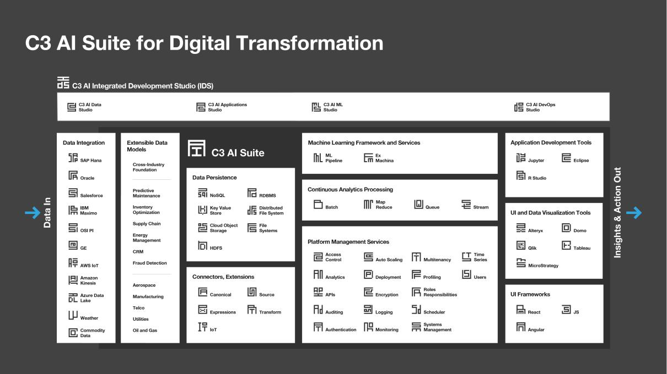

We have built the AI Suite of the future that enables our customers to rapidly develop, deploy, and operate large-scale Enterprise AI applications. Customers can deploy C3.ai products on major public cloud infrastructures, the private cloud, hybrid environments, or directly on their on-premise servers and processors.

Designed with our model-driven architecture, the C3 AI Suite enables us and our customers to develop Enterprise AI applications by using conceptual models of all the elements required by the application—e.g., data objects (customer, order, contract, etc.), computing resources (database, storage, messaging), data processing services (stream processing, batch processing, etc.), AI and machine learning services (model training, model pipeline management, etc.)—instead of having to write complex, lengthy code. This approach vastly reduces technical complexity for developers and the amount of code they need to write. The C3 AI Suite provides comprehensive capabilities to rapidly develop, deploy, and operate Enterprise AI applications at scale, including:

- Data Integration and Management Services. To easily and automatically ingest and aggregate massive volumes of diverse data from numerous internal and external sources and unify the data in a common and extensible data image.

- AI Application Development and Operationalization Services. Automated services to explore data, build and train AI models, and operationalize AI models and applications at enterprise scale.

- Operational and Security Services. Cohesive core platform services (e.g., access control, data encryption, cybersecurity, time-series services, normalization, data privacy, etc.).

- C3 AI Integrated Development Studio (C3 AI IDS). A low-code/no-code visual toolkit for developing, deploying, and operating Enterprise AI applications.

C3 AI Applications

C3 AI Applications is an expanding portfolio of turnkey cross-industry and industry-specific Enterprise AI applications that address a range of mission-critical use cases. With C3 AI Applications, organizations can typically deploy production AI applications in one to six months. Each of these applications is extensible and customizable to meet customer requirements.

89

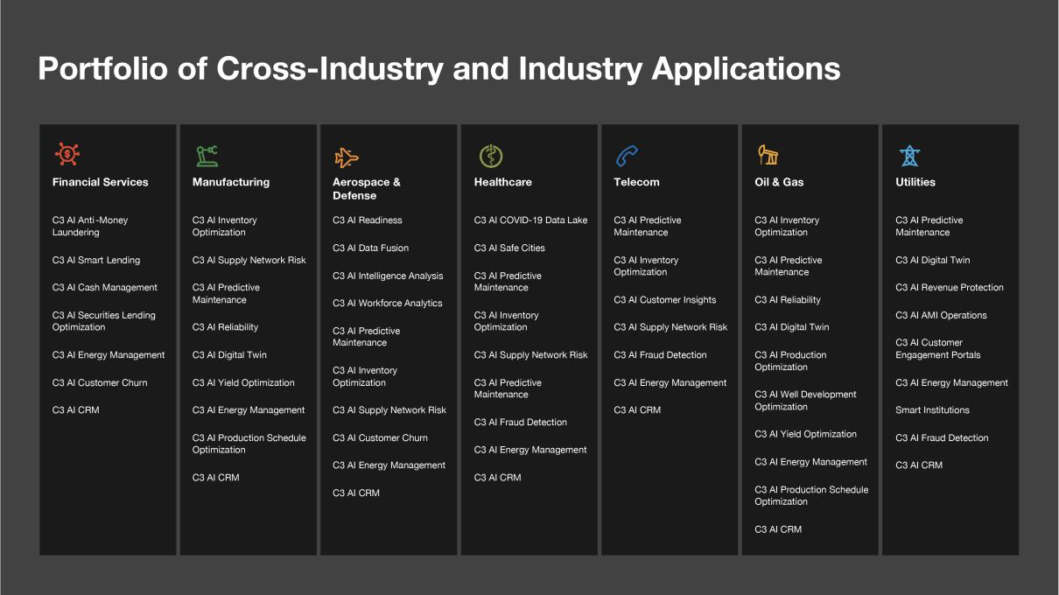

Prebuilt Applications

Prebuilt cross-industry C3 AI Applications include:

- C3 AI Inventory Optimization. Applies advanced AI/machine learning and stochastic optimization techniques to help optimize raw material, in-process, and finished goods inventory levels, while ensuring stock availability when and where needed.

- C3 AI Supply Network Risk. Provides enterprise supply chain managers with visibility into risks of disruption throughout their supply chain operations.

- C3 AI Customer Churn Management. Enables account executives and relationship managers to monitor customer satisfaction using all available transactional, behavioral, and contextual information, and take proactive, early action to prevent customer churn with AI-based and human-interpretable predictions and advance warning.

- C3 AI Production Schedule Optimization. Dynamically optimizes production schedules to maximize throughput of high-profit-margin products while addressing customer demand and respecting production constraints.

- C3 AI Predictive Maintenance. Provides maintenance planners and equipment operators with insight into asset risk so they can maintain higher levels of asset availability across their entire operations.

- C3 AI Fraud Detection. Pinpoints patterns in event data streams that identify revenue leakage or maintenance and safety issues so investigation teams can act upon a single, continuously updated, and prioritized queue of leads.

- C3 AI Energy Management. Uses machine learning to help enterprises gain visibility into their energy expenditure and prioritize actions to reduce their operational costs while lowering their carbon footprint.

Industry-Specific Applications

We also offer integrated families of turnkey Enterprise AI applications to serve the needs of a growing list of vertical market segments including oil and gas, chemicals, utilities, manufacturing, financial services, defense, intelligence, aerospace, healthcare, and telecommunications. For each of these vertical markets we have deployed or are planning to deploy a complete family of integrated AI applications that address the entire value chain of each industry.

90

Financial Services
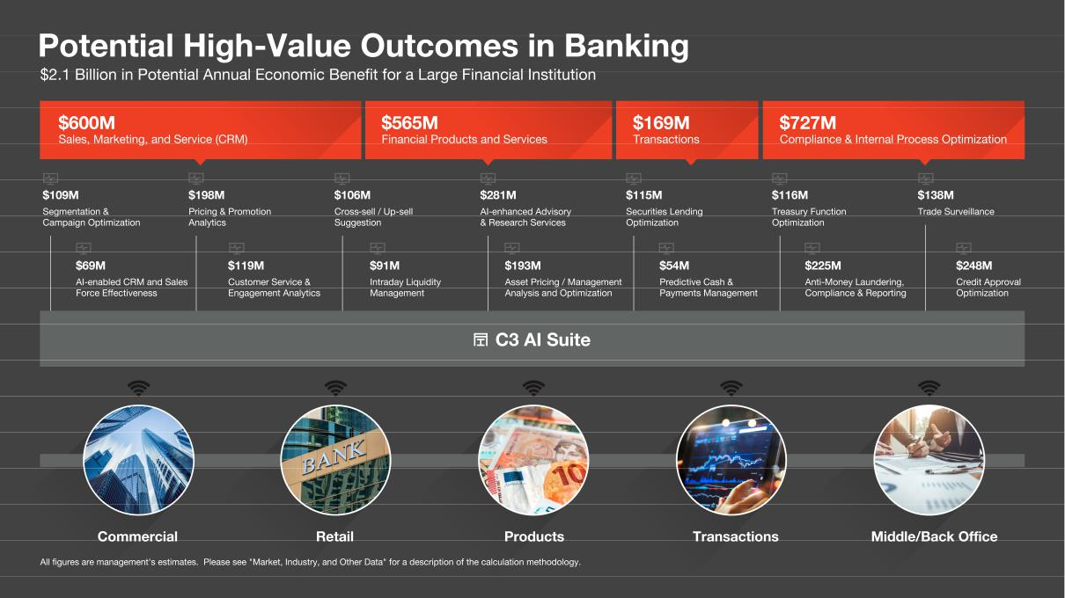

- C3 AI Smart Lending. Drives productivity and customer satisfaction within the credit application and approval process, providing credit officers with contextualized insights, enabling them to reduce time on easy approval or easy rejection decisions and focus on more nuanced credit applications.

- C3 AI Cash Management. Leverages advanced AI algorithms to quantify client treasury activity and predict the clients most likely to reduce or end their cash management and treasury services relationship with the bank.

- C3 AI Securities Lending Optimization. Helps banks automate and optimize securities lending operations by using machine learning to quantify client and lender uncertainties and subsequently automatically approve all executable client inquiries.

- C3 AI Anti-Money Laundering. Is an AI-enabled, workflow-centric application that uses comprehensive machine learning techniques to increase true Suspicious Activity Report identification while reducing false positive alerts.

91

Manufacturing
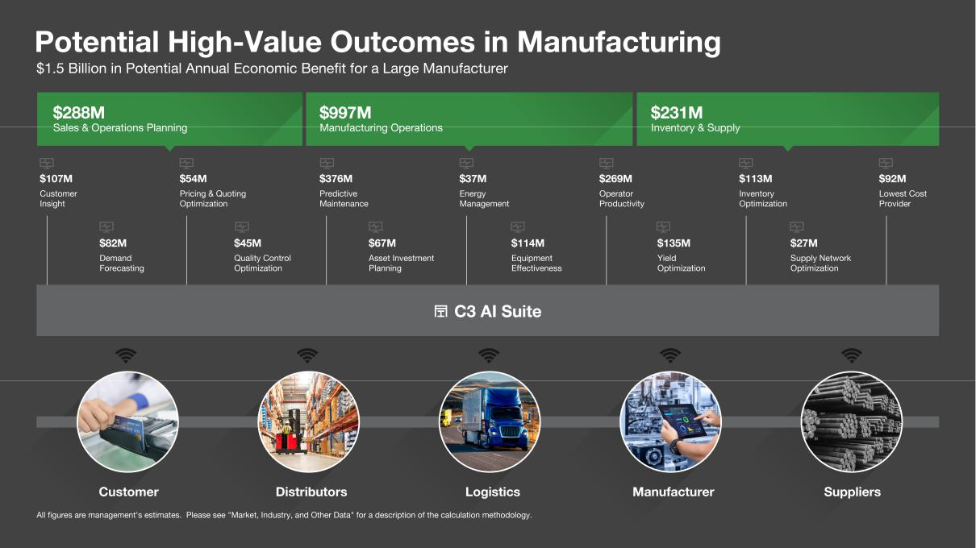

- C3 AI Inventory Optimization. Applies advanced AI/machine learning and stochastic optimization techniques to analyze variability in demand, supplier delivery times, quality issues, and product-line disruptions to build real-time recommendations and monitoring.

- C3 AI Predictive Maintenance. Provides manufacturing maintenance planners and equipment operators with comprehensive insight into asset risk, enabling them to maintain higher levels of asset availability, deliver services-based differentiation, and reduce maintenance costs.

- C3 AI Energy Management. Uses machine learning to enable accurate forecasting, benchmarking, building optimization, demand response, and anomaly detection, helping manufacturers to lower costs, improve operations, and meet energy-efficiency goals.

- C3 AI Sensor Health. Ensures the operational health and optimal deployment of IoT sensor devices, using AI/machine learning to predict sensor failures and identify sensor and network health issues with a high degree of precision.

92

Utilities
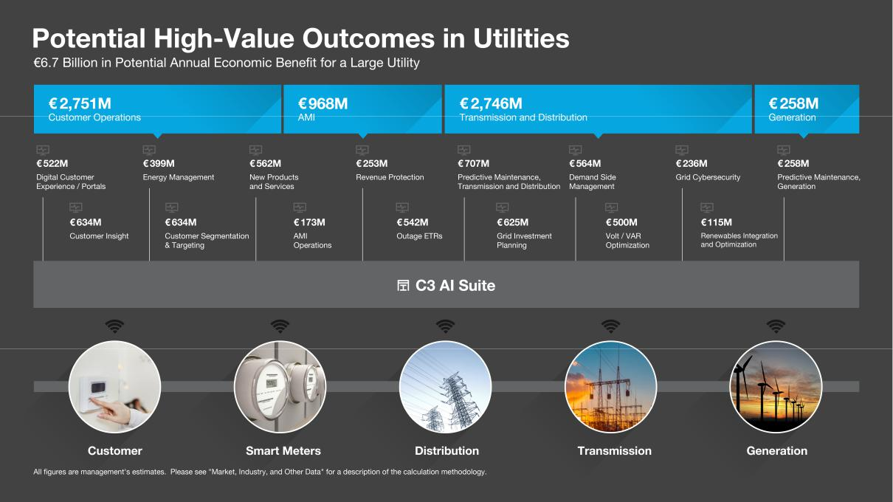

- C3 AI Revenue Protection. Identifies instances of energy theft to protect core revenue at higher accuracy and lower cost than conventional rules-based approaches.

- C3 AI AMI Operations. Integrates and analyzes near real-time advanced metering infrastructure data and utilizes supervised and unsupervised machine learning techniques to assess meter deployment and asset health.

- C3 AI Customer Engagement Portals. Combine data across multiple disparate customer systems, including billing, CRM, demographics, and AMI to provide a 360-degree customer profile to enable both utility customers and customer service representatives to understand and manage their energy usage and costs.

93

Oil and Gas
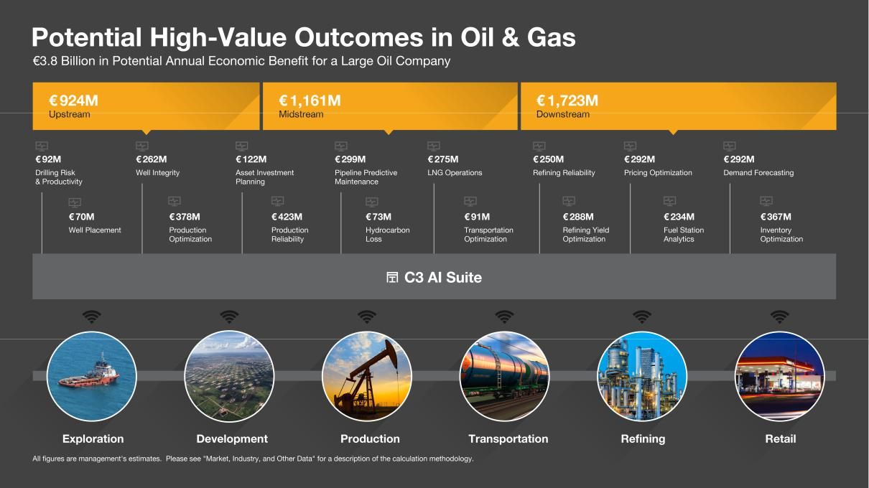

- C3 AI Production Optimization. Optimizes upstream production at-scale with detailed injection well influence, AI-based production forecasts, and artificial lift optimization.

- C3 AI Reliability. Integrates sensor networks, enterprise systems, and data historians to arm reliability engineers, process engineers, and maintenance managers with AI-enabled insights to address process and equipment performance risks in production facilities and refineries.

- C3 AI Yield Optimization. Integrates enterprise resource planning data, lab test data, asset data, and manufacturing systems data and deploys machine learning models to identify problems or opportunities for improvement at key points in process manufacturing.

Aerospace and Defense

- C3 AI Readiness. Integrates and unifies data from aircraft telemetry, mission file, maintenance, and operational systems and leverages advanced AI models to monitor subsystem health and predict component failures.

- C3 AI Workforce Analytics. Helps risk and compliance officers to efficiently parse financial, commercial, public, and law enforcement records to determine if individuals pose a security risk.

- C3 AI Intelligence Analysis. Generates knowledge graphs of entities extracted from both structured (e.g., existing curated databases) and unstructured (e.g., news sources, social media sources, academic reports, and patent databases) data sets.

- C3 AI Intelligence Data Fusion. Ingests intelligence data from disparate sources into a unified, federated data image to enable analysts to conduct their work faster.

C3.ai Ex Machina

C3.ai Ex Machina is a no-code solution that provides secure, easy access to analysis-ready data, and enables business analysts without data science training to rapidly perform data science tasks such as building, configuring, and training AI models. It can be used by itself as a standalone application— providing a modern, cloud-native, highly scalable replacement for last-generation tools—and can also be used with the C3 AI Suite, typically as the primary tool used by non-developer

94

business analysts to build, train, and tune models on the C3 AI Suite. C3.ai Ex Machina targets the broad range of business analysts and data analysts that want to leverage AI capabilities but lack advanced coding skills. Ex Machina is targeted at the ‘citizen’ data scientist and allows customers to sign up online and immediately begin using the product, including paid subscriptions and an initial no cost offering.

Large Total Addressable Market

We serve a large and rapidly growing market, estimated to be $174 billion in 2020, growing to $271 billion in 2024, based on IDC and Gartner reports.

Our total addressable market, or TAM, comprises multiple enterprise software segments that are growing at a combined compound annual growth rate, or CAGR, of 12%:

- Enterprise AI Software. According to IDC, the relatively new but rapidly growing global Enterprise AI software market totaled $18 billion in 2020, and will grow to $44 billion in 2024—a 24% CAGR.⁷ We address this market with our AI Suite and full portfolio of AI Applications.
- Enterprise Infrastructure Software. The C3 AI Suite replaces a wide range of existing enterprise infrastructure software categories, including Application Development, Application Infrastructure and Middleware, Data Integration Tools and Data Quality Tools, and Master Data Management Products. According to Gartner, the size of the infrastructure software market across these four segments totaled $63 billion in 2020, and will grow to $82 billion in 2024—a 7% CAGR.⁸

- Enterprise Applications. C3 AI Applications address a wide range of Analytics and Business Intelligence use cases as well as the Customer Experience and Relationship Management (CRM) segment. According to Gartner, the size of the software market across these segments totaled $93 billion in 2020, and will grow to $145 billion in 2024—a 12% CAGR. ⁹

C3.ai is an active participant in the Enterprise AI/ML, Data Analytics, Cloud Computing, and Digital Transformation markets. According to IDC, by 2022, 65% of CIOs will digitally empower and enable front-line workers with data, AI, and security and by 2025, 80% of CIOs alongside lines-of-business will implement intelligent capabilities to sense, learn, and predict changing customer behaviors.¹⁰

First-Mover Advantage

Due to our significant investment in our products and technology over the last decade, we enjoy a significant first-mover advantage in Enterprise AI. We are not aware of others who have made as much progress as we have in this space. We believe that we have the world’s most extensive Enterprise AI production footprint. Our goal is to establish and maintain a global leadership position in Enterprise AI across all market segments including large enterprises, small and medium businesses, and government entities.

Our production footprint across the C3.ai customer base today includes: 770 unique enterprise and extraprise source data integrations; integrated data from 622 million sensors; 4.8 million machine learning models in production use; 1.1 billion predictions per day generated by customers; and 50 million businesses and customers touched daily.

In some instances our data processing rates exceed nearly 1 million transactions per second. Our system availability across our production application use base in the six months ended October 31, 2020 was 99.98%.

- IDC, Worldwide Artificial Intelligence Systems Spending Guide, September 2019
- Gartner, Forecast: Enterprise Infrastructure Software, Worldwide, 2018-2024, 3Q20 Update

⁹ Gartner, Forecast: Enterprise Application Software, Worldwide, 2018-2024, 3Q20 Update
¹⁰ Source: IDC FutureScape: Worldwide CIO Agenda 2021 Predictions, October 2020

95

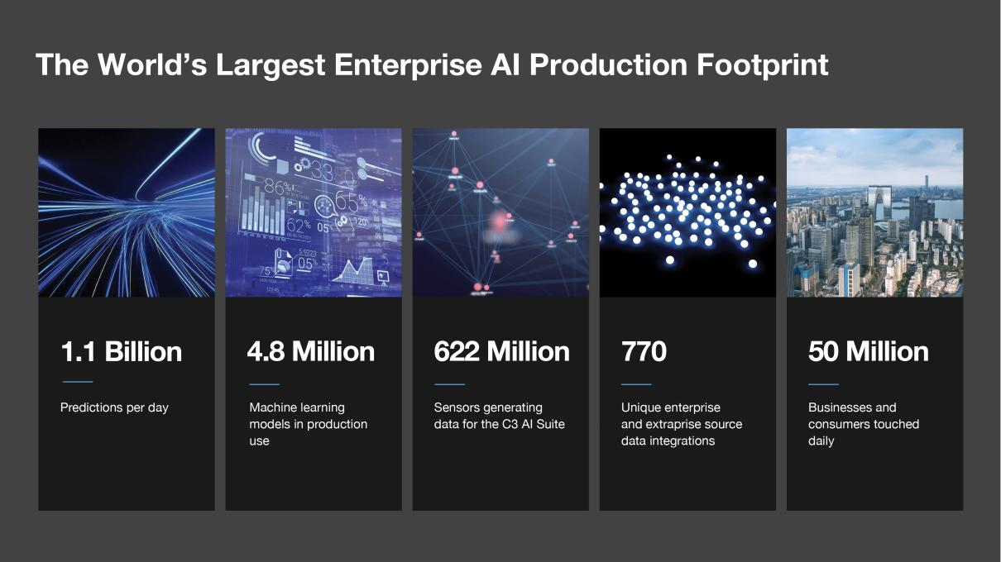

Rapid Revenue Growth

We are growing rapidly, with total revenue of $156.7 million in the fiscal year ended April 30, 2020 compared to $91.6 million in the fiscal year ended April 30, 2019, representing year-over-year growth of 71%. Over the same period, our subscription revenue grew to $135.4 million from $77.5 million, a 75% increase. We incurred net losses of $69.4 million and $33.3 million in the fiscal years ended April 30, 2020 and 2019, respectively.
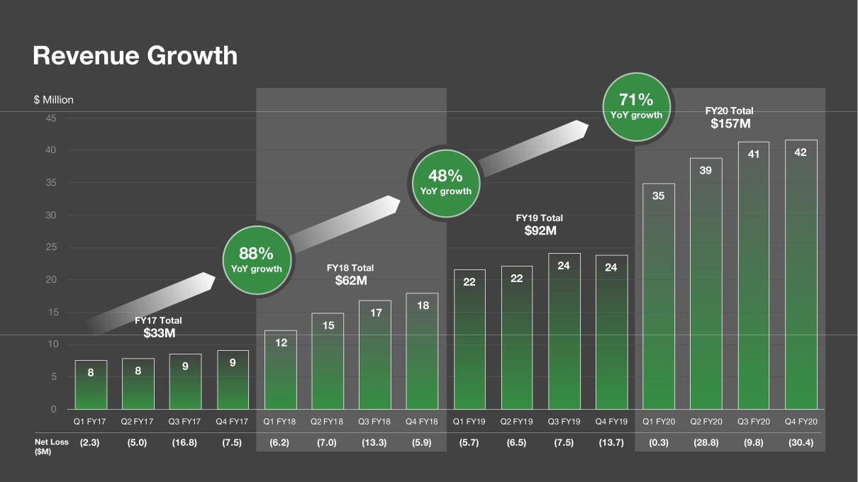

96

Lighthouse Customers

Our market-entry strategy has been to establish high-value customer engagements with large global early adopters, or lighthouse customers, in Europe, Asia, and the United States across a range of industries. These lighthouse customers serve as proof points for other potential customers in their particular industries. We have established intimate strategic relationships with our customers that include many of the world’s iconic organizations. Our customers include a number of large multinational corporations and government entities. We commonly enter into enterprise-wide agreements with Entities that include multiple operating entities or divisions. We define an Entity as each such buying entity that has an enterprise agreement to deploy or establish the governing terms should we contract to deploy the C3 AI Suite or one or more C3 AI Applications to different customers within the Entity. We often provide our software to distinct departments, business units, or groups within an Entity, and use customer to include each distinct department, unit, or group within an Entity. As of October 31, 2020 we had contracts with 30 Entities as compared with 21 and 25 as of April 30, 2019 and 2020, respectively. As of October 31, 2020 we had 64 customers.
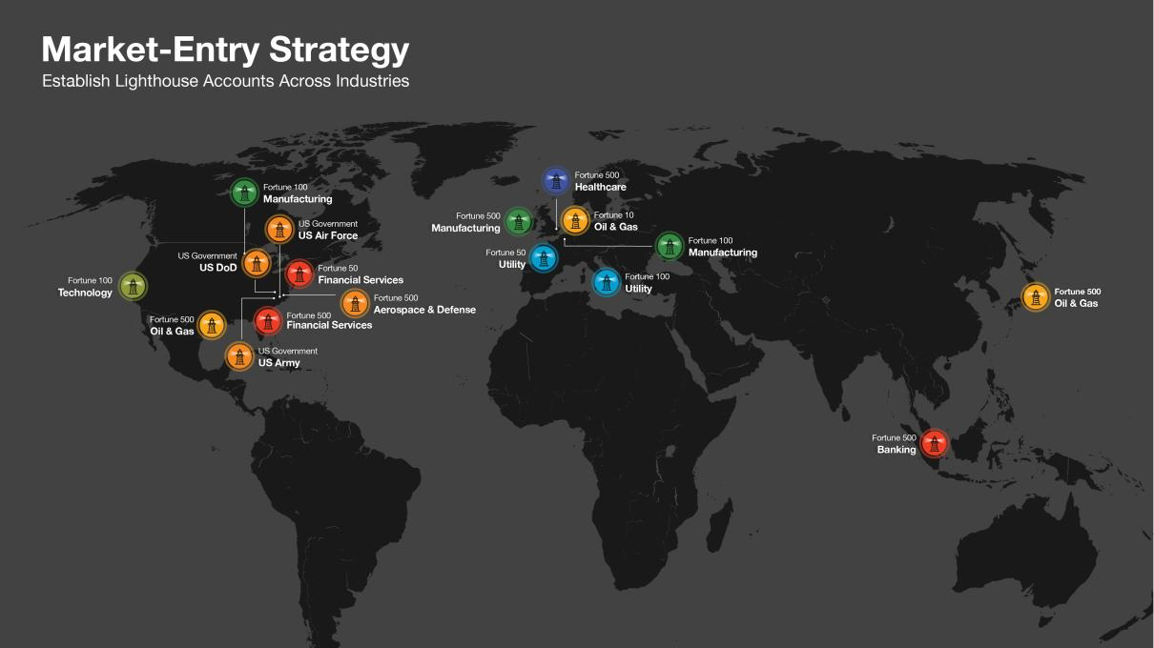

The core of this strategy is to rapidly deliver high-value outcomes at large scale, that are broadly deployed into many industry leaders, including those in banking, oil and gas, utilities, defense, and manufacturing. We then use these cases and outcomes to initiate discussions at numerous other leading companies in each sector.

High-Value Outcomes

We are enabling the digital transformation of many of the world’s leading organizations and, in the process, helping them to attain short time-to-value and exceptionally high economic returns. At some companies, based on feedback and other information provided from our customers, we estimate our solutions have returned hundreds of millions of dollars in economic benefit.¹¹ We estimate, based on our C3.ai production roadmaps, that we may enable billions of dollars in annual economic benefit for many customers.¹²

- Management estimates based on results from trials or deployments using customer data from more than 20 projects across 15 customers. Data and feedback were collected from 2016 to 2020. See the section titled “Market, Industry, and Other Data” for additional information.

- Based on actual results achieved in trials or deployments using actual customer data and business processes as provided by our customers. These estimates are limited by the scaling factors of extrapolating these results from the specific project scope of each trial or deployment across the customer’s entire business. These estimates are based on more than 20 projects across 15 customers, and the data and feedback were collected from customer engagements occurring in the years 2016 to 2020.

97

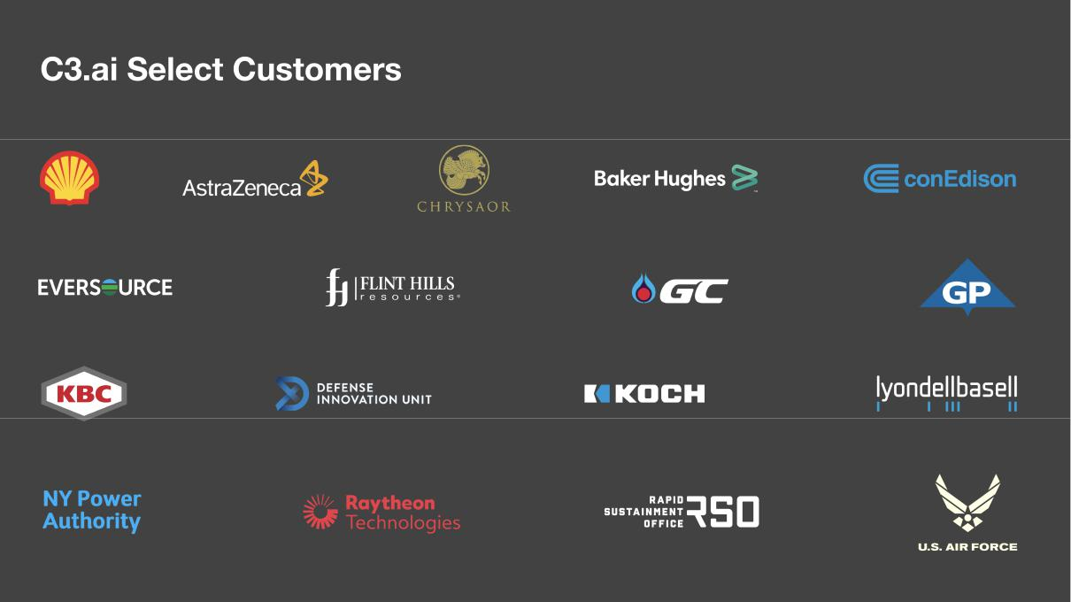

Rapid Time to Value

The key to our market success to date and our primary competitive differentiator is our ability to leverage the C3 AI Suite and C3 AI Applications to bring high-value Enterprise AI applications into production use rapidly. We have deployed Enterprise AI applications into production use in as little as four weeks. We have highlighted below some actual use cases from our customers and our estimate of the current annual economic benefits to our customers. The following case studies are examples of how some of our customers have selected, deployed, and benefited from the C3 AI Suite and C3 AI Applications. These are individual experiences with the C3 AI Suite and C3 AI Applications and not all customers may experience all of the benefits described below or concur with our estimates of such benefits.

Global Bank

Use Case:

Securities Lending Optimization

Trial Completion:

16 Weeks

Production Deployment:

36 Weeks

Benefit:

$14 billion in additional daily trades

98

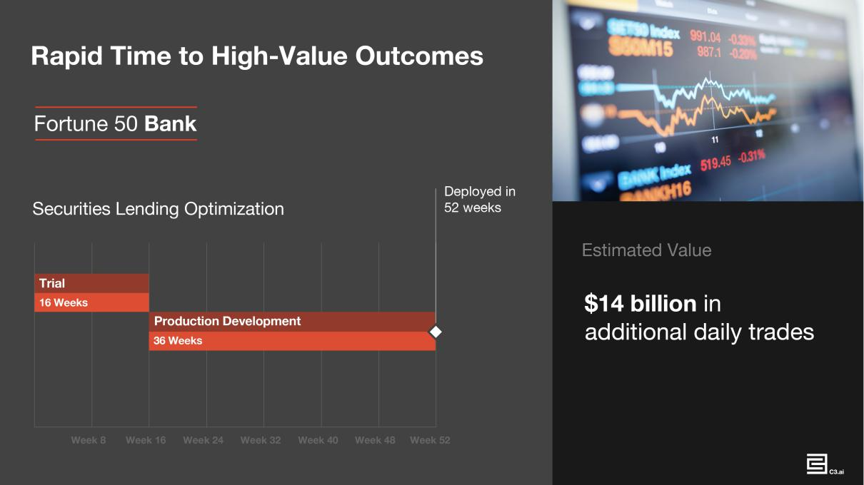

Oil and Gas Company

Use Case:

Trial Completion:

Production Deployment:

Benefit:

AI Predictive Maintenance for Offshore Oil Rigs

4 Weeks

34 Weeks

$28 million per year in avoided shutdowns

99

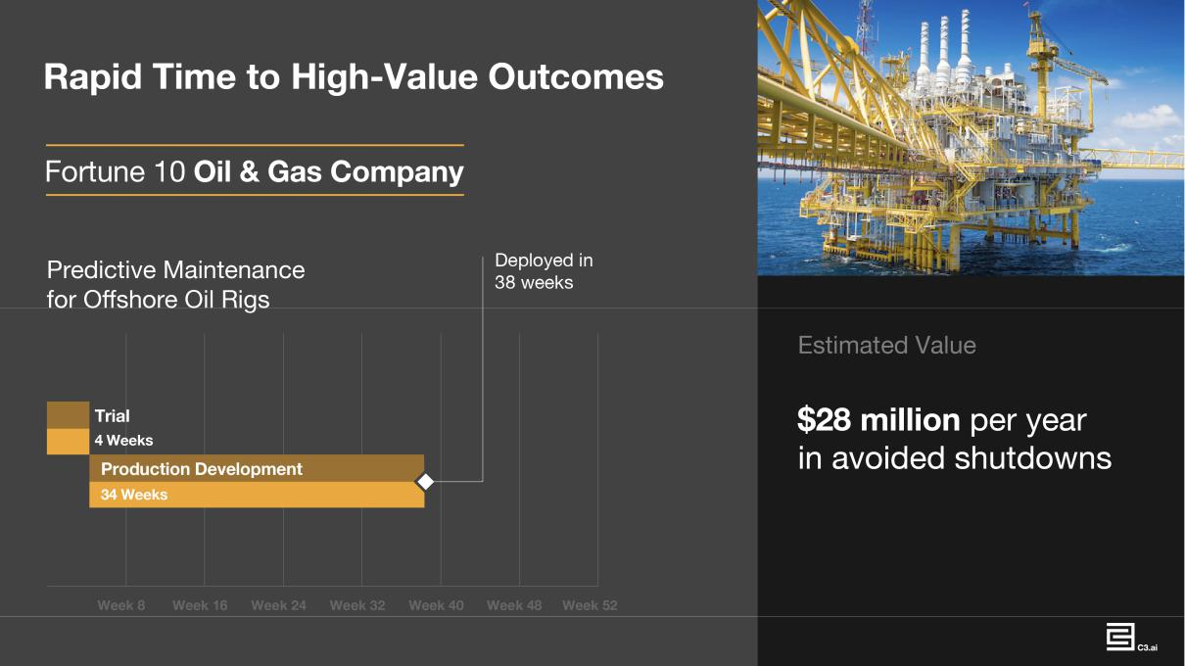

Healthcare Manufacturing

Use Case:

Trial Completion:

Production Deployment:

Benefit:

Production Optimization (Maximization)

No trial

4 Weeks

300% increase in unit production

100

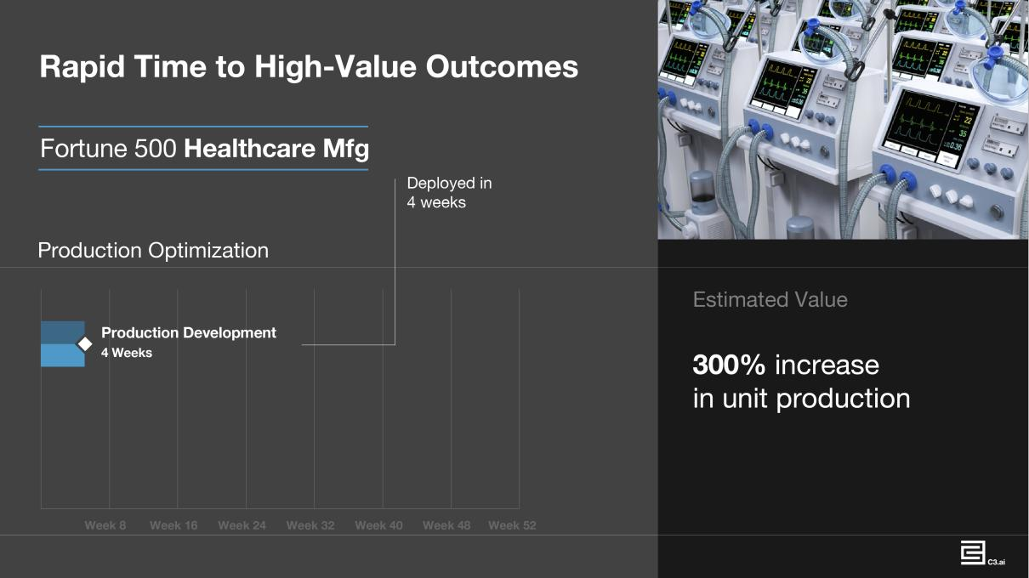

Outsized Average Total Subscription Contract Value

As a result of the high-value outcomes that we enable, we enjoy uncommonly high total subscription contract values for software subscriptions. Our average total contract value for contracts entered into in fiscal years 2016, 2017, 2018, 2019, and 2020 was $1.2 million, $11.7 million, $10.8 million, $16.2 million, and $12.1 million, respectively. We believe this is a high-water mark for the applications software industry.¹³ For example:

- Large Integrated Energy Company. The total value of our contract with a large integrated energy company was €4.3 million at year one, €4.3 million at year two, €34.4 million at year three, and €35.3 million at year four.

- Large Global Financial Institution. The total value of our initial contract with a large global financial institution was $1.8 million, increasing to $31 million at year one and $39 million at year two.

- Large Global Oil and Gas Company. The total value of our contract with a large global oil and gas company was €1.8 million at year one, €19.8 million at year two, €24.2 million at year three, and €25.4 million at year four.

- Large Global Energy Company. The total value of our contract with a large global energy company was €19.4 million at year one, €20.3 million at year two, €26.1 million at year three, and €43.1 million at year four.

- Major Government Agency. The total value of our contract with a major government agency was $6.2 million at year one, $8.7 million at year two, and $14.9 million at year three.

Total contract value is the sum of total subscription contract value plus paid trials, contractual increases of less than 12 months in duration, and monthly actual usage-based fees. Our average total contract value for contracts entered into in fiscal years 2016, 2017, 2018, 2019, 2020, and the six months ended October 31, 2020 was $0.6 million, $2.6 million, $1.2 million, $1.4 million, $1.3 million, and $1.7 million, respectively.

The average total subscription contract value is decreasing and we expect it to continue to decrease as we have restructured our sales organization and expanded our market-partner ecosystem to effectively address small, medium, and large enterprise sales opportunities. We have seen significant progress to date in this regard. Our average total subscription contract value for the six months ended October 31, 2020 was $7.7 million.

- Based on our review of the estimated contract values of approximately 100 representative applications software companies from publicly available sources.

101

C3.ai Sales Cycle

Our typical sales cycle begins with one or more product and technical presentations about C3.ai, leading to a mapping of our capabilities to customer use cases. This frequently leads to a paid trial that lasts from five to 16 weeks. During that period, we deploy a production-level application that is representative of our customer’s AI and digital transformation requirements. Examples include: Stochastic Optimization of the Supply Chain, Production Optimization, Fraud Detection, and Predictive Maintenance. After completing a successful trial, our customers will frequently license one or more C3 AI Applications. Either concurrent with or subsequent to licensing C3 AI Applications, our customers will often license additional C3 AI Applications and/or the C3 AI Suite. Over time, our customers tend to purchase additional C3 AI Applications and additional C3 AI Suite developer seats and incur ongoing and increasing runtime fees as usage scales.

Land and Expand

Our bookings footprint within a customer starts quite large and tends to increase over time, as the customer licenses additional applications, adds more developer seats for the C3 AI Suite, and increases runtime fees that accrue from application usage.

An analysis of our largest 15 Entities from 2010 to date shows that subsequent to trial completion, their average initial purchase was $12.8 million. On average, each of these customers has subsequently purchased an additional $26.1 million in product subscriptions and services from us since their initial subscription contract to date.
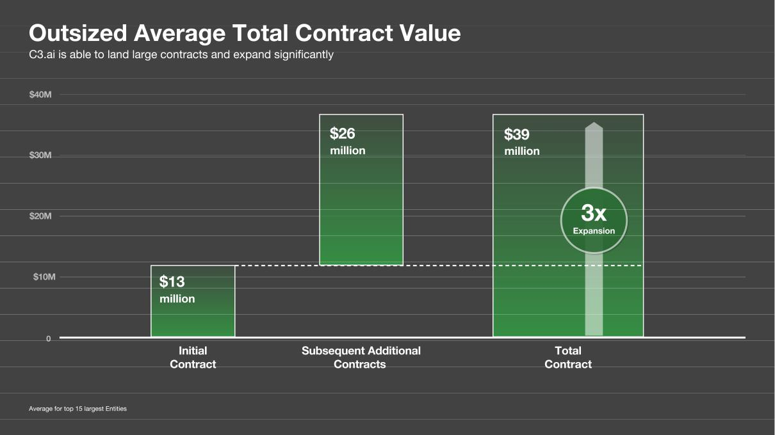

The duration of our contracts vary by customer. The weighted average contract duration for commercial Entities in the year ended April 30, 2020 was 35 months, while the weighted average contract duration for federal agency Entities was 11 months.

The following are representative examples of how some of our customers are benefiting from their use of C3.ai technology. These are individual experiences with C3.ai technology and not all customers may experience all of the benefits described below or concur with our estimates of such benefits.

102

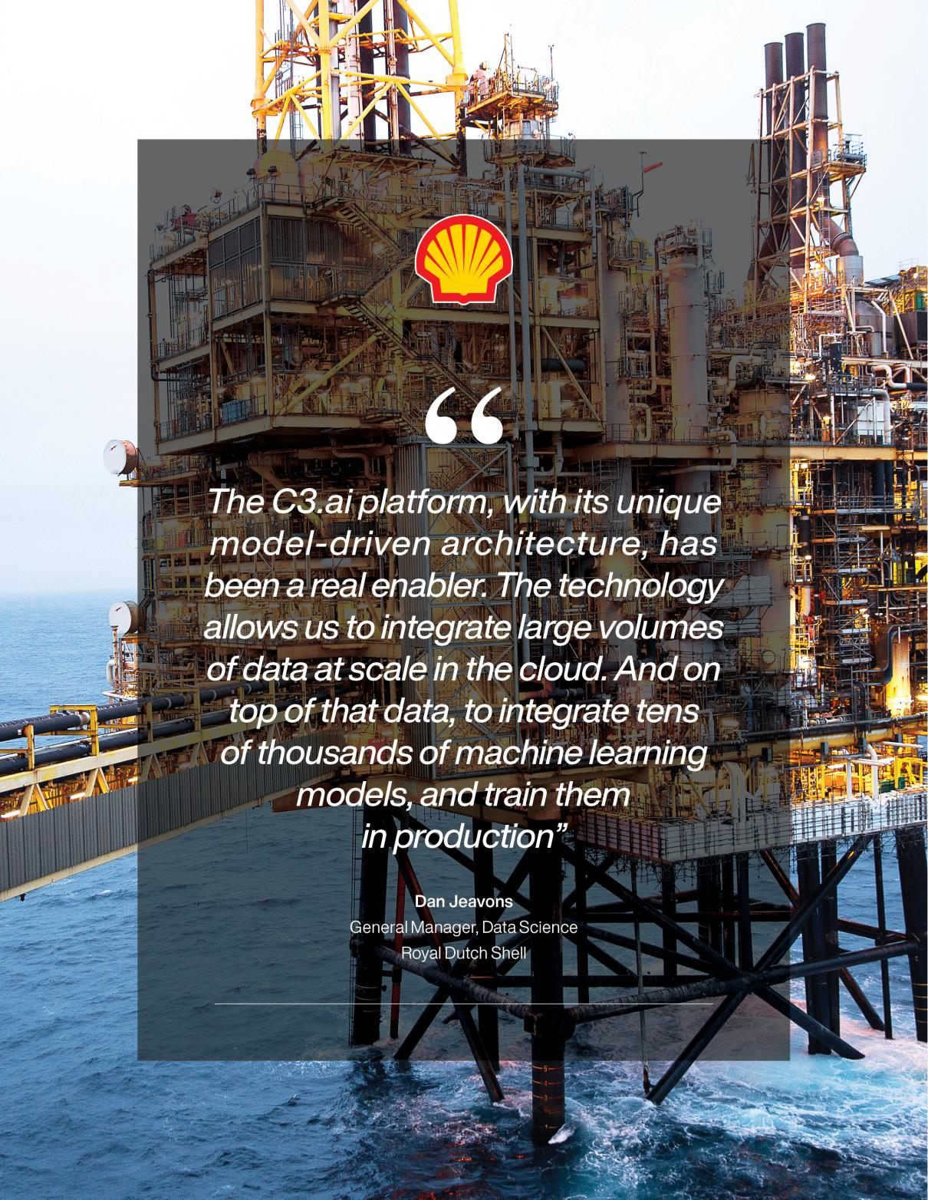

103

Royal Dutch Shell

Situation. With $345 billion in annual revenue, around 80,000 employees, and operations in more than 70 countries, Shell – one of the world’s largest companies – has a long history of technological innovation, and is strategically deploying information technology solutions as it leads the global energy transition. The company operates a vast range of assets throughout the world, including thousands of onshore and offshore wells, 15 refineries, and over 44,000 retail stores, Shell required a scalable Enterprise AI solution to help ensure continued focus on its health, safety, and environment goals, to improve and optimize its upstream, midstream, and downstream operations, and to accelerate new energy and digital opportunities.

C3.ai Solution. Beginning in 2018, Shell adopted the C3 AI Suite as a core platform to develop and deploy large-scale AI applications across its enterprise, leveraging the model-driven architecture of the C3 AI Suite. Initially starting with predictive maintenance for equipment at one oilfield, Shell’s AI roadmap has expanded and is now monitoring 2,500 pieces of equipment across Upstream, Downstream Manufacturing, and Integrated Gas assets. This includes predictive maintenance for compressors, pumps, and valves across multiple assets globally. For example, Shell is using the C3 AI Suite to develop, train, deploy, and manage machine learning models that ingest around 10 billion rows of data per week from 822,000 sensors, at minute-level granularity.

Customer-Reported Outcome. The economic benefit is substantial. In the case of predictive maintenance for valves, the C3.ai solution provided an early-warning system to alert operators before a valve fails, helping to reduce unplanned maintenance costs, increase production uptime, enhance safety, and extend asset lifetime.

Expansion. Our initial engagement with Shell started with two successful predictive maintenance trials addressing different types of assets on (1) offshore oil rigs and (2) at a natural gas unit in Australia in 2017. Those resulted in application licensing agreements that led to the production deployment of C3 AI Predictive Maintenance in early 2018 in both of those units. Subsequently, a successful proof of technology demonstrated the capabilities of the C3 AI Suite to solve large-scale machine learning problems requiring the management of millions of concurrent machine learning models. As a result, in mid-2018 Shell licensed the C3 AI Suite as an Enterprise AI development platform, and has continued to expand its use of the C3 AI Suite, adding numerous additional developers in 2019 and 2020 to address multiple use cases. In 2020, Shell announced that it had selected C3.ai as its AI application development standard and has a large application roadmap planned.

104

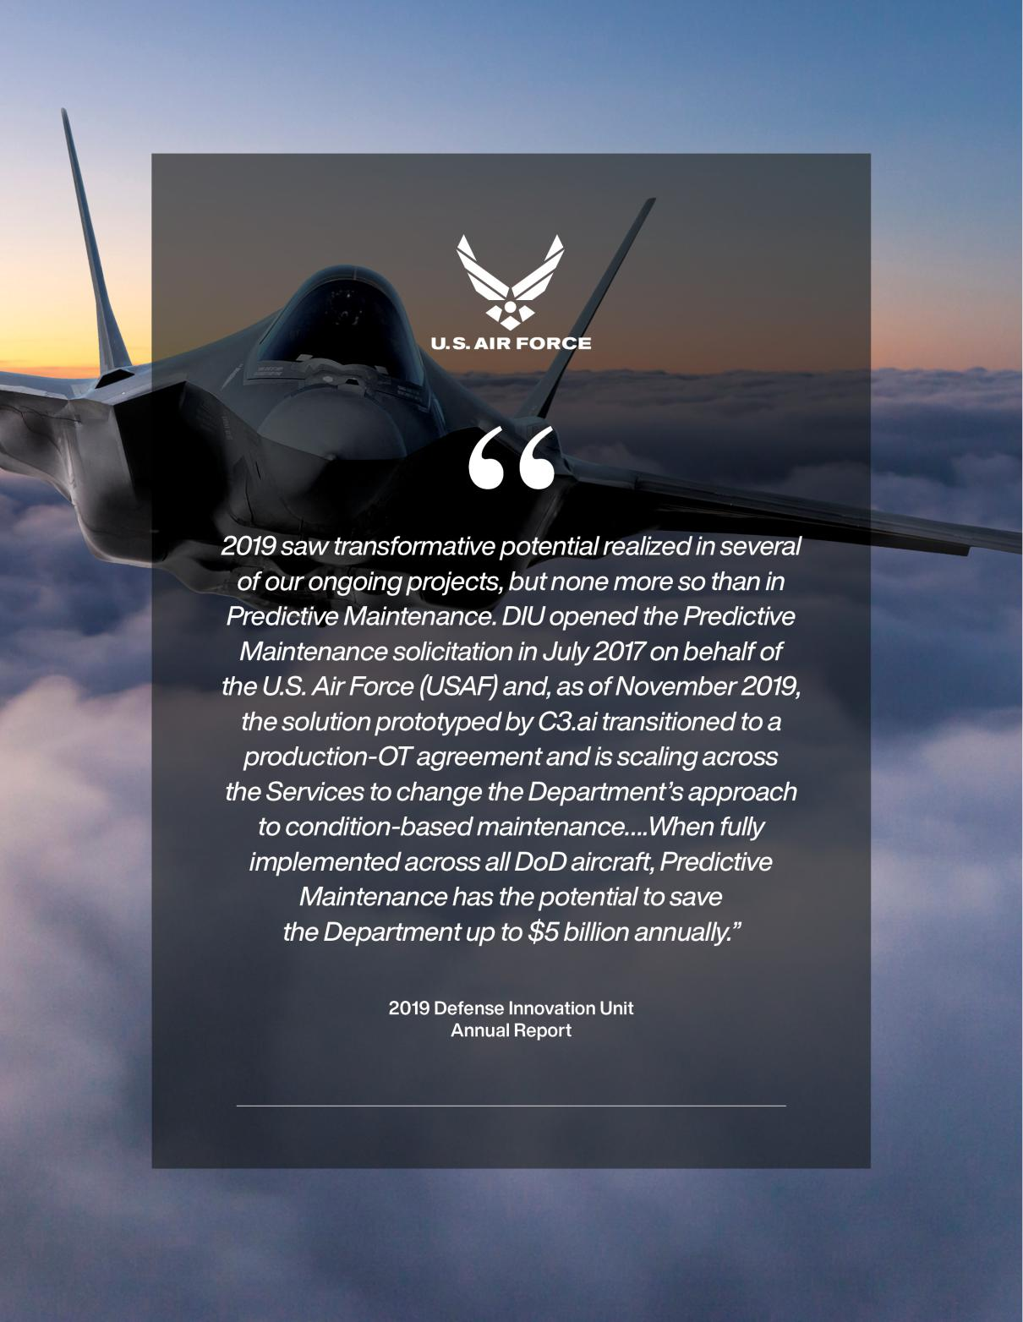

105

U.S. Air Force

Situation. As stated in the 2019 Annual Report of the Defense Innovation Unit, or DIU, a division of the U.S. Department of Defense, or DoD, in 2017 the DoD was “seeking software for predictive or condition-based maintenance.” The solicitation specified that the “Solution must be capable of integrating both historical structured (e.g. sensor reports) and unstructured (e.g. maintenance logs) datasets. Solution will need to apply machine learning to optimize maintenance schedules and provide analysis and recommendations at both a component and system level. Companies must have previously delivered predictive maintenance platforms to commercial customers, preferably in the aviation sector.”

C3.ai Solution. According to the 2019 DIU Annual Report, “2019 saw transformative potential realized in several of our ongoing projects, but none more so than in Predictive Maintenance. DIU opened the Predictive Maintenance solicitation in July 2017 on behalf of the U.S. Air Force, or USAF, and, as of November 2019, the solution prototyped by C3.ai transitioned to a production-OT agreement and is scaling across the Services to change the Department’s approach to condition-based maintenance.

The goal of the prototype effort was to increase aircraft readiness and availability through a reduction in the frequency and duration of unscheduled maintenance. Providing maintainers with the tools to understand, prior to failure, when to change key components (and ensure component availability) would also decrease the number of maintenance related mission aborts. DIU and the USAF supported four prototype implementations of the C3.ai readiness application to over 920 aircraft including the E-3 Sentry, C-5 Galaxy, and F-16 Fighting Falcon aircraft.”

Customer-Reported Outcome. The 2019 DIU Annual Report described the impact of the C3.ai implementation: “The prototype effort was successful in demonstrating AI and machine learning techniques to improve readiness. Specifically, in advance of failures, supervised machine learning can accurately predict the probability of failure of various subsystems over different time horizons. As a result, maintenance technicians are able to identify component-level failures before they occur, pre-position parts in anticipation of failures, and replace components with a high potential for failure.

Prototype implementations of C3.ai technology in partnership with the USAF demonstrated the potential for a 3-6% improvement in mission capability; up to a 35% reduction of base-level occurrences of aircrafts sitting on the ground awaiting parts; and up to a 40% reduction in unscheduled maintenance events. The prototype also demonstrated minimal impact to component part supply chains and identified 80-90 parts (out of more than 1,000) that are responsible for 90% of total aircraft downtime. Additionally, the potential readiness benefits from adopting predictive maintenance tools are achievable across aircraft types, data quality, and data source.

As an Office of the Under Secretary of Defense, or OUSD, organization, DIU can scale successful prototype efforts across DoD through production-OT contracts. DIU sponsored the current up-to-$95 million production-OT agreement that allows all Services and other federal agencies to procure C3.ai’s software for aircraft predictive maintenance. 2020 goals include increased use by U.S. Army Aviation for its UH-60 Blackhawk and AH-64 Apache helicopter platforms and adoption by the F-35 Joint Strike Fighter Lightning II Joint Program Office. When fully implemented across all DoD aircraft, Predictive Maintenance has the potential to save the Department up to $5 billion annually.”

In September 2020, C3.ai announced an agreement with the USAF Rapid Sustainment Office, or RSO, to deliver and deploy the C3 AI Suite and C3.ai Readiness to support predictive analytics and maintenance across the Air Force enterprise, initially deploying the application to the HH-60 Pave Hawk aircraft weapon system. RSO’s Condition-Based Maintenance Plus, or CBM+, Program Office will use the C3 AI Suite and extend C3.ai Readiness to improve the efficiency and effectiveness of maintenance processes. This initiative will also lay a foundation and framework for the enhancement of RSO’s overall AI and machine learning capabilities.

“C3.ai’s proven technology has demonstrated success across multiple industries with its AI-based readiness application for predictive maintenance and logistics planning, making C3.ai an ideal partner to implement RSO’s vision to increase mission readiness,” said Nathan Parker‚ RSO Deputy Program Executive Officer. “By partnering with C3.ai, RSO’s CBM+ Program Office will be able to accelerate scaling AI and ML capabilities across the Air Force enterprise, and combine data science with Air Force operational maintenance, to digitally transform how we maintain our global fleet.”

Fortune 50 Bank

Situation. An acknowledged industry innovator, this multinational bank, one of the 10 largest financial services companies in the world, recognized the potential for AI technology to drive significant impact in many areas of its business, including its corporate cash management and its securities lending operations. For corporate cash management, the bank

106

determined that an AI-based approach could help predict clients’ satisfaction with the interest rate, products, and services the bank offers – across a customer base of more than 100,000 corporate clients with approximately $400 billion in cash balances – and thereby give client managers advance insight into the health of their clients’ satisfaction. On the brokerage side, the bank’s hedge fund clients make hundreds of thousands of inquiries each day regarding available securities inventory for short selling. The bank saw an opportunity for AI to help it more accurately predict hedge fund demand for securities and improve efficiency in matching securities for lending to actual demand. Each of these problems are exceedingly complex in terms of the volume, velocity, and variability of the data.

C3.ai Solution. The bank worked with C3.ai to establish a Center of Excellence to address both the cash management and securities lending use cases. C3 AI Suite now has dozens of integrations with over one billion rows of data behind nearly two hundred predictive models in production, driving two critical revenue-generating applications: C3 AI Cash Management and C3 AI Short Sale Predictor.

Outcome. Using the C3 AI Cash Management application, the bank can predict client satisfaction and give client managers actionable insight up to 90 days in advance so they can take proactive measures to engage with clients to retain and grow their business. The application also detects customers’ sensitivity to interest rates and provides a comprehensive view of customer behavior. Together these capabilities help the bank’s treasury sales team take targeted and proactive steps to better serve and retain customers. On the brokerage side, the C3 AI Short Sale Predictor application predicts client short activity against more than 400,000 requests to locate stocks that clients can borrow, allowing the bank to optimize its stock inventory. The application predicts the actual quantities of stocks that clients (primarily hedge funds) will need to borrow each day, enabling the bank to have the right quantities on hand and better fulfill each request, resulting in $14 billion in additional daily trades. Building on the success of C3.ai in addressing these use cases, the bank has created a roadmap to address a significant number of additional use cases using C3.ai technology.

Expansion. The bank’s engagement with C3.ai started in two lines of business with three successful paid trials in late 2018, each focused on a different uses case, that proved the capabilities of the C3.ai platform to solve previously unsolved problems. Since licensing the C3 AI Suite in 2019, the bank has deployed C3 AI Cash Management and C3 AI Short Sale Predictor, and has continued to significantly expand its use of the platform to address additional use cases in multiple lines of business, with numerous additional planned applications on its roadmap.

Fortune Global 500 Healthcare Company

Situation. With more than $20 billion in annual revenue, this Fortune Global 500 company ranks in the top-ten global healthcare technology providers and is a leader in multiple product categories, including diagnostic imaging, image-guided therapy, and patient monitoring. As a result of the COVID-19 pandemic, the company faced unprecedented demand spikes globally, requiring a four-fold increase in production for critical medical products and creating tight customer deadlines and significant stresses on factories and suppliers. Efficient supply chain management is a challenging endeavor even in the best of times, and the pandemic intensified the need to have near real-time visibility into inventories, orders, and lead times. In order to deliver the right products in the right quantities to the right locations on time, the company needed an AI-enabled solution to provide end-to-end visibility of its ventilators products.

C3.ai Solution. In 2020, C3.ai worked with the company to deploy C3 AI Inventory Optimization and C3 AI Supply Network Risk applications into production in just four weeks – a project that may have taken several months using other technologies. The C3.ai-powered solution aggregates and unifies 500 million rows of data from the Company’s source systems – a remarkable achievement due to the disparity of the data. The solution spans the company’s global supply chain, including three factories and six distribution centers, providing up-to-date visibility of finished goods across its products.

Outcome. The company’s planners immediately utilized the information to identify orders with long lead times and were able to pinpoint and resolve specific issues in the supply chain to meet delivery requirements, enabling a 300% increase in unit production. Building on this success, the deployment is being extended to predict production lead times (from raw materials to customer delivery); apply stochastic optimization of raw supply materials to improve output; and to provide end-to-end inventory visibility and lead time predictions for several thousand SKUs.

107

Extensive Partner Ecosystem

We have established strategic relationships with technology leaders including Amazon Web Services, or AWS, Baker Hughes, Fidelity National Information Services, or FIS, Google, IBM, Microsoft, and Raytheon. These world-leading technology companies can marshal tens of thousands of talented resources to establish and serve small, medium, and large C3.ai customer relationships at global scale.

We form go-to-market and product co-development alliances with our partners that combine our AI expertise and technology with our partners’ deep domain expertise to bring next-generation C3.ai solutions to joint customers. Our partnerships include strategic alliances across four categories:

- Industry Partners. Each industry partnership focuses on a key vertical. We have formed global strategic alliances in the energy industry with France-based global energy leader ENGIE (also a customer); in oil and gas with Baker Hughes, a global leader in oilfield services (also a customer); and in financial services with FIS, leading technology provider to the global financial services industry; and in the U.S. Federal and aerospace sectors with Raytheon, one of the world’s largest aerospace and defense manufacturers.

- Hyperscale Cloud and Infrastructure Partners. We have formed global strategic go-to-market alliances with hyperscale cloud providers including Amazon, Microsoft, and Google. In addition, we have strategic alliances with leading hardware infrastructure providers to deliver our software optimized for their technology. These partners include Hewlett Packard Enterprise and Intel.

- Consulting and Services. We have formed a global strategic go-to-market alliance with IBM Global Business Services, who employs more than 100,000 service professionals. We have also established partnerships with select specialized systems integrators that provide application design and development, data engineering, data science, and systems integration services, including Aubay, BGP, CMC, Data Reply, Infoedge Technology, Informatica El Corte Ingles, Intelia, Neal Analytics, Ortec, Pariveda, SCAP, and Synechron. These alliances are focused on helping organizations accelerate their Enterprise AI and digital transformation programs.

- Independent Software Vendors. Our ISV partners develop, market, and sell application solutions that are natively built on or tightly integrated with the C3 AI Suite. The C3 AI Suite enables ISVs to deliver AI capabilities to their installed user base that enhance or complement existing ISV application functionality. As of September 2020, ISV partners include ENGIE, FIS, and Ortec.

Sales Model

Our sales organization is organized both geographically and into vertical market segments that cooperate to sell to and service customers. We have a highly leveraged go-to-market model comprised of a global field sales force combined with significant alliance partnerships, that we believe will accelerate our entry into diverse global market segments. As of October 31, 2020, we had 41 individuals serving on our sales team globally. Each of our strategic partners—including AWS, Baker Hughes, FIS, Google, IBM, Microsoft, and Raytheon—has a large installed customer base with strong, established relationships, and a large global sales force that vastly extends our market coverage. We form specific sales targets and goals with each partner, enabling us to quickly and efficiently engage in customer accounts.

108

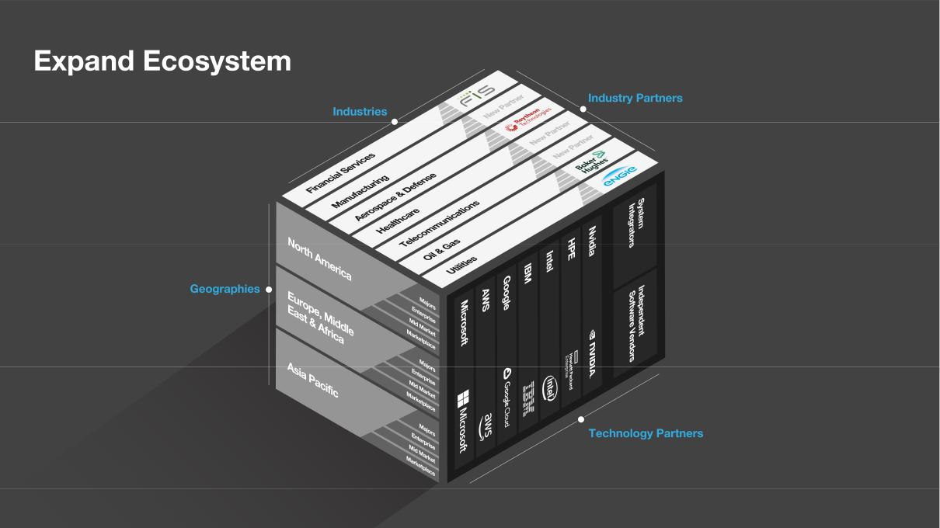

We have been focused on the oil and gas, aerospace, defense, utilities, manufacturing, and financial services sectors, as those appear to be the early adopters in Enterprise AI. As we expand our industry presence into, for example, telecommunications, retailing, precision medicine, etc., we plan to continue that market entry strategy.

Our strategy has been to achieve early leadership with a focus on large enterprise sales to establish successful lighthouse customers across a range of industries and geographies. Our goal is to rapidly move down-market in the next few years to capture the small and medium business segments of each industry. We intend to leverage our partner ecosystem and establish telesales and direct marketing organizations to address the middle market.

Our average sales cycles have been decreasing over time. We believe this is due to increased acceptance of cloud adoption, increased prioritization of Enterprise AI, increasing corporate mandates for digital transformation, increased brand recognition of C3.ai, and increasing numbers of live, production C3.ai customers.

109

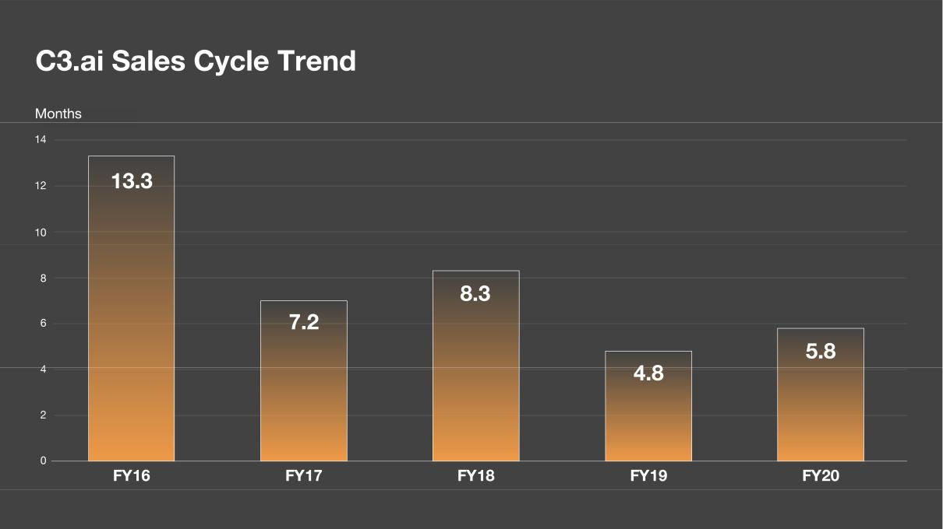

Revenue Model

The bulk of our revenue is generated from subscriptions to our software, accounting for roughly 86% of our total revenue. We currently have four primary revenue sources:

- Term subscriptions of the C3 AI Suite, usually three years in duration.

- Term subscriptions of C3 AI Applications, usually three years in duration.

- Monthly runtime fees of the C3 AI Applications and customer-developed applications built using the C3 AI Suite, usage-based upon CPU-hour consumption.

- Professional services fees associated with training and assisting our customers.

110

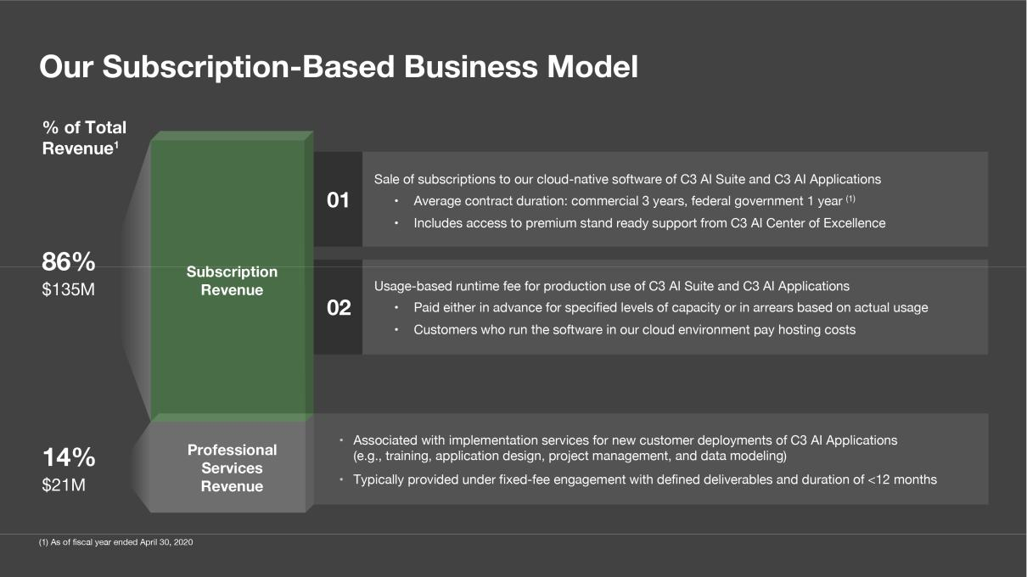

Marketing

Our multichannel marketing function is focused on market education, brand awareness, thought leadership, and demand creation. We engage the market through digital, radio, television, outdoor, airport, and print advertising; virtual and physical events, including our C3.ai Transform annual customer conference; and C3.ai Live, a bi-weekly series of livestreamed events featuring C3.ai customers, C3.ai partners, and C3.ai experts in AI, machine learning, and data science. Our Chief Executive Officer, Tom Siebel—a recognized technology thought leader and author of the 2019 Wall Street Journal and Amazon best seller Digital Transformation: Survive and Thrive in an Era of Mass Extinction—is a frequent industry keynote speaker and is often interviewed by leading media, including the Wall Street Journal, Financial Times, The Economist, Fortune, Forbes, BloombergTV, Yahoo! Finance, and others.

Professional Services

We maintain a small professional services organization that offers resources, methodologies, and experience to help customers develop and deploy enterprise-scale AI applications. Our services are complemented by those of our partners.

C3 AI Implementation Services help ensure successful customer outcomes throughout the application development and deployment phases, including setup and configuration, machine learning model development and tuning, and integration of multiple complex source systems.

C3 AI Academy provides a role-based, in-person, and online curriculum to help developers, data scientists, administrators, and project personnel take advantage of C3 AI Suite capabilities quickly and robustly.

Our professional services strategy is to quickly train our customers to develop, customize, and deploy applications independently of us, making them rapidly self-sufficient. In those instances where a large or continuing professional services presence may be desired or necessary, we rely upon our partner ecosystem, including IBM and Baker Hughes, to provide those services. We believe this will enable us to maintain high gross margins and allow us to rapidly deploy trained professional services personnel at large scale any place on the planet.

Rich Human Capital

Our strongest asset is unquestionably the human capital that we have been able to attract, retain, and motivate. We have won the Glassdoor Best Place to Work award, were named a WayUp Top 100 Internship Program, and are consistently ranked among the best places to work. As a result, we attract exceptionally talented, highly educated, experienced, motivated

111

employees. We hired 214 new employees in the past year. We received approximately 52,000 applications for those positions. Approximately 10,000 of those were engaged in rigorous skill evaluation and interview cycles for a final selection of 214. Fifty-seven percent of our employees have advanced degrees, many from the world’s most prestigious institutions.

We have built a culture of high performance based on four core values:

- Drive and Innovation Propelling Growth. We self-select for people who love to work hard, think with rigor, speak with purpose, and act to achieve great things.

- Natural Curiosity to Solve the Impossible. We are self-learners, always seeking knowledge to accelerate innovation.

- Professional Integrity Governing All Endeavors. We comport ourselves with unwavering ethical integrity, respect, and courtesy.

- Collective Intelligence. We believe the unity of our team is substantially greater than the sum of its parts.

Through our C3.ai Management Development Series, we train our managers to motivate and lead their teams by setting clear objectives with an outcomes-based approach. We offer cash incentives to employees who complete professional training and will even pay for employees to earn a master’s degree in computer science.

Our talent acquisition team engages various constituency groups to recruit qualified under-represented minorities, women, and military veterans to job opportunities. We host tech talks and workshops at top universities across the nation with the Women in Computer Science Associations, the Society of Women in Engineering, the Society of Latinx Engineers, and the Society of Black Engineers. We joined with BreakLine to help support hiring military veterans. Our goal is to find and recruit the best talent in the world.

As of October 31, 2020, we had 482 full-time employees, with 386 based in the United States and 73 in our international locations. The average age of C3.ai employees is 36.

Our Culture of High Performance

We are dedicated to achieving our mission to accelerate digital transformation of organizations globally by enabling the deployment of Enterprise AI at scale. Our people are domain experts in their respective fields. We are individuals with exceptional education and professional backgrounds. We are uncompromising in the quality of our work product. We build relationships with our customers grounded upon the highest levels of business ethics and professionalism, with a laser focus on customer success. We execute with precision.

Recognized AI-Industry Leadership

We are broadly recognized as a leader in Enterprise AI with many other industry recognitions, including CNBC Disruptor 50 (2020, 2019, 2018), BloombergNEF Pioneer (2020), Forbes Cloud 100 (2020, 2019, 2018, 2017), Deloitte Technology Fast 500 (2019), and EY Entrepreneur of the Year (2018, 2017) and have been named a leader by Forrester Wave: Industrial IoT Software Platforms (2019, 2018).

112

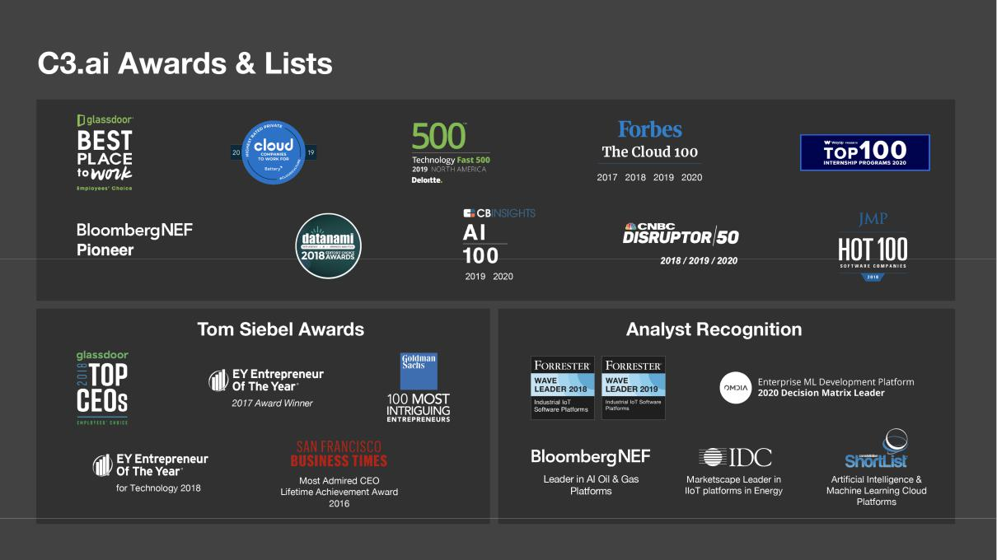

Sustainable Competitive Advantage: C3.ai Model-Driven Architecture

Our core technology, the C3 AI Suite, is a cohesive family of integrated software services developed over a decade, engineered with a proprietary model-driven architecture, that provides all the software services and microservices necessary and sufficient to rapidly develop and deploy Enterprise AI applications.
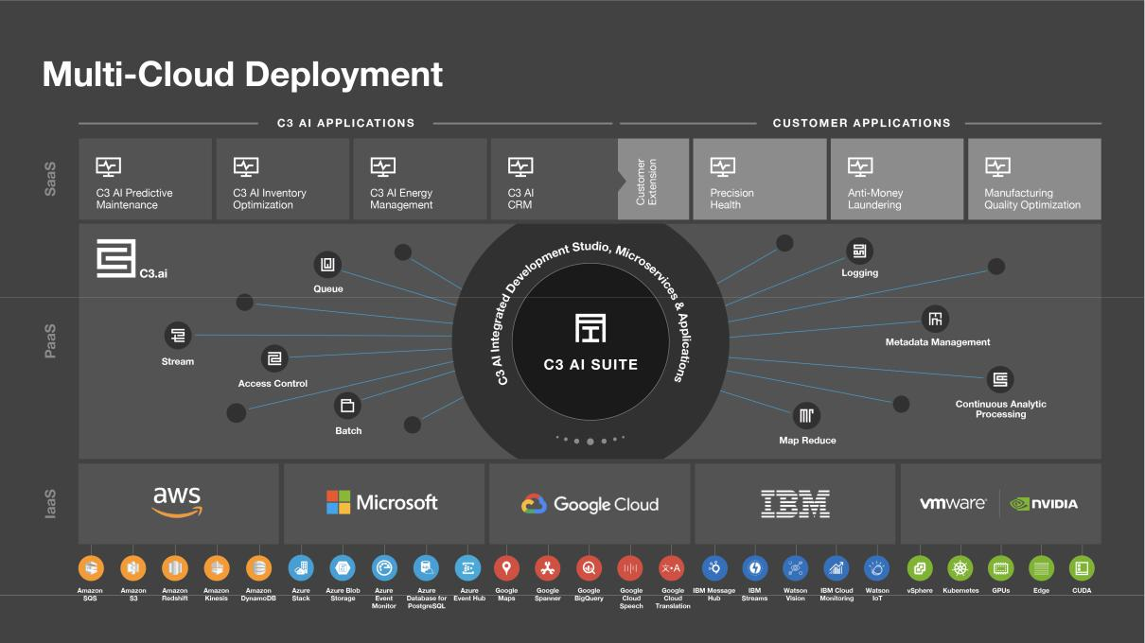

113

Applications developed with the C3 AI Suite can leverage any open source software solutions and all of the cloud services of AWS, Azure, Google Cloud, and IBM Cloud, and can operate on any of these cloud platforms, on-premises, or in a hybrid cloud.

Compared to the structured programming approach that most organizations typically attempt, our model-driven architecture speeds development by a factor of 26, while reducing the amount of code that must be written by up to 99%.

The big data and application demands of Enterprise AI applications require numerous underlying interdependent elements. These include enterprise data, extraprise data, sensor data, data persistence services, data streaming services, messaging services, analytics services, machine-learning services, security services, data visualization, application development services, application monitoring services, and scores to hundreds more. With a traditional structured programming approach, developers spend significant time and effort to write extensive code to define, manage, connect, and control each element. This often results in overwhelming complexity and highly brittle applications that can break any time an underlying element is changed or updated —a primary reason why the vast majority of Enterprise AI efforts have not been deployed into production.

By contrast, our model-driven architecture provides an “abstraction layer,” that allows our partners and our customers, as well as our internal C3.ai developers, to build or customize Enterprise AI applications by using conceptual models of all the elements an application requires, instead of writing lengthy code. C3.ai provides a library of tens of thousands of prebuilt conceptual models, growing by more than 4,000 per year, that can be easily modified and extended, and developers can efficiently create their own models as well. These prebuilt, extensible models encompass a vast range of business objects (customer, order, contract, etc.), physical systems and subsystems (engine, boiler, chiller, compressor, etc.), computing resources and services (database, stream processing, etc.)—virtually anything an application requires can be represented as a model in our model-driven architecture. To ensure ongoing operability of our thousands of prebuilt and extensible models on different underlying infrastructure (e.g., AWS, Azure, etc.), our automated testing continuously executes approximately 60,000 tests and security scans with each change or update made to the software or infrastructure.

Leveraging this model-driven architecture, application developers and data scientists can focus on delivering immediate value, without the need to manage the complex interdependencies of the underlying elements. These conceptual models can be reused by many applications, thereby accelerating development of new applications.

Compared to traditional structured programming, our model-driven architecture and declarative programming shorten time to value and reduce total cost of ownership by:

- Enabling developers to build AI applications 26 times faster and with up to 99% less code than with other technologies, by using conceptual models (including tens of thousands of C3.ai’s prebuilt models)

- Reducing the resources required to build AI applications

- Making developers more productive by allowing them to ramp quickly on new application projects, through reuse of models across applications and reduced coding requirements

- Decreasing application operating and maintenance requirements

- Accelerating the ability to enhance applications with new features

We believe our model-driven architecture provides significant competitive advantage both by enabling our customers and partners to successfully develop and deploy Enterprise AI applications faster, and by providing the foundation for C3.ai to rapidly extend our portfolio of cross-industry and industry-specific applications.

Strategic Competitive IP Advantage

We enjoy a rich patent portfolio that is a substantial competitive advantage, both offensive and defensive, in the Enterprise AI market—most notably, our most recently issued U.S. patents (No. 10,817,530 and No. 10,824,634) which were granted for systems, methods, and devices for an enterprise AI and internet-of-things platform.

Our patent portfolio covers the key capabilities of our model-driven architecture that are the foundation of our highly differentiated technology. This includes methods, systems, and devices for data aggregation and unification, times-series data processing, data abstraction, machine learning implementation, and much more.

114

As of November 23, 2020, our technology is protected by a broad patent portfolio, with six issued patents in the United States, five issued patents in a number of international jurisdictions, 11 patent applications (including two applications that have been allowed and one provisional application) pending in the United States, and 26 patent applications pending internationally. Our issued patents expire between February 23, 2033 and April 17, 2037. We continually review our development efforts to assess the existence and patentability of new intellectual property.

Intellectual property is important to the success of our business. We rely on a combination of patent, copyright, trademark, and trade secret laws in the United States and other jurisdictions, as well as license agreements, confidentiality procedures, non-disclosure agreements with third parties, and other contractual protections, to protect our intellectual property rights, including our proprietary technology, software, know-how, and brand. Although we rely on intellectual property rights, including patents, copyrights, trademarks, and trade secrets, as well as contractual protections to establish and protect our proprietary rights, we believe that factors such as the technological and creative skills of our personnel, creation of new services, features and functionality, and frequent enhancements to our platform are more essential to establishing and maintaining our technology leadership position. See the section titled “Risk Factors—Risks Related to Our Intellectual Property” for a discussion of the risks associated with our intellectual property.

Our Secret Sauce: The C3.ai Model-Driven Architecture

Over the last four decades, the information technology industry has grown from about $120 billion globally in 1980 to more than $2 trillion today. During this time, the IT industry has experienced the transition from mainframe computing to minicomputers, to personal computing, to internet computing, and to handheld computing. The software industry has transitioned from custom applications based on mainframe standards such as MVS, VSAM, and ISAM, to applications developed on a relational database foundation, to enterprise application software, to SaaS and mobile apps, and now to the AI-enabled enterprise. The internet and the iPhone changed everything.

Each of these transitions represented a replacement market for its predecessor. Each delivered dramatic benefits in productivity. Each offered organizations the opportunity to gain competitive advantage. Companies that failed to take advantage of each new generation of technology ceased to be competitive. Today it is unimaginable that a major global corporation would try to close its books without an enterprise resource planning system or run its business solely on mainframe computers.

The IT industry is now undergoing another major transition. A new generation of 21st century technologies—including elastic cloud computing, the IoT, and AI—is driving digital transformation across industry, commerce, and government globally. Digital transformation presents a number of unique requirements that create the need for an entirely new software technology stack. The requirements are daunting.

Enterprise AI applications require a new digital transformation software stack. The traditional approach to developing AI and IoT enterprise software —i.e., using structured programming to build applications by assembling and integrating various open source components and cloud services—can be slow, costly, and ineffective. Based on experience and expertise, we believe that Enterprise-scale AI and IoT applications generally share a set of demanding requirements as described in greater detail below.

Requirements of the Model-Driven Architecture

To develop an effective Enterprise AI application, it is necessary to aggregate data from a variety of enterprise information systems, suppliers, distributors, markets, products in customer use, and sensor networks, in order to provide a view of the extended enterprise.

Today’s data velocities are dramatic, requiring the ability to ingest and aggregate data from hundreds of millions of endpoints at very high frequency, sometimes exceeding 1,000 Hz cycles. The data need to be processed at the rate they arrive, in a highly secure and resilient system that addresses persistence, event processing, machine learning, and visualization. This requires massively horizontally scalable elastic distributed processing capability offered only by modern cloud platforms and supercomputer systems.

The resultant data persistence requirements are staggering. These data sets rapidly aggregate into hundreds of petabytes, even exabytes. Each data type needs to be stored in an appropriate database capable of handling these volumes at high frequency. Relational databases, key-value stores, graph databases, distributed file systems, and blobs are all important to organizing and linking data across these divergent technologies.

115

Reference AI Software Platform

The problems that have to be addressed to enable today’s AI and IoT applications are nontrivial. Massively parallel elastic computing and storage capacity are prerequisite. These services are provided today at increasingly low cost by AWS, Azure, and others. The elastic cloud is a major breakthrough that has dramatically transformed modern computing. In addition to the cloud, multiple data services are necessary to develop, provision, and operate AI and IoT applications.

The array of capabilities and services necessary for building and operating AI and IoT applications at scale represents a development problem on the order of magnitude of a relatively simple enterprise software application such as CRM. This is not a trivial problem. Consider just a few of these requirements.
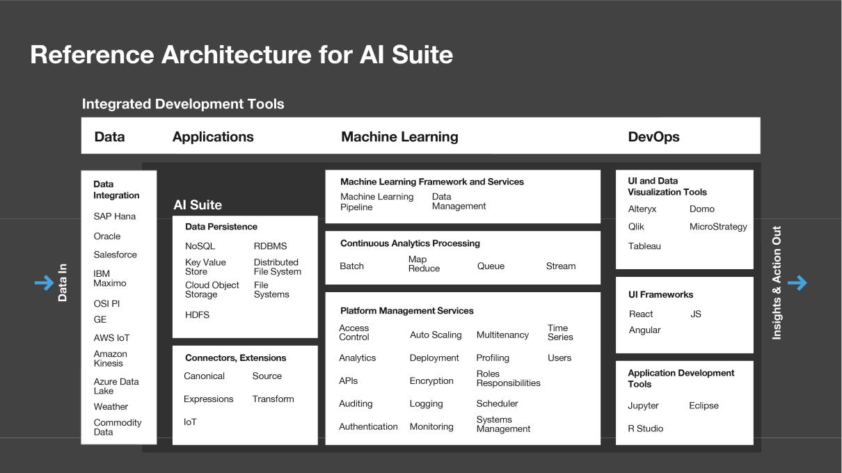

- Data Integration. This problem has haunted the computing industry for decades. Prerequisite to machine learning and AI at industrial scale is the availability of a unified, federated image of all the data contained in the multitude of (1) enterprise information systems—ERP, CRM, SCADA, HR, MRP—typically thousands of systems in each large enterprise; (2) sensor IoT networks—SIM chips, smart meters, programmable logic arrays, machine telemetry, bioinformatics; and (3) relevant extraprise data—weather, terrain, satellite imagery, social media, biometrics, trade data, pricing, market data, etc.

- Data Persistence. The data aggregated and processed includes every type of structured and unstructured data imaginable. Personally identifiable information, census data, images, text, video, telemetry, voice, network topologies. There is no “one size fits all” database that is optimized for all of these data types. This results in the need for a multiplicity of database technologies including but not limited to relational, NoSQL, key-value stores, distributed file systems, graph databases, and blobs.

- Platform Services. A myriad of sophisticated platform services are necessary for any Enterprise AI or IoT application. Examples include access control, data encryption in motion, encryption at rest, ETL, queuing, pipeline management, autoscaling, multitenancy, authentication, authorization, cybersecurity, time-series services, normalization, data privacy, GDPR privacy compliance, NERC-CIP compliance, and SOC2 compliance.

- Analytics Processing. The volumes and velocity of data acquisition in such systems are blinding and the types of data and analytics requirements are highly divergent, requiring a range of analytics processing services. These include continuous analytics processing, MapReduce, batch processing, stream processing, and recursive processing.

116

- Machine Learning Services. The whole point of these systems is to enable data scientists to develop and deploy machine learning models. There is a range of tools necessary to enable that, including Jupyter Notebooks, Python, DIGITS, R, and Scala. Increasingly important is an extensible curation of machine learning libraries such as TensorFlow, Caffe, Torch, Amazon Machine Learning, and AzureML. An effective AI and IoT platform needs to support them all.

- Data Visualization Tools. Any viable AI architecture needs to enable a rich and varied set of data visualization tools including Excel, Tableau, Qlik, Spotfire, Oracle BI, Business Objects, Domo, Alteryx, and others.

- Developer Tools and UI Frameworks. An organization’s IT development and data science teams each have adopted and become comfortable with a set of application development frameworks and user interface development tools. An AI and IoT platform must support all of these tools— including, for example, the Eclipse IDE, VI, Visual Studio, React, Angular, R Studio, and Jupyter—or it will be rejected as unusable by the IT development teams.

- Open, Extensible, Future-Proof. The current pace of software and algorithm innovation is accelerating. The techniques used today will likely be obsolete in five to 10 years. An AI and IoT platform architecture must therefore provide the capability to replace any components with their next-generation improvements. Moreover, the platform must enable the incorporation of any new open source or proprietary software innovations without adversely affecting the functionality or performance of an organization’s existing applications. This is a level-zero requirement.

To meet this extensive set of requirements, C3.ai has spent the last decade and invested nearly $800 million researching and refining these requirements, and in developing and enhancing the C3 AI Suite to address these requirements. The C3 AI Suite has been refined, tested, and proven in some of the most demanding industries and production environments—electric utilities, manufacturing, oil and gas, and defense—comprising petabyte-scale datasets from thousands of vastly disparate source systems, massive volumes of high-frequency time series data from millions of devices, and hundreds of thousands of machine learning models.

Awash in “AI Platforms”

Industry analysts estimate that organizations will invest $170 billion annually in digital transformation software by 2024. According to a leading consulting firm, companies will generate $13 trillion annually in added value from the use of these new technologies. This is the fastest-growing enterprise software market in history and represents an entire replacement market for enterprise application software.

Today the market is awash in “AI Platforms” that purport to be solutions sufficient to design, develop, provision, and operate Enterprise AI applications, including Cassandra, Cloudera, DataStax, AWS IoT, and Hadoop. AWS, Azure, IBM, and Google, each of which offer an elastic cloud computing platform. In addition, each offers an increasingly innovative library of microservices that can be used for data aggregation, ETL, queuing, data streaming, MapReduce, continuous analytics processing, machine learning services, data visualization, etc. They all appear to do the same thing and they all appear to provide a complete AI platform. While these products are useful, we believe that none offers the scope of utility necessary and sufficient to develop and operate an Enterprise AI or IoT application.

117

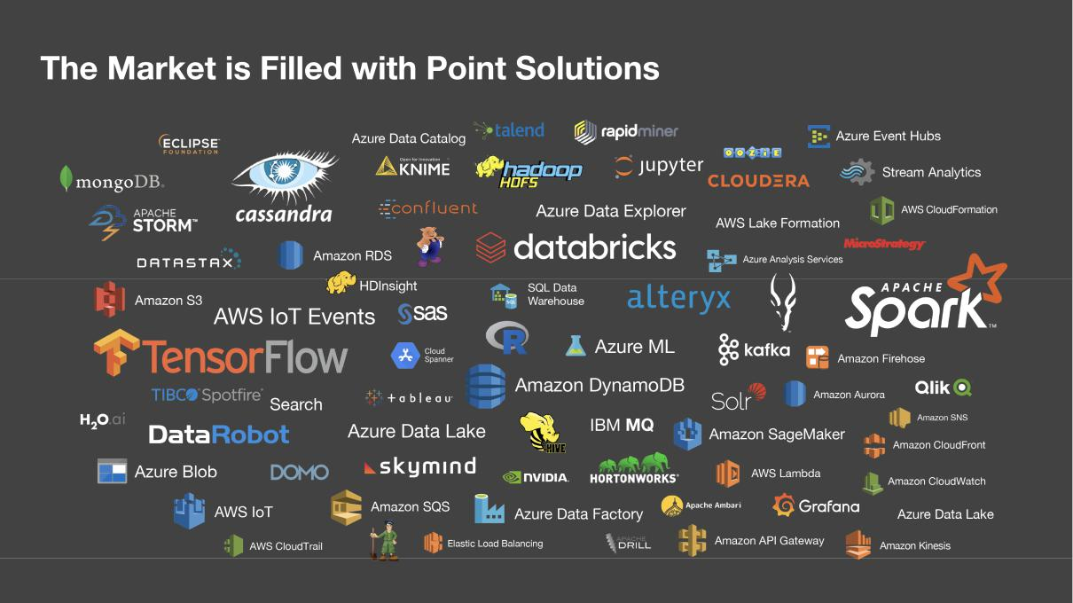

Consider Cassandra, for example. It is a key-value data store, a special-purpose database that is particularly useful for storing and retrieving longitudinal data, like telemetry. For that purpose, it is an effective product. But that functionality represents only a small fraction of the required solution. Likewise, HDFS is a distributed file system, useful for storing unstructured data. TensorFlow, a set of math libraries published by Google, is useful in enabling certain types of machine learning models. AWS IoT is a utility for gathering data from machine-readable IoT sensors. The point is: these utilities are all useful, but we believe none is sufficient by itself. Each addresses only a part of the problem required to develop and deploy an AI or IoT application.

Moreover, our experience is that these utilities are written in different languages, with different computational models and potentially incompatible data structures, developed by programmers of varying levels of experience and training from a variety of sources, rather than being designed from the start to work together. In our experience, few, if any, were written to commercial programming standards necessary to meet the requirements of an enterprise-scale deployment. Many of these efforts have ultimately been contributed to the open source community, which includes a growing collection of hundreds of computer source code programs available for anyone to download, modify at will, and use at no cost, rather than being deployed as enterprise-scale commercial solutions.

“Do It Yourself” AI?

Software innovation cycles follow a typical pattern. Early in the cycle, companies often take a “do it yourself” approach and try building the new technology themselves. In the 1980s, for example, when Oracle first introduced relational database management system, or RDBMS, software to the market, interest was high. In our experience, RDBMS technology offered dramatic cost economies and productivity gains in application development and maintenance. We believe it proved an enabling technology for the next generation of enterprise applications that followed, including material requirements planning, or MRP, enterprise resource planning, or ERP, customer relationship management, or CRM, manufacturing automation, and others.

The early competitors in the RDBMS market included Oracle, IBM (DB2), Relational Technology (Ingres), and Sperry (Mapper). But the primary competitor to Oracle was not any of these companies. In our experience, it was in many cases the CIO, who attempted to build the organization’s own RDBMS with IT personnel, offshore personnel, or the help of a systems integrator. When those efforts failed, the CIO was replaced and the organization installed a commercial RDBMS.

When enterprise applications including ERP and CRM were introduced to the market in the 1990s, the primary competitors included Oracle, SAP, and Siebel Systems. But in the early years of that innovation cycle, many CIOs attempted

118

to develop these complex enterprise applications internally. Hundreds of person-years and hundreds of millions of dollars were spent on those projects. A few years later, a new CIO would install a working commercial system.

In our experience, some of the most technologically astute companies—including Hewlett-Packard, IBM, and Compaq—repeatedly failed at internally developed CRM projects. All ultimately became successful Siebel Systems CRM customers.

Just as happened with the introduction of RDBMS, ERP, and CRM software in prior innovation cycles, the initial reaction of many IT organizations is to try to internally develop a general-purpose AI and IoT platform, using open source software with a combination of microservices from cloud providers like AWS and Google. The process starts by taking some subset of the myriad of proprietary and open source solutions and organizing them into a platform architecture.
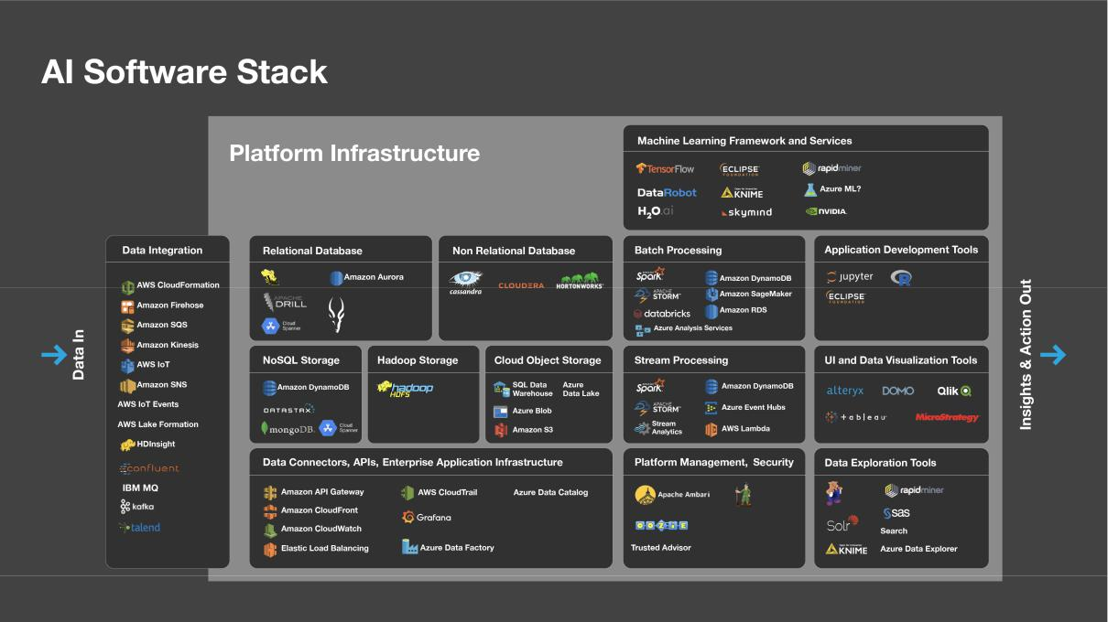

The next step is to assemble hundreds to thousands of programmers, frequently distributed around the world, using structured programming and application programming interfaces, or APIs, to attempt to stitch these various programs, data sources, sensors, machine learning models, development tools, and user interface paradigms together into a unified, functional, seamless whole that will enable the organization to excel at designing, developing, provisioning, and deploying numerous enterprise scale AI and IoT applications.

The complexity of such a system is much greater than developing a CRM or ERP system.

119

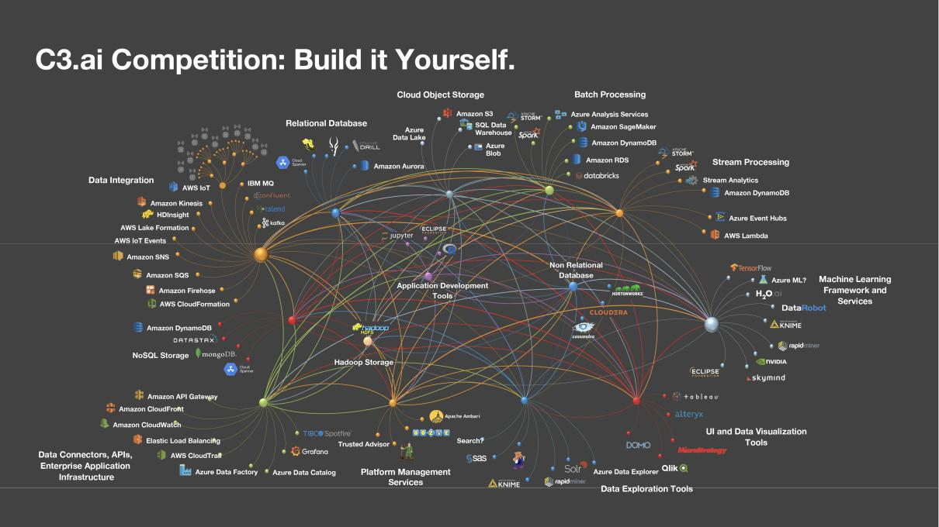

There are a number of problems with this approach:

- Complexity. Using structured programming, the number of software API connections that one needs to establish, harden, test, and verify for a complex system can, in our estimation, approach the order of 10¹³. The developers of the system need to individually and collectively grasp that level of complexity to get it to work. We believe the number of programmers capable of dealing with that level of complexity is quite small.

Aside from the platform developers, the application developers and data scientists also need to understand the complexity of the architecture and all the underlying data and process dependencies in order to develop any application.

- Brittleness. Spaghetti-code applications of this nature are highly dependent upon each and every component working properly. If one developer introduces a bug into any one of the open source components, all applications developed with that platform may cease to function.

- Future Proof. As new libraries, faster databases, and new machine learning techniques become available, those new utilities need to be available within the platform. Consequently, every application that was built on the platform will likely need to be reprogrammed in order to function correctly. This may take months to years.

- Data Integration. An integrated, federated common object data model is absolutely necessary for this application domain. Using this type of structured programming, API-driven architecture may require hundreds of person-years to develop an integrated data model for any large corporation. This is the primary reason why tens to hundreds of millions of dollars get spent, and several years later, no applications are deployed. The Fortune 500 is littered with such disaster stories.

The Gordian Knot of Structured Programming

Structured programming is a technique introduced in the mid-1960s to simplify code development, testing, and maintenance. Prior to structured programming, software was written in large monolithic tomes replete with APIs and “go-to” statements. The resultant product might consist of millions of lines of code with thousands of such APIs and go-to statements that were difficult to develop, understand, debug, and maintain.

The essential idea of structured programming was to break the code into a relatively simple “main routine” and then use something called an application programming interface to call subroutines that were designed to be modular and reusable.

120

Example subroutines might provide services like complete a ballistics calculation, or a fast Fourier transform, a linear regression, an average, a sum, or a mean. Structured programming remains the state of the art for many applications today, and has dramatically simplified the process of developing and maintaining computer code.

While this technique is appropriate for many classes of applications, it breaks down with the complexity and scale of the requirements for a modern AI or IoT application, resulting in a Gordian knot.

Cloud Vendor Tools

An alternative to the open source cluster is to attempt to assemble the various services and microservices offered by the cloud providers into a working seamless and cohesive Enterprise AI and IoT platform. Leading vendors like AWS are developing increasingly useful services and microservices that in many cases replicate the functionality of the open source providers and in many cases provide new and unique functionality. The advantage of this approach over open source is that these products are developed, tested, and quality assured by highly professional enterprise engineering organizations. In addition, these services were generally designed and developed with the specific purpose that they would work together and interact in a common system. The same points hold true for Azure, Google, and IBM.
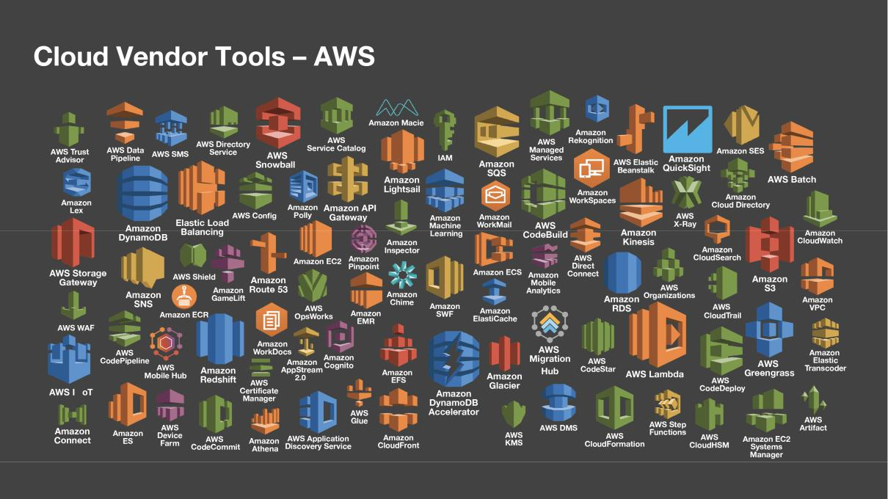

The problem with this approach is that because these systems lack a model-driven architecture like that of the C3 AI Suite, described in the following section, programmers still need to employ structured programming to stitch together the various services. This results in the same type of complexity previously described—many lines of spaghetti code and numerous interdependencies that create brittle applications that are difficult and costly to maintain.

The difference between using structured programming with cloud vendor services and using the model-driven architecture of the C3 AI Suite is dramatic. To demonstrate this stark difference, C3.ai commissioned a third-party consultancy to develop an AI predictive maintenance application designed to run on the AWS cloud platform. The consultancy—a Premier AWS Consulting Partner, with significant experience developing enterprise applications on AWS for Fortune 2000 customers—was asked to develop the application using two different approaches: the C3 AI Suite and structured programming.

The time to develop and deploy this application was approximately 120 person-days at a cost in 2019 dollars of approximately $458,000. The effort required writing 16,000 lines of custom code that must be maintained over the life of the application. The resulting application runs only on AWS. To run this application on Google, it may have to be completely rebuilt for each of those platforms at a similar cost, time, and coding effort.

121

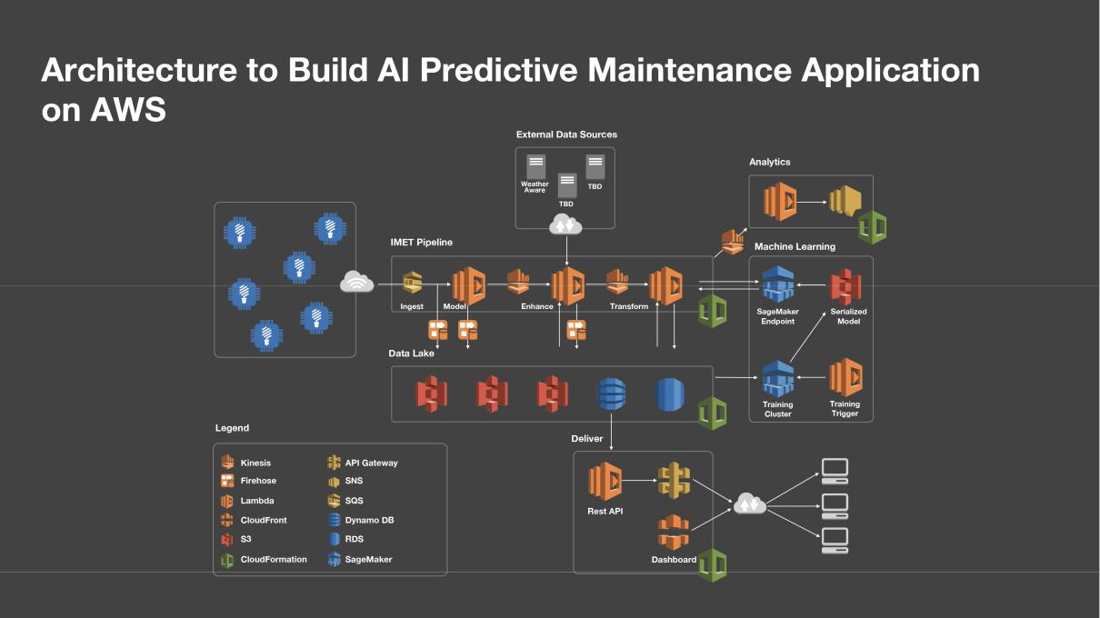

By contrast, using the C3 AI Suite with its modern model-driven architecture, the same application, employing the same AWS services, was developed and tested in five person-days at a cost of approximately $19,000. Only 14 lines of code were generated, dramatically decreasing the lifetime cost of maintenance. Moreover, the application will run on any cloud platform without modification, eliminating any additional effort and cost of refactoring the application if moving it to a different cloud vendor.

C3 AI Suite: Model-Driven Architecture

The notion of a model-driven architecture was developed at the beginning of the 21st century in response to the growing complexity of enterprise application development requirements. Model-driven architecture provides the knife to cut the Gordian knot of structured programming for highly complex problems. The C3 AI Suite is designed and built with a model-driven architecture.

Central to a model-driven architecture is the concept of a “model” that serves as an abstraction layer to simplify the programming problem. Using models, the programmer or application developer does not have to be concerned with all the data types, data interconnections, and processes that act on the data associated with any given entity, e.g., customer, tractor, doctor, or fuel type. He or she simply needs to address the model for any given entity—e.g., customer—and all the underlying data, data interrelationships, pointers, APIs, associations, connections, and processes associated with or used to manipulate those data are abstracted in the model itself.

Using the C3 AI Suite and its model-driven architecture, virtually anything can be represented as a model—even, for example, applications, including databases, natural language processing engines, and image recognition systems. Models also support a concept called inheritance. An AI application built with the C3 AI Suite might include a model called relational database, that in turn serves as a placeholder that might incorporate any relational database system like Oracle, Postgres, Aurora, Spanner, or SQL Server. A key-value store model might contain Cassandra, HBase, Cosmos DB, or DynamoDB.

C3.ai Reduces Complexity, Simplifies Development

With its model-driven architecture, the C3 AI Suite provides an abstraction layer and semantics to represent the application. This frees the programmer from having to worry about data mapping, API syntax, and the mechanics of the myriad of computational processes like ETL, queuing, pipeline management, encryption, etc.

The optimal design for an object model to address AI and IoT applications uses abstract models as placeholders to which a programmer can link an appropriate application. The relational database model might link to Postgres. A report writer

122

model might link to MicroStrategy. A data visualization model might link to Tableau. And so on. A powerful feature of a model-driven architecture is that as new open source or proprietary solutions become available, the object model library can simply be extended to incorporate that new feature.

Another important capability of the C3 AI Suite enabled by its model-driven architecture is that the applications developed on the platform are future-proofed: due to the modular nature of the model-driven architecture, new, upgraded, or enhanced services can be easily integrated with the C3 AI Suite. Suppose, for example, that an organization developed all its applications initially using Oracle as the relational database and then later decided to switch to an alternate RDBMS. The only modification required is to change the link in the RDBMS meta-model to point to the new RDBMS. All the applications deployed previously using Oracle as the RDBMS will continue to run without modification after that replacement. This enables organizations to immediately and easily take advantage of new and improved product offerings as they become available.

Platform Independence: Multi-Cloud and Polyglot Cloud Deployment

The rate of cloud computing adoption in recent years has been dramatic and continues to accelerate. As recently as 2011, the message delivered by chief executive officers and corporate leadership worldwide was clear: “Our data will never reside in the public cloud.” The message today is equally clear: “We have a cloud-first strategy. All new applications are being deployed in the cloud. Existing applications will be migrating to the cloud. But understand, we have a multi-cloud strategy.”

This 180-degree turn at global scale in the span of a few years is remarkable. But while corporate leaders are eagerly embracing the cloud, they are also very concerned about cloud vendor lock-in. They want to be able to continually negotiate. They want to deploy different applications in clouds from different vendors, and they want to be free to move applications from one cloud vendor to another.

Multi-cloud deployment is therefore an additional requirement of a modern model-driven software platform that is fully supported by the C3 AI Suite. Applications developed with the C3 AI Suite can run without modification on any cloud and on bare metal behind the firewall in a hybrid cloud environment.

A final requirement for the new AI technology stack—that the C3 AI Suite delivers—is polyglot cloud deployment capability: the ability to mix various services from multiple cloud providers and to easily swap and replace those services. The cloud vendors provide the market a great service by enabling instant access to virtually unlimited horizontally scalable computing capacity and effectively infinite storage capacity at exceptionally low cost. As the cloud vendors aggressively compete with one another on price, the cost of cloud computing and storage is consistently decreasing.

A second important service cloud vendors provide is rapid innovation of microservices. Microservices like TensorFlow from Google accelerate machine learning. Amazon Forecast facilitates deep learning for time-series data. Azure Stream Analytics integrates with Azure IoT Hub and Azure IoT Suite to enable powerful real-time analytics of IoT sensor data. It seems not a week goes by without another announcement of yet another useful microservice from AWS, Azure, Google, and IBM.

C3 AI Suite: A Tested, Proven, and Patented AI Suite

The model-driven approach to developing Enterprise AI and IoT applications using the C3 AI Suite has been tested and proven in dozens of large-scale, real-world deployments at some of the world’s largest organizations.

The C3 AI Suite provides a powerful platform enabling these and other leading organizations to develop and operate Enterprise AI and IoT applications at scale, with a fraction of the effort and resources required by other approaches. Applications built with the C3 AI Suite are flexible, easily upgraded, and can be ported across different cloud platforms with little or no modification, providing a solution that future-proofs customers’ investment in Enterprise AI and IoT application development.

123

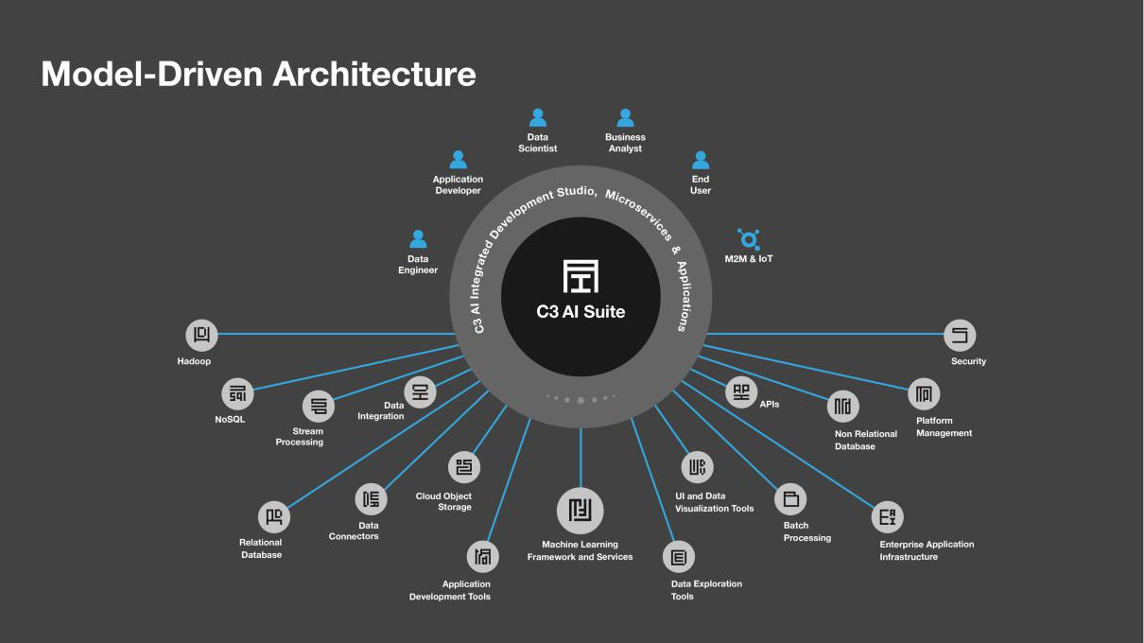

Competition

Our primary competition is largely do-it-yourself, custom-developed, company-specific AI platforms and applications. These tend to be very costly complex software engineering projects, often fail, and, if at all successful, usually require many years to realize economic return. Most of our customers have tried and failed at one or more such bespoke development efforts, sometimes at great expense, before turning to C3.ai for their AI solution.

We are unaware of any end-to-end AI development platforms that are directly competitive with the C3 AI Suite. The commercial product offerings that were formerly positioned as functionally equivalent to C3.ai were GE Predix and IBM Watson, both multi-billion dollar software engineering efforts backed by massive promotional campaigns; however, we no longer encounter them in competitive situations.

Our primary competition comes from IT organizations that attempt to custom develop bespoke AI application development and runtime platforms. Such efforts usually involve the integration of internally developed tools, open source solutions, and point solutions offered by independent software vendors, and/or components offered in the AWS, Azure, or Google cloud platforms. Frequently these efforts will be managed as professional service projects by organizations like Accenture or Lockheed Martin. We have found that these efforts are often costly, time consuming, and not always fully successful.

Sales Alliances

Strategic partnerships are core to our growth strategy with market-leading companies offering highly leveraged distribution channels to various markets.

- Baker Hughes: Oil, Gas, and Chemicals. In 2019, we a formed a strategic alliance with Baker Hughes, a $24 billion oil and gas services company. Under the terms of this alliance, Baker Hughes has standardized on C3.ai for all internal use AI applications. In addition, we are jointly marketing and selling a range of Enterprise AI solutions to address the entire value of upstream, mid-stream, and downstream activity under the BHC3.ai brand to oil and gas companies globally with the active engagement of Baker Hughes, which has a 12,000-person sales organization.

- Fidelity National Information Systems (FIS): Financial Services. In September 2020, we entered into a strategic alliance with FIS, a $10.3 billion technology provider to the global financial services industry whose systems process 75 billion transactions per year worth $9 trillion. This alliance brings together the extensive financial services domain expertise of FIS with C3.ai’s AI expertise to market and deploy the C3 AI Suite and C3 AI

124

Applications, including C3 AI Anti-Money Laundering and C3 AI Securities Lending Optimization, into financial services businesses. FIS will also utilize the C3 AI Suite to develop AI applications.

- AWS, IBM, Intel, and Microsoft. In addition, we have announced global alliances with AWS, IBM, Intel, and Microsoft to jointly market, sell, and service our combined offerings across industry verticals.

In the majority of our sales opportunities we are aligned with one or more of these partners.

New AI CRM Offering

In October 2020, we entered into a partnership with Microsoft and Adobe to bring to market C3 AI CRM powered by Microsoft Dynamics 365 and Adobe Experience Cloud, a new generation of AI-enabled, industry-specific CRM solutions.

The C3 AI CRM product family will include sales, marketing, and customer service functionality. The products will be available in vertical market-specific offerings specifically designed to meet the needs of industries such as financial services, healthcare, telecommunications, oil and gas, manufacturing, utilities, aerospace, automotive, public sector, defense, and intelligence. The C3 AI CRM solutions will be sold through a variety of channels, and through our distribution partner network, including Baker Hughes and Microsoft.

CRM has grown to a $63 billion software market today. We are confident that AI-enablement will be a fundamental requirement of the CRM market in the coming decade. We are assembling the product, plan, personnel, and partnerships around the C3 AI CRM product family with the goal of establishing a leadership position in that segment of the CRM market.

Thought Leadership

Our CEO, Tom Siebel, and our Chief Technology Officer, Ed Abbo, are recognized leaders in information technology, facilitating broad market validation by media, analysts, and industry groups. Their decades of technology leadership in enterprise software position them well to engage strategically with the executive leadership of leading corporations and government entities.

We have launched a communications strategy with the objective of establishing thought leadership in Enterprise AI and Digital Transformation. We believe our CEO’s bestselling book, Digital Transformation: Survive and Thrive in an Era of Mass Extinction, has contributed to this effort. Digital Transformation is soon to be released for publication in French, Chinese, Russian, and Korean.

We will continue to expand our thought leadership in AI through ongoing publications, industry conferences, advertising, keynote speeches, media interviews, television appearances, blog posts, and contributed articles.

Growth Strategy

We are substantially investing in the expansion of our direct enterprise sales and service organization both geographically and across vertical markets to expand the use of C3.ai solutions within existing customers and establish new customer relationships.

We are growing a middle market sales organization to address the needs of divisions of large organizations in addition to small and medium businesses.

We will expand our leveraged distribution channel with additional distribution partners.

We will continue to develop high volume distribution channels including digital marketing, telesales, and strategic distributors, particularly to address the needs of small and medium businesses.

We are bringing new product families to market, such as C3 AI CRM powered by Microsoft Dynamics 365 and Adobe Experience Cloud, that we believe will develop into substantial recurring revenue streams for C3.ai.

We expect to form additional strategic development and distribution agreements, like those we have in place with Microsoft and Baker Hughes, that we expect will provide us highly leveraged access to other vertical and horizontal markets.

We continue to invest heavily in research and development (41% of our revenue in fiscal year 2020) to maintain technology leadership. Our product roadmap includes a wide range of new functions and products to be released in the coming years that we expect to contribute to revenue growth with both new and existing customers.

125

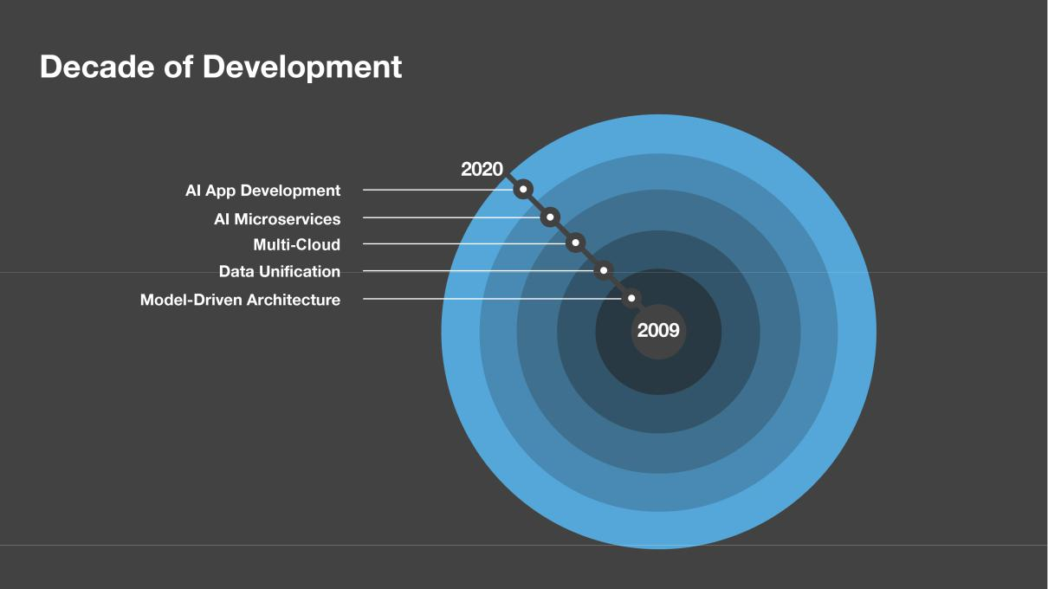

University Relations: C3.ai Digital Transformation Institute

Established in February 2020, the C3.ai Digital Transformation Institute, or C3.ai DTI, is a research consortium dedicated to accelerating the benefits of artificial intelligence for business, government, and society. C3.ai DTI engages the world’s leading scientists to conduct research and train practitioners in the new Science of Digital Transformation, which operates at the intersection of artificial intelligence, machine learning, cloud computing, internet of things, big data analytics, organizational behavior, public policy, and ethics.

The nine C3.ai DTI consortium member universities and laboratories are: University of Illinois at Urbana-Champaign, or UIUC, University of California, Berkeley, Carnegie Mellon University, Lawrence Berkeley National Laboratory, Massachusetts Institute of Technology, National Center for Supercomputing Applications, or NCSA, at UIUC, Princeton University, Stanford University, and the University of Chicago. Industry partners include C3.ai and Microsoft. To support C3.ai DTI, C3.ai is providing C3.ai DTI $57,250,000 in cash contributions over the first five years of operation. C3.ai and Microsoft will contribute an additional in-kind support, including use of the C3 AI Suite and Azure computing, storage, and technical resources to support C3.ai DTI research.

The goal of C3.ai DTI is to develop the field of Digital Transformation Science by leveraging laboratory and research facilities at UC Berkeley, UIUC, and consortium institutions. C3.ai DTI forms dynamic teams of the world's best researchers to interact with faculty and students to advance AI techniques for industrial, commercial, and public sector applications. At the heart of C3.ai DTI is a constant flow of new ideas and expertise provided by ongoing research, visiting scholars and research scientists, and educational programs. This rich ecosystem focuses on addressing some of the complex issues inherent in the digital transformation of society and developing the new Science of Digital Transformation. C3.ai DTI focuses research on the intersection of artificial intelligence, machine learning, internet of things, cloud computing, big data analytics, organizational behavior, public policy, and ethics.

Specifically, C3.ai DTI supports the development of machine learning algorithms, data security, and cybersecurity techniques to address and advance solutions related to predictive analytics, resilient operation under faults and cyberattack, and assured system security. C3.ai DTI research is engaged in analyzing new business operation models, developing methods for organizational change management, developing advanced methods of protecting privacy, and advancing dialog related to the ethical implications of AI. Central to C3.ai DTI’s research is the development and validation of algorithms and designs that can dramatically affect societal systems.

126

In addition to contributing to the public good, C3.ai DTI exposes the capabilities of our AI Suite and AI Applications to potentially thousands of researchers, undergraduates, and graduate students at these world-renowned institutions. This helps to further build the community of C3.ai users and to establish C3.ai as the standard for developing and deploying large-scale Enterprise AI applications to solve the world’s hardest problems.

C3.ai DTI Research Award Program

Through a Call for Research Proposals managed by UC Berkeley and UIUC, C3.ai DTI annually awards up to 26 grants, ranging from $100,000 to $500,000 and for 12 months in duration. In addition to the grants, C3.ai DTI provides recipients with significant cloud computing, supercomputing, data, and software resources. This includes unlimited use of the C3 AI Suite, free access to Azure, and access to the NCSA Blue Waters supercomputer at UIUC and the NERSC Perlmutter supercomputer at Lawrence Berkeley National Laboratory. Multidisciplinary and multi-institution projects are favored. Recipients are encouraged to conduct breakthrough research and to pursue and establish larger research projects with federal and other funding sources. Award recipients disseminate the results of their research during the award period, and all research results, methods, and algorithms, including algorithms and software from their research, are made available in the public domain (non-exclusive, royalty-free).

C3.ai DTI has initially funded 26 research projects to develop new AI techniques to address the challenges of the COVID-19 pandemic.

C3.ai DTI Visiting Scholars Program

C3.ai DTI Visiting Scholars participate in scholarly activities to promote the Science of Digital Transformation, including conducting research, organizing workshops, and developing curricula. All research results and curriculum development, including methods, algorithms, and software resulting from the collaborative research conducted by C3.ai DTI Visiting Scholars are made freely available in the public domain.

C3.ai DTI Data Analytics Platform

C3.ai DTI hosts an elastic cloud, big data, development, and operating platform, including the C3 AI Suite hosted in an Azure instance, for the purpose of supporting C3.ai DTI research, curriculum development, and classwork. In addition, UC Berkeley and UIUC provide additional cloud computing and storage resources as well as use of the National Energy Research Supercomputer NERSC-9 Perlmutter at Lawrence Berkeley National Laboratory and the NCSA Blue Waters at UIUC. These resources are available to award recipients to conduct research on the development of machine learning algorithms, data security techniques, and cybersecurity methodologies related specifically to AI and IoT. The AI/ML and data analytics platform will also serve as an instructional and research platform for Digital Transformation Science courses.

C3.ai Investment Thesis

Enterprise AI is a huge addressable market.

We have a highly experienced CEO and management team with an established track record of identifying large technology markets in their nascent stage, developing innovative, superior solutions to meet the needs of those markets, assembling and organizing high-performance organizations, and building rapidly growing, financially sound, cash-positive, profitable, professionally managed, market-leading companies that accrue substantial value to customers, employees, partners, and investors.

We have developed a patented Enterprise AI suite enabling the successful digital transformation of leading corporations and government entities. First-mover advantage. Technology leadership. Substantial market eco-system. Recognized Enterprise AI market leadership. A high-performance corporate culture. Focused on excellence in execution.

We are in this for the long run, with the singular focus of establishing and maintaining recognized technology innovation and global market leadership in the Enterprise AI application software market.

127

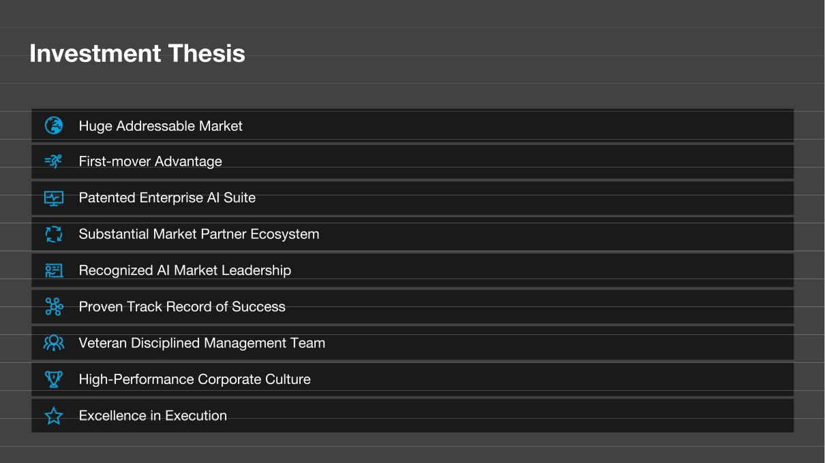

128

MANAGEMENT

Executive Officers and Directors

The following table sets forth information for our executive officers and directors and senior advisor as of November 13, 2020:

Name |  | Age |  | Position
Executive Officers
Thomas M. Siebel |  | 67 |  | Chief Executive Officer and Chairman of the Board
David Barter |  | 49 |  | Senior Vice President and Chief Financial Officer
Edward Y. Abbo |  | 55 |  | Chief Technology Officer
Houman Behzadi |  | 42 |  | Chief Product Officer
Bruce Cleveland |  | 61 |  | Senior Vice President and Chief Marketing Officer
Brady Mickelsen |  | 50 |  | Senior Vice President and General Counsel
Non-Employee Directors
Patricia A. House(2) |  | 66 |  | Director
Richard C. Levin(1) |  | 73 |  | Director
Michael G. McCaffery(1)(3) |  | 67 |  | Lead Independent Director
Condoleezza Rice |  | 65 |  | Director
Nehal Raj |  | 42 |  | Director
S. Shankar Sastry |  | 64 |  | Director
Bruce Sewell(2)(3) |  | 62 |  | Director
Lorenzo Simonelli(1) |  | 47 |  | Director
Stephen M. Ward, Jr.(2)(3) |  | 65 |  | Director
Senior Advisor
James H. Snabe |  | 55 |  | Senior Advisor to the Chief Executive Officer

__________________

- Member of the audit committee.

- Member of the compensation committee.

- Member of the nominating and corporate governance committee.

Executive Officers

Thomas M. Siebel. Mr. Siebel is the founder of our company and has served as the Chairman of our board of directors since January 2009, and as our Chief Executive Officer since July 2011. Prior to founding our company, Mr. Siebel founded and served as the Chief Executive Officer of Siebel Systems, a global CRM software company. Siebel Systems merged with Oracle Corporation in January 2006. Mr. Siebel served in various leadership positions with Oracle Corporation from January 1984 to September 1990. Mr. Siebel currently serves as a member of the College of Engineering boards at the University of Illinois at Urbana-Champaign and the University of California, Berkeley. He was elected a member of the American Academy of Arts and Sciences in April 2013. Mr. Siebel holds a B.A. in History, an M.B.A., and an M.S. in Computer Science, each from the University of Illinois at Urbana-Champaign. He is the author of four books, including most recently the best-selling Digital Transformation: Survive and Thrive in an Era of Mass Extinction (RosettaBooks, 2019).

We believe Mr. Siebel is qualified to serve as a member of our board of directors because of his perspective and experience as our founder, as well as his extensive experience with technology companies.

David Barter. Mr. Barter has served as our Chief Financial Officer since October 2020. From May 2017 to October 2020, Mr. Barter served as Senior Vice President and Chief Financial Officer of Model N, Inc., a software company. From September 2013 to May 2017, Mr. Barter served as the Vice President of Finance at Guidewire Software, Inc., a provider of software solutions to the insurance industry. From October 2005 to September 2013, Mr. Barter held several senior leadership positions with Microsoft Corporation, including as the Chief Financial Officer of the Microsoft Financing division. Mr.

129

Barter holds a B.A. in Finance and Philosophy from the University of Notre Dame and an M.B.A from Northwestern University, Kellogg School of Management.

Edward Y. Abbo. Mr. Abbo has served as our Chief Technology Officer since July 2011. He previously served as our Chief Executive Officer from September 2009 to July 2011 and a member of our board of directors from August 2009 to November 2020. Prior to joining us, Mr. Abbo served as Senior Vice President of Engineering and Chief Technology Officer for Siebel Systems from July 1994 until it merged with Oracle Corporation in January 2006, and Senior Vice President of Oracle Corporation from January 2006 to July 2009. Mr. Abbo holds a B.S. in Mechanical and Aerospace Engineering from Princeton University and an M.S. in Mechanical Engineering from the Massachusetts Institute of Technology.

Houman Behzadi. Mr. Behzadi has served as our Chief Product Officer since October 2016. Mr. Behzadi previously served as our Senior Vice President and Chief Product Officer from October 2016 to July 2020, our Senior Vice President of Products and Engineering from July 2012 to October 2016, and our Vice President of Engineering from January 2010 to July 2012. Prior to joining us, Mr. Behzadi held various leadership roles with Siebel Systems from January 2001 until it merged with Oracle Corporation in January 2006, and then served as Director, Application Development at Oracle Corporation from January 2006 to January 2010. Mr. Behzadi holds a B.A. in Economics from the University of California, Santa Barbara.

Bruce Cleveland. Mr. Cleveland has served as our Senior Vice President and Chief Marketing Officer since November 2019. Mr. Cleveland previously served as an Advisor to our company from January 2009 to November 2019. From January 2016 to November 2019, Mr. Cleveland served as a General Partner of Wildcat Venture Partners, an early-stage venture capital firm. From June 2006 to December 2015, Mr. Cleveland served as Venture Partner and then a General Partner for InterWest Partners, a diversified venture capital firm. Mr. Cleveland held various leadership roles, including Senior Vice President and General Manager of Marketing, with Siebel Systems from April 1996 until it merged with Oracle Corporation in January 2006. Mr. Cleveland holds a B.S. in Business Administration from California State University, Sacramento.

Brady Mickelsen. Mr. Mickelsen has served as our Senior Vice President and General Counsel since August 2019. Prior to joining us, Mr. Mickelsen was Senior Vice President and Chief Legal Officer for TriNet Group, Inc., a publicly-traded human resources, payroll, and benefits solutions company, from June 2015 to November 2018. From October 2010 to June 2015, Mr. Mickelsen served as a partner at White & Case LLP, a global law firm. From March 2005 to October 2010, Mr. Mickelsen served in the legal department at Oracle Corporation, most recently as Vice President & Associate General Counsel. Mr. Mickelsen holds a B.A. in Public Policy from Stanford University and a J.D. from the University of Chicago Law School.

Non-Employee Directors

Patricia A. House. Ms. House is a co-founder of our company and has served as the Vice Chairman of our board of directors since January 2009. Until it merged with Oracle Corporation in January 2006, Ms. House served as a co-founder of Siebel Systems and held various leadership positions most recently as Executive Vice President. Ms. House has served on the board of directors of The William and Flora Hewlett, Foundation since March 2011 and on the board of directors the Carnegie Endowment for International Peace since October 2010. She also previously served on the board of directors of Levi Strauss & Co from July 2003 until November 2007. Ms. House holds a B.A. in Education from Western Michigan University.

We believe Ms. House is qualified to serve as a member of our board of directors because of her significant knowledge of our company and leadership experience in the technology industry.

Richard C. Levin. Dr. Levin has served as a member of our board of directors since August 2010. From April 2014 until June 2017, Dr. Levin was the Chief Executive Officer of Coursera, an online learning platform company. Prior to his role at Coursera, Dr. Levin served as President of Yale University from July 1993 to June 2013. Dr. Levin is currently a Fellow of the American Academy of Arts and Sciences and the American Philosophical Society and is a former trustee of The William and Flora Hewlett Foundation. Dr. Levin served as a director of American Express Co. from January 2007 to May 2019. Dr. Levin also served as an advisor on President Obama’s Council of Advisors on Science and Technology. Dr. Levin holds a B.A. from Stanford University, a B.Litt. from Oxford University, and a Ph.D. in Economics from Yale University.

We believe Dr. Levin is qualified to serve as a member of our board of directors because of his significant management experience and financial expertise.

Michael G. McCaffery. Mr. McCaffery has served as a member of our board of directors since March 2009. Since December 2005, Mr. McCaffery has served as the Managing Director for Makena Capital Management, an investment

130

management firm, and was Chief Executive Officer of Makena Capital Management from December 2005 to January 2013. Since February 2015, Mr. McCaffery has also served on the board of directors for NVIDIA Corporation, a technology company. Mr. McCaffery holds a B.A. from the Woodrow Wilson School of Public and International Affairs at Princeton University, a B.A. Honours and an M.A. in Politics, Philosophy and Economics from Merton College at Oxford University as a Rhodes Scholar, and an M.B.A. from Stanford Graduate School of Business.

We believe Mr. McCaffery is qualified to serve as a member of our board of directors because of his extensive market, investment and business expertise in the technology industry.

Nehal Raj. Mr. Raj has served as a member of our board of directors since August 2016. Since July 2006, Mr. Raj has been an investment professional at TPG, a private investment firm, where he is a Partner. Mr. Raj also served on the boards of directors for Domo, Inc., a cloud software company, from March 2014 to September 2019, and Zscaler, Inc., a cloud-based information security company, from July 2015 to January 2020. Mr. Raj also sits on the boards of directors for a number of privately held companies. Mr. Raj holds a B.A. in Economics and an M.S. in Industrial Engineering from Stanford University, and an M.B.A. from Harvard Business School.

We believe Mr. Raj is qualified to serve as a member of our board of directors because of his experience as a director of public technology companies and his background in the venture capital and private equity industry.

Condoleezza Rice. Dr. Rice has served as a member of our board of directors since December 2009. Since September 2020, Dr. Rice has served as the Tad and Dianne Taube Director of the Hoover Institution at Stanford University. In addition, since Dr. Rice has served as the Denning Professor of Global Business and the Economy for the Stanford Graduate School of Business since September 2010. Since March 2009, Dr. Rice has served as the Thomas and Barbara Stephenson Senior Fellow of Public Policy for the Hoover Institution, Stanford University, as a Senior Fellow for the Freeman Spogli Institute for International Studies, Stanford University, and as a Professor of Political Science for Stanford University. Dr. Rice has also served as a partner at RiceHadleyGates LLC, an international strategic consulting firm that Dr. Rice founded, since November 2009. From January 2005 to January 2009, Dr. Rice served as the Secretary of State of the United States of America and from January 2001 to January 2005, Dr. Rice served as Chief National Security Advisor to President George W. Bush. Dr. Rice currently serves on the boards of directors of Dropbox, Inc., a cloud-based file sharing company, and Makena Capital Management, LLC, a private endowment firm. Dr. Rice holds a Ph.D. in Political Science from the University of Denver, an M.A. in Political Science from the University of Notre Dame, and a B.A. in Political Science from the University of Denver.

We believe Dr. Rice is qualified to serve as a member of our board of directors because of her global business expertise and service on the boards of directors of various public companies.

S. Shankar Sastry. Dr. Sastry has served as a member of our board of directors since January 2009. Dr. Sastry has served in a number of roles with the University of California, Berkeley, including as the Thomas Siebel Professor of Computer Science since January 2019, the director of the Blum Center for Developing Economies since February 2007, and the co-director of the C3 Digital Transformation Institute since March 2020. He also served the Dean and Roy W. Carlson Professor of Engineering from July 2007 to June 2018 and as Chairman, Department of Electrical Engineering and Computer Sciences, University of California, Berkeley from January 2001 through June 2004. From October 2004 to July 2007, Dr. Sastry served the Director of the Center for Information Technology in the Interests of Society, an interdisciplinary center spanning UC Berkeley, Davis, Merced and Santa Cruz. From November 1999 to March 2001, he was the Director of the Information Technology Office at the Defense Advanced Research Projects Agency. He was elected to the National Academy of Engineering in 2001 and the American Academy of Arts and Sciences in 2004, and elected as a Fellow of IEEE in 1994, and International Federation of Automatic Control Fellow in 2016. Dr. Sastry received the President of India Gold Medal in 1977, the IBM Faculty Development in 1983, and the NSF U.S. Presidential Young Investigator Award in 1985. In 1990, he received the Eckman Award of the American Automatic Control Council in 1990, and in 2005, he received the Ragazzini Award for Distinguished Accomplishments in teaching. Dr. Sastry also received the distinguished Alumnus Award of the Indian Institute of Technology in 1999, the Distinguished Alumnus of the International House at UC Berkeley, and the David Marr prize for the best paper at the International Conference in Computer Vision in 1999. Dr. Sastry holds a B.Tech. from the Indian Institute of Technology, Bombay and an M.S. in Electrical Engineering and Computer Science, an M.A. in Mathematics and a Ph.D. in Electrical Engineering and Computer Sciences each from the University of California, Berkeley.

We believe Dr. Sastry is qualified to serve as a member of our board of directors because of his significant leadership experience in the engineering and technology industries.

131

Bruce Sewell. Mr. Sewell has served as a member of our board of directors since May 2017. Mr. Sewell served as the Senior Vice President, General Counsel and Secretary of Apple Inc., a technology company, from September 2009 to December 2017. From October 1996 to September 2009, Mr. Sewell served in various leadership positions with Intel Corporation, including as Senior Vice President, General Counsel from September 2002 to September 2009. Since January 2013, Mr. Sewell has served on the board of directors for Vail Resorts, Inc., a mountain resort company. Mr. Sewell holds a B.S. from Lancaster University (U.K.) and a J.D. from The George Washington University Law School.

We believe Mr. Sewell is qualified to serve as a member of our board of directors because of his significant executive experience in the technology industry.

Lorenzo Simonelli. Mr. Simonelli has served as a member of our board of directors since August 2019. Since October 2017, Mr. Simonelli has served as Chairman of the board of directors for Baker Hughes Company, an energy technology company, and since July 2017, has served as the Director, President, and Chief Executive Officer. From October 2013 to July 2017, Mr. Simonelli served as the President and Chief Executive Officer for GE Oil & Gas. Mr. Simonelli currently serves on the board of CNH Industrial, an industrial equipment company. Mr. Simonelli holds a B.S. in Business and Economics from Cardiff University and a Master Honoris Causa in Chemical Sciences from the University of Florence.

We believe Mr. Simonelli is qualified to serve as a member of our board of directors because of his significant experience in the energy industry and as a member of the boards of directors of various public companies.

Stephen M. Ward, Jr. Mr. Ward has served as a member of our board of directors since January 2009. Mr. Ward served as the Chief Executive Officer for Lenovo Group Limited, the international personal computer company formed by the acquisition of IBM’s personal computer division by Lenovo, from April 2005 to January 2006. Prior to that acquisition, Mr. Ward held a number of management positions with IBM from September 1978 to April 2005, including Senior Vice President and General Manager of the Personal Systems and Retail Systems Group from March 2003 to April 2005, General Manager of the Industrial Sector from February 2000 to March 2003, General Manager of the Thinkpad and Mobile division from January 1998 to March 2000 and Chief Information Officer from February 1997 to March 2000. Mr. Ward has also served as a member of the board of directors for Carpenter Technology Corporation, a specialty metals company, since March 2001. From December 2014 until its sale to The Boeing Company in October 2018, Mr. Ward served as a member the board of directors of KLX Inc., an aerospace solutions and supply chain company, and since September 2018, he served as a member of the board of directors of KLX Energy Services Holdings, Inc., an oilfield services company spun out from KLX Inc. Mr. Ward also previously served as a member of the board of directors of E2Open, a supply chain SAS company he co-founded, from January 2001 to March 2015, E-Ink Corporation, a maker of electronic paper displays, from December 2006 to December 2009 and QD Vision, Inc., a nanomaterials product company, from June 2014 until its sale to Samsung in November 2016. Mr. Ward holds a B.S. in Mechanical Engineering from California Polytechnic State University, San Luis Obispo.

We believe Mr. Ward is qualified to serve as a member of our board of directors because of his extensive management experience in the technology industry and as a member of boards of directors of various public companies.

Senior Advisor

James H. Snabe. Mr. Snabe has served as a senior advisor to the Chief Executive Officer, Mr. Siebel, since September 2020. In his role, Mr. Snabe provides strategic advice and counsel to Mr. Siebel and the executive team and attends meetings of the Board of Directors in an ex officio, non-voting capacity. Mr. Snabe served as Co-Chief Executive Officer of SAP AG, a technology company, from February 2010 to May 2014, and as a member of the SAP AG supervisory board from May 2014 to May 2018. Mr. Snabe currently serves as Chairman of the Supervisory Board of Siemens AG, an industrial technology company and of A.P. Møller – Mærsk A/S, a shipping and transportation company. and also serves as a member of the Supervisory Board of Allianz SE, a financial services company. Mr. Snabe also serves as member of the Board of Trustees of the World Economic Forum, a non-profit organization.

Composition of Our Board of Directors

Our business and affairs are managed under the direction of our board of directors. We currently have 10 directors. Our current directors will continue to serve as directors until their resignation, removal or successor is duly elected.

Our board of directors may establish the authorized number of directors from time to time by resolution. In accordance with our amended and restated certificate of incorporation that will be in effect upon the completion of this offering, immediately after this offering, our board of directors will be divided into three classes with staggered three-year terms. At

132

each annual general meeting of stockholders, the successors to directors whose terms then expire will be elected to serve from the time of election and qualification until the third annual meeting following election. Our directors will be divided among the three classes as follows:

- the Class I directors will be Thomas M. Siebel, Patricia A. House, Nehal Raj, and S. Shankar Sastry, and their terms will expire at our first annual meeting of stockholders following this offering;

- the Class II directors will be Richard C. Levin, Bruce Sewell, and Lorenzo Simonelli, and their terms will expire at our second annual meeting of stockholders following this offering; and

- the Class III directors will be Michael G. McCaffery, Condoleezza Rice, and Stephen M. Ward, Jr., and their terms will expire at our third annual meeting of stockholders following this offering.

We expect that any additional directorships resulting from an increase in the number of directors will be distributed among the three classes so that, as nearly as possible, each class will consist of one third of the directors. The division of our board of directors into three classes with staggered three-year terms may delay or prevent a change of our management or a change in control.

Director Independence

Our board of directors has undertaken a review of the independence of each director. Based on information provided by each director concerning his or her background, employment and affiliations, our board of directors has determined that each of Mmes. House and Rice and Messrs. Levin, McCaffery, Raj, Sastry, Sewell, Simonelli, and Ward do not have relationships that would interfere with the exercise of independent judgment in carrying out the responsibilities of a director and that each of these directors is “independent” as that term is defined under the listing standards of the New York Stock Exchange. In making these determinations, our board of directors considered the current and prior relationships that each non-employee director has with our company and all other facts and circumstances our board of directors deemed relevant in determining their independence, including the beneficial ownership of our shares held by each non-employee director and the transactions described in the section titled “Certain Relationships and Related Party Transactions.”

Lead Independent Director

Our corporate governance guidelines provide that if the chairman of the board of directors is not an independent director, our independent directors will designate one of the independent directors to serve as lead independent director, and if the chairman of the board of directors is an independent director, our board of directors may determine whether it is appropriate to appoint a lead independent director. The corporate governance guidelines provide that if our board of directors elects a lead independent director, currently Mr. McCaffery, such lead independent director will preside over meetings of our independent directors, coordinate activities of the independent directors, oversee, with our nominating and corporate governance committee, the self-evaluation of our board of directors, including committees of our board of directors, and preside over any portions of meetings of our board of directors at which the performance of our board of directors is presented or discussed, be available for consultation and director communication with stockholders as deemed appropriate, and perform such additional duties as our board of directors may otherwise determine and delegate.

Committees of Our Board of Directors

Our board of directors has established an audit committee, a compensation committee and a nominating and corporate governance committee. The composition and responsibilities of each of the committees of our board of directors are described below. Members serve on these committees until their resignation or until otherwise determined by our board of directors. Our board of directors may establish other committees as it deems necessary or appropriate from time to time.

Audit Committee

Our audit committee consists of Messrs. Levin, McCaffery, and Simonelli. Our board of directors has determined that each member of the audit committee satisfies the independence requirements under the listing standards of the New York Stock Exchange and Rule 10A-3(b)(1) of the Exchange Act. The chair of our audit committee is Mr. McCaffery. Our board of directors has determined that each of Messrs. Levin, McCaffery, and Simonelli is an “audit committee financial expert” within the meaning of SEC regulations. Each member of our audit committee can read and understand fundamental financial statements in accordance with applicable requirements. In arriving at these determinations, our board of directors has examined each audit committee member’s scope of experience and the nature of his employment.

133

Our Chief Executive Officer, Thomas M. Siebel, is a non-voting ex officio member of the Audit Committee. He does not have any voting power on audit committee matters nor does he have any role in policy making in regard to audit committee matters.

The primary purpose of the audit committee is to discharge the responsibilities of our board of directors with respect to our corporate accounting and financial reporting processes, systems of internal control and financial statement audits, and to oversee our independent registered public accounting firm. Specific responsibilities of our audit committee include:

- helping our board of directors oversee our corporate accounting and financial reporting processes;

- managing the selection, engagement, qualifications, independence and performance of a qualified firm to serve as the independent registered public accounting firm to audit our financial statements;

- discussing the scope and results of the audit with the independent registered public accounting firm, and reviewing, with management and the independent accountants, our interim and year-end operating results;

- developing procedures for employees to submit concerns anonymously about questionable accounting or audit matters;

- reviewing related person transactions;

- obtaining and reviewing a report by the independent registered public accounting firm at least annually that describes our internal quality control procedures, any material issues with such procedures and any steps taken to deal with such issues when required by applicable law; and

- approving or, as permitted, pre-approving, audit and permissible non-audit services to be performed by the independent registered public accounting firm.

Our audit committee operates under a written charter that satisfies the applicable listing standards of the New York Stock Exchange. Compensation Committee

Our compensation committee consists of Ms. House and Messrs. Sewell and Ward. The chair of our compensation committee is Mr. Ward. Our board of directors has determined that each member of the compensation committee is independent under the listing standards of the New York Stock Exchange, and a “non-employee director” as defined in Rule 16b-3 promulgated under the Exchange Act.

The primary purpose of our compensation committee is to discharge the responsibilities of our board of directors in overseeing our compensation policies, plans and programs and to review and determine the compensation to be paid to our executive officers, directors and other senior management, as appropriate. Specific responsibilities of our compensation committee include:

- reviewing and recommending to our board of directors the compensation of our chief executive officer and other executive officers;

- reviewing and recommending to our board of directors the compensation of our directors;

- administering our equity incentive plans and other benefit programs;

- reviewing, adopting, amending and terminating incentive compensation and equity plans, severance agreements, profit sharing plans, bonus plans, change-of-control protections and any other compensatory arrangements for our executive officers and other senior management; and

- reviewing and establishing general policies relating to compensation and benefits of our employees, including our overall compensation philosophy.

Our compensation committee operates under a written charter that satisfies the applicable listing standards of the New York Stock Exchange.

134

Nominating and Corporate Governance Committee

Our nominating and corporate governance committee consists of Messrs. McCaffery, Sewell, and Ward. The chair of our nominating and corporate governance committee is Mr. Sewell. Our board of directors has determined that each member of the nominating and corporate governance committee is independent under the listing standards of the New York Stock Exchange.

Specific responsibilities of our nominating and corporate governance committee include:

- identifying and evaluating candidates, including the nomination of incumbent directors for reelection and nominees recommended by stockholders, to serve on our board of directors;

- considering and making recommendations to our board of directors regarding the composition and chairmanship of the committees of our board of directors;

- developing and making recommendations to our board of directors regarding corporate governance guidelines and related matters; and

- overseeing periodic evaluations of the board of directors’ performance, including committees of the board of directors.

Our nominating and corporate governance committee operates under a written charter that satisfies the applicable listing standards of the New York Stock Exchange.

Code of Business Conduct and Ethics

We have adopted a code of business conduct and ethics that applies to our directors, officers, and employees, including our principal executive officer, principal financial officer, principal accounting officer or controller, or persons performing similar functions. Our code of business conduct and ethics is available under the Corporate Governance section of our website at C3.ai. In addition, we intend to post on our website all disclosures that are required by law or the listing standards of the New York Stock Exchange concerning any amendments to, or waivers from, any provision of the code. The reference to our website address does not constitute incorporation by reference of the information contained at or available through our website, and you should not consider it to be a part of this prospectus.

Compensation Committee Interlocks and Insider Participation

None of the members of the compensation committee is currently or has been at any time one of our officers or employees. None of our executive officers currently serves, or has served during the last year, as a member of the board of directors or compensation committee of any entity that has one or more executive officers serving as a member of our board of directors or compensation committee.

Director Compensation

During the fiscal year ended April 30, 2020, we did not pay cash compensation to any of our non-employee directors for service on our board of directors. We have reimbursed and will continue to reimburse all of our non-employee directors for their reasonable out-of-pocket expenses incurred in attending board of directors and committee meetings.

The following table sets forth information regarding the compensation earned or paid to our directors during the fiscal year ended April 30, 2020, other than Thomas M. Siebel, our Chief Executive Officer, who is also a member of our board of

135

directors but did not receive any additional compensation for service as directors. The compensation of Mr. Siebel as a named executive officer is set forth in the section titled “Executive Compensation—Summary Compensation Table.”

 |  | Option Awards ($)(1)
Name |  | (2) |  | Total ($)
Patricia A. House(3) |  | 689,650 |  | 689,650
Richard C. Levin(4) |  | 750,169 |  | 750,169
Michael G. McCaffery(5) |  | 951,619 |  | 951,619
Condoleezza Rice(6) |  | 732,595 |  | 732,595
Nehal Raj |  | — |  | —
S. Shankar Sastry(7) |  | 664,353 |  | 664,353
Bruce Sewell(8) |  | 492,618 |  | 492,618
Lorenzo Simonelli |  | — |  | —
Stephen M. Ward, Jr.(9) |  | 951,619 |  | 951,619

__________________

- The amounts disclosed represent the aggregate grant date fair value of the stock options granted under our 2012 Plan, computed in accordance with ASC Topic 718. The assumptions used in calculating the grant date fair value of the stock options are set forth in the notes to our audited consolidated financial statements included elsewhere in this prospectus. This amount does not reflect the actual economic value that may be realized by the named executive officers.

- Five percent of the shares subject to the option vest on a quarterly basis over the five-year period following the grant date, provided, however, if the optionholder fails to attend any regularly scheduled meeting of the board of directors during a quarter, then vesting for such quarter shall not occur and will be suspended. If the director satisfies the attendance requirements in subsequent quarters, then any shares which did not vest during prior quarters will vest upon the fifth anniversary of the applicable grant date. Each option also vests in full upon a change of control (as defined in the option agreement with each optionholders).

- As of April 30, 2020, Ms. House held options to purchase 135,954 shares of Class A common stock granted during the fiscal year ended April 30, 2020, all of which were exercisable as of such date.
- As of April 30, 2020, Dr. Levin held options to purchase 135,954 shares of Class A common stock granted during the fiscal year ended April 30, 2020, all of which were exercisable as of such date.
- As of April 30, 2020, Mr. McCaffery held options to purchase 203,931 shares of Class A common stock granted during the fiscal year ended April 30, 2020, all of which were exercisable as of such date.
- As of April 30, 2020, Dr. Rice held options to purchase 135,954 shares of Class A common stock granted during the fiscal year ended April 30, 2020, all of which were exercisable as of such date.
- As of April 30, 2020, Dr. Sastry held options to purchase 135,954 shares of Class A common stock granted during the fiscal year ended April 30, 2020, all of which were exercisable as of such date.
- As of April 30, 2020, Mr. Sewell held options to purchase 135,954 shares of Class A common stock granted during the fiscal year ended April 30, 2020, all of which were exercisable as of such date.
- As of April 30, 2020, Mr. Ward held options to purchase 203,931 shares of Class A common stock granted during the fiscal year ended April 30, 2020, all of which shares were exercisable as of such date.

In August 2020, our board of directors granted options to purchase: (i) 151,333 shares of common stock to Ms. House, (ii) 100,833 shares to Dr. Levin,

- 201,666 shares of common stock Mr. McCaffery, (iv) 100,833 shares to Dr. Rice, (v) 151,333 shares of common stock to Mr. Ward, (vi) 100,833 shares of common stock to Dr. Sastry and (vii) 321,711 shares of common stock to Mr. Sewell. Each of the options have an exercise price per share of $11.16. Five percent of the shares subject to the option vest on a quarterly basis over the five-year period following the grant date, provided, however, if the optionholder fails to attend any regularly scheduled meeting of the board of directors during a quarter, then vesting for such quarter shall not occur and will be suspended. If the director satisfies the attendance requirements in subsequent quarters, then any shares which did not vest during prior quarters will vest upon the fifth anniversary of the applicable grant date. Each option also vests in full upon a change of control (as defined in the option agreement with each optionholder).

In addition, in September 2020, our board of directors granted an option to purchase 5,000 shares of common stock to Dr. Rice with an exercise price per share of $11.16. The shares of common stock subject to such option vest in equal quarterly installments over twelve months measured from August 27, 2020, subject to Dr. Rice’s continuous service with us as of each such vesting date.

In addition, the options permit early exercise, whereby the holder may purchase shares subject to such options prior to vesting, subject to our right to repurchase such shares, lapsing over time in accordance with the vesting schedule of the stock option.

136

EXECUTIVE COMPENSATION

Our named executive officers for the fiscal year ended April 30, 2020, consisting of our principal executive officer and the next two most highly compensated executive officers, were:

- Thomas M. Siebel, our Chief Executive Officer and Chairman of the Board;

- Edward Y. Abbo, our Chief Technology Officer; and

- Houman Behzadi, our Chief Product Officer.

Summary Compensation Table

The following table presents all of the compensation awarded to or earned by or paid to our named executive officers during the fiscal year ended April 30, 2020.

 |  |  |  |  |  |  |  |  |  |  |  |  |  | Non-Equity
 |  |  |  |  |  |  |  |  |  |  |  |  |  | Incentive Plan |  |  | Other
Name and Principal Position |  | Year |  |  | Salary |  |  | Bonus |  | Option Awards(1) |  |  |  | Compensation |  | Compensation(2) |  |  |  | Total
Thomas M. Siebel,
Chief Executive Officer |  | 2020 |  | $ | 5,676 |  | $ | — |  | $ | 10,303,125 |  | $ | — |  | $ | — $ |  |  | 10,308,801
Edward Y. Abbo,
Chief Technology Officer |  | 2020 |  |  | 550,000 |  |  | — |  |  | 313,697 |  |  | 250,000 |  |  | 6,665,489 |  |  | 7,779,186
Houman Behzadi,
Chief Product Officer |  | 2020 |  |  | 450,000 |  |  | — |  |  | 235,237 |  |  | 250,000 |  |  | 3,557,453 |  |  | 4,492,690
__________________

- The amounts disclosed represent the aggregate grant date fair value of the stock options granted under our 2012 Plan, computed in accordance with ASC Topic 718. The assumptions used in calculating the grant date fair value of the stock options are set forth in the notes to our audited consolidated financial statements included elsewhere in this prospectus. This amount does not reflect the actual economic value that may be realized by the named executive officers.

- The amount disclosed represents the net proceeds paid in connection with the tender offer, as described in the section titled “Certain Relationships and Related Party Transactions—Tender Offer.”

Annual Base Salary

The compensation of our named executive officers is generally determined and approved by the compensation committee of our board of directors.

The base salaries of each of our executive officers for the fiscal year ended April 30, 2020 are listed in the table below.

 |  |  | Fiscal Year Ended
 |  |  | April 30, 2020
Name |  |  | Base Salary
Thomas M. Siebel |  | $ | 5,676
Edward Y. Abbo |  |  | 550,000
Houman Behzadi |  |  | 450,000

Annual Performance-Based Bonus Opportunity

In addition to base salaries, our executive officers other than Mr. Siebel are eligible to receive performance-based cash bonuses, which are designed to provide appropriate incentives to our executives to achieve defined performance goals and to reward our executives for individual achievement towards these goals. The performance-based bonus each executive officer is eligible to receive is generally based on the extent to which we achieve the corporate goals that our board or compensation committee establishes and is paid quarterly.

Equity-Based Incentive Awards

Prior to this offering, we have granted stock options to each of our named executive officers pursuant to the Amended and Restated 2012 Equity Incentive Plan, or 2012 Plan, the terms of which are described below under “—Employee Benefit and Stock Plans.” All options are granted with a per share exercise price equal to no less than the fair market value of a share of our common stock on the date of the grant of such award.

137

In June 2019, our compensation committee granted options to purchase 144,737 shares of common stock to Mr. Abbo and 103,070 shares to Mr. Behzadi. Each of the options have an exercise price per share of $4.56. Twenty percent of the shares of common stock subject to such options vest on the one-year anniversary of the grant date, and the remaining 80% of the shares of common stock subject to the option vest in equal monthly installments over four years thereafter, subject to such executive’s continuous service with us as of each such vesting date. In addition, each of the options permit early exercise, whereby the optionholder may purchase shares subject to such options prior to vesting, subject to our right to repurchase such shares, lapsing over time in accordance with the vesting schedule of the stock option.

In October 2019, our compensation committee granted options to purchase 5,438,182 shares of common stock to Mr. Siebel. The option has an exercise price per share of $4.68. The shares of common stock subject to such option vest in equal quarterly installments over five years measured from the grant date, subject to Mr. Siebel’s continuous service with us as of each such vesting date. In addition, the options permit early exercise, whereby Mr. Siebel may purchase shares subject to such options prior to vesting, subject to our right to repurchase such shares, lapsing over time in accordance with the vesting schedule of the stock option.

In October 2019, Mr. Abbo exercised options granted in January 2014, July 2016 and May 2018 to purchase an aggregate of 129,822 shares of common stock.

Agreements with Our Named Executive Officers

We have entered into offer letter agreements setting forth the terms and conditions of employment for each of our named executive officers, except for Mr. Siebel, as described below. These agreements provide for at-will employment. In addition, each of our named executive officers has executed our standard form of confidential information and inventions assignment agreement.

Thomas M. Siebel

Mr. Siebel’s current annual base salary is $5,676.

Edward Y. Abbo

We entered into an offer letter agreement with Mr. Abbo in July 2009, which was amended by an ongoing employment letter agreement that we entered into with Mr. Abbo in August 2011. Mr. Abbo’s current annual base salary is $550,000, and he is eligible for a discretionary performance bonus equal to $250,000.

Houman Behzadi

We entered into an offer letter agreement with Mr. Behzadi in January 2010. Mr. Behzadi’s current annual base salary is $500,000, and he is eligible for a discretionary performance bonus equal to $250,000.

Potential Payments upon Termination or Change in Control

Each of our named executive officers’ stock options are subject to the terms of the 2012 Plan and form of stock option agreement thereunder. A description of the termination and change in control provisions in the 2012 Plan and stock options granted thereunder is provided below under “— Employee Benefit and Stock Plans.”

138

Outstanding Equity Awards at Fiscal Year-End

The following table presents the outstanding equity incentive plan awards held by each named executive officer as of April 30, 2020.

 |  |  |  |  |  | Option Awards(1)
 |  |  |  | Number of Securities |  | Number of Securities
 |  |  |  | Underlying |  | Underlying
 |  |  |  | Unexercised Options |  | Unexercised Options |  | Option Exercise Price |  |  | Option Expiration
Name |  | Grant Date |  | Exercisable |  | Unexercisable(2) |  |  | Per Share(3) |  | Date
Thomas M. Siebel |  | 11/30/2016(4) |  | 1,500,000 |  | — |  | $ | 1.86 |  | 11/29/2026
 |  | 11/8/2017(4) |  | 3,000,000 |  | — |  |  | 2.04 |  | 11/7/2027
 |  | 11/28/2018(4) |  | 3,000,000 |  | — |  |  | 3.90 |  | 11/27/2028
 |  | 10/19/2019(5) |  | 5,438,182 |  | — |  |  | 4.68 |  | 10/18/2029
Edward Y. Abbo |  | 8/13/2012(6) |  | 56,250 |  | — |  |  | 0.60 |  | 8/12/2022
 |  | 10/25/2012(6) |  | 16,041 |  | — |  |  | 0.60 |  | 10/24/2022
 |  | 1/21/2014(6) |  | 309,562 |  | — |  |  | 1.56 |  | 1/20/2024
 |  | 7/13/2016(5) |  | 107,143 |  | — |  |  | 1.68 |  | 7/12/2026
 |  | 11/30/2016(5) |  | 250,000 |  | — |  |  | 1.86 |  | 11/29/2026
 |  | 5/23/2018(5) |  | 61,111 |  | — |  |  | 2.82 |  | 5/22/2028
 |  | 6/13/2019(5) |  | 166,666 |  | — |  |  | 4.56 |  | 6/12/2029
Houman Behzadi |  | 8/13/2012(6) |  | 29,754 |  | — |  |  | 0.60 |  | 8/12/2022
 |  | 3/13/2013(6) |  | 136,111 |  | — |  |  | 0.60 |  | 3/12/2023
 |  | 1/21/2014(6) |  | 143,055 |  | — |  |  | 1.56 |  | 1/20/2024
 |  | 7/13/2016(6) |  | 133,333 |  | — |  |  | 1.68 |  | 7/12/2026
 |  | 11/30/2016(5) |  | 166,666 |  | — |  |  | 1.86 |  | 11/29/2026
 |  | 6/8/2017(5) |  | 434,666 |  | — |  |  | 1.86 |  | 6/7/2027
 |  | 5/23/2018(5) |  | 41,666 |  | — |  |  | 2.82 |  | 5/22/2028
 |  | 6/13/2019(5) |  | 125,000 |  | — |  |  | 4.56 |  | 6/12/2029
__________________
- All of the option awards were granted under the 2012 Plan, the terms of which plan is described below under “—Employee Benefit and Stock Plans.”

- All of the option awards may be early exercised prior to vesting.

- All of the option awards were granted with a per share exercise price equal to the fair market value of one share of our common stock on the date of grant, as determined in good faith by our board of directors or compensation committee.
- The shares subject to the option vest in equal quarterly installments over five years, subject to Mr. Siebel’s continuous service with us as of each such vesting date.

- 20% of the shares subject to the option vested on the one-year anniversary of the grant date, and the remaining 80% of the shares subject to the option vest in equal monthly installments over four years thereafter, subject to the optionholder’s continuous service with us as of each such vesting date.
- The option is fully vested.

Other Compensation and Benefits

All of our current named executive officers are eligible to participate in our broad-based employee benefit plans, generally available to our employees, including our medical, dental, vision, life, disability, and accidental death and dismemberment insurance plans, in each case on the same basis as all of our other employees. We pay the premiums for the life, disability, and accidental death and dismemberment insurance for all of our employees, including our named executive officers. Other than such broad-based benefits and our 401(k) plan as described below, we generally do not provide perquisites or personal benefits to our named executive officers.

We maintain a 401(k) plan that provides eligible U.S. employees with an opportunity to save for retirement on a tax advantaged basis. Eligible employees are able to defer eligible compensation up to certain Code limits, which are updated annually. We have the ability to make matching and discretionary contributions to the 401(k) plan. Currently, we do not make matching contributions or discretionary contributions to the 401(k) plan. The 401(k) plan is intended to be qualified under Section 401(a) of the Code, with the related trust intended to be tax exempt under Section 501(a) of the Code. As a tax-

139

qualified retirement plan, contributions to the 401(k) plan are deductible by us when made and contributions and earnings on those amounts are not generally taxable to the employees until withdrawn or distributed from the 401(k) plan.

Our named executive officers did not participate in, or earn any benefits under, a nonqualified deferred compensation plan sponsored by us during the fiscal year ended April 30, 2020. Our board of directors may elect to provide our officers and other employees with nonqualified defined contribution or other nonqualified deferred compensation benefits in the future if it determines that doing so is in our best interests.

Our named executive officers did not participate in, or otherwise receive any benefits under, any pension or retirement plan sponsored by us during the fiscal year ended April 30, 2020.

Employee Benefit and Stock Plans

2020 Equity Incentive Plan

Our board of directors adopted and our stockholders approved our 2020 Equity Incentive Plan, or the 2020 Plan, in November 2020. Our 2020 Plan became effective in connection with this offering. No further grants will be made under our 2012 Plan.

Awards.

Our 2020 Plan provides for the grant of incentive stock options, or ISOs, within the meaning of Section 422 of the Code, to our employees and our parent and subsidiary corporations’ employees, and for the grant of nonstatutory stock options, or NSOs, stock appreciation rights, restricted stock awards, restricted stock unit awards, performance awards and other forms of awards to our employees, directors and consultants and any of our affiliates’ employees and consultants.

Authorized Shares.

Initially, the maximum number of shares of our Class A common stock that may be issued under our 2020 Plan after it becomes effective will not exceed 67,535,205 shares of our Class A common stock, which is the sum of (i) 22,000,000 new shares, plus (ii) an additional number of shares not to exceed 45,535,205 shares, consisting of (a) shares that remain available for the issuance of awards under our 2012 Plan as of immediately prior to the time our 2020 Plan becomes effective and (b) any shares of our Class A common stock subject to outstanding stock options or other stock awards granted under our 2012 Plan that, on or after our 2020 Plan becomes effective, terminate or expire prior to exercise or settlement; are not issued because the award is settled in cash; are forfeited because of the failure to vest; or are reacquired or withheld (or not issued) to satisfy a tax withholding obligation or the purchase or exercise price. In addition, the number of shares of our Class A common stock reserved for issuance under our 2020 Plan will automatically increase on May 1st of each year for a period of ten years, beginning on May 1, 2021 and continuing through May 1, 2030, in an amount equal to (1) 5% of the total number of shares of our Class A common stock outstanding on April 30th of the immediately preceding fiscal year, or (2) a lesser number of shares determined by our board of directors no later than April 30th of the immediately preceding fiscal year. The maximum number of shares of our Class A common stock that may be issued on the exercise of ISOs under our 2020 Plan will be 202,605,615 shares.

Shares subject to stock awards granted under our 2020 Plan that expire or terminate without being exercised in full or that are paid out in cash rather than in shares will not reduce the number of shares available for issuance under our 2020 Plan. Shares withheld under a stock award to satisfy the exercise, strike or purchase price of a stock award or to satisfy a tax withholding obligation will not reduce the number of shares available for issuance under our 2020 Plan. If any shares of our Class A common stock issued pursuant to a stock award are forfeited back to or repurchased or reacquired by us (i) because of a failure to meet a contingency or condition required for the vesting of such shares; (ii) to satisfy the exercise, strike or purchase price of a stock award; or (iii) to satisfy a tax withholding obligation in connection with a stock award, the shares that are forfeited or repurchased or reacquired will revert to and again become available for issuance under our 2020 Plan.

Plan Administration.

Our board of directors, or a duly authorized committee of our board of directors, will administer our 2020 Plan. Our board of directors may delegate to one or more of our officers the authority to (i) designate employees (other than officers) to receive specified stock awards; and (ii) determine the number of shares subject to such stock awards. Under our 2020 Plan, our board of directors will have the authority to determine stock award recipients, the types of stock awards to be granted, grant dates, the number of shares subject to each stock award, the fair market value of our Class A common stock, and the provisions of each stock award, including the period of exercisability and the vesting schedule applicable to a stock award.

140

Under our 2020 Plan, our board of directors also generally will have the authority to effect, with the consent of any materially adversely affected participant, (i) the reduction of the exercise, purchase, or strike price of any outstanding option or stock appreciation right; (ii) the cancellation of any outstanding option or stock appreciation right and the grant in substitution therefore of other awards, cash, or other consideration; or (iii) any other action that is treated as a repricing under generally accepted accounting principles.

Stock Options.

ISOs and NSOs are granted under stock option agreements adopted by the administrator. The administrator will determine the exercise price for stock options, within the terms and conditions of our 2020 Plan, except the exercise price of a stock option generally will not be less than 100% of the fair market value of our Class A common stock on the date of grant. Options granted under our 2020 Plan will vest at the rate specified in the stock option agreement as will be determined by the administrator.

The administrator will determine the term of stock options granted under our 2020 Plan, up to a maximum of 10 years. Unless the terms of an optionholder’s stock option agreement, or other written agreement between us and the recipient, provide otherwise, if an optionholder’s service relationship with us or any of our affiliates ceases for any reason other than disability, death, or cause, the optionholder may generally exercise any vested options for a period of three months following the cessation of service. This period may be extended in the event that exercise of the option is prohibited by applicable securities laws. If an optionholder’s service relationship with us or any of our affiliates ceases due to death, or an optionholder dies within a certain period following cessation of service, the optionholder or a beneficiary may generally exercise any vested options for a period of 18 months following the date of death. If an optionholder’s service relationship with us or any of our affiliates ceases due to disability, the optionholder may generally exercise any vested options for a period of 12 months following the cessation of service. In the event of a termination for cause, options generally terminate upon the termination date. In no event may an option be exercised beyond the expiration of its term.

Acceptable consideration for the purchase of Class A common stock issued upon the exercise of a stock option will be determined by the administrator and may include (i) cash, check, bank draft or money order; (ii) a broker-assisted cashless exercise; (iii) the tender of shares of our Class A common stock previously owned by the optionholder; (iv) a net exercise of the option if it is an NSO; or (v) other legal consideration approved by the administrator.

Unless the administrator provides otherwise, options or stock appreciation rights generally are not transferable except by will or the laws of descent and distribution. Subject to approval of the administrator or a duly authorized officer, an option may be transferred pursuant to a domestic relations order, official marital settlement agreement, or other divorce or separation instrument.

Tax Limitations on ISOs.

The aggregate fair market value, determined at the time of grant, of our Class A common stock with respect to ISOs that are exercisable for the first time by an award holder during any calendar year under all of our stock plans may not exceed $100,000. Options or portions thereof that exceed such limit will generally be treated as NSOs. No ISO may be granted to any person who, at the time of the grant, owns or is deemed to own stock possessing more than 10% of our total combined voting power or that of any of our parent or subsidiary corporations unless (i) the option exercise price is at least 110% of the fair market value of the stock subject to the option on the date of grant; and (ii) the term of the ISO does not exceed five years from the date of grant.

Restricted Stock Unit Awards.

Restricted stock unit awards are granted under restricted stock unit award agreements adopted by the administrator. Restricted stock unit awards may be granted in consideration for any form of legal consideration that may be acceptable to our board of directors and permissible under applicable law. A restricted stock unit award may be settled by cash, delivery of stock, a combination of cash and stock as deemed appropriate by the administrator, or in any other form of consideration set forth in the restricted stock unit award agreement. Additionally, dividend equivalents may be credited in respect of shares covered by a restricted stock unit award. Except as otherwise provided in the applicable award agreement, or other written agreement between us and the recipient, restricted stock unit awards that have not vested will be forfeited once the participant’s continuous service ends for any reason.

Restricted Stock Awards.

141

Restricted stock awards are granted under restricted stock award agreements adopted by the administrator. A restricted stock award may be awarded in consideration for cash, check, bank draft or money order, past or future services to us, or any other form of legal consideration that may be acceptable to our board of directors and permissible under applicable law. The administrator will determine the terms and conditions of restricted stock awards, including vesting and forfeiture terms. If a participant’s service relationship with us ends for any reason, we may receive any or all of the shares of Class A common stock held by the participant that have not vested as of the date the participant terminates service with us through a forfeiture condition or a repurchase right.

Stock Appreciation Rights.

Stock appreciation rights are granted under stock appreciation right agreements adopted by the administrator. The administrator will determine the purchase price or strike price for a stock appreciation right, which generally will not be less than 100% of the fair market value of our Class A common stock on the date of grant. A stock appreciation right granted under our 2020 Plan will vest at the rate specified in the stock appreciation right agreement as will be determined by the administrator. Stock appreciation rights may be settled in cash or shares of our Class A common stock or in any other form of payment as determined by our board of directors and specified in the stock appreciation right agreement.

The administrator will determine the term of stock appreciation rights granted under our 2020 Plan, up to a maximum of 10 years. If a participant’s service relationship with us or any of our affiliates ceases for any reason other than cause, disability, or death, the participant may generally exercise any vested stock appreciation right for a period of three months following the cessation of service. This period may be further extended in the event that exercise of the stock appreciation right following such a termination of service is prohibited by applicable securities laws. If a participant’s service relationship with us, or any of our affiliates, ceases due to disability or death, or a participant dies within a certain period following cessation of service, the participant or a beneficiary may generally exercise any vested stock appreciation right for a period of 12 months in the event of disability and 18 months in the event of death. In the event of a termination for cause, stock appreciation rights generally terminate upon the termination date. In no event may a stock appreciation right be exercised beyond the expiration of its term.

Performance Awards.

Our 2020 Plan permits the grant of performance awards that may be settled in stock, cash or other property. Performance awards may be structured so that the stock or cash will be issued or paid only following the achievement of certain pre-established performance goals during a designated performance period. Performance awards that are settled in cash or other property are not required to be valued in whole or in part by reference to, or otherwise based on, our Class A common stock.

The performance goals may be based on any measure of performance selected by our board of directors. The performance goals may be based on company-wide performance or performance of one or more business units, divisions, affiliates, or business segments, and may be either absolute or relative to the performance of one or more comparable companies or the performance of one or more relevant indices. Unless specified otherwise by our board of directors at the time the performance award is granted, our board will appropriately make adjustments in the method of calculating the attainment of performance goals as follows: (i) to exclude restructuring or other nonrecurring charges; (ii) to exclude exchange rate effects; (iii) to exclude the effects of changes to generally accepted accounting principles; (iv) to exclude the effects of any statutory adjustments to corporate tax rates; (v) to exclude the effects of items that are “unusual” in nature or occur “infrequently” as determined under generally accepted accounting principles; (vi) to exclude the dilutive effects of acquisitions or joint ventures; (vii) to assume that any business divested by us achieved performance objectives at targeted levels during the balance of a performance period following such divestiture; (viii) to exclude the effect of any change in the outstanding shares of our Class A common stock by reason of any stock dividend or split, stock repurchase, reorganization, recapitalization, merger, consolidation, spin-off, combination or exchange of shares or other similar corporate change, or any distributions to Class A common stockholders other than regular cash dividends; (ix) to exclude the effects of stock based compensation and the award of bonuses under our bonus plans; (x) to exclude costs incurred in connection with potential acquisitions or divestitures that are required to be expensed under generally accepted accounting principles; and (xi) to exclude the goodwill and intangible asset impairment charges that are required to be recorded under generally accepted accounting principles.

Other Stock Awards.

The administrator will be permitted to grant other awards based in whole or in part by reference to our Class A common stock. The administrator will set the number of shares under the stock award (or cash equivalent) and all other terms and conditions of such awards.

142

Non-Employee Director Compensation Limit.

The aggregate value of all compensation granted or paid to any non-employee director with respect to any calendar year, including awards granted and cash fees paid by us to such non-employee director, will not exceed $700,000 in total value, except such amount will increase to $900,000 for the first year for newly appointed or elected non-employee directors.

Changes to Capital Structure.

In the event there is a specified type of change in our capital structure, such as a stock split, reverse stock split, or recapitalization, appropriate adjustments will be made to (i) the class and maximum number of shares reserved for issuance under our 2020 Plan, (ii) the class and maximum number of shares by which the share reserve may increase automatically each year, (iii) the class and maximum number of shares that may be issued on the exercise of ISOs, and (iv) the class and number of shares and exercise price, strike price, or purchase price, if applicable, of all outstanding stock awards.

Corporate Transactions.

In the event of a corporate transaction (as defined below), unless otherwise provided in a participant’s stock award agreement or other written agreement with us or one of our affiliates or unless otherwise expressly provided by the administrator at the time of grant, any stock awards outstanding under our 2020 Plan may be assumed, continued or substituted for by any surviving or acquiring corporation (or its parent company), and any reacquisition or repurchase rights held by us with respect to the stock award may be assigned to the successor (or its parent company). If the surviving or acquiring corporation (or its parent company) does not assume, continue or substitute for such stock awards, then (i) with respect to any such stock awards that are held by participants whose continuous service has not terminated prior to the effective time of the corporate transaction, or current participants, the vesting (and exercisability, if applicable) of such stock awards will be accelerated in full (or, in the case of performance awards with multiple vesting levels depending on the level of performance, vesting will accelerate at 100% of the target level) to a date prior to the effective time of the corporate transaction (contingent upon the effectiveness of the corporate transaction), and such stock awards will terminate if not exercised (if applicable) at or prior to the effective time of the corporate transaction, and any reacquisition or repurchase rights held by us with respect to such stock awards will lapse (contingent upon the effectiveness of the corporate transaction); and (ii) any such stock awards that are held by persons other than current participants will terminate if not exercised (if applicable) prior to the effective time of the corporate transaction, except that any reacquisition or repurchase rights held by us with respect to such stock awards will not terminate and may continue to be exercised notwithstanding the corporate transaction.

In the event a stock award will terminate if not exercised prior to the effective time of a corporate transaction, the administrator may provide, in its sole discretion, that the holder of such stock award may not exercise such stock award but instead will receive a payment equal in value to the excess (if any) of
- the value of the property the participant would have received upon the exercise of the stock award, over (ii) any per share exercise price payable by such holder, if applicable. In addition, any escrow, holdback, earn out or similar provisions in the definitive agreement for the corporate transaction may apply to such payment to the same extent and in the same manner as such provisions apply to the holders of our Class A common stock.

Under our 2020 Plan, a “corporate transaction” is generally the consummation of (i) a sale or other disposition of all or substantially all of our consolidated assets; (ii) a sale or other disposition of at least 50% of our outstanding securities; (iii) a merger, consolidation or similar transaction following which we are not the surviving corporation; or (iv) a merger, consolidation or similar transaction following which we are the surviving corporation but the shares of our Class A common stock outstanding immediately prior to such transaction are converted or exchanged into other property by virtue of the transaction.

Change in Control.

Stock awards granted under our 2020 Plan may be subject to acceleration of vesting and exercisability upon or after a change in control (as defined below) as may be provided in the applicable stock award agreement or in any other written agreement between us or any affiliate and the participant, but in the absence of such provision, no such acceleration will automatically occur.

Under our 2020 Plan, a “change in control” is generally (i) the acquisition by any person or company of more than 50% of the combined voting power of our then outstanding stock; (ii) a merger, consolidation or similar transaction in which our stockholders immediately before the transaction do not own, directly or indirectly, more than 50% of the combined voting

143

power of the surviving entity (or the parent of the surviving entity) in substantially the same proportions as their ownership immediately prior to such transaction; (iii) stockholder approval of a complete dissolution or liquidation; (iv) a sale, lease, exclusive license or other disposition of all or substantially all of our assets other than to an entity more than 50% of the combined voting power of which is owned by our stockholders in substantially the same proportions as their ownership of our outstanding voting securities immediately prior to such transaction; or (v) when a majority of our board of directors becomes comprised of individuals who were not serving on our board of directors on the date of the underwriting agreement related to this offering, or the incumbent board, or whose nomination, appointment, or election was not approved by a majority of the incumbent board still in office.

Plan Amendment or Termination.

Our board of directors has the authority to amend, suspend, or terminate our 2020 Plan at any time, provided that such action does not materially impair the existing rights of any participant without such participant’s written consent. Certain material amendments also require the approval of our stockholders. No ISOs may be granted after the tenth anniversary of the date our board of directors adopts our 2020 Plan. No stock awards may be granted under our 2020 Plan while it is suspended or after it is terminated.

2020 Employee Stock Purchase Plan

Our board of directors adopted and our stockholders approved our 2020 Employee Stock Purchase Plan, or the ESPP, in November 2020. Our ESPP became effective in connection with this offering. The purpose of our ESPP is to secure the services of new employees, to retain the services of existing employees, and to provide incentives for such individuals to exert maximum efforts toward our success and that of our affiliates. Our ESPP will include two components. One component will be designed to allow eligible U.S. employees to purchase our Class A common stock in a manner that may qualify for favorable tax treatment under Section 423 of the Code. The other component will permit the grant of purchase rights that do not qualify for such favorable tax treatment in order to allow deviations necessary to permit participation by eligible employees who are foreign nationals or employed outside of the U.S. while complying with applicable foreign laws.

Share Reserve.

Our ESPP authorizes the issuance of 3,000,000 shares of our Class A common stock under purchase rights granted to our employees or to employees of any of our designated affiliates. The number of shares of our Class A common stock reserved for issuance will automatically increase on May 1st of each year for a period of ten years, beginning on May 1, 2021 and continuing through May 1, 2030, by the lesser of (i) 1% of the total number of shares of our Class A common stock outstanding on April 30th of the immediately preceding fiscal year; and (ii) 4,500,000 shares, except before the date of any such increase, our board of directors may determine that such increase will be less than the amount set forth in clauses (i) and (ii).

Administration.

Our board of directors will administer our ESPP and may delegate its authority to administer our ESPP to our compensation committee. Our ESPP will be implemented through a series of offerings under which eligible employees are granted purchase rights to purchase shares of our Class A common stock on specified dates during such offerings. Under our ESPP, our board of directors will be permitted to specify offerings with durations of not more than 27 months and to specify shorter purchase periods within each offering. Each offering will have one or more purchase dates on which shares of our Class A common stock will be purchased for employees participating in the offering. Our ESPP will provide that an offering may be terminated under certain circumstances.

Payroll Deductions.

Generally, all regular employees, including executive officers, employed by us or by any of our designated affiliates, will be eligible to participate in our ESPP and to contribute, normally through payroll deductions, up to 15% of their earnings (as defined in our ESPP) for the purchase of our Class A common stock under our ESPP. Unless otherwise determined by our board of directors, Class A common stock will be purchased for the accounts of employees participating in our ESPP at a price per share equal to the lesser of (i) 85% of the fair market value of a share of our Class A common stock on the first day of an offering; or (ii) 85% of the fair market value of a share of our Class A common stock on the date of purchase.

Limitations.

144

Employees may have to satisfy one or more of the following service requirements before participating in our ESPP, as determined by our board of directors: (i) being customarily employed for more than 20 hours per week; (ii) being customarily employed for more than five months per calendar year; or (iii) continuous employment with us or one of our affiliates for a period of time (not to exceed two years). No employee will be permitted to purchase shares under our ESPP at a rate in excess of $25,000 worth of our Class A common stock (based on the fair market value per share of our Class A common stock at the beginning of an offering) for each calendar year such a purchase right is outstanding. Finally, no employee will be eligible for the grant of any purchase rights under our ESPP if immediately after such rights are granted, such employee has voting power over 5% or more of our outstanding capital stock measured by vote or value under Section 424(d) of the Code.

Changes to Capital Structure.

Our ESPP provides that in the event there occurs a change in our capital structure through such actions as a stock split, merger, consolidation, reorganization, recapitalization, reincorporation, stock dividend, dividend in property other than cash, large nonrecurring cash dividend, liquidating dividend, combination of shares, exchange of shares, change in corporate structure, or similar transaction, our board of directors will make appropriate adjustments to: (i) the class(es) and maximum number of shares reserved under our ESPP; (ii) the class(es) and maximum number of shares by which the share reserve may increase automatically each year; (iii) the class(es) and number of shares subject to, and purchase price applicable to, outstanding offerings and purchase rights; and (iv) the class(es) and number of shares that are subject to purchase limits under ongoing offerings.

Corporate Transactions.

Our ESPP provides that in the event of a corporate transaction (as defined below), any then-outstanding rights to purchase our stock under our ESPP may be assumed, continued, or substituted for by any surviving or acquiring entity (or its parent company). If the surviving or acquiring entity (or its parent company) elects not to assume, continue, or substitute for such purchase rights, then the participants’ accumulated payroll contributions will be used to purchase shares of our Class A common stock within 10 business days before such corporate transaction, and such purchase rights will terminate immediately after such purchase.

Under our ESPP, a “corporate transaction” is generally the consummation of (i) a sale or other disposition of all or substantially all of our consolidated assets; (ii) a sale or other disposition of at least 50% of our outstanding securities; (iii) a merger, consolidation or similar transaction following which we are not the surviving corporation; or (iv) a merger, consolidation or similar transaction following which we are the surviving corporation but the shares of our Class A common stock outstanding immediately prior to such transaction are converted or exchanged into other property by virtue of the transaction.

Amendment or Termination.

Our board of directors will have the authority to amend or terminate our ESPP, except in certain circumstances such amendment or termination may not materially impair any outstanding purchase rights without the holder’s consent. We will obtain stockholder approval of any amendment to our ESPP as required by applicable law or listing requirements.

Amended and Restated 2012 Equity Incentive Plan

Our board of directors adopted, and our stockholders approved, our 2012 Plan in July 2012. Our 2012 Plan was most recently amended in August 2020. No further stock awards will be granted under our 2012 Plan on or after the effectiveness of our 2020 Plan; however, awards outstanding under our 2012 Plan will continue to be governed by their existing terms.

Stock Awards

Our 2012 Plan provides for the grant of incentive stock options, or ISOs, to our employees and our parent and subsidiary corporations’ employees, and for the grant of nonstatutory options, or NSOs, stock appreciation rights, restricted stock awards, restricted stock unit awards, and other forms of stock awards to our employees, directors and consultants and any of our affiliates’ employees and consultants.

Authorized Shares

As of October 31, 2020, we had reserved 64,309,629 shares of our Class A common stock for issuance under our 2012 Plan, all of which could be issued on the exercise of ISOs. As of October 31, 2020, there were stock options to purchase

145

42,661,167 shares of our Class A common stock outstanding under our 2012 Plan and 3,741,693 shares of our Class A common stock remained available for issuance under our 2012 Plan.

Prior to the effectiveness of our 2020 Plan, the expiration or termination of a stock award without all of the shares covered by the stock award being issued or settlement of a stock award for cash will not reduce or offset the number of shares of our Class A common stock that may be issued under our 2012 Plan, and any shares issued pursuant to a stock award that are forfeited back to or repurchased by us due to the failure to vest or reacquired to satisfy tax withholding obligations on, or the exercise or purchase price of, a stock award will again become available for issuance under our 2012 Plan. We expect that upon and following the effectiveness of our 2020 Plan, any such shares will be added to the shares available for issuance under our 2020 Plan as shares of our Class A common stock. In addition, we expect that upon the effectiveness of our 2020 Plan, the shares reserved but not issued or subject to outstanding awards under our 2012 Plan, if any, will be added to the shares available for issuance under our 2020 Plan as shares of our Class A common stock.

Plan Administration

Our board of directors, or a duly authorized committee of our board of directors, administers our 2012 Plan. The administrator has the authority to construe and interpret our 2012 Plan and stock awards granted under it and to make all other determinations necessary or expedient for the administration of our 2012 Plan. Under our 2012 Plan, the administrator also has the authority to effect, with the consent of any adversely affected participant, (1) the reduction of the exercise, purchase, or strike price of any outstanding stock award; (2) the cancellation of any outstanding stock award and the grant in substitution therefore of other awards, cash, or other consideration; or (3) any other action that is treated as a repricing under generally accepted accounting principles.

Stock Options

ISOs and NSOs are granted under stock option agreements adopted by the administrator. The administrator determines the exercise price for stock options, within the terms and conditions of our 2012 Plan, except the exercise price of a stock option generally will not be less than 100% of the fair market value of our Class B common stock on the date of grant. Options granted under our 2012 Plan vest at the rate specified in the stock option agreement as determined by the administrator.

The administrator determines the term of stock options granted under our 2012 Plan, up to a maximum of 10 years. Unless the terms of an optionholder’s stock option agreement, or other written agreement between us and the optionholder, provide otherwise, if an optionholder’s service relationship with us or any of our affiliates ceases for any reason other than disability, death, or cause, the optionholder may generally exercise any vested options for a period of three months following the cessation of service. This period may be extended if exercise of the option is prohibited by certain securities laws or our insider trading policy. If an optionholder’s service relationship with us or any of our affiliates ceases due to death, or an optionholder dies within a certain period following cessation of service, the optionholder’s estate or certain other persons may generally exercise any vested options for a period of 18 months following the date of death. If an optionholder’s service relationship with us or any of our affiliates ceases due to disability, the optionholder may generally exercise any vested options for a period of 12 months following the cessation of service. In the event of a termination for cause, options generally terminate upon the termination date. In no event may an option be exercised beyond the expiration of its term.

Acceptable consideration for the purchase of common stock issued upon the exercise of a stock option will be determined by the administrator and may include (1) cash, check, bank draft or money order; (2) a broker-assisted cashless exercise; (3) the tender of shares of our common stock previously owned by the optionholder; (4) a net exercise of the option if it is an NSO; or (5) other legal consideration approved by the administrator.

Unless the administrator provides otherwise, options generally are not transferable except by will or the laws of descent and distribution. Subject to approval of the administrator or a duly authorized officer, an option may be transferred pursuant to a domestic relations order, official marital settlement agreement, or other divorce or separation instrument.

Tax Limitations on ISOs

The aggregate fair market value, determined at the time of grant, of our common stock with respect to ISOs that are exercisable for the first time by an optionholder during any calendar year under all of our stock plans may not exceed $100,000. Options or portions thereof that exceed such limit will generally be treated as NSOs. No ISO may be granted to any person who, at the time of the grant, owns or is deemed to own stock possessing more than 10% of our total combined voting power or that of any of our parent or subsidiary corporations unless (1) the option exercise price is at least 110% of the

146

fair market value of the stock subject to the option on the date of grant; and (2) the term of the option does not exceed five years from the date of grant.

Restricted Stock Awards

Restricted stock awards are granted under restricted stock award agreements adopted by the administrator. A restricted stock award may be awarded in consideration for cash, check, bank draft or money order, past or future services to us, or any other form of legal consideration that may be acceptable to our board of directors and permissible under applicable law. The administrator will determine the terms and conditions of restricted stock awards, including vesting and forfeiture terms. If a participant’s service relationship with us ends for any reason, we may receive any or all of the shares of common stock held by the participant that have not vested as of the date the participant terminates service with us through a forfeiture condition or a repurchase right.

Changes to Capital Structure

If there is a specified type of change in our capital structure, such as a stock split, reverse stock split, or recapitalization, the administrator will appropriately and proportionately adjust (1) the class(es) and maximum number of shares reserved for issuance under our 2012 Plan; (2) the class(es) and maximum number of shares that may be issued on the exercise of ISOs; and (3) the class(es) and number of shares and price per share, if applicable, of stock subject to outstanding stock awards.

Corporate Transaction

Our 2012 Plan provides that in the event of a corporate transaction (as defined below), unless otherwise provided in an award agreement or other written agreement between us and the participant, the administrator may take one or more of the following actions with respect to outstanding stock awards:

- arrange for the assumption, continuation, or substitution of a stock award by the surviving or acquiring corporation or its parent company;

- arrange for the assignment of any reacquisition or repurchase rights held by us to the surviving or acquiring corporation or its parent company;

- accelerate the vesting, in whole or in part, of the stock award and, if applicable, the time at which the stock award may be exercised, to a date prior to the effective time of the corporate transaction and provide for its termination if not exercised (if applicable) at or prior to the effective time of the corporate transaction;

- arrange for the lapse, in whole or in part, of any reacquisition or repurchase rights held by us;

- cancel the stock award, to the extent not vested or not exercised prior to the effective time of the corporate transaction, in exchange for such cash consideration, if any, as the administrator deems appropriate; and

- make a payment, in such form as determined by the administrator, equal to the excess, if any, of the value of the property the participant would have received upon the exercise of the stock award immediately prior to the effective time of the corporate transaction over any exercise price payable by the holder in connection with such exercise.

The administrator is not obligated to treat all stock awards or portions of stock awards in the same manner and is not obligated to treat all participants in the same manner.

Under our 2012 Plan, a “corporate transaction” is generally the consummation of (1) a sale or other disposition of all or substantially all of our consolidated assets; (2) a sale or other disposition of at least 90% of our outstanding securities; (3) a merger, consolidation or similar transaction following which we are not the surviving corporation; or (4) a merger, consolidation or similar transaction following which we are the surviving corporation but the shares of our common stock outstanding immediately prior to such transaction are converted or exchanged into other property by virtue of the transaction.

Change in Control

A stock award under our 2012 Plan may be subject to additional acceleration of vesting and exercisability upon or after a change in control (as defined below) as may be provided in the award agreement or any other written agreement between us and the participant, but in the absence of such provision, no such acceleration will occur.

147

Under our 2012 Plan, unless specified otherwise in a written agreement between us and a participant with respect to such participant’s stock awards, a “change in control” is generally (1) the acquisition by any person or entity (or group of persons and/or entities) of more than 50% of the combined voting power of our then outstanding securities other than by merger, consolidation, or similar transaction; (2) a merger, consolidation or similar transaction in which our stockholders immediately before the transaction do not own, directly or indirectly, more than 50% of the combined voting power of the surviving entity (or the parent of the surviving entity) in substantially the same proportions as their ownership immediately prior to such transaction; (3) approval of a plan of complete dissolution or liquidation of our company by our stockholders or board of directors (except for a liquidation into a parent corporation); (4) a sale, lease, exclusive license or other disposition of all or substantially all of our consolidated assets other than to an entity more than 50% of the combined voting power of which is owned by our stockholders in substantially the same proportions as their ownership of our outstanding voting securities immediately prior to such transaction; or (5) the individuals who made up our board of directors on the date that the 2012 Plan was adopted, or the incumbent board, ceasing for any reason to constitute at least a majority of the members of our board of directors, except if the appointment or election of any new board member was approved or recommended by a majority vote of the incumbent board then still in office, such new member will, for purposes of the 2012 Plan, be considered as a member of the incumbent board.

Plan Amendment and Termination

The administrator may amend, suspend, or terminate our 2012 Plan at any time, provided that such action does not impair the existing rights of any participant without such participant’s written consent. Certain material amendments of our 2012 Plan also require the approval of our stockholders. As noted above, no further awards will be granted under our 2012 Plan on or after the effectiveness of our 2020 Plan; however, awards outstanding under our 2012 Plan will continue to be governed by their existing terms.

Limitations of Liability and Indemnification Matters

Upon the completion of this offering, our amended and restated certificate of incorporation will contain provisions that limit the liability of our current and former directors for monetary damages to the fullest extent permitted by Delaware law. Delaware law provides that directors of a corporation will not be personally liable for monetary damages for any breach of fiduciary duties as directors, except liability for:

- any breach of the director’s duty of loyalty to the corporation or its stockholders;

- any act or omission not in good faith or that involves intentional misconduct or a knowing violation of law;

- unlawful payments of dividends or unlawful stock repurchases or redemptions; or

- any transaction from which the director derived an improper personal benefit.

Such limitation of liability does not apply to liabilities arising under federal securities laws and does not affect the availability of equitable remedies such as injunctive relief or rescission.

Our amended and restated certificate of incorporation that will be in effect upon the completion of this offering will authorize us to indemnify our directors, officers, employees and other agents to the fullest extent permitted by Delaware law. Our amended and restated bylaws that will be in effect upon the completion of this offering will provide that we are required to indemnify our directors and officers to the fullest extent permitted by Delaware law and may indemnify our other employees and agents. Our amended and restated bylaws that will be in effect upon the completion of this offering will also provide that, on satisfaction of certain conditions, we will advance expenses incurred by a director or officer in advance of the final disposition of any action or proceeding, and permit us to secure insurance on behalf of any officer, director, employee or other agent for any liability arising out of his or her actions in that capacity regardless of whether we would otherwise be permitted to indemnify him or her under the provisions of Delaware law. We have entered and expect to continue to enter into agreements to indemnify our directors and executive officers. With certain exceptions, these agreements provide for indemnification for related expenses including attorneys’ fees, judgments, fines and settlement amounts incurred by any of these individuals in connection with any action, proceeding or investigation. We believe that these amended and restated certificate of incorporation and amended and restated bylaw provisions are necessary to attract and retain qualified persons as directors and officers. We also maintain customary directors’ and officers’ liability insurance.

The limitation of liability and indemnification provisions in our amended and restated certificate of incorporation and amended and restated bylaws may discourage stockholders from bringing a lawsuit against our directors for breach of their

148

fiduciary duty. They may also reduce the likelihood of derivative litigation against our directors and officers, even though an action, if successful, might benefit us and other stockholders. Further, a stockholder’s investment may be adversely affected to the extent that we pay the costs of settlement and damage awards against directors and officers as required by these indemnification provisions.

Insofar as indemnification for liabilities arising under the Securities Act may be permitted for directors, executive officers or persons controlling us, we have been informed that, in the opinion of the SEC, such indemnification is against public policy as expressed in the Securities Act and is therefore unenforceable.

149

CERTAIN RELATIONSHIPS AND RELATED PARTY TRANSACTIONS

Other than compensation arrangements for our directors and executive officers, which are described elsewhere in this prospectus, the following describes transactions since May 1, 2017 and each currently proposed transaction in which:

- we have been or are to be a participant;

- the amounts involved exceeded or will exceed $120,000; and

- any of our directors, executive officers or holders of more than 5% of our outstanding capital stock, or any immediate family member of, or person sharing the household with, any of these individuals or entities, had or will have a direct or indirect material interest.

Sale of Series F and Series G Convertible Preferred Stock

Between January and February 2018, we sold shares of our Series F convertible preferred stock, and between February and April 2019, we sold shares of our Series G convertible preferred stock, to certain holders of more than 5% of our capital stock, our directors, officers or their respective affiliates, each as set forth below.

 | Shares of Series F |  | Shares of Series G
 | Convertible Preferred | Series F Aggregate | Convertible Preferred | Series G Aggregate
Name | Stock | Purchase Price | Stock | Purchase Price

Entities affiliated with TPG(1)(2) |  | 3,825,203 |  | $ | 74,999,997.75 |  | 2,522,042 |  | $ | 49,999,996.97
The Siebel Living Trust u/a/d 7/27/1993, as amended(3) |  | 1,251,920 |  | $ | 24,546,158.13 |  | — |  | $ | —
Patricia A. House(4) |  | 51,002 |  | $ | 999,999.09 |  | 50,033 |  | $ | 991,924.15
__________________
- Entities associated with TPG holding shares of our Series F convertible preferred stock whose shares are aggregated for purposes of reporting share ownership information are The Rise Fund Cadia, L.P. and TPG Growth III Cadia, L.P.
- Nehal Raj, a member of our board of directors since August 2016, serves as a Partner at TPG.

- Thomas M. Siebel, our Chief Executive Officer and Chairman of the Board, controls The Siebel Living Trust u/a/d 7/27/1993. Such shares of Series F convertible preferred stock were purchased in exchange for a full recourse promissory note of $24.5 million, bearing an interest rate of 2.18%, which note has been repaid in full in the amount of approximately $26.0 million, including the payment of the outstanding principal and accrued interest.

- Ms. House is a member of our board of directors.

Transactions with Baker Hughes

In June 2019, we sold 9,529,762 shares of our Class B common stock and 1,283,333 shares of our Series G convertible preferred stock to Baker Hughes Holdings LLC, or Baker Hughes, a holder of more than 5% of our outstanding capital stock, at a purchase price of $4.62 per share and $19.8252 per share, respectively.

In June 2019, we also entered into agreements with Baker Hughes under which Baker Hughes received a three-year subscription to use our offerings for internal use and development of applications on the C3 AI Suite, as well as the exclusive right to resell our offerings worldwide in the oil and gas market and non-exclusively in other markets. This arrangement was revised in June 2020 to extend the term to a total of five years with an expiration date in the fiscal year ending April 30, 2024 and to modify the annual contractual amount of Baker Hughes’ commitments to $53.3 million, $75.0 million, $125.0 million, and $150.0 million, which are inclusive of their revised direct subscription fees of $27.2 million per year over the fiscal years ending April 30, 2021, 2022, 2023, and 2024, respectively. See the section titled “Management’s Discussion and Analysis of Financial Condition and Results of Operations” for additional information.

Lorenzo Simonelli, a member of our board of directors, serves as Chairman, President, and Chief Executive Officer of Baker Hughes. Mr. Simonelli was appointed to our board in connection with the strategic collaboration agreements described above. Concurrently with the execution of such agreements, we entered into a voting agreement with Thomas M. Siebel, our founder and Chief Executive Officer, and Baker Hughes, which provides that we will nominate and Mr. Siebel will vote all shares held by him and his affiliates so as to elect one individual designated by Baker Hughes, provided that such person is reasonably approved by the board.

150

Tender Offer

In September and October 2019, as part of a tender offer to employees, we repurchased the following options to purchase shares of common stock and shares of Class A common stock from the following related parties:

 |  | Options to Purchase
 |  | Shares of Class A |  | Shares of Class A |  |  | Aggregate Net
Name |  | Common Stock |  | Common Stock |  |  | Proceeds
Edward Y. Abbo(1) |  | 121,458 |  | 101,437 |  | $ | 6,665,488.94
Houman Behzadi(2) |  | 120,058 |  | — |  | $ | 3,557,453.41
Persons affiliated with Thomas M. Siebel(3) |  | 13,733 |  | — |  | $ | 384,028.40
__________________
- Mr. Abbo is our Chief Technology Officer.

- Mr. Behzadi is our Chief Product Officer.

- A son of Thomas M. Siebel is employed by us and participated in the tender offer.

Secondary Sales

In October 2019, Thomas M. Siebel (1) sold to TPG an aggregate of 2,083,332 shares of our Class A-1 common stock, Series C* convertible preferred stock, and Series D convertible preferred stock for an aggregate purchase price of approximately $50.0 million, and (2) sold to another existing stockholder an aggregate of 1,879,466 shares of our Series D convertible preferred stock and Series E convertible preferred stock for an aggregate purchase price of approximately $50.0 million.

Travel Expense Reimbursement

Our board of directors has approved an aircraft reimbursement policy which provides for reimbursement for an eligible executive who uses his or her own aircraft for business travel at a rate determined by the audit committee to be below market rates for the charter of similar aircraft. Thomas M. Siebel owns aircraft which he uses from time to time for business travel. Pursuant to this policy an aggregate of $9.0 million was paid in March 2020 to Mr. Siebel with respect to such business travel from 2012 through April 2020, representing reimbursement for such nine-year period of business-related travel. Due to the fact that the hourly reimbursement rate for the use of the aircraft is less than the actual operational costs incurred by Mr. Siebel as owner of the aircraft, Mr. Siebel does not profit from the use of the aircraft.

Transactions with Immediate Family

A son of Thomas M. Siebel is employed by us. He does not share a household with Mr. Siebel, is not one of our executive officers and does not report to any of our executive officers. His compensation was established by us in accordance with its compensation practices applicable to employees with comparable qualifications and responsibilities and holding similar positions and without the involvement of Mr. Siebel. His total cash compensation in each of fiscal 2020 and 2019 was less than $315,000, exclusive of proceeds received in connection with the tender offer described above. He has received and continues to be eligible for equity awards on the same general terms and conditions as applicable to employees in similar positions who do not have such family relationship.

Registration Rights Agreement

We are party to an amended and restated registration rights agreement, or the Registration Rights Agreement, with certain holders of our capital stock, including entities affiliated with each of Thomas M. Siebel, TPG, and Baker Hughes. The Registration Rights Agreement provides the holders of our convertible preferred stock with certain registration rights, including the right to demand that we file a registration statement or request that their shares be covered by a registration statement that we are otherwise filing, including the registration statement related to this offering. In connection with this offering, the holders of up to 55,057,773 shares of our Class A common stock issuable on conversion of outstanding preferred stock will be entitled to rights with respect to the registration of their shares under the Securities Act under the Registration Rights Agreement. For a description of these registration rights, see the section titled “Description of Capital Stock—Registration Rights.”

Investors’ Rights Agreement

We are party to an amended and restated investors’ rights agreement, or the IRA, with certain holders of our capital stock, including entities affiliated with each of Thomas M. Siebel, TPG, and Baker Hughes. The IRA provides the holders of

151

our convertible preferred stock with information rights and a right of first refusal with regard to certain issuances of our capital stock, which will not apply to this offering. Both the information rights and right of right of first refusal will terminate upon the completion of this offering.

Co-Sale Agreement

We are party to an amended and restated co-sale agreement, or the Co-Sale Agreement, with certain holders of our capital stock, including entities affiliated with each of Thomas M. Siebel, TPG, and Baker Hughes. The Co-Sale Agreement provides that entities affiliated with TPG, and Baker Hughes have a right to purchase shares of our capital stock which entities affiliated with Thomas M. Siebel propose to sell or transfer to other parties. This right will terminate upon the completion of this offering.

Rights of First Refusal

Pursuant to our amended and restated bylaws, equity compensation plans and certain agreements with our stockholders, we or our assignees have a right to purchase shares of our capital stock which stockholders propose to sell to other parties. Since May 2019, we have waived our right of first refusal in connection with the sale of certain shares of our capital stock, including sales by certain of our executive officers, resulting in the purchase of such shares by certain of our stockholders, including related persons. See the section titled “Principal Stockholders” for additional information regarding beneficial ownership of our capital stock.

Indemnification

Our amended and restated certificate of incorporation that will be in effect upon the completion of this offering will contain provisions limiting the liability of directors, and our amended and restated bylaws that will be in effect upon the completion of this offering will provide that we will indemnify each of our directors and officers to the fullest extent permitted under Delaware law. Our amended and restated certificate of incorporation and amended and restated bylaws that will be in effect upon the completion of this offering will also provide our board of directors with discretion to indemnify our employees and other agents when determined appropriate by the board.

Policies and Procedures for Related Person Transactions

Prior to the completion of this offering, our board of directors will adopt a related person transaction policy to be effective in connection with this offering. Pursuant to this policy, our executive officers, directors, nominees for election as a director, beneficial owners of more than 5% of any class of our common stock, and any members of the immediate family of any of the foregoing persons are not permitted to enter into a related person transaction with us without the approval or ratification of our board of directors or our audit committee. Any request for us to enter into a transaction with an executive officer, director, nominee for election as a director, beneficial owner of more than 5% of any class of our common stock, or any member of the immediate family of any of the foregoing persons, in which the amount involved exceeds $120,000 and such person would have a direct or indirect interest, must be presented to our board of directors or our audit committee for review, consideration, and approval. In approving or rejecting any such proposal, our board of directors or our audit committee is to consider the material facts of the transaction, including whether the transaction is on terms no less favorable than terms generally available to an unaffiliated third party under the same or similar circumstances and the extent of the related person’s interest in the transaction.

152

PRINCIPAL STOCKHOLDERS

The following table sets forth information with respect to the beneficial ownership of our capital stock as of October 31, 2020, and as adjusted to reflect the sale of our Class A common stock offered by us in this offering and the concurrent private placements assuming no exercise of the underwriters’ option to purchase additional shares, for:

- each of our named executive officers;

- each of our directors;

- all of our executive officers and directors as a group; and

- each person or group of affiliated persons known by us to beneficially own more than 5% of our Class A or Class B common stock.

We have determined beneficial ownership in accordance with the rules and regulations of the SEC and the information is not necessarily indicative of beneficial ownership for any other purpose. Except as indicated by the footnotes below, we believe, based on information furnished to us, that the persons and entities named in the table below have sole voting and sole investment power with respect to all shares that they beneficially own, subject to applicable community property laws.

Applicable percentage ownership before the offering and the concurrent private placements is based on 73,276,582 shares of Class A common stock and 3,499,992 shares of Class B common stock outstanding as of October 31, 2020, assuming the automatic conversion of (i) all 33,628,776 outstanding shares of our convertible preferred stock as of October 31, 2020, except our Series A* Preferred Stock, into an aggregate of 33,628,776 shares of our Class A common stock and (ii) all 3,499,992 outstanding shares of our Series A* Preferred Stock as of October 31, 2020, into an aggregate of 3,499,992 shares of our Class B common stock, which will occur immediately prior to the completion of this offering and the concurrent private placements. Applicable percentage ownership after the offering and the concurrent private placements is based on shares of Class A common stock and shares of Class B common stock outstanding immediately after the completion of this offering and the concurrent private placements, assuming no exercise by the underwriters of their option to purchase additional shares of Class A common stock. In computing the number of shares beneficially owned by a person and the percentage ownership of such person, we deemed to be outstanding all shares subject to options held by the person that are currently exercisable, or exercisable within 60 days of October 31, 2020. However, except as described above, we did not deem such shares outstanding for the purpose of computing the percentage ownership of any other person.

153

Unless otherwise indicated, the address of each beneficial owner listed below is c/o C3.ai, Inc., 1300 Seaport Blvd, Suite 500, Redwood City, California 94063.

 |  | Shares Beneficially Owned Prior to Offering and the Concurrent Private Placements |  |  |  |  |  |  |  |  |  |  |  | Shares Beneficially Owned After Offering and the Concurrent Private Placements
 |  | Class A |  |  |  |  | Class B |  |  |  |  |  |  | Class A |  |  |  |  | Class B
 |  | Common Stock |  |  |  |  | Common Stock |  |  |  |  | % of Total |  | Common Stock |  |  |  |  | Common Stock |  |  |  |  | % of Total
Name of Beneficial Owner |  | Shares |  |  | % |  | Shares |  |  | % |  | Voting Power† |  | Shares |  |  | % |  | Shares |  |  | % |  | Voting Power†
5% Stockholders
Entities affiliated with Thomas M. Siebel(1)
(2) |  | 34,836,577 |  |  | 37.71% |  | 3,425,800 |  |  | 97.88% | 77.09% |  |  | 34,836,577 |  |  | 31.26% |  | 3,425,800 |  |  | 97.88% | 71.96%
Entities affiliated with TPG(3) |  | 16,206,631 |  |  | 22.12 |  | — |  |  | — | 6.53 |  |  | 16,206,631 |  |  | 17.55 |  | — |  |  | — | 6.06
Baker Hughes Holdings LLC(4) |  | 10,813,095 |  |  | 14.76 |  | — |  |  | — | 4.36 |  |  | 10,813,095 |  |  | 11.71 |  | — |  |  | — | 4.04
Named Executive Officers and Directors
Thomas. M. Siebel(1) |  | 34,827,361 |  |  | 37.70 |  | 2,925,800 |  |  | 83.59 | 67.74 |  |  | 34,827,361 |  |  | 31.25 |  | 2,925,800 |  |  | 83.59 | 63.23
Shares subject to voting proxy(2) |  | 9,216 |  |  | * |  | 500,000 |  |  | 14.29 | 10.07 |  |  | 9,216 |  |  | * |  | 500,000 |  |  | 14.29 | 9.35
Total |  | 34,836,577 |  |  | 37.71 |  | 3,425,800 |  |  | 97.88 | 77.09 |  |  | 34,836,577 |  |  | 31.26 |  | 3,425,800 |  |  | 97.88 | 71.96
Edward Y. Abbo(5) |  | 2,080,308 |  |  | 2.80 |  | — |  |  | — | * |  |  | 2,080,308 |  |  | 2.23 |  | — |  |  | — | *
Houman Behzadi(6) |  | 1,394,080 |  |  | 1.87 |  | — |  |  | — | * |  |  | 1,394,080 |  |  | 1.49 |  | — |  |  | — | *
Patricia A. House(7) |  | 1,019,536 |  |  | 1.39 |  | 500,000 |  |  | 14.29 | 10.47 |  |  | 1,019,536 |  |  | 1.10 |  | 500,000 |  |  | 14.29 | 9.72
Richard Levin(8) |  | 644,965 |  |  | * |  | — |  |  | — | * |  |  | 644,965 |  |  | * |  | — |  |  | — | *
Michael G. McCaffery(9) |  | 1,378,776 |  |  | 1.88 |  | — |  |  | — | * |  |  | 1,378,776 |  |  | 1.49 |  | — |  |  | — | *
Nehal Raj(10) |  | — |  |  | — |  | — |  |  | — |  | — |  | — |  |  | — |  | — |  |  | — |  | —
Condoleezza Rice(11) |  | 667,349 |  |  | * |  | — |  |  | — | * |  |  | 667,349 |  |  | * |  | — |  |  | — | *
S. Shankar Sastry(12) |  | 644,962 |  |  | * |  | — |  |  | — | * |  |  | 644,962 |  |  | * |  | — |  |  | — | *
Bruce Sewell(13) |  | 633,831 |  |  | * |  | — |  |  | — | * |  |  | 633,831 |  |  | * |  | — |  |  | — | *
Lorenzo Simonelli(4) |  | 10,813,095 |  |  | 14.76 |  | — |  |  | — | 4.36 |  |  | 10,813,095 |  |  | 11.71 |  | — |  |  | — | 4.04
Stephen M. Ward. Jr.(14) |  | 1,213,365 |  |  | 1.64 |  | — |  |  | — | * |  |  | 1,213,365 |  |  | 1.31 |  | — |  |  | — | *
All directors and officers as a group |  | 58,525,707 |  |  | 58.17 |  | 3,425,800 |  |  | 97.88 | 83.39 |  |  | 58,525,707 |  |  | 48.90 |  | 3,425,800 |  |  | 97.88 | 77.99

__________________

- Represents beneficial ownership of less than 1%.

- Represents the voting power with respect to all shares of our Class A common stock and Class B common stock, voting together as a single class. Each share of Class A common stock will be entitled to one vote per share, and each share of Class B common stock will be entitled to 50 votes per share. The Class A common stock and Class B common stock will vote together on all matters (including the election of directors) submitted to a vote of stockholders, except under limited circumstances described in “Description of Capital Stock—Class A and Class B

- Consists of (a) 9,216 shares of Class A common stock held of record by First Virtual Holdings, LLC, (b) 2,175,666 shares of Class A common stock held of record by Thomas M. Siebel, (c) 170,294 shares of Class A common stock held of record by Siebel Asset Management, L.P., (d) 72,695 shares of Class A common stock held of record by Siebel Asset Management III, L.P.,
(e) 1,237,115 shares of Class A common stock held of record by The Siebel 2011 Irrevocable Children’s Trust, (f) 12,057,527 shares of Class A common stock held of record by The Siebel Living Trust u/a/d 7/27/1993, (g) 19,104,848 shares of Class A common stock subject to options exercisable within 60 days of October 31, 2020, of which 4,912,636 shares of Class A common stock are vested as of such date, (h) 500,000 shares of Class B common stock held of record by First Virtual Holdings, LLC, (i) 2,050,788 shares of Class B common stock held of record by The Siebel Living Trust u/a/d 7/27/1993 and (j) the following shares over which Mr. Siebel has sole dispositive power: (i) 43,378 shares of Class B common stock held of record by The Siebel 2013 Annuity Trust I u/a/d 10/8/2013, (ii) 43,378 shares of Class B common stock held of record by The Siebel 2013 Annuity Trust II u/a/d 10/8/2013, (iii) 82,582 shares of Class B common stock held of record by The Siebel 2014 Annuity Trust I u/a/d 10/22/2014, (iv) 82,582 shares of Class B common stock held of record by The Siebel 2014 Annuity Trust II u/a/d 10/22/2014, (v) 23,914 shares of Class B common stock held of record by The Siebel 2017 Annuity Trust I u/a/d 11/28/2017, (vi) 23,914 shares of Class B common stock held of record by The Siebel 2017 Annuity Trust II u/a/d 11/28/2017, (vii) 18,623 shares of Class B common stock held of record by The Siebel 2018 Annuity Trust I u/a/d 12/13/2018, (viii) 18,623 shares of Class B common stock held of record by The Siebel 2018 Annuity Trust II u/a/d 12/13/2018, (ix) 19,009 shares of Class B common stock held of record by The Siebel 2020 Annuity Trust I u/a/d 3/4/2020 and (x) 19,009 shares of Class B common stock held of record by The Siebel 2020 Annuity Trust II u/a/d 3/4/2020.
- Consists of 9,216 shares of Class A Common Stock and 500,000 shares of Class B Common stock over which Mr. Siebel holds an irrevocable proxy pursuant to a voting agreement between Mr. Siebel and Patricia A. House. We do not believe that the parties to these voting agreements constitute a “group” under Section 13 of the Securities Exchange Act of 1934, as amended, as Mr. Siebel exercises voting control over these shares. For more information about the voting agreements, see the section titled “Description of Capital Stock—Voting Agreement.”
- Consists of (a) 4,318,374 shares of Class A common stock held of record by The Rise Fund Cadia, L.P., a Delaware limited partnership, (b) 9,804,925 shares of Class A common stock held of record by TPG Growth III Cadia, L.P., a Delaware limited partnership, and (c) 2,083,332 shares of Class A common stock held of record by TPG Tech Adjacencies Cadia, L.P., a Delaware limited partnership (together with TPG Growth III Cadia, L.P. and The Rise Fund Cadia, L.P., the “TPG Funds”). The general partner of TPG Growth III Cadia, L.P. is TPG Growth GenPar III, L.P., a Delaware limited partnership, whose general partner is TPG Growth GenPar III Advisors, LLC, a Delaware limited liability company, whose sole member is TPG Holdings I, L.P., a Delaware limited partnership (“TPG Holdings I”), whose general partner is TPG Holdings I-A, LLC, a Delaware limited liability company, whose sole member is TPG Group Holdings (SBS), L.P., a Delaware limited partnership, whose general partner TPG Group Holdings (SBS) Advisors, LLC, a Delaware limited liability company, whose sole member is TPG Group Holdings (SBS) Advisors, Inc., a Delaware corporation. The general partner of The Rise Fund Cadia, L.P. is The Rise Fund GenPar, L.P., a Delaware limited partnership, whose general partner is The Rise Fund GenPar Advisors, LLC, a Delaware limited liability company, whose sole member is TPG Holdings I. The general partner of TPG Tech Adjacencies Cadia, L.P. is TPG Tech Adjacencies SPV GP, LLC, a Cayman limited liability company, whose sole member is TPG Tech Adjacencies GenPar, L.P.,

154

a Delaware limited partnership, whose general partner is TPG Tech Adjacencies GenPar Advisors, LLC, a Delaware limited liability company, whose sole member is TPG Holdings I. David Bonderman and James G. Coulter are sole stockholders of TPG Group Holdings (SBS) Advisors, Inc. and may therefore be deemed to beneficially own the securities held by the TPG Funds. Messrs. Bonderman and Coulter disclaim beneficial ownership of the securities held by the TPG Funds except to the extent of their pecuniary interest therein. The address of TPG Group Holdings (SBS) Advisors, Inc. and Messrs. Bonderman and Coulter is c/o TPG Global, LLC, 301 Commerce Street, Suite 3300, Fort Worth, Texas 76102.

- Consists of 10,813,095 shares of Class A common stock held of record by Baker Hughes Holdings LLC, or Baker Hughes. The address for Baker Hughes is 17021 Aldine Westfield Road, Houston, Texas 77073.
- Consists of (a) 840,574 shares of Class A common stock held of record by Mr. Abbo, (b) 1,061,147 shares of Class A common stock subject to options exercisable within 60 days of October 31, 2020, 658,368 of which are vested as of such date, (c) 54,666 shares of Class A common stock held of record by Abbo 2012 Children’s Trust, and (d) 123,921 shares of Class A common stock held of record by Edward Y. Abbo and Alison C. Abbo 2001 Family Trust.

- Consists of (a) 231,108 shares of Class A common stock held of record by Mr. Behzadi and (b) 1,162,972 shares of Class A common stock subject to options exercisable within 60 days of October 31, 2020, 695,885 of which are vested as of such date.
- Consists of (a) 717,574 shares of Class A common stock held of record by Ms. House, 69,088 of which are subject to a right of repurchase by us as of December 30, 2020, 60 days after October 31, 2020, (b) 301,962 shares of Class A common stock subject to options exercisable within 60 days of October 31, 2020, none of which are vested as of such date, and (c) 500,000 shares of Class B common stock held of record by Ms. House. Includes 9,216 shares of Class A Common stock and 500,000 shares of Class B Common stock over which Mr. Siebel holds an irrevocable proxy pursuant to a voting agreement between Mr. Siebel and Patricia A. House. See Footnote (2) for additional details.
- Consists of (a) 408,178 shares of Class A common stock held of record by Dr. Levin and (b) 236,787 shares of Class A common stock subject to options exercisable within 60 days of October 31, 2020, 27,190 of which are vested as of such date.
- Consists of (a) 652,493 shares of Class A common stock held of record by Mr. McCaffery, (b) 201,666 shares of Class A common stock subject to options exercisable within 60 days of October 31, 2020, none of which are vested as of such date, and (c) 524,617 shares of Class A common stock held of record by McCaffery Family Trust as amended 12/18/00.
- Nehal Raj is a partner at TPG. Mr. Raj has no voting or investment power over, and disclaims beneficial ownership of, the shares held by the TPG Funds listed in footnote (3) above. The address of Mr. Raj is c/o TPG Global, LLC, 301 Commerce Street, Suite 3300, Fort Worth, Texas 76102.
- Consists of (a) 74,387 shares of Class A common stock held of record by Dr. Rice and (b) 592,962 shares of Class A common stock subject to options exercisable within 60 days of October 31, 2020, 272,721 of which are vested as of such date.
- Consists of (a) 74,640 shares of Class A common stock held of record by Dr. Sastry and (b) 570,322 shares of Class A common stock subject to options exercisable within 60 days of October 31, 2020, 254,248 of which are vested as of such date.
- Consists of 633,831 shares of Class A common stock subject to options exercisable within 60 days of October 31, 2020, 118,347 of which are vested as of such date.

- Consists of (a) 673,018 shares of Class A common stock held of record by Mr. Ward and (b) 540,347 shares of Class A common stock subject to options exercisable within 60 days of October 31, 2020, 124,814 of which are vested as of such date.

155

DESCRIPTION OF CAPITAL STOCK

General

The following is a summary of the rights of our common and preferred stock and some of the provisions of our amended and restated certificate of incorporation and amended and restated bylaws, which will each become effective upon the completion of this offering, the amended and restated investors’ rights agreement and relevant provisions of Delaware General Corporation Law. The descriptions herein are qualified in their entirety by our amended and restated certificate of incorporation, amended and restated bylaws, and amended and restated investors’ rights agreement, copies of which have been filed as exhibits to the registration statement of which this prospectus is a part, as well as the relevant provisions of Delaware General Corporation Law.

Our amended and restated certificate of incorporation provides for two classes of common stock: Class A common stock and Class B common stock. Upon completion of this offering, our amended and restated certificate of incorporation will authorize shares of undesignated preferred stock, the rights, preferences, and privileges of which may be designated from time to time by our board of directors.

Upon the completion of this offering, our authorized capital stock will consist of the following shares, all with a par value of $0.001 per share, of which:

- 1,000,000,000 shares are designated as Class A common stock;

- 3,500,000 shares are designated as Class B common stock; and

- 200,000,000 shares are designated as preferred stock.

After giving effect to the conversion of all outstanding shares of preferred stock, other than shares of our Series A* Preferred Stock, and all outstanding shares of Class A-1 common stock, into shares of Class A common stock immediately upon the completion of this offering and the concurrent private placements, there would have been 93,391,966 shares of Class A common stock outstanding on October 31, 2020, held by 562 stockholders of record. After giving effect to the conversion of all outstanding shares of Series A* Preferred Stock into shares of Class B common stock immediately prior to the completion of this offering, there would have been 3,499,992 shares of Class B common stock outstanding on October 31, 2020, held by 21 stockholders of record. As of October 31, 2020, we had outstanding options to acquire 42,661,167 shares of Class A common stock under Amended and Restated 2012 Equity Incentive Plan, or the 2012 Plan.

Class A and Class B Common Stock

All issued and outstanding shares of our Class A common stock and Class B common stock will be duly authorized, validly issued, fully paid and non-assessable. All authorized but unissued shares of our Class A common stock and Class B common stock will be available for issuance by our board of directors without any further stockholder action, except as required by the listing standards of the New York Stock Exchange. Our amended and restated certificate of incorporation will provide that, except with respect to voting rights and conversion rights, the Class A common stock and Class B common stock are treated equally and identically.

Voting Rights

Holders of Class A common stock will be entitled to one vote per share on all matters to be voted upon by the stockholders, and holders of Class B common stock will be entitled to 50 votes per share on all matters to be voted upon by the stockholders. The holders of our Class A common stock and Class B common stock will generally vote together as a single class on all matters submitted to a vote of our stockholders, unless otherwise required by Delaware law or our amended and restated certificate of incorporation. Delaware law could require either holders of our Class A common stock or Class B common stock to vote separately as a single class in the following circumstances:

- if we were to seek to amend our amended and restated certificate of incorporation to increase or decrease the number of authorized shares of a class of our capital stock, then that class would be required to vote separately to approve the proposed amendment;

- if we were to seek to amend our amended and restated certificate of incorporation to increase or decrease the par value of a class of our capital stock, then that class would be required to vote separately to approve the proposed amendment; and

156

- if we were to seek to amend our amended and restated certificate of incorporation in a manner that alters or changes the powers, preferences, or special rights of a class of our capital stock in a manner that affected its holders adversely, then that class would be required to vote separately to approve the proposed amendment.

As a result, in these limited instances, the holders of a majority of the Class A common stock could defeat an amendment to our amended and restated certificate of incorporation.

Our amended and restated certificate of incorporation that will be in effect upon the completion of this offering will not provide for cumulative voting for the election of directors.

Dividend Rights

Holders of Class A common stock and Class B common stock will be entitled to ratably receive dividends if, as and when declared from time to time by our board of directors at its own discretion out of funds legally available for that purpose, after payment of dividends required to be paid on outstanding preferred stock, if any. Under Delaware law, we can only pay dividends either out of “surplus” or out of the current or the immediately preceding year’s net profits. Surplus is defined as the excess, if any, at any given time, of the total assets of a corporation over its total liabilities and statutory capital. The value of a corporation’s assets can be measured in a number of ways and may not necessarily equal their book value.

Right to Receive Liquidation Distributions

Upon our dissolution, liquidation or winding-up, the assets legally available for distribution to our stockholders are distributable ratably among the holders of our Class A common stock and Class B common stock, subject to prior satisfaction of all outstanding debt and liabilities and the preferential rights and payment of liquidation preferences, if any, on any outstanding shares of preferred stock.

Conversion

Each share of our Class B common stock is convertible at any time at the option of the holder into one share of our Class A common stock. In addition, each share of our Class B common stock will convert automatically into one share of our Class A common stock upon any transfer, whether or not for value, except certain transfers to entities, to the extent the transferor retains sole dispositive power and exclusive voting control with respect to the shares of Class B common stock, and certain other transfers described in our amended and restated certificate of incorporation. All outstanding shares of our Class B common stock will convert into shares of our Class A common stock upon the earliest of (1) the date that is six months following the death or incapacity of Mr. Siebel, (2) the date that is six months following the date that Mr. Siebel is no longer providing services to us as an officer, employee, director or consultant, (3) the 20-year anniversary of the date of the closing of our initial public offering, and (4) the date specified by the holders of a majority of the then outstanding shares of Class B common stock, voting as a separate class.

Other Matters

The Class A common stock and Class B common stock will have no preemptive rights pursuant to the terms of our amended and restated certificate of incorporation and our amended and restated bylaws. There will be no redemption or sinking fund provisions applicable to the Class A common stock and Class B common stock. All outstanding shares of our Class A common stock will be fully paid and non-assessable, and the shares of our Class A common stock offered in this offering, upon payment and delivery in accordance with the underwriting agreement, will be fully paid and non-assessable.

Preferred Stock

As of October 31, 2020, there were 37,128,768 shares of convertible preferred stock outstanding. See Note 8 to our consolidated financial statements included elsewhere in this prospectus for more information regarding the terms of our outstanding convertible preferred stock. Immediately prior to the completion of this offering, (1) each outstanding share of convertible preferred stock, other than shares of our Series A* Preferred Stock will convert into one share of our Class A common stock and (2) each outstanding share of our Series A* Preferred Stock will convert into one share of our Class B common stock.

Upon the completion of this offering, our board of directors may, without further action by our stockholders, fix the rights, preferences, privileges, and restrictions of up to an aggregate of 200,000,000 shares of preferred stock in one or more series and authorize their issuance. These rights, preferences, and privileges could include dividend rights, conversion rights, voting rights, terms of redemption, liquidation preferences, sinking fund terms and the number of shares constituting any

157

series or the designation of such series, any or all of which may be greater than the rights of our common stock. The issuance of our preferred stock could adversely affect the voting power of holders of our common stock and the likelihood that such holders will receive dividend payments and payments upon liquidation. In addition, the issuance of preferred stock could have the effect of delaying, deferring or preventing a change of control or other corporate action. Upon the completion of this offering, no shares of preferred stock will be outstanding, and we have no present plan to issue any shares of preferred stock.

Options

As of October 31, 2020, we had outstanding options under our equity compensation plans to purchase an aggregate of 42,661,167 shares of our Class A common stock under the 2012 Plan, with a weighted-average exercise price of $5.5665 per share.

Voting Agreement

Thomas M. Siebel, our Chief Executive Officer, has entered into a voting agreement, or the Voting Agreement, with Patricia A. House, a member of our board of directors, that will remain in effect after the completion of this offering. This voting agreement covers 9,216 shares of Class A Common Stock and 500,000 shares of Class B common stock held by Ms. House, or the House Shares, which will represent approximately 9.34% of the outstanding voting power of our capital stock after our initial public offering.

Under the Voting Agreement, Ms. House agreed to vote the House Shares as directed by, and granted an irrevocable proxy to, Mr. Siebel at his discretion on all matters to be voted upon by stockholders. Such proxy and power granted by Ms. House to Mr. Siebel will survive the death, incompetency or disability of Ms. House. The Voting Agreement will terminate (1) upon the closing of an Acquisition (as defined in our amended and restated certificate of incorporation, as may be amended from time to time) or (2) at such time as Mr. Siebel terminates the Voting Agreement by written action.

We do not believe that the parties to these voting agreements constitute a “group” under Section 13 of the Exchange Act, as Mr. Siebel exercises voting control over the shares held by these stockholders.

Registration Rights

We are party to an amended and restated registration rights agreement, or the Registration Rights Agreement, that provides that certain holders of our preferred stock and certain shares of our preferred stock, including certain holders of at least 1% of our outstanding capital stock, have certain registration rights as set forth below. The registration of shares of our common stock by the exercise of registration rights described below would enable the holders to sell these shares without restriction under the Securities Act when the applicable registration statement is declared effective. We will pay the registration expenses, not to exceed $25,000, of the shares registered by the demand, piggyback and Form S-3 registrations described below.

Generally, in an underwritten offering, the managing underwriter, if any, has the right, subject to specified conditions, to limit the number of shares such holders may include. The demand, piggyback and Form S-3 registration rights described below will expire three years after the completion of this offering, of which this prospectus is a part, or with respect to any particular stockholder, (1) such time after the completion of this offering that such stockholder can sell all of its shares entitled to registration rights under Rule 144 of the Securities Act during any 90-day period or (2) such time that such stockholder owns less than 1% of our outstanding Class A Common Stock as converted pursuant to this offering.

Demand Registration Rights

The holders of an aggregate of 55,057,773 shares of our Class A common stock will be entitled to certain demand registration rights. At any time beginning 180 days after the completion of this offering, the holders of a majority of these shares may request that we register all or a portion of their shares. We are obligated to effect only two such registrations.

Piggyback Registration Rights

In connection with this offering, the holders of an aggregate of 55,057,773 shares of our Class A common stock were entitled to, and the necessary percentage of holders waived, their rights to notice of this offering and to include their shares of registrable securities in this offering. After this offering, if we propose to register any of our securities under the Securities Act, either for our own account or for the account of other security holders, the holders of these shares and the shares to be sold in the concurrent private placements will be entitled to certain piggyback registration rights allowing the holder to include their shares in such registration, subject to certain marketing and other limitations. As a result, whenever we propose

158

to file a registration statement under the Securities Act, other than with respect to (1) a registration relating solely to employee benefit plans, (2) a registration relating to the offer and sale of debt securities, (3) a registration relating to a corporate reorganization or other Rule 145 transaction, or (4) a registration on any registration form that does not permit secondary sales, the holders of these shares are entitled to notice of the registration and have the right to include their shares in the registration, subject to limitations that the underwriters may impose on the number of shares included in the offering.

Form S-3 Registration Rights

The holders of an aggregate of 55,057,773 shares of Class A common stock will be entitled to certain Form S-3 registration rights. The holders of these shares can make a request that we register their shares on Form S-3 if we are qualified to file a registration statement on Form S-3 and if the reasonably anticipated aggregate gross proceeds of the shares offered would equal or exceed $1.0 million.

Anti-Takeover Effects of Delaware Law and Our Certificate of Incorporation and Bylaws

Some provisions of Delaware law, our amended and restated certificate of incorporation and our amended and restated bylaws contain or will contain provisions that could make the following transactions more difficult: (1) an acquisition of us by means of a tender offer; (2) an acquisition of us by means of a proxy contest or otherwise; (3) or the removal of our incumbent officers and directors. It is possible that these provisions could make it more difficult to accomplish or could deter transactions that stockholders may otherwise consider to be in their best interest or in our best interests, including transactions which provide for payment of a premium over the market price for our shares.

These provisions, summarized below, are intended to discourage coercive takeover practices and inadequate takeover bids. These provisions are also designed to encourage persons seeking to acquire control of us to first negotiate with our board of directors. We believe that the benefits of the increased protection of our potential ability to negotiate with the proponent of an unfriendly or unsolicited proposal to acquire or restructure us outweigh the disadvantages of discouraging these proposals because negotiation of these proposals could result in an improvement of their terms.

Dual Class Stock

As described above in “—Class A and Class B Common Stock—Voting Rights,” our amended and restated certificate of incorporation provides for a dual class common stock structure, which provides our founders with significant influence over all matters requiring stockholder approval, including the election of directors and significant corporate transactions, such as a merger or other sale of our company or our assets.

Stockholder Meetings

Our amended and restated bylaws will provide that a special meeting of stockholders may be called only by our chairman of the board, chief executive officer or president, or by a resolution adopted by a majority of our board of directors.

Requirements for Advance Notification of Stockholder Nominations and Proposals

Our amended and restated bylaws will establish advance notice procedures with respect to stockholder proposals to be brought before a stockholder meeting and the nomination of candidates for election as directors, other than nominations made by or at the direction of the board of directors or a committee of the board of directors.

Elimination of Stockholder Action by Written Consent

Our amended and restated certificate of incorporation and amended and restated bylaws will eliminate the right of stockholders to act by written consent without a meeting.

Staggered Board

Our board of directors will be divided into three classes. The directors in each class will serve for a three-year term, one Class being elected each year by our stockholders. For more information on the classified board, see the section titled “Management—Composition of Our Board of Directors.” This system of electing and removing directors may tend to discourage a third party from making a tender offer or otherwise attempting to obtain control of us because it generally makes it more difficult for stockholders to replace a majority of the directors.

159

Removal of Directors

Our amended and restated certificate of incorporation will provide that no member of our board of directors may be removed from office by our stockholders except for cause and, in addition to any other vote required by law, upon the approval of not less than two thirds of the total voting power of all of our outstanding voting stock then entitled to vote in the election of directors.

Stockholders Not Entitled to Cumulative Voting

Our amended and restated certificate of incorporation will not permit stockholders to cumulate their votes in the election of directors. Accordingly, the holders of a majority of the outstanding shares of our common stock entitled to vote in any election of directors can elect all of the directors standing for election, if they choose, other than any directors that holders of our preferred stock may be entitled to elect.

Delaware Anti-Takeover Statute

We are subject to Section 203 of the Delaware General Corporation Law, which prohibits persons deemed to be “interested stockholders” from engaging in a “business combination” with a publicly held Delaware corporation for three years following the date these persons become interested stockholders unless the business combination is, or the transaction in which the person became an interested stockholder was, approved in a prescribed manner or another prescribed exception applies. Generally, an “interested stockholder” is a person who, together with affiliates and associates, owns, or within three years prior to the determination of interested stockholder status did own, 15% or more of a corporation’s voting stock. Generally, a “business combination” includes a merger, asset or stock sale, or other transaction resulting in a financial benefit to the interested stockholder. The existence of this provision may have an anti-takeover effect with respect to transactions not approved in advance by the board of directors.

Choice of Forum

Our amended and restated certificate of incorporation will provide that the Court of Chancery of the State of Delaware will be the exclusive forum for the following types of actions or proceedings under Delaware statutory or common law: (1) any derivative action or proceeding brought on our behalf; (2) any action asserting a claim of breach of a fiduciary duty or other wrongdoing by any of our directors, officers, employees, or agents to us or our stockholders; (3) any action asserting a claim against us arising pursuant to any provision of the General Corporation Law of the State of Delaware or our certificate of incorporation or bylaws; (4) any action to interpret, apply, enforce, or determine the validity of our certificate of incorporation or bylaws; or

- any action asserting a claim governed by the internal affairs doctrine. The provisions would not apply to suits brought to enforce a duty or liability created by the Securities Act, the Exchange Act, or any other claim for which the U.S. federal courts have exclusive jurisdiction. However, as Section 22 of the Securities Act creates concurrent jurisdiction for federal and state courts over all suits brought to enforce any duty or liability created by the Securities Act, and an investor cannot waive compliance with the federal securities laws and the rules and regulations thereunder, there is uncertainty as to whether a court would enforce such a provision. To prevent having to litigate claims in multiple jurisdictions and the threat of inconsistent or contrary rulings by different courts, among other considerations, our amended and restated certificate of incorporation provides that the U.S. federal district courts will be the exclusive forum for resolving any complaint asserting a cause of action arising under the Securities Act.

While the Delaware courts have determined that such choice of forum provisions are facially valid, a stockholder may nevertheless seek to bring a claim in a venue other than those designated in the exclusive forum provisions. In such instance, we would expect to vigorously assert the validity and enforceability of the exclusive forum provisions of our amended and restated certificate of incorporation. This may require significant additional costs associated with resolving such action in other jurisdictions and there can be no assurance that the provisions will be enforced by a court in those other jurisdictions.

These exclusive forum provisions may limit a stockholder’s ability to bring a claim in a judicial forum that it finds favorable for disputes with us or our directors, officers, or other employees, which may discourage lawsuits against us and our directors, officers and other employees. If a court were to find either exclusive-forum provision in our amended and restated certificate of incorporation to be inapplicable or unenforceable in an action, we may incur further significant additional costs associated with resolving the dispute in other jurisdictions, all of which could seriously harm our business.

160

Amendment of Charter Provisions

The amendment of any of the above provisions, except for the provision making it possible for our board of directors to issue preferred stock, would require approval by holders of at least two-thirds of the total voting power of all of our outstanding voting stock.

The provisions of Delaware law, our amended and restated certificate of incorporation, and our amended and restated bylaws could have the effect of discouraging others from attempting hostile takeovers, and as a consequence, they may also inhibit temporary fluctuations in the market price of our Class A common stock that often result from actual or rumored hostile takeover attempts. These provisions may also have the effect of preventing changes in the composition of our board and management. It is possible that these provisions could make it more difficult to accomplish transactions that stockholders may otherwise deem to be in their best interests.

Transfer Agent and Registrar

The transfer agent and registrar for our Class A common stock and Class B common stock will be Computershare Trust Company, N.A. The transfer agent’s address is 250 Royall Street, Canton, Massachusetts 02021.

Exchange Listing

Our Class A common stock is currently not listed on any securities exchange. We have been approved to have our Class A common stock listed on the New York Stock Exchange under the symbol “AI.”

161

SHARES ELIGIBLE FOR FUTURE SALE

Prior to this offering, there has been no public market for our Class A common stock. Future sales of substantial amounts of Class A common stock in the public market, or the perception that such sales may occur, could adversely affect the market price of our Class A common stock. Although we have been approved to have our Class A common stock listed on the New York Stock Exchange, we cannot assure you that there will be an active public market for our Class A common stock.

Following the completion of this offering and the concurrent private placements, based on the number of shares of our Class A common stock and Class B common stock outstanding as of October 31, 2020 and assuming (1) the conversion of all outstanding shares of our convertible preferred stock, other than shares of our Series A* Preferred Stock into 33,628,776 shares of our Class A common stock immediately prior to the completion of this offering, (2) the conversion of all outstanding shares of our Series A* Preferred Stock into 3,499,992 shares of our Class B common stock immediately prior to the completion of this offering, and (3) no exercise of the underwriters’ option to purchase additional shares of Class A common stock, we will have outstanding an aggregate of approximately 92,348,010 shares of Class A common stock and 3,499,992 shares of Class B common stock.

Of these shares, all shares of Class A common stock sold in this offering will be freely tradable without restriction or further registration under the Securities Act, except for any shares of Class A common stock purchased by our “affiliates,” as that term is defined in Rule 144 under the Securities Act. Shares purchased by our affiliates would be subject to the Rule 144 resale restrictions described below, other than the holding period requirement.

The outstanding shares of Class A common stock not sold in this offering and the Class B common stock outstanding after this offering will be “restricted securities,” as that term is defined in Rule 144 under the Securities Act. These restricted securities are eligible for public sale only if they are registered under the Securities Act or if they qualify for an exemption from registration under Rules 144 or 701 under the Securities Act, each of which is summarized below. All of these shares will be subject to a lock-up period under the lock-up agreements and market standoff agreements described below.

In addition, of the 42,661,167 shares of our Class A common stock that were subject to stock options outstanding under the Amended and Restated 2012 Equity Incentive Plan, or the 2012 Plan, as of October 31, 2020, of which options to purchase 12,855,912 shares of Class A common stock were vested as of such date, upon exercise, these shares will be eligible for sale subject to the lock–up agreements described below and Rules 144 and 701 under the Securities Act.

Lock-Up Agreements and Market Standoff Provisions

We, and all of our directors, executive officers and the holders of substantially all of our common stock and securities exercisable for or convertible into our Class A common stock and Class B common stock outstanding immediately on the completion of this offering, have agreed, or will agree, with the underwriters that, until 180 days after the date of this prospectus, or the restricted period, subject to certain exceptions, we and they will not, without the prior written consent of Morgan Stanley & Co. LLC and J.P. Morgan Securities LLC, offer, sell, contract to sell, pledge, grant any option to purchase, make any short sale or otherwise dispose of any of our shares of common stock, any options or warrants to purchase any of our shares of common stock or any securities convertible into or exchangeable for or that represent the right to receive shares of our common stock; provided that such restricted period will end with respect to 20% of the shares subject to each lock-up agreement if at any time beginning 90 days after the date of this prospectus (1) we have issued a quarterly earnings release announced by press release through a major news service, or on a report on Form 8-K and (2) the last reported closing price of our Class A common stock is at least 33% greater than the initial public offering price of our Class A common stock for 10 out of any 15 consecutive trading days, ending on or after the 90th day after the date of this prospectus; and provided further that, if 90 days after the date of this prospectus occurs within five trading days of a trading black-out period, the above referenced early expiration period will be the sixth trading day immediately preceding the commencement of the trading black-out period. In addition, with respect to shares not released as a result of such early release, if 180 days after the date of this prospectus occurs within five trading days of a trading black-out period, the restricted period will expire on the sixth trading day immediately preceding the commencement of the trading black-out period. These agreements are described in the section titled “Underwriters.” Morgan Stanley & Co. LLC and J.P. Morgan Securities LLC may release any of the securities subject to these lock-up agreements at any time, subject to applicable notice requirements.

In addition to the restrictions contained in the lock-up agreements described above, we have entered into agreements with all of our security holders that contain market stand-off provisions imposing restrictions on the ability of such security holders to offer, sell or transfer our equity securities for a period of 180 days following the date of this prospectus.

162

Upon expiration of the lock-up period, certain of our stockholders will have the right to require us to register their shares under the Securities Act. See the sections titled “—Registration Rights” below and “Description of Capital Stock—Registration Rights.”

Upon the expiration of the lock-up period, substantially all of the shares subject to such lock-up restrictions will become eligible for sale, subject to the exceptions and limitations discussed below.

After the offering, certain of our employees, including our executive officers, and/or directors may enter into written trading plans that are intended to comply with Rule 10b5-1 under the Securities Act. Sales under these trading plans would not be permitted until the expiration of the lock-up agreements relating to the offering described above.

The shares sold in the concurrent private placements to Spring Creek Capital, LLC, an affiliate of Koch Industries, Inc., and Microsoft Corporation will be subject to market standoff agreements with us for a period of up to 365 days after the date of this prospectus as well as being subject to lock-up agreements with the underwriters described above.

Rule 144

Affiliate Resales of Restricted Securities

In general, beginning 90 days after the effective date of the registration statement of which this prospectus is a part, a person who is an affiliate of ours, or who was an affiliate at any time during the 90 days before a sale, and who has beneficially owned shares of our capital stock for at least six months would be entitled to sell in “broker’s transactions” or certain “riskless principal transactions” or to market makers, a number of shares within any three-month period that does not exceed the greater of:

- 1% of the number of shares of our Class A common stock then outstanding, which will equal approximately 923,480 shares immediately after this offering and the concurrent private placements; or

- the average weekly trading volume in our Class A common stock on during the four calendar weeks preceding the filing of a notice on Form 144 with respect to such sale.

Affiliate resales under Rule 144 are also subject to the availability of current public information about us. In addition, if the number of shares being sold under Rule 144 by an affiliate during any three-month period exceeds 5,000 shares or has an aggregate sale price in excess of $50,000, the seller must file a notice on Form 144 with the Securities and Exchange Commission and concurrently with either the placing of a sale order with the broker or the execution of a sale directly with a market maker.

Non-Affiliate Resales of Restricted Securities

In general, beginning 90 days after the effective date of the registration statement of which this prospectus is a part, a person who is not an affiliate of ours at the time of sale, and has not been an affiliate at any time during the 90 days preceding a sale, and who has beneficially owned shares of our capital stock for at least six months but less than a year, is entitled to sell such shares subject only to the availability of current public information about us. If such person has held our shares for at least one year, such person can resell under Rule 144(b)(1) without regard to any Rule 144 restrictions, including the 90-day public company requirement and the current public information requirement.

Non-affiliate resales are not subject to the manner of sale, volume limitation or notice filing provisions of Rule 144.

Rule 701

In general, under Rule 701, any of our employees, directors, officers, consultants or advisors who purchases shares from us in connection with a compensatory stock or option plan or other written agreement before the effective date of a registration statement under the Securities Act is entitled to sell such shares 90 days after such effective date in reliance on Rule 144. Securities issued in reliance on Rule 701 are restricted securities and, subject to the contractual restrictions described above, beginning 90 days after the date of this prospectus, may be sold by persons other than “affiliates,” as defined in Rule 144, subject only to the manner of sale provisions of Rule 144 and by “affiliates” under Rule 144 without compliance with its one-year minimum holding period requirement. However, substantially all Rule 701 shares are subject to lock-up agreements as described above and will become eligible for sale upon the expiration of the restrictions set forth in those agreements.

163

Form S-8 Registration Statement

We intend to file one or more registration statements on Form S-8 under the Securities Act to register all shares of Class A common stock subject to outstanding stock options and Class A common stock issued or issuable under the 2020 Equity Incentive Plan, or 2020 Plan, the 2012 Plan and the 2020 Employee Stock Purchase Plan, or the ESPP. We expect to file the registration statement covering shares offered pursuant to these stock plans shortly after the date of this prospectus, permitting the resale of such shares by non-affiliates in the public market without restriction under the Securities Act and the sale by affiliates in the public market subject to compliance with the resale provisions of Rule 144.

Registration Rights

As of October 31, 2020, holders of up to 55,057,773 shares of our Class A common stock, which includes all of the shares of Class A common stock issuable upon the automatic conversion of our convertible preferred stock, other than shares of our Series A* Preferred Stock, immediately prior to the completion of this offering and the concurrent private placements, or their transferees, will be entitled to various rights with respect to the registration of these shares under the Securities Act upon the completion of this offering and the expiration of lock-up agreements. Registration of these shares under the Securities Act would result in these shares becoming fully tradable without restriction under the Securities Act immediately upon the effectiveness of the registration, except for shares purchased by affiliates. See the section titled “Description of Capital Stock—Registration Rights” for additional information. Shares covered by a registration statement will be eligible for sale in the public market upon the expiration or release from the terms of the lock-up agreement.

164

MATERIAL U.S. FEDERAL INCOME TAX CONSEQUENCES TO NON-U.S. HOLDERS OF OUR CLASS A COMMON STOCK

The following discussion is a summary of the material U.S. federal income tax consequences to non-U.S. holders (as defined below) of the acquisition, ownership and disposition of our Class A common stock issued pursuant to this offering. This discussion is not a complete analysis of all potential U.S. federal income tax consequences relating thereto, does not address the potential application of the Medicare contribution tax on net investment income or the alternative minimum tax, and does not address any estate or gift tax consequences or any tax consequences arising under any state, local or foreign tax laws, or any other U.S. federal tax laws. This discussion is based on the U.S. Internal Revenue Code of 1986, as amended, or the Code, Treasury Regulations promulgated thereunder, judicial decisions and published rulings and administrative pronouncements of the Internal Revenue Service, or the IRS, all as in effect as of the date of this prospectus. These authorities are subject to differing interpretations and may change, possibly retroactively, resulting in U.S. federal income tax consequences different from those discussed below. We have not requested a ruling from the IRS with respect to the statements made and the conclusions reached in the following summary, and there can be no assurance that the IRS or a court will agree with such statements and conclusions.

This discussion is limited to non-U.S. holders who purchase our Class A common stock pursuant to this offering and who hold our Class A common stock as a “capital asset” within the meaning of Section 1221 of the Code (generally, property held for investment). This discussion does not address all of the U.S. federal income tax consequences that may be relevant to a particular holder in light of such holder’s particular circumstances. This discussion also does not consider any specific facts or circumstances that may be relevant to holders subject to special rules under the U.S. federal income tax laws, including:

- certain former citizens or long-term residents of the United States;

- partnerships or other pass-through entities (and investors therein);

- “controlled foreign corporations”;

- “passive foreign investment companies”;

- corporations that accumulate earnings to avoid U.S. federal income tax;

- banks, financial institutions, investment funds, insurance companies, brokers, dealers or traders in securities;

- tax-exempt organizations and governmental organizations;

- tax-qualified retirement plans;

- persons subject to special tax accounting rules under Section 451(b) of the Code;

- persons who hold or receive our Class A common stock pursuant to the exercise of any employee stock option or otherwise as compensation;

- “qualified foreign pension funds” as defined in Section 897(l)(2) of the Code and entities all of the interests of which are held by qualified foreign pension funds;

- persons that own, or have owned, actually or constructively, more than 5% of our Class A common stock;

- persons who have elected to mark securities to market; and

- persons holding our Class A common stock as part of a hedging or conversion transaction or straddle, or a constructive sale, or other risk reduction strategy or integrated investment.

If an entity or arrangement that is classified as a partnership for U.S. federal income tax purposes holds our Class A common stock, the U.S. federal income tax treatment of a partner in the partnership will generally depend on the status of the partner and the activities of the partnership. Partnerships holding our Class A common stock and the partners in such partnerships are urged to consult their tax advisors about the particular U.S. federal income tax consequences to them of holding and disposing of our Class A common stock.

165

THIS DISCUSSION IS FOR INFORMATIONAL PURPOSES ONLY AND IS NOT TAX ADVICE. PROSPECTIVE INVESTORS SHOULD CONSULT THEIR TAX ADVISORS REGARDING THE PARTICULAR U.S. FEDERAL INCOME TAX CONSEQUENCES TO THEM OF ACQUIRING, OWNING AND DISPOSING OF OUR CLASS A COMMON STOCK, AS WELL AS ANY TAX CONSEQUENCES ARISING UNDER ANY STATE, LOCAL OR FOREIGN TAX LAWS AND ANY OTHER U.S. FEDERAL TAX LAWS.

Definition of Non-U.S. Holder

For purposes of this discussion, a non-U.S. holder is any beneficial owner of our Class A common stock that is not a “U.S. person” or a partnership (including any entity or arrangement treated as a partnership) for U.S. federal income tax purposes. A U.S. person is any person that, for U.S. federal income tax purposes, is or is treated as any of the following:

- an individual who is a citizen or resident of the United States;

- a corporation (or any entity treated as a corporation for U.S. federal income tax purposes) created or organized under the laws of the United States, any state thereof or the District of Columbia;

- an estate, the income of which is subject to U.S. federal income tax regardless of its source; or

- a trust (1) whose administration is subject to the primary supervision of a U.S. court and which has one or more U.S. persons who have the authority to control all substantial decisions of the trust or (2) that has a valid election in effect under applicable Treasury Regulations to be treated as a U.S. person.

Distributions on Our Class A Common Stock

As described under the section titled “Dividend Policy,” we have not paid and do not anticipate paying any cash distributions in the foreseeable future. However, if we make cash or other property distributions on our Class A common stock, such distributions will constitute dividends for U.S. federal income tax purposes to the extent paid from our current or accumulated earnings and profits, as determined under U.S. federal income tax principles. Amounts that exceed such current and accumulated earnings and profits and, therefore, are not treated as dividends for U.S. federal income tax purposes will constitute a return of capital and will first be applied against and reduce a holder’s tax basis in our Class A common stock, but not below zero. Any excess amount distributed will be treated as gain realized on the sale or other disposition of our Class A common stock and will be treated as described under the section titled “—Gain On Disposition of Our Class A Common Stock” below.

Subject to the discussions below regarding effectively connected income, backup withholding and FATCA (as defined below), dividends paid to a non-U.S. holder of our Class A common stock generally will be subject to U.S. federal withholding tax at a rate of 30% of the gross amount of the dividends or such lower rate specified by an applicable income tax treaty. To receive the benefit of a reduced treaty rate, a non-U.S. holder must furnish us or the applicable withholding agent a valid IRS Form W-8BEN or IRS Form W-8BEN-E (or applicable successor form) certifying such holder’s qualification for the reduced rate. This certification must be provided to us or the withholding agent before the payment of dividends and must be updated periodically. If the non-U.S. holder holds the stock through a financial institution or other agent acting on the non-U.S. holder’s behalf, the non-U.S. holder will be required to provide appropriate documentation to the agent, which then will be required to provide certification to us or the withholding agent, either directly or through other intermediaries.

If a non-U.S. holder holds our Class A common stock in connection with the conduct of a trade or business in the United States, and dividends paid on our Class A common stock are effectively connected with such holder’s U.S. trade or business (and are attributable to such holder’s permanent establishment or fixed base in the United States if required by an applicable tax treaty), the non-U.S. holder will be exempt from U.S. federal withholding tax. To claim the exemption, the non-U.S. holder must generally furnish a valid IRS Form W-8ECI (or applicable successor form) to the applicable withholding agent.

However, any such effectively connected dividends paid on our Class A common stock generally will be subject to U.S. federal income tax on a net income basis at the regular U.S. federal income tax rates in the same manner as if such holder were a resident of the United States. A non-U.S. holder that is a foreign corporation also may be subject to an additional branch profits tax equal to 30% (or such lower rate specified by an applicable income tax treaty) of its effectively connected earnings and profits for the taxable year, as adjusted for certain items.

Non-U.S. holders that do not provide the required certification on a timely basis, but that qualify for a reduced treaty rate, may obtain a refund of any excess amounts withheld by timely filing an appropriate claim for refund with the IRS.

166

Non-U.S. holders should consult their tax advisors regarding any applicable income tax treaties that may provide for different rules. Gain on Disposition of Our Class A Common Stock

Subject to the discussions below regarding backup withholding and FATCA, a non-U.S. holder generally will not be subject to U.S. federal income tax on any gain realized on the sale or other disposition of our Class A common stock, unless:

- the gain is effectively connected with the non-U.S. holder’s conduct of a trade or business in the United States and, if required by an applicable income tax treaty, is attributable to a permanent establishment or fixed base maintained by the non-U.S. holder in the United States;

- the non-U.S. holder is a nonresident alien individual present in the United States for 183 days or more during the taxable year of the disposition and certain other requirements are met; or

- our Class A common stock constitutes a “United States real property interest” by reason of our status as a United States real property holding corporation, or USRPHC, for U.S. federal income tax purposes at any time within the shorter of the five-year period preceding the disposition or the non-U.S. holder’s holding period for our Class A common stock, and our Class A common stock is not regularly traded on an established securities market (as defined in applicable Treasury Regulations).

Determining whether we are a USRPHC depends on the fair market value of our U.S. real property interests relative to the fair market value of our other trade or business assets and our foreign real property interests. We believe that we are not currently and do not anticipate becoming a USRPHC for U.S. federal income tax purposes, although there can be no assurance we will not in the future become a USRPHC.

Gain described in the first bullet point above generally will be subject to U.S. federal income tax on a net income basis at the regular U.S. federal income tax rates in the same manner as if such holder were a resident of the United States. A non-U.S. holder that is a foreign corporation also may be subject to an additional branch profits tax equal to 30% (or such lower rate specified by an applicable income tax treaty) of its effectively connected earnings and profits for the taxable year, as adjusted for certain items. Gain described in the second bullet point above will be subject to U.S. federal income tax at a flat 30% rate (or such lower rate specified by an applicable income tax treaty), but may be offset by certain U.S.-source capital losses (even though the individual is not considered a resident of the United States), provided that the non-U.S. holder has timely filed U.S. federal income tax returns with respect to such losses. Gain described in the third bullet point above will generally be subject to U.S. federal income tax in the same manner as gain that is effectively connected with the conduct of a U.S. trade or business (subject to any provisions under an applicable income tax treaty), except that the branch profits tax generally will not apply. Non-U.S. holders should consult their tax advisors regarding any applicable income tax treaties that may provide for different rules.

Information Reporting and Backup Withholding

Annual reports are required to be filed with the IRS and provided to each non-U.S. holder indicating the amount of dividends on our Class A common stock paid to such holder and the amount of any tax withheld with respect to those dividends. These information reporting requirements apply even if no withholding was required because the dividends were effectively connected with the holder’s conduct of a U.S. trade or business, or withholding was reduced or eliminated by an applicable income tax treaty. This information also may be made available under a specific treaty or agreement with the tax authorities in the country in which the non-U.S. holder resides or is established. Backup withholding, currently at a 24% rate, generally will not apply to payments to a non-U.S. holder of dividends on or the gross proceeds of a disposition of our Class A common stock provided the non-U.S. holder furnishes the required certification for its non-U.S. status, such as by providing a valid IRS Form W-8BEN, IRS Form W-8BEN-E or IRS Form W-8ECI (or applicable successor form), or certain other requirements are met. Backup withholding may apply if the payor has actual knowledge, or reason to know, that the holder is a U.S. person who is not an exempt recipient.

Backup withholding is not an additional tax. If any amount is withheld under the backup withholding rules, the non-U.S. holder should consult with a U.S. tax advisor regarding the possibility of and procedure for obtaining a refund or a credit against the non-U.S. holder’s U.S. federal income tax liability, if any.

167

Withholding on Foreign Entities

Sections 1471 through 1474 of the Code, commonly referred to as FATCA, impose a U.S. federal withholding tax of 30% on certain payments made to a “foreign financial institution” (as specially defined under these rules) unless such institution enters into an agreement with the U.S. government to withhold on certain payments and to collect and provide to the U.S. tax authorities substantial information regarding certain U.S. account holders of such institution (which includes certain equity and debt holders of such institution, as well as certain account holders that are foreign entities with U.S. owners) or an exemption applies. FATCA also generally will impose a U.S. federal withholding tax of 30% on certain payments made to a non-financial foreign entity unless such entity either certifies that it does not have any “substantial United States owners” as defined in the Code or provides the withholding agent a certification identifying certain direct and indirect U.S. owners of the entity or an exemption applies. An intergovernmental agreement between the United States and an applicable foreign country may modify these requirements. Under certain circumstances, a non-U.S. holder might be eligible for refunds or credits of such taxes. FATCA currently applies to dividends paid on our Class A common stock. FATCA would have applied to payments of gross proceeds from the sale or other disposition of stock, but under proposed regulations (the preamble to which specifies that taxpayers are permitted to rely on such proposed regulations pending finalization), no withholding would apply with respect to payments of gross proceeds.

Prospective investors are encouraged to consult with their own tax advisors regarding the possible implications of FATCA on their investment in our Class A common stock.

168

UNDERWRITERS

Under the terms and subject to the conditions in an underwriting agreement dated the date of this prospectus, the underwriters named below, for whom Morgan Stanley & Co. LLC, J.P. Morgan Securities LLC and BofA Securities, Inc. are acting as representatives, have severally agreed to purchase, and we have agreed to sell to them, severally, the number of shares indicated below:

 | Name |  | Number of Shares
 | Morgan Stanley & Co. LLC |  | 4,650,000
 | J.P. Morgan Securities LLC |  | 4,650,000
 | BofA Securities, Inc. |  | 3,100,000
 | Deutsche Bank Securities Inc. |  | 465,000
 | Canaccord Genuity LLC |  | 465,000
 | JMP Securities LLC |  | 465,000
 | KeyBanc Capital Markets Inc. |  | 465,000
 | Needham & Company, LLC |  | 465,000
 | Piper Sandler & Co. |  | 465,000
 | Wedbush Securities Inc. |  | 310,000
 |  | Total | 15,500,000

The underwriters are offering the shares of Class A common stock subject to their receipt and acceptance of the shares from us and subject to prior sale and the underwriters’ right to reject any order in whole or in part. The underwriting agreement provides that the obligations of the several underwriters to pay for and accept delivery of the shares of Class A common stock offered by this prospectus are subject to the approval of certain legal matters by their counsel and to certain other conditions. The underwriters are obligated to take and pay for all of the shares of Class A common stock offered by this prospectus if any such shares are taken. However, the underwriters are not required to take or pay for the shares covered by the underwriters’ option to purchase additional shares of Class A common stock described below.

The underwriters initially propose to offer part of the shares of Class A common stock directly to the public at the offering price listed on the cover page of this prospectus and part to certain dealers at a price that represents a concession not in excess of $1.575 per share under the public offering price. After the initial offering of the shares of Class A common stock, the offering price and other selling terms may from time to time be varied by the representatives.

We have granted to the underwriters an option, exercisable for 30 days from the date of this prospectus, to purchase up to 2,325,000 additional shares of Class A common stock at the public offering price listed on the cover page of this prospectus, less underwriting discounts and commissions. The underwriters may exercise this option solely for the purpose of covering over-allotments, if any, made in connection with the offering of the shares of Class A common stock offered by this prospectus. To the extent the option is exercised, each underwriter will become obligated, subject to certain conditions, to purchase about the same percentage of the additional shares of Class A common stock as the number listed next to the underwriter’s name in the preceding table bears to the total number of shares of Class A common stock listed next to the names of all underwriters in the preceding table.

At our request, the underwriters have reserved up to 5% of the shares offered by this prospectus for sale at the initial public offering price to certain individuals identified by our officers and directors who have expressed an interest in purchasing common stock in this offering. The sales will be made at our direction by J.P. Morgan Securities LLC and its affiliates through a directed share program. The number of shares available for sale to the general public in this offering will be reduced to the extent that such participants purchase the reserved shares. Any reserved shares not so purchased will be offered by the underwriters to the general public on the same terms as the other shares offered by this prospectus. We have agreed to indemnify the underwriters against certain liabilities and expenses, including liabilities under the Securities Act, in connection with the sale of the shares reserved for the directed share program.

169

The following table shows the per share and total public offering price, underwriting discounts and commissions, and proceeds before expenses to us. These amounts are shown assuming both no exercise and full exercise of the underwriters’ option to purchase up to an additional 2,325,000 shares of Class A common stock.

 |  |  |  |  | Total
 |  | Per Share
 |  |  |  |  | No Exercise |  |  | Full Exercise
Public offering price | $ | 42.00 |  | $ | 651,000,000 |  | $ | 748,650,000
Underwriting discounts and commissions to be paid by us: |  | 2.625 |  |  | 40,687,500 |  |  | 46,790,625
Proceeds, before expenses, to us |  | 39.375 |  |  | 610,312,500 |  |  | 701,859,375

The estimated expenses related to the offering and the concurrent private placements payable by us, exclusive of the underwriting discounts and commissions, are approximately $7.5 million. We have agreed to reimburse the underwriters for expenses relating to clearance of this offering with the Financial Industry Regulatory Authority up to $35,000.

The underwriters have informed us that they do not intend sales to discretionary accounts to exceed 5% of the total number of shares of Class A common stock offered by them.

We have been approved to have our Class A common stock listed on the New York Stock Exchange under the trading symbol “AI.”

We and all directors and officers, the holders of all of our outstanding stock and stock options have agreed that, without the prior written consent of Morgan Stanley & Co. LLC and J.P. Morgan Securities LLC, on behalf of the underwriters, subject to certain exceptions, we and they will not, and will not publicly disclose an intention to, during the period ending 180 days after the date of this prospectus, or the restricted period:

- offer, pledge, sell, contract to sell, sell any option or contract to purchase, purchase any option or contract to sell, grant any option, right or warrant to purchase, lend, or otherwise transfer or dispose of, directly or indirectly, any shares of common stock or any securities convertible into or exercisable or exchangeable for shares of common stock;

- file any registration statement with the Securities and Exchange Commission relating to the offering of any shares of common stock or any securities convertible into or exercisable or exchangeable for common stock; or

- engage in any hedging or other transaction or arrangement (including, without limitation, any short sale or the purchase or sale of, or entry into, any put or call option, or combination thereof, forward, swap or any other derivative transaction or instrument, however described or defined) that is designed or intended, or which could reasonably be expected, to lead to or result in a sale or disposition of any shares of common stock, or of securities convertible into or exercisable or exchangeable for common stock, or that otherwise transfers to another, in whole or in part, any of the economic consequences of ownership of common stock.

whether any such transaction described above is to be settled by delivery of common stock or such other securities, in cash or otherwise; provided that such restricted period will end with respect to 20% of the shares subject to each lock-up agreement if at any time beginning 90 days after the date of this prospectus (1) we have issued a quarterly earnings release announced by press release through a major news service or on a report on Form 8-K and (2) the last reported closing price of our Class A common stock is at least 33% greater than the initial public offering price of our Class A common stock for 10 out of any 15 consecutive trading days ending on or after the 90th day after the date of this prospectus; and provided further that, if 90 days after the date of this prospectus occurs within five trading days of a trading black-out period, the above referenced early expiration period will be the sixth trading day immediately preceding the commencement of the trading black-out period. In addition, with respect to shares not released as a result of such early release, if 180 days after the date of this prospectus occurs within five trading days of a trading black-out period, the restricted period will expire on the sixth trading day immediately preceding the commencement of the trading black-out period. In addition, we and each such person agrees that, without the prior written consent of Morgan Stanley & Co. LLC and J.P. Morgan Securities LLC, on behalf of the underwriters, we or such other person will not, during the restricted period, make any demand for, or exercise any right with respect to, the registration of any shares of common stock or any security convertible into or exercisable or exchangeable for common stock.

170

The shares sold in the concurrent private placements to Spring Creek Capital, LLC, an affiliate of Koch Industries, Inc., and Microsoft Corporation will be subject to market standoff agreements with us for a period of up to 365 days after the date of this prospectus as well as being subject to lock-up agreements with the underwriters described above.

The restrictions described in the immediately preceding paragraphs are subject to specified exceptions, including, without limitation, the following:

- transfers of shares of common stock acquired in open market transactions after the completion of this offering provided that no filing under Section 16 of the Exchange Act would be required or voluntarily made;

- sales of shares of Class A common stock pursuant to the underwriting agreement;

- transfers of shares of common stock or any security convertible into or exercisable or exchangeable for common stock (1) as bona fide gifts, charitable contributions or for bona fide estate planning purposes; (2) upon death, by will or intestate succession; (3) to an immediate family member or a trust for the direct or indirect benefit of the lock-up party or the immediate family of the lock-up party; or (4) by a lock-up party that is a trust to a trustor or beneficiary of the trust or to the estate of a beneficiary of such trust;

- transfers or distributions of shares of common stock or any security convertible into or exercisable or exchangeable for common stock by a lock-up party that is a corporation, partnership, limited liability company, trust or other business entity (1) to limited partners, members, stockholders or holders of similar equity interests in the undersigned (or in each case its nominee or custodian) or (2) to another corporation, partnership, limited liability company, trust or other business entity that is an affiliate of the lock-up party, or to any investment fund or other entity controlled or managed by the lock-up party or affiliates of the lock-up party;

- transfers of shares of common stock or any security convertible into or exercisable or exchangeable for common stock that occurs by operation of law pursuant to a qualified domestic order or in connection with a divorce settlement; provided that any filing required by Section 16 of the Exchange Act shall clearly indicate in the footnotes thereto the nature and conditions of such transfer and that such transfer occurred by operation of law, court order, or in connection with a divorce settlement, as the case may be; provided further that no other public announcement or filing shall be required or shall be voluntarily made during the restricted period;

- (1) the receipt by the lock-up party of shares of common stock upon the exercise, vesting or settlement of options, restricted stock units or other equity awards granted under a stock incentive plan or other equity award plan, which plan is described in this prospectus, or (2) the transfer of shares of common stock or any securities convertible into common stock to us upon a vesting or settlement event of our restricted stock units or other securities or upon the exercise of options to purchase our securities on a “cashless” or “net exercise” basis to the extent permitted by the instruments representing such options (and any transfer to us necessary in respect of such amount needed for the payment of taxes, including estimated taxes and withholding tax and remittance obligations, due as a result of such vesting, settlement or exercise whether by means of a “net settlement” or otherwise) so long as such vesting, settlement, “cashless” exercise or “net exercise” is effected solely by the surrender of outstanding options (or the common stock issuable upon the exercise thereof) or shares of common stock to us and our cancellation of all or a portion thereof to pay the exercise price and/or withholding tax and remittance obligations in connection with the vesting, settlement or exercise of the restricted stock unit, option or other equity award; provided that the shares received upon vesting, settlement or exercise of the restricted stock unit, option or other equity award are subject to a lock-up agreement with the underwriters, and that in the case of (1) or (2), no public announcement or filing under Section 16 of the Exchange Act, or any other public filing or disclosure or such receipt or transfer, shall be required or shall be voluntarily made by or on behalf of the lock-up party within 60 days after the date of this prospectus, and thereafter, any filing required under Section 16 of the Exchange Act to be made during the remainder of the restricted period shall include a statement to the effect that (A) such transaction reflects the circumstances described in (1) or (2), as the case may be, (B) such transaction was only with the Company and (C) in the case of (1) the shares of common stock received upon exercise or settlement of the option, restricted stock units or other equity awards are subject to the lock-up agreement with the underwriters;

- transfers to us of shares of common stock or any security convertible into or exercisable or exchangeable for common stock in connection with the repurchase by us from the lock-up party of shares of common stock or any security convertible into or exercisable or exchangeable for common stock pursuant to a repurchase right arising upon the termination of the lock-up party’s employment;

171

- with us; provided that such repurchase right is pursuant to contractual agreements with us; provided further that any filing required by Section 16 of the Exchange Act shall clearly indicate in the footnotes thereto that the such transfer is being made pursuant to the circumstances described in this bullet point and that no shares or securities were sold by the reporting person; provided further that no other public announcement or filing shall be required or shall be voluntarily made during the restricted period;

- transfers of shares of common stock or any security convertible into or exercisable or exchangeable for common stock pursuant to a bona fide third-party tender offer, merger, consolidation or other similar transaction involving a change of control which occurs after the consummation of this offering that is approved by our board of directors and made to all holders of capital stock of the Company, is open to all holders of our capital stock; provided that in the event that such tender offer, merger, consolidation or other such transaction is not completed, the securities held by the lock-up party shall remain subject to the provisions of the lock-up agreement;

- the establishment of a trading plan on behalf of a stockholder, officer or director pursuant to Rule 10b5-1 under the Exchange Act for the transfer of shares of common stock; provided that (1) such plan does not provide for the transfer of common stock during the restricted period and (2) to the extent a public announcement or filing under the Exchange Act, if any, is required of or voluntarily made by or on behalf of the lock-up party or us regarding the establishment of such plan, such announcement or filing shall include a statement to the effect that no transfer of common stock may be made under such plan during the restricted period; or

- (1) to the conversion of outstanding preferred stock into shares of common stock in connection with the consummation of this offering or (2) any conversion or reclassification of common stock as described in this prospectus (including the conversion of shares of Class B common stock into Class A common stock), provided that such shares of common stock received upon conversion remain subject to the terms of the lock-up agreement; provided further that in the case of (2) any filing required by Section 16 of the Exchange Act shall clearly indicate in the footnotes thereto the nature and conditions of such conversion or reclassification.

provided that:

- in the case of any transfer or distribution pursuant to the third through fifth bullets above, each donee, trustee, distributee or transferee shall sign and deliver a lock-up letter agreement; and

- in the case of any transfer or distribution pursuant to the third and fourth bullets above, (1) no public announcement or filing under Section 16 of the Exchange Act, or any other public filing or disclosure shall be required or shall be voluntarily made during the restricted period, and (2) such transfer or distribution shall not involve a disposition for value.

Morgan Stanley & Co. LLC and J.P. Morgan Securities LLC, in their sole discretion, may release the common stock and other securities subject to the lock-up agreements described above in whole or in part at any time provided that, if the stockholder is one of our officers or directors, Morgan Stanley & Co. LLC and J.P. Morgan Securities LLC will notify us of the impending release or waiver at least three business days before the release or waiver, and we have agreed to announce the impending release or waiver at least two business days before the release or waiver, except where the release or waiver is effected solely to permit a transfer of securities that is not for consideration and where the transferee has agreed in writing to be bound by the same lock-up agreement terms in place for the transferor.

In order to facilitate the offering of the Class A common stock, the underwriters may engage in transactions that stabilize, maintain or otherwise affect the price of the Class A common stock. Specifically, the underwriters may sell more shares than they are obligated to purchase under the underwriting agreement, creating a short position. A short sale is covered if the short position is no greater than the number of shares available for purchase by the underwriters under the option. The underwriters can close out a covered short sale by exercising the option or purchasing shares in the open market. In determining the source of shares to close out a covered short sale, the underwriters will consider, among other things, the open market price of shares compared to the price available under the option. The underwriters may also sell shares in excess of the option, creating a naked short position. The underwriters must close out any naked short position by purchasing shares in the open market. A naked short position is more likely to be created if the underwriters are concerned that there may be downward pressure on the price of the Class A common stock in the open market after pricing that could adversely affect investors who purchase in this offering. As an additional means of facilitating this offering, the underwriters may bid for, and purchase, shares of Class A common stock in the open market to stabilize the price of the Class A common stock. These activities may raise or maintain the market price of the Class A common stock above independent market levels or prevent or

172

retard a decline in the market price of the Class A common stock. The underwriters are not required to engage in these activities and may end any of these activities at any time.

We and the underwriters have agreed to indemnify each other against certain liabilities, including liabilities under the Securities Act.

A prospectus in electronic format may be made available on websites maintained by one or more underwriters, or selling group members, if any, participating in this offering. The representatives may agree to allocate a number of shares of Class A common stock to underwriters for sale to their online brokerage account holders. Internet distributions will be allocated by the representatives to underwriters that may make Internet distributions on the same basis as other allocations.

The underwriters and their respective affiliates are full service financial institutions engaged in various activities, which may include securities trading, commercial and investment banking, financial advisory, investment management, investment research, principal investment, hedging, financing and brokerage activities. Certain of the underwriters and their respective affiliates have, from time to time, performed, and may in the future perform, various financial advisory and investment banking services for us, for which they received or will receive customary fees and expenses. Certain of the underwriters and their respective affiliates are our customers or have been customers from time to time and may be customers in the future in arm’s length transactions on market competitive terms.

In addition, in the ordinary course of their various business activities, the underwriters and their respective affiliates may make or hold a broad array of investments and actively trade debt and equity securities (or related derivative securities) and financial instruments (including bank loans) for their own account and for the accounts of their customers and may at any time hold long and short positions in such securities and instruments. Such investment and securities activities may involve our securities and instruments. The underwriters and their respective affiliates may also make investment recommendations or publish or express independent research views in respect of such securities or instruments and may at any time hold, or recommend to clients that they acquire, long or short positions in such securities and instruments.

Pricing of the Offering

Prior to this offering, there has been no public market for our Class A common stock. The initial public offering price was determined by negotiations between us and the representatives. Among the factors considered in determining the initial public offering price was our future prospects and those of our industry in general, our sales, earnings and certain other financial and operating information in recent periods, and the price-earnings ratios, price-sales ratios, market prices of securities, and certain financial and operating information of companies engaged in activities similar to ours. After the public offering of the shares of our Class A common stock, the offering price and other selling terms may be changed by the underwriters. Sales of shares made outside of the United States may be made by affiliates of the underwriters.

Selling Restrictions

General

Other than in the United States, no action has been taken by us or the underwriters that would permit a public offering of the shares of Class A common stock offered by this prospectus in any jurisdiction where action for that purpose is required. The shares of Class A common stock offered by this prospectus may not be offered or sold, directly or indirectly, nor may this prospectus or any other offering material or advertisements in connection with the offer and sale of any such securities be distributed or published in any jurisdiction, except under circumstances that will result in compliance with the applicable rules and regulations of that jurisdiction. Persons into whose possession this prospectus comes are advised to inform themselves about and to observe any restrictions relating to the offering and the distribution of this prospectus. This prospectus does not constitute an offer to sell or a solicitation of an offer to buy any securities offered by this prospectus in any jurisdiction in which such an offer or a solicitation is unlawful.

European Economic Area and the United Kingdom

In relation to each Member State of the European Economic Area and the United Kingdom, or each a Relevant State, no shares of our Class A common stock have been offered or will be offered pursuant to the offering to the public in that Relevant State prior to the publication of a prospectus in relation to shares of our Class A common stock which has been approved by the competent authority in that Relevant State or, where appropriate, approved in another Relevant State and notified to the competent authority in that Relevant State, all in accordance with the Prospectus Regulation, except that offers

173

of shares of our Class A common stock may be made to the public in that Relevant State at any time under the following exemptions under the Prospectus Regulation:

- to any legal entity which is a qualified investor as defined under the Prospectus Regulation;

- to fewer than 150 natural or legal persons (other than qualified investors as defined under the Prospectus Regulation), subject to obtaining the prior consent of the representatives; or

- in any other circumstances falling within Article 1(4) of the Prospectus Regulation,

provided that no such offer of shares of our Class A common stock shall require us or any of our representatives to publish a prospectus pursuant to Article 3 of the Prospectus Regulation or supplement a prospectus pursuant to Article 23 of the Prospectus Regulation.

For the purposes of this provision, the expression an “offer to the public” in relation to any shares of our Class A common stock in any Relevant State means the communication in any form and by any means of sufficient information on the terms of the offer and any shares of our Class A common stock to be offered so as to enable an investor to decide to purchase any shares of our Class A common stock, and the expression “Prospectus Regulation” means Regulation (EU) 2017/1129 (as amended).

This European Economic Area selling restriction is in addition to any other selling restrictions set out below.

United Kingdom

In the United Kingdom, this prospectus is only addressed to and directed at qualified investors who are (1) investment professionals falling within Article 19(5) of the Financial Services and Markets Act 2000 (Financial Promotion) Order 2005 (the Order); or (2) high net worth entities and other persons to whom it may lawfully be communicated, falling within Article 49(2)(a) to (d) of the Order (all such persons together being referred to as “relevant persons”). Any investment or investment activity to which this prospectus relates is available only to relevant persons and will only be engaged with relevant persons. Any person who is not a relevant person should not act or rely on this prospectus or any of its contents.

Canada

The shares of Class A common stock may be sold only to purchasers purchasing, or deemed to be purchasing, as principal that are accredited investors, as defined in National Instrument 45-106 Prospectus Exemptions or subsection 73.3(1) of the Securities Act (Ontario), and are permitted clients, as defined in National Instrument 31-103 Registration Requirements, Exemptions and Ongoing Registrant Obligations. Any resale of the shares of Class A common stock must be made in accordance with an exemption from, or in a transaction not subject to, the prospectus requirements of applicable securities laws.

Securities legislation in certain provinces or territories of Canada may provide a purchaser with remedies for rescission or damages if this prospectus (including any amendment thereto) contains a misrepresentation, provided that the remedies for rescission or damages are exercised by the purchaser within the time limit prescribed by the securities legislation of the purchaser’s province or territory. The purchaser should refer to any applicable provisions of the securities legislation of the purchaser’s province or territory for particulars of these rights or consult with a legal advisor.

Pursuant to section 3A.3 (or, in the case of securities issued or guaranteed by the government of a non-Canadian jurisdiction, section 3A.4) of National Instrument 33-105 Underwriting Conflicts (NI 33-105), the underwriters are not required to comply with the disclosure requirements of NI 33-105 regarding underwriter conflicts of interest in connection with this offering.

Hong Kong

Shares of our Class A common stock may not be offered or sold by means of any document other than (1) in circumstances which do not constitute an offer to the public within the meaning of the Companies Ordinance (Cap. 32, Laws of Hong Kong), (2) to “professional investors” within the meaning of the Securities and Futures Ordinance (Cap.571, Laws of Hong Kong) and any rules made thereunder, or (iii) in other circumstances which do not result in the document being a “prospectus” within the meaning of the Companies Ordinance (Cap. 32, Laws of Hong Kong), and no advertisement, invitation, or document relating to shares of our Class A common stock may be issued or may be in the possession of any person for the purpose of issue (in each case whether in Hong Kong or elsewhere), which is directed at, or the contents of

174

which are likely to be accessed or read by, the public in Hong Kong (except if permitted to do so under the laws of Hong Kong) other than with respect to shares of our Class A common stock which are or are intended to be disposed of only to persons outside Hong Kong or only to “professional investors” within the meaning of the Securities and Futures Ordinance (Cap. 571, Laws of Hong Kong) and any rules made thereunder.

Singapore

This prospectus has not been registered as a prospectus with the Monetary Authority of Singapore. Accordingly, this prospectus and any other document or material in connection with the offer or sale, or invitation for subscription or purchase, of shares of our Class A common stock may not be circulated or distributed, nor may the shares of our Class A common stock be offered or sold, or be made the subject of an invitation for subscription or purchase, whether directly or indirectly, to persons in Singapore other than (1) to an institutional investor under Section 274 of the Securities and Futures Act, Chapter 289 of Singapore (SFA) (2) to a relevant person, or any person pursuant to Section 275(1A), and in accordance with the conditions, specified in Section 275 of the SFA, or (3) otherwise pursuant to, and in accordance with the conditions of, any other applicable provision of the SFA.

Where shares of our Class A common stock are subscribed or purchased under Section 275 by a relevant person which is: (1) a corporation (which is not an accredited investor) the sole business of which is to hold investments and the entire share capital of which is owned by one or more individuals, each of whom is an accredited investor; or (2) a trust (where the trustee is not an accredited investor) whose sole purpose is to hold investments and each beneficiary is an accredited investor, shares, debentures and units of shares and debentures of that corporation or the beneficiaries’ rights and interest in that trust shall not be transferable for six months after that corporation or that trust has acquired shares of our Class A common stock under Section 275 except:

- to an institutional investor under Section 274 of the SFA or to a relevant person, or any person pursuant to Section 275(1A), and in accordance with the conditions, specified in Section 275 of the SFA; (2) where no consideration is given for the transfer; or (3) by operation of law.

Solely for purposes of the notification requirements under Section 309B(1)(c) of the Securities and Futures Act, Chapter 289 of Singapore. The shares are “prescribed capital markets products” (as defined in the Securities and Futures (Capital Markets Products) Regulations 2018) and Excluded Investment Products (as defined in MAS Notice SFA 04-N12: Notice on the Sale of Investment Products and MAS Notice FAA-N16: Notice on Recommendations on Investment Products).

Japan

No registration pursuant to Article 4, paragraph 1 of the Financial Instruments and Exchange Law of Japan (Law No. 25 of 1948, as amended), or the FIEL, has been made or will be made with respect to the solicitation of the application for the acquisition of the shares of Class A common stock.

Accordingly, the shares of Class A common stock have not been, directly or indirectly, offered or sold and will not be, directly or indirectly, offered or sold in Japan or to, or for the benefit of, any resident of Japan (which term as used herein means any person resident in Japan, including any corporation or other entity organized under the laws of Japan) or to others for re-offering or re-sale, directly or indirectly, in Japan or to, or for the benefit of, any resident of Japan except pursuant to an exemption from the registration requirements, and otherwise in compliance with, the FIEL and the other applicable laws and regulations of Japan.

For Qualified Institutional Investors, or QIIs

Please note that the solicitation for newly-issued or secondary securities (each as described in Paragraph 2, Article 4 of the FIEL) in relation to the shares of Class A common stock constitutes either a “QII only private placement” or a “QII only secondary distribution” (each as described in Paragraph 1, Article 23-13 of the FIEL). Disclosure regarding any such solicitation, as is otherwise prescribed in Paragraph 1, Article 4 of the FIEL, has not been made in relation to the shares of Class A common stock. The shares of Class A common stock may only be transferred to QIIs.

For Non-QII Investors

Please note that the solicitation for newly-issued or secondary securities (each as described in Paragraph 2, Article 4 of the FIEL) in relation to the shares of Class A common stock constitutes either a “small number private placement” or a “small number private secondary distribution” (each as is described in Paragraph 4, Article 23-13 of the FIEL). Disclosure regarding any such solicitation, as is otherwise prescribed in Paragraph 1, Article 4 of the FIEL, has not been made in relation

175

to the shares of Class A common stock. The shares of Class A common stock may only be transferred en bloc without subdivision to a single investor.

Switzerland

This prospectus is not intended to constitute an offer or solicitation to purchase or invest in the Class A common stock. The Class A common stock may not be publicly offered, directly or indirectly, in Switzerland within the meaning of the Swiss Financial Services Act, or FinSA, and will not be listed on the SIX Swiss Exchange, or SIX, or on any other stock exchange or regulated trading venue (exchange or multilateral trading facility) in Switzerland. This document does not constitute a prospectus within the meaning of, and has been prepared without regard to, the disclosure standards for issuance prospectuses under art. 652a or art. 1156 of the Swiss Code of Obligations or the disclosure standards for listing prospectuses under art. 27 ff. of the SIX Listing Rules or the listing rules of any other stock exchange or regulated trading venue (exchange or multilateral trading facility) in Switzerland. Neither this document nor any other offering or marketing material relating to the Class A common stock constitutes a prospectus pursuant to the FinSA, and neither this document nor any other offering or marketing material relating to the Class A common stock or the offering may be publicly distributed or otherwise made publicly available in Switzerland.

Neither this document nor any other offering or marketing material relating to the offering, the Company, or the Class A common stock have been or will be filed with or approved by any Swiss regulatory authority. In particular, this document will not be filed with, and the offer of Class A common stock will not be supervised by, the Swiss Financial Market Supervisory Authority FINMA, or FINMA, and the offer of Class A common stock has not been and will not be authorized under the Swiss Federal Act on Collective Investment Schemes, or CISA. The investor protection afforded to acquirers of interests in collective investment schemes under the CISA does not extend to acquirers of Class A common stock.

Australia

No placement document, prospectus, product disclosure statement, or other disclosure document has been lodged with the Australian Securities and Investments Commission, or ASIC, in relation to this offering. This prospectus does not constitute a prospectus, product disclosure statement, or other disclosure document under the Corporations Act 2001 (the Corporations Act) and does not purport to include the information required for a prospectus, product disclosure statement, or other disclosure document under the Corporations Act.

Any offer in Australia of our Class A common stock may only be made to persons, or Exempt Investors, who are “sophisticated investors” (within the meaning of section 708(8) of the Corporations Act), “professional investors” (within the meaning of section 708(11) of the Corporations Act), or otherwise pursuant to one or more exemptions contained in section 708 of the Corporations Act so that it is lawful to offer our Class A common stock without disclosure to investors under Chapter 6D of the Corporations Act.

The Class A common stock applied for by Exempt Investors in Australia must not be offered for sale in Australia in the period of 12 months after the date of allotment under the offering, except in circumstances where disclosure to investors under Chapter 6D of the Corporations Act would not be required pursuant to an exemption under section 708 of the Corporations Act or otherwise or where the offer is pursuant to a disclosure document which complies with Chapter 6D of the Corporations Act. Any person acquiring securities must observe such Australian on-sale restrictions.

This prospectus contains general information only and does not take account of the investment objectives, financial situation, or particular needs of any particular person. It does not contain any securities recommendations or financial product advice. Before making an investment decision, investors need to consider whether the information in this prospectus is appropriate to their needs, objectives and circumstances, and, if necessary, seek expert advice on those matters.

Brazil

The offer and sale of our Class A common stock has not been, and will not be, registered (or exempted from registration) with the Brazilian Securities Commission (Comissão de Valores Mobiliários – CVM) and, therefore, will not be carried out by any means that would constitute a public offering in Brazil under Law No. 6,385, of December 7, 1976, as amended, under CVM Rule No. 400, of December 29, 2003, as amended, or under CVM Rule No. 476, of January 16, 2009, as amended. Any representation to the contrary is untruthful and unlawful. As a consequence, our Class A common stock cannot be offered and sold in Brazil or to any investor resident or domiciled in Brazil. Documents relating to the offering of our Class A common stock, as well as information contained therein, may not be supplied to the public in Brazil, nor used in connection with any public offer for subscription or sale of Class A common stock to the public in Brazil.

176

China

This prospectus will not be circulated or distributed in the People’s Republic of China, or PRC, and the Class A common stock will not be offered or sold, and will not be offered or sold to any person for re-offering or resale directly or indirectly to any residents of the PRC except pursuant to any applicable laws and regulations of the PRC. Neither this prospectus nor any advertisement or other offering material may be distributed or published in the PRC, except under circumstances that will result in compliance with applicable laws and regulations.

France

Neither this prospectus nor any other offering material relating to the Class A common stock offered by this prospectus has been and will not be submitted to the clearance procedures of the Autorité des Marchés Financiers or of the competent authority of another member state of the European Economic Area and notified to the Autorité des Marchés Financiers. The Class A common stock has not been offered or sold and will not be offered or sold, directly or indirectly, to the public in France. Neither this prospectus nor any other offering material relating to the Class A common stock has been or will be:

- released, issued, distributed or caused to be released, issued or distributed to the public in France;

- used in connection with any offer for subscription or sale of the notes to the public in France. Such offers, sales and distributions will be made in France only:
- to qualified investors (investisseurs qualifiés) and/or to a restricted circle of investors (cercle restreint d’investisseurs), in each case acting for their own account, or otherwise in circumstances in which no offer to the public occurs, all as defined in and in accordance with Articles L.411-2, D.411-1, D.411-2, D.734-1, D.744-1, D.754-1 and D.764-1 of the French Code monétaire et financier;

- to investment services providers authorized to engage in portfolio management on behalf of third parties; or

- in a transaction that, in accordance with Article L.411-2-I-1°-or-2° -or 3° of the French Code monétaire et financier and Article 211-2 of the General Regulations (Règlement Général) of the Autorité des Marchés Financiers, does not constitute a public offer (offre au public).

The Class A common stock may not be distributed directly or indirectly to the public except in accordance with Articles L.411-1, L.411-2, L.412-1 and L.621-8 through L.621-8-3 of the French Code monétaire et financier and applicable regulations thereunder.

Kuwait

The Class A common stock has not been authorized or licensed for offering, marketing or sale in the State of Kuwait. The distribution of this prospectus and the offering and sale of the Class A common stock in the State of Kuwait is restricted by law unless a license is obtained from the Kuwait Ministry of Commerce and Industry in accordance with Law 31 of 1990. Persons into whose possession this prospectus comes are required by us and the international underwriters to inform themselves about and to observe such restrictions. Investors in the State of Kuwait who approach us or any of the international underwriters to obtain copies of this prospectus are required by us and the international underwriters to keep such prospectus confidential and not to make copies thereof or distribute the same to any other person and are also required to observe the restrictions provided for in all jurisdictions with respect to offering, marketing and the sale of the Class A common stock.

Qatar

The Class A common stock described in this prospectus have not been, and will not be, offered, sold or delivered, at any time, directly or indirectly in the State of Qatar in a manner that would constitute a public offering. This prospectus has not been, and will not be, registered with or approved by the Qatar Financial Markets Authority or Qatar Central Bank and may not be publicly distributed. This prospectus is intended for the original recipient only and must not be provided to any other person. It is not for general circulation in the State of Qatar and may not be reproduced or used for any other purpose.

Saudi Arabia

This document may not be distributed in the Kingdom of Saudi Arabia except to such persons as are permitted under the Offers of Securities Regulations as issued by the board of the Saudi Arabian Capital Market Authority, or CMA, pursuant to

177

resolution number 2-11-2004 dated 4 October 2004 as amended by resolution number 1-28-2008, as amended, or the CMA Regulations. The CMA does not make any representation as to the accuracy or completeness of this document and expressly disclaims any liability whatsoever for any loss arising from, or incurred in reliance upon, any part of this document. Prospective purchasers of the securities offered hereby should conduct their own due diligence on the accuracy of the information relating to the securities. If you do not understand the contents of this document, you should consult an authorised financial adviser.

United Arab Emirates

The Class A common stock has not been, and are not being, publicly offered, sold, promoted or advertised in the United Arab Emirates (including the Dubai International Financial Centre) other than in compliance with the laws of the United Arab Emirates (and the Dubai International Financial Centre) governing the issue, offering and sale of securities. Further, this prospectus does not constitute a public offer of securities in the United Arab Emirates (including the Dubai International Financial Centre) and is not intended to be a public offer. This prospectus has not been approved by or filed with the Central Bank of the United Arab Emirates, the Securities and Commodities Authority or the Dubai Financial Services Authority.

178

CONCURRENT PRIVATE PLACEMENTS

Each of Spring Creek Capital, LLC, an affiliate of Koch Industries, Inc., and Microsoft Corporation has entered into an agreement with us pursuant to which they have agreed to purchase $100.0 million and $50.0 million, respectively, of our Class A common stock in a private placement at a per share price equal to the initial public offering price. Based on an initial public offering price of $42.00 per share, Spring Creek Capital, LLC and Microsoft Corporation will purchase 2,380,952 and 1,190,476 shares, respectively, of our Class A common stock. We will receive the full proceeds and will not pay any underwriting discounts or commissions with respect to the shares that are sold in the private placements. Our agreements with each of Spring Creek Capital, LLC and Microsoft Corporation are contingent upon, and are scheduled to close immediately subsequent to, the closing of this offering as well as the satisfaction of certain conditions to closing. The sale of these shares to Spring Creek Capital, LLC and Microsoft Corporation will not be registered in this offering and will be subject to market standoff agreements with us for a period of up to 365 days after the date of this prospectus and lock-up agreements with the underwriters. See the section titled “Shares Eligible for Future Sale—Lock-Up Agreements and Market Standoff Provisions” for additional information regarding such restrictions. We refer to these private placements as the concurrent private placements.

179

LEGAL MATTERS

The validity of the shares of Class A common stock being offered by this prospectus will be passed upon for us by Cooley LLP, Palo Alto, California. As of the date of this prospectus, a partner in Cooley LLP beneficially owns 37,500 shares of our Series B* convertible preferred stock, 8,060 shares of our Series B-1A* convertible preferred stock, and 4,252 shares of our Series D convertible preferred stock, which collectively represent less than 1% of our outstanding shares of capital stock. Wilson Sonsini Goodrich & Rosati, P.C., Palo Alto, California, is acting as counsel to the underwriters in connection with this offering.

EXPERTS

The consolidated financial statements as of April 30, 2019 and April 30, 2020 and for each of the years then ended have been included in this Prospectus, have been audited by Deloitte & Touche LLP, an independent registered public accounting firm, as stated in their report appearing herein. Such financial statements are included in reliance upon the report of such firm given upon their authority as experts in accounting and auditing

WHERE YOU CAN FIND MORE INFORMATION

We have filed with the SEC a registration statement on Form S-1, including exhibits and schedules, under the Securities Act, with respect to the shares of Class A common stock being offered by this prospectus. This prospectus, which constitutes part of the registration statement, does not contain all of the information in the registration statement and its exhibits. For further information with respect to us and the Class A common stock offered by this prospectus, we refer you to the registration statement and its exhibits. Statements contained in this prospectus as to the contents of any contract or any other document referred to are not necessarily complete, and in each instance, we refer you to the copy of the contract or other document filed as an exhibit to the registration statement. Each of these statements is qualified in all respects by this reference.

You can read our SEC filings, including the registration statement, over the Internet at the SEC’s website at www.sec.gov.

Upon the completion of this offering, we will be subject to the information reporting requirements of the Securities Exchange Act of 1934 and we will file reports, proxy statements and other information with the SEC. We also maintain a website at C3.ai, at which, following the completion of this offering, you may access these materials free of charge as soon as reasonably practicable after they are electronically filed with, or furnished to, the SEC. Information contained on or accessible through our website is not a part of this prospectus, and the inclusion of our website address in this prospectus is an inactive textual reference only.

180

 |  | INDEX TO CONSOLIDATED FINANCIAL STATEMENTS
Report of Independent Registered Public Accounting Firm |  |  |  |  | F-2
Consolidated Balance Sheets |  |  |  |  | F-3
Consolidated Statements of Operations |  |  |  |  | F-4
Consolidated Statements of Comprehensive Loss |  |  |  |  | F-5
Consolidated Statements of Redeemable Convertible Preferred Stock, Redeemable Convertible Class A-1 Common Stock and Stockholders’
 | Deficit |  |  |  | F-6
Consolidated Statements of Cash Flows |  |  |  |  | F-8
Notes to Consolidated Financial Statements |  |  |  |  | F-9

F-1

REPORT OF INDEPENDENT REGISTERED PUBLIC ACCOUNTING FIRM

To the Stockholders and Board of Directors of C3.ai, Inc.

Opinion on the Financial Statements

We have audited the accompanying consolidated balance sheets of C3.ai, Inc. and subsidiaries (the “Company”) as of April 30, 2020 and 2019, the related consolidated statements of operations, comprehensive loss, redeemable convertible preferred stock, redeemable convertible A-1 common stock and stockholders’ deficit, cash flows, and the related notes for each of the two years in the period ended April 30, 2020 (collectively referred to as the “financial statements”). In our opinion, the consolidated financial statements present fairly, in all material respects, the financial position of the Company as of April 30, 2020 and 2019, and the results of its operations and its cash flows for each of the two years in the period ended April 30, 2020, in conformity with accounting principles generally accepted in the United States of America.

Basis for Opinion

These financial statements are the responsibility of the Company's management. Our responsibility is to express an opinion on the Company's financial statements based on our audits. We are a public accounting firm registered with the Public Company Accounting Oversight Board (United States) (PCAOB) and are required to be independent with respect to the Company in accordance with the U.S. federal securities laws and the applicable rules and regulations of the Securities and Exchange Commission and the PCAOB.

We conducted our audits in accordance with the standards of the PCAOB. Those standards require that we plan and perform the audit to obtain reasonable assurance about whether the financial statements are free of material misstatement, whether due to error or fraud. The Company is not required to have, nor were we engaged to perform, an audit of its internal control over financial reporting. As part of our audits, we are required to obtain an understanding of internal control over financial reporting but not for the purpose of expressing an opinion on the effectiveness of the Company’s internal control over financial reporting. Accordingly, we express no such opinion.

Our audits included performing procedures to assess the risks of material misstatement of the financial statements, whether due to error or fraud, and performing procedures that respond to those risks. Such procedures included examining, on a test basis, evidence regarding the amounts and disclosures in the financial statements. Our audits also included evaluating the accounting principles used and significant estimates made by management, as well as evaluating the overall presentation of the financial statements. We believe that our audits provide a reasonable basis for our opinion.

/s/ DELOITTE & TOUCHE LLP

San Jose, California

September 18, 2020, (November 30, 2020 as to the effects of the reverse stock split described in Note 1)

We have served as the Company's auditor since 2018.

F-2

C3.AI, INC.

CONSOLIDATED BALANCE SHEETS

(In thousands, except for share and per share data)

 |  |  |  |  |  |  |  |  | Pro Forma Stockholders’
 |  |  |  |  |  |  |  |  |  | Equity
 |  | April 30, |  |  |  |  | October 31, |  |  | October 31,
 |  | 2019 |  |  | 2020 |  | 2020 |  |  | 2020
 |  |  |  |  |  |  | (unaudited) |  |  | (unaudited)
Assets
Current assets
Cash and cash equivalents | $ | 98,607 |  | $ | 33,104 |  | 114,603
Short-term investments |  | 57,910 |  |  | 211,874 |  | 175,841
Accounts receivable, net of allowance of $755, $755, and $773 (unaudited) as of April 30, 2019 and 2020 and
October 31, 2020, respectively⁽¹⁾ |  | 63,486 |  |  | 30,827 |  | 33,190
Prepaid expenses and other current assets |  | 3,824 |  |  | 5,400 |  | 11,510
Total current assets |  | 223,827 |  |  | 281,205 |  | 335,144
Property and equipment, net |  | 7,303 |  |  | 8,723 |  | 7,413
Goodwill |  | 625 |  |  | 625 |  | 625
Long-term investments |  | 33,505 |  |  | 725 |  | 725
Other assets, non-current |  | 2,225 |  |  | 13,830 |  | 11,693
Total assets | $ | 267,485 |  | $ | 305,108 |  | 355,600
Liabilities, redeemable convertible preferred stock, redeemable convertible Class A-1 common stock and
stockholders’ (deficit) equity
Current liabilities
Accounts payable | $ | 5,660 |  | $ | 4,726 |  | 10,059
Accrued compensation and employee benefits |  | 13,042 |  |  | 13,693 |  | 12,977
Deferred revenue, current⁽²⁾ |  | 80,197 |  |  | 53,537 |  | 78,681
Accrued and other current liabilities |  | 3,301 |  |  | 9,083 |  | 10,648
Total current liabilities |  | 102,200 |  |  | 81,039 |  | 112,365
Deferred revenue, non-current |  | 11,028 |  |  | 6,758 |  | 3,275
Other long-term liabilities |  | 926 |  |  | 6,001 |  | 5,734
Total liabilities |  | 114,154 |  |  | 93,798 |  | 121,374
Commitments and contingencies (note 7)
Redeemable convertible preferred stock, $0.001 par value. 223,183,791, 233,107,379 and 233,107,379 shares
authorized as of April 30, 2019 and 2020, and October 31, 2020 (unaudited), respectively; 34,191,515,
37,128,768 and 37,128,768 shares issued and outstanding as of April 30, 2019 and 2020 and October 31, 2020
(unaudited), respectively; Liquidation preference of $300,734, $376,178, and $400,725 as of April 30, 2019 and
2020 and October 31, 2020 (unaudited), respectively; no shares authorized, issued or outstanding as of October
31, 2020, pro forma (unaudited) |  | 299,965 |  |  | 375,207 |  | 399,753 |  |  | —
Redeemable convertible class A-1 common stock, $0.001 par value. 6,666,667 shares authorized as of April 30,
2019 and 2020 and October 31, 2020 (unaudited); 6,666,665 shares issued and outstanding as of April 30, 2019
and 2020 and October 31, 2020 (unaudited); Liquidation preference of $18,800 as of April 30, 2019 and 2020
and October 31, 2020 (unaudited); no shares authorized, issued or outstanding as of October 31, 2020, pro
forma (unaudited) |  | 18,800 |  |  | 18,800 |  | 18,800 |  |  | —
Stockholders’ (deficit) equity
Class A common stock, $0.001 par value. 390,000,000 shares authorized as of April 30, 2019 and 2020 and
October 31, 2020 (unaudited); 20,057,254, 31,210,159, and 32,981,141 shares issued and outstanding as of
April 30, 2019 and 2020 and October 31, 2020 (unaudited), respectively; 1,000,000,000 shares authorized,
73,276,582 issued and outstanding as of October 31, 2020, pro forma (unaudited) |  | 20 |  |  | 31 |  | 33 |  |  | 73
Class B common stock, $0.001 par value; 21,000,000 shares authorized as of April 30, 2019 and 2020 and October
31, 2020; no shares issued and outstanding as of April 30, 2019 and 2020 and October 31, 2020, respectively;
3,500,000 shares authorized, 3,499,992 shares issued and outstanding as of October 31, 2020 pro forma
(unaudited) |  | — |  |  | — |  | — |  |  | 3
Additional paid-in capital |  | 58,731 |  |  | 110,485 |  | 124,009 |  |  | 542,518
Accumulated other comprehensive income |  | 74 |  |  | 424 |  | 62 |  |  | 62
Accumulated deficit |  | (224,259) |  |  | (293,637) |  | (308,431) |  |  | (308,431)
Total stockholders’ (deficit) equity |  | (165,434) |  |  | (182,697) |  | (184,327) |  |  | 234,226
Total liabilities, redeemable convertible preferred stock, redeemable convertible Class A-1 common stock and | $ | 267,485 |  | $ | 305,108 |  | 355,600 |  | $ | 355,600
stockholders’ (deficit) equity | $ | 267,485 |  | $ | 305,108 |  | 355,600 |  | $ | 355,600

- Including amounts from a related party of $20,000, $250 and $400 (unaudited) as of April 30, 2019 and 2020 and October 31, 2020, respectively.

- Including amounts from a related party of $19,944, $1,499 and $16,279 (unaudited) as of April 30, 2019 and 2020 and October 31, 2020, respectively.

The accompanying notes are an integral part of these consolidated financial statements.

F-3

C3.AI, INC.

CONSOLIDATED STATEMENTS OF OPERATIONS

(In thousands, except per share data)

 |  | Year Ended April 30, |  |  |  |  |  | Six Months Ended October 31,
 |  | 2019 |  |  | 2020 |  |  | 2019 |  |  | 2020
 |  |  |  |  |  |  |  | (unaudited)
Revenue
Subscription⁽¹⁾ | $ | 77,472 |  | $ | 135,394 | $ |  | 63,998 |  | $ | 71,549
Professional services⁽²⁾ |  | 14,133 |  |  | 21,272 |  |  | 9,767 |  |  | 10,275
Total revenue |  | 91,605 |  |  | 156,666 |  |  | 73,765 |  |  | 81,824
Cost of revenue
Subscription |  | 24,560 |  |  | 31,479 |  |  | 14,630 |  |  | 15,671
Professional services |  | 5,826 |  |  | 7,308 |  |  | 3,716 |  |  | 4,909
Total cost of revenue |  | 30,386 |  |  | 38,787 |  |  | 18,346 |  |  | 20,580
Gross profit |  | 61,219 |  |  | 117,879 |  |  | 55,419 |  |  | 61,244
Operating expenses
Sales and marketing |  | 37,882 |  |  | 94,974 |  |  | 37,224 |  |  | 36,446
Research and development |  | 37,318 |  |  | 64,548 |  |  | 34,791 |  |  | 29,398
General and administrative |  | 22,061 |  |  | 29,854 |  |  | 14,250 |  |  | 13,249
Total operating expenses |  | 97,261 |  |  | 189,376 |  |  | 86,265 |  |  | 79,093
Loss from operations |  | (36,042) |  |  | (71,497) |  |  | (30,846) |  |  | (17,849)
Interest income |  | 3,508 |  |  | 4,251 |  |  | 1,979 |  |  | 868
Other (expense) income, net |  | (546) |  |  | (1,752) |  |  | (96) |  |  | 2,440
Net loss before provision for income taxes |  | (33,080) |  |  | (68,998) |  |  | (28,963) |  |  | (14,541)
Provision for income taxes |  | 266 |  |  | 380 |  |  | 185 |  |  | 253
Net loss | $ | (33,346) |  | $ | (69,378) | $ |  | (29,148) |  | $ | (14,794)
Net loss per share attributable to common stockholders, basic and diluted | $ | (1.32) |  | $ | (1.94) | $ |  | (0.85) |  | $ | (0.39)
Weighted-average shares used in computing net loss per share attributable to
 |  | 25,329 |  |  | 35,800 |  |  | 34,380 |  |  | 37,673
common stockholders, basic and diluted |  | 25,329 |  |  | 35,800 |  |  | 34,380 |  |  | 37,673
Pro forma net loss per share, basic and diluted (unaudited) |  |  |  | $ | (0.97) |  |  |  |  | $ | (0.20)
Weighted-average shares used in computing pro forma net loss per share, basic and
 |  |  |  |  | 71,192 |  |  |  |  |  | 73,550
diluted (unaudited) |  |  |  |  | 71,192 |  |  |  |  |  | 73,550

- Including related party revenue of $56, $40,425, $20,695 (unaudited) and $13,620 (unaudited) for the years ended April 30, 2019 and 2020 and the six months ended October 31, 2019 and 2020, respectively.
- Including related party revenue of nil, $292, $98 (unaudited) and nil (unaudited) for the years ended April 30, 2019 and 2020 and the six months ended October 31, 2019 and 2020, respectively.

The accompanying notes are an integral part of these consolidated financial statements.

F-4

C3.AI, INC.

CONSOLIDATED STATEMENTS OF COMPREHENSIVE LOSS

(In thousands)

 | Year Ended April 30, |  |  |  |  | Six Months Ended October 31,
 | 2019 |  | 2020 |  |  | 2019 |  |  | 2020
 |  |  |  |  |  | (unaudited)
Net loss | (33,346) |  | (69,378) |  | $ | (29,148) |  | $ | (14,794)
Other comprehensive income
Unrealized gains and losses on investment securities, net of tax | 75 |  | 350 |  |  | 67 |  |  | (362)
Total comprehensive loss | (33,271) |  | (69,028) |  |  | (29,081) |  |  | (15,156)

The accompanying notes are an integral part of these consolidated financial statements.

F-5

C3.AI, INC.

CONSOLIDATED STATEMENTS OF REDEEMABLE CONVERTIBLE PREFERRED STOCK,

REDEEMABLE CONVERTIBLE CLASS A-1 COMMON STOCK AND STOCKHOLDERS’ DEFICIT

(In thousands)


 | Redeemable |  |  |  | Redeemable
 | Convertible Preferred |  |  |  | Convertible A-1
 | Stock |  |  |  | Common Stock
 | Shares |  | Amount |  | Shares |  | Amount
Balance as of April 30, 2018
Balance as of April 30, 2018 | 31,582 |  | $248,471 |  | 6,667 |  | $ 18,800
Issuance of Series G Preferred Stock,
net of issuance costs of $257 | 2,610 |  | 51,494 |  | — |  | —
Issuance of Class A common stock
upon exercise of stock options | — |  | — |  | — |  | —
Vesting of early exercised Class A
common stock options | — |  | — |  | — |  | —
Stock-based compensation expense | — |  | — |  | — |  | —
Cumulative-effect adjustment related to
the adoption of ASU 2016-09 | — |  | — |  | — |  | —
Other comprehensive income | — |  | — |  | — |  | —
Net loss | — |  | — |  | — |  | —
Balance as of April 30, 2019 | 34,192 |  | 299,965 |  | 6,667 |  | 18,800
Issuance of Series G Preferred Stock,
net of issuance costs $34 | 1,283 |  | 25,406 |  | — |  | —
Issuance of Class A common stock | — |  | — |  | — |  | —
Issuance of Series H Preferred Stock,
net of issuance costs $164 | 1,654 |  | 49,836 |  | — |  | —
Issuance of Class A common stock
upon exercise of stock options | — |  | — |  | — |  | —
Vesting of early exercised Class A
common stock options | — |  | — |  | — |  | —
Tender offer repurchases | — |  | — |  | — |  | —
Stock-based compensation expense | — |  | — |  | — |  | —
Other comprehensive income | — |  | — |  | — |  | —
Net loss | — |  | — |  | — |  | —
Balance as of April 30, 2020 | 37,129 |  | $375,207 |  | 6,667 |  | $ 18,800

 |  |  |  |  |  |  |  | Accumulated
Common Stock |  |  |  |  | Additional |  |  |  | Other |  |  |  |  |  | Total
 |  |  |  |  |  | Paid-In |  | Comprehensive |  |  | Accumulated |  |  | Stockholders’
Shares |  | Amount |  |  |  | Capital |  | (Loss) Income |  |  |  | Deficit |  |  | Deficit
18,568 |  | $ | 19 |  | $ | 50,999 |  | $ | (1) |  | $ | (190,847) |  | $ | (139,830)
— |  |  | — |  |  | — |  |  | — |  |  | — |  |  | —
1,489 |  |  | 1 |  |  | 1,838 |  |  | — |  |  | — |  |  | 1,839
— |  |  | — |  |  | 1,561 |  |  | — |  |  | — |  |  | 1,561
— |  |  | — |  |  | 4,267 |  |  | — |  |  | — |  |  | 4,267
— |  |  | — |  |  | 66 |  |  | — |  |  | (66) |  |  | —
— |  |  | — |  |  | — |  |  | 75 |  |  | — |  |  | 75
— |  |  | — |  |  | — |  |  | — |  |  | (33,346) |  |  | (33,346)
20,057 |  |  | 20 |  |  | 58,731 |  |  | 74 |  |  | (224,259) |  |  | (165,434)
— |  |  | — |  |  | — |  |  | — |  |  | — |  |  | —
9,530 |  |  | 10 |  |  | 44,017 |  |  | — |  |  | — |  |  | 44,027
— |  |  | — |  |  | — |  |  | — |  |  | — |  |  | —
1,787 |  |  | 2 |  |  | 2,319 |  |  | — |  |  | — |  |  | 2,321
— |  |  | — |  |  | 655 |  |  | — |  |  | — |  |  | 655
(164) |  |  | (1) |  |  | (3,547) |  |  | — |  |  | — |  |  | (3,548)
— |  |  | — |  |  | 8,310 |  |  | — |  |  | — |  |  | 8,310
— |  |  | — |  |  | — |  |  | 350 |  |  | — |  |  | 350
— |  |  | — |  |  | — |  |  | — |  |  | (69,378) |  |  | (69,378)
31,210 |  | $ | 31 |  | $ | 110,485 |  | $ | 424 |  | $ | (293,637) |  | $ | (182,697)

The accompanying notes are an integral part of these consolidated financial statements.

F-6

C3.AI, INC.

CONSOLIDATED STATEMENTS OF REDEEMABLE CONVERTIBLE PREFERRED STOCK,

REDEEMABLE CONVERTIBLE CLASS A-1 COMMON STOCK AND STOCKHOLDERS’ DEFICIT

(In thousands)
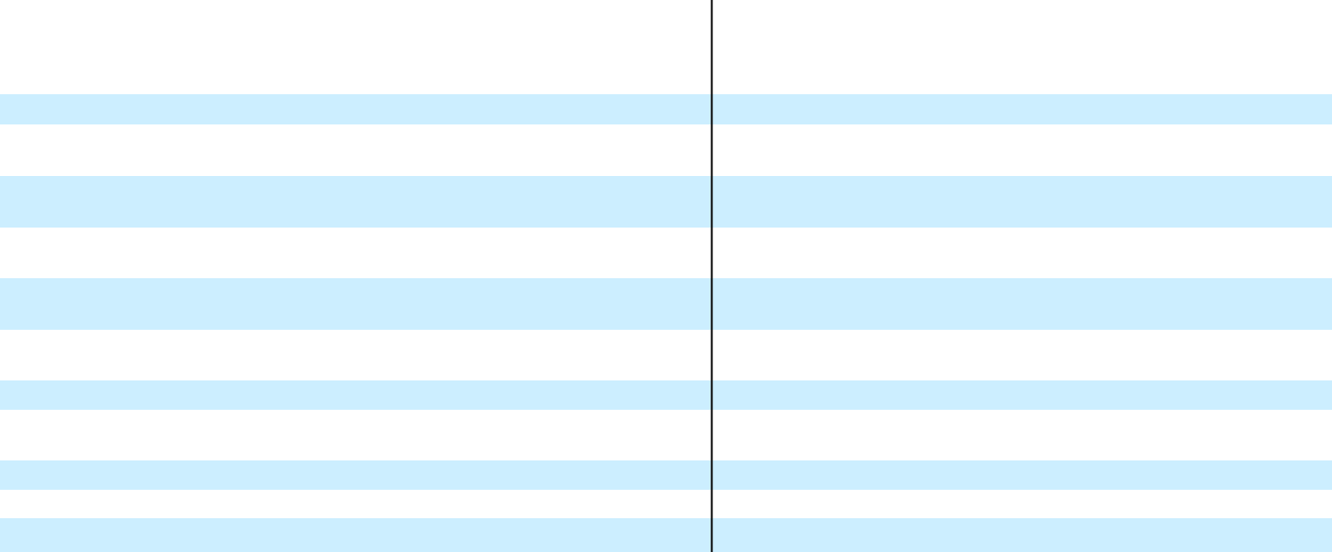

 | Redeemable |  |  |  | Redeemable
 | Convertible Preferred |  |  |  | Convertible A-1
 | Stock |  |  |  | Common Stock
 | Shares |  | Amount |  | Shares |  | Amount
Balance as of April 30, 2019
Balance as of April 30, 2019 | 34,192 |  | $299,965 |  | 6,667 |  | $ 18,800
Issuance of Series G Preferred Stock, net
of issuance costs $34 (unaudited) | 1,283 |  | 25,406 |  | — |  | —
Issuance of Class A common stock
(unaudited) | — |  | — |  | — |  | —
Issuance of Series H Preferred Stock, net
of issuance costs $164 | 1,654 |  | 49,836 |  | — |  | —
Issuance of Class A common stock upon
exercise of stock options (unaudited) | — |  | — |  | — |  | —
Vesting of early exercised Class A
common stock options (unaudited) | — |  | — |  | — |  | —
Tender offer repurchases | — |  | — |  | — |  | —
Stock-based compensation expense
(unaudited) | — |  | — |  | — |  | —
Other comprehensive income (unaudited) | — |  | — |  | — |  | —
Net loss (unaudited) | — |  | — |  | — |  | —
Balance as of October 31, 2019 (unaudited) | 37,129 |  | $375,207 |  | 6,667 |  | $ 18,800
 | Redeemable |  |  |  | Redeemable
 | Convertible Preferred |  |  |  | Convertible A-1
 | Stock |  |  |  | Common Stock
 | Shares |  | Amount |  | Shares |  | Amount
Balance as of April 30, 2020
Balance as of April 30, 2020 | 37,129 |  | $375,207 |  | 6,667 |  | $ 18,800
Repayment of shareholder loan | — |  | 24,546 |  | — |  | —
Issuance of Class A common stock
(unaudited) | — |  | — |  | — |  | —
Vesting of early exercised Class A
common stock options (unaudited) | — |  | — |  | — |  | —
Stock-based compensation expense
(unaudited) | — |  | — |  | — |  | —
Other comprehensive income (unaudited) | — |  | — |  | — |  | —
Net loss (unaudited) | — |  | — |  | — |  | —
Balance as of October 31, 2020 (unaudited) | 37,129 |  | $399,753 |  | 6,667 |  | $ 18,800
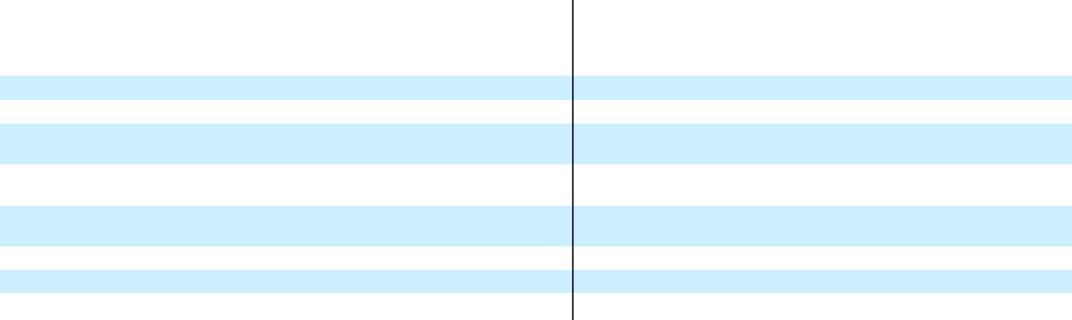

 |  |  |  |  |  |  | Accumulated
Common Stock |  |  |  |  | Additional |  |  | Other |  |  |  |  |  | Total
 |  |  |  |  | Paid-In |  | Comprehensive |  |  | Accumulated |  |  | Stockholders’
Shares |  | Amount |  |  | Capital |  | (Loss) Income |  |  |  | Deficit |  |  | Deficit
20,057 |  | $ | 20 |  | $ 58,731 |  | $ | 74 |  | $ | (224,259) |  | $ | (165,434)
— |  |  | — |  | — |  |  | — |  |  | — |  |  | —
9,530 |  |  | 10 |  | 44,017 |  |  | — |  |  | — |  |  | 44,027
— |  |  | — |  | — |  |  | — |  |  | — |  |  | —
1,356 |  |  | 1 |  | 1,568 |  |  | — |  |  | — |  |  | 1,569
— |  |  | — |  | 263 |  |  | — |  |  | — |  |  | 263
(164) |  |  | (1) |  | (3,547) |  |  | — |  |  | — |  |  | (3,548)
— |  |  | — |  | 3,371 |  |  | — |  |  | — |  |  | 3,371
— |  |  | — |  | — |  |  | 67 |  |  | — |  |  | 67
— |  |  | — |  | — |  |  | — |  |  | (29,148) |  |  | (29,148)
30,779 |  | $ | 30 |  | $104,403 |  | $ | 141 |  | $ | (253,407) |  | $ | (148,833)
 |  |  |  |  |  |  | Accumulated
Common Stock |  |  |  |  | Additional |  |  | Other |  |  |  |  |  | Total
 |  |  |  |  | Paid-In |  | Comprehensive |  |  | Accumulated |  |  | Stockholders’
Shares |  | Amount |  |  | Capital |  | (Loss) Income |  |  |  | Deficit |  |  | Deficit
31,210 |  | $ | 31 |  | $110,485 |  | $ | 424 |  | $ | (293,637) |  | $ | (182,697)
— |  |  | — |  | 1,457 |  |  | — |  |  | — |  |  | 1,457
1,771 |  |  | 2 |  | 3,061 |  |  | — |  |  | — |  |  | 3,063
— |  |  | — |  | 1,325 |  |  | — |  |  | — |  |  | 1,325
— |  |  | — |  | 7,681 |  |  | — |  |  | — |  |  | 7,681
— |  |  | — |  | — |  |  | (362) |  |  | — |  |  | (362)
— |  |  | — |  | — |  |  | — |  |  | (14,794) |  |  | (14,794)
32,981 |  | $ | 33 |  | $124,009 |  | $ | 62 |  | $ | (308,431) |  | $ | (184,327)

The accompanying notes are an integral part of these consolidated financial statements.

F-7

C3.AI, INC.

CONSOLIDATED STATEMENTS OF CASH FLOWS

(In thousands)

Year Ended April 30,

2019 2020

Six Months Ended October 31,

2019 2020

(unaudited)

Cash flows from operating activities:
Net loss | $ | (33,346) |  | $ | (69,378) |  | $ | (29,148) |  | $ | (14,794)
Adjustments to reconcile net loss to net cash provided by (used in) operating activities
Depreciation and amortization |  | 550 |  |  | 1,302 |  |  | 362 |  |  | 2,098
Non-cash operating lease cost |  | — |  |  | 3,052 |  |  | 1,497 |  |  | 1,650
Stock-based compensation expense |  | 4,267 |  |  | 8,310 |  |  | 3,362 |  |  | 7,681
Impairment on investment |  | — |  |  | 1,025 |  |  | — |  |  | —
Other |  | 534 |  |  | (657) |  |  | (42) |  |  | (75)
Changes in operating assets and liabilities
Accounts receivable⁽¹⁾ |  | (46,144) |  |  | 32,659 |  |  | 42,094 |  |  | (2,380)
Prepaid expenses, other current assets and other assets |  | (1,677) |  |  | (4,265) |  |  | (6,158) |  |  | (48)
Accounts payable |  | 48 |  |  | (1,219) |  |  | 1,093 |  |  | 3,159
Accrued compensation and employee benefits |  | 4,170 |  |  | 651 |  |  | (2,219) |  |  | (716)
Lease liability |  | — |  |  | (3,174) |  |  | (1,536) |  |  | (1,745)
Other liabilities |  | (533) |  |  | 1,343 |  |  | (349) |  |  | 2,345
Deferred revenue⁽²⁾ |  | 37,255 |  |  | (30,930) |  |  | (11,677) |  |  | 21,661
Net cash provided by (used in) operating activities |  | (34,876) |  |  | (61,281) |  |  | (2,721) |  |  | 18,836
Cash flows from investing activities:
Purchase of property and equipment |  | (6,811) |  |  | (2,298) |  |  | (1,503) |  |  | (919)
Capitalized software development costs |  | — |  |  | (581) |  |  | (708) |  |  | —
Purchase of investments |  | (166,303) |  |  | (219,853) |  |  | — |  |  | (128,330)
Maturity and sale of investments |  | 76,886 |  |  | 98,659 |  |  | 41,648 |  |  | 164,098
Net cash provided by (used in) investing activities |  | (96,228) |  |  | (124,073) |  |  | 39,437 |  |  | 34,849
Cash flows from financing activities:
Proceeds from repayment of shareholder loan |  | — |  |  | — |  |  | — |  |  | 26,003
Proceeds from issuance of Series G, net of issuance costs |  | 51,567 |  |  | 25,333 |  |  | 25,333 |  |  | —
Proceeds from issuance of Series H, net of issuance costs |  | — |  |  | 49,836 |  |  | 49,837 |  |  | —
Repurchase of common stock and options in tender offer |  | — |  |  | (3,548) |  |  | (3,548) |  |  | —
Proceeds from Payroll Protection Program loan |  | — |  |  | — |  |  | — |  |  | —
Payment of deferred offering costs |  | — |  |  | — |  |  | — |  |  | (2,325)
Proceeds from issuance of common stock |  | — |  |  | 44,027 |  |  | 44,027 |  |  | —
Proceeds from exercise of Class A common stock options |  | 2,905 |  |  | 4,203 |  |  | 2,961 |  |  | 4,536
Net cash provided by financing activities |  | 54,472 |  |  | 119,851 |  |  | 118,610 |  |  | 28,214
Net increase (decrease) in cash, cash equivalents and restricted cash |  | (76,632) |  |  | (65,503) |  |  | 155,326 |  |  | 81,899
Cash, cash equivalents and restricted cash at beginning of period |  | 175,739 |  |  | 99,107 |  |  | 99,107 |  |  | 33,604
Cash, cash equivalents and restricted cash at end of period | $ | 99,107 |  | $ | 33,604 |  | $ | 254,433 |  | $ | 115,503
Cash and cash equivalents |  | 98,607 |  |  | 33,104 |  |  | 253,933 |  |  | 114,603
Restricted cash included in other assets |  | 500 |  |  | 500 |  |  | 500 |  |  | 900
Total cash, cash equivalents and restricted cash | $ | 99,107 |  | $ | 33,604 |  | $ | 254,433 |  | $ | 115,503
Supplemental disclosures of cash flow information—cash paid for income taxes | $ | 131 |  | $ | 660 |  | $ | 351 |  | $ | 323
Supplemental disclosure of non-cash investing and financing activity:
Purchases of property and equipment included in accounts payable and accrued liabilities | $ | 60 |  | $ | 417 |  | $ | 87 |  | $ | 146
Purchases of capitalized software included in accounts payable and accrued liabilities | $ | — |  | $ | — |  | $ | — |  | $ | —
Deferred offering costs included in accounts payable and accrued liabilities | $ | — |  | $ | — |  | $ | — |  | $ | 2,994
Series G issuance cost included in accounts payable | $ | 73 |  | $ | — |  | $ | — |  | $ | —
Series H issuance cost included in accounts payable | $ | — |  | $ | — |  | $ | 1 |  | $ | —
Vesting of early exercised stock options | $ | 1,561 |  | $ | 655 |  | $ | 263 |  | $ | 1,325

- Including changes in related party balances of $(20,000), $19,750, $19,967 (unaudited) and $(150) (unaudited) for the years ended April 30, 2019 and 2020 and for the six months ended October 31, 2019 and 2020, respectively.
- Including changes in related party balances of $19,944, $(18,445), $1,262 (unaudited) and $14,780 (unaudited) for the years ended April 30, 2019 and 2020 and for the six months ended October 31, 2019 and 2020, respectively.

The accompanying notes are an integral part of these consolidated financial statements.

F-8

C3.AI, INC.

NOTES TO CONSOLIDATED FINANCIAL STATEMENTS

(information as of October 31, 2020 and for the six months ended October 31, 2019 and 2020 is unaudited)

- Summary of Business and Significant Accounting Policies

Business

C3.ai, Inc. and subsidiaries, or collectively, C3 or the Company, is an enterprise artificial intelligence, or AI, software provider for accelerating digital transformation. The C3 AI Suite supports the value chain in various industries with prebuilt and configurable AI applications for business use cases including predictive maintenance, fraud detection, sensor network health, supply network optimization, energy management, anti-money laundering, and customer engagement. The Company supports customers in the United States, Europe, and the rest of the world. The Company was initially formed as a limited liability company in Delaware on January 8, 2009 and converted to a Delaware corporation in June 2012.

Basis of Presentation and Principles of Consolidation

The Company prepares its consolidated financial statements in accordance with generally accepted accounting principles in the United States, or GAAP. The consolidated financial statements include the accounts of C3.ai, Inc. and its wholly owned subsidiaries. All intercompany balances and transactions have been eliminated in consolidation.

Reverse Stock Split

On November 25, 2020, the Company amended and restated its certificate of incorporation to effect a reclassification of the Company’s Class B common stock and Class C common stock into Class A common stock and redeemable convertible Class B-1 common stock into a new redeemable convertible Class A-1 common stock. The rights, including the liquidation, dividend, and voting rights, are substantially identical for each class of common stock reclassified. All references to Class B common stock and Class C common stock have been recast to Class A common stock, and all references to redeemable convertible Class B-1 common stock have been recast to redeemable convertible Class A-1 common stock in these consolidated financial statements to give retrospective effect to the reclassification for all periods presented. The Company also authorized a new Class B common stock. The rights, including the liquidation and dividend rights, of the Class A common stock and the new Class B common stock are substantially identical, other than the voting rights and conversion rights upon transfer of the Class B common stock. See Note 8 for more information.

Additionally, the Company effected a 6-for-1 reverse stock split of the Company’s outstanding common stock, preferred stock, and stock option awards. The par value of the common stock and preferred stock was not adjusted as a result of the reverse stock split. The authorized shares of the Class A common stock, new Class A-1 common stock, new Class B common stock and preferred stock was adjusted to 390,000,000 shares, 6,666,667 shares, 21,000,000 shares, and 233,107,379 shares, respectively. All authorized, issued, and outstanding shares of common stock, preferred stock, stock option awards, and per share data included in these financial statements have been recast to give retrospective effect to the adjusted authorized shares and reverse stock split for all periods presented.

Use of Estimates

The preparation of the accompanying consolidated financial statements in conformity with GAAP requires management to make estimates and assumptions about future events. These estimates and the underlying assumptions affect the amounts of assets and liabilities reported, disclosures about contingent assets and liabilities, and reported amounts of revenue and expenses. Actual results and outcomes could differ significantly from the Company’s estimates, judgments, and assumptions. Significant estimates include determining standalone selling price for performance obligations in contracts with customers and estimating variable consideration, the estimated expected benefit period for deferred contract acquisition costs, the useful lives of long-lived assets, the value of common stock and other assumptions used to measure stock-based compensation, and the valuation of deferred income tax assets and uncertain tax positions. These estimates and assumptions are based on management’s best estimates and judgment. Management evaluates its estimates and assumptions on an ongoing basis using historical experience and other factors, including the current economic environment, which management believes to be reasonable under the circumstances. The Company adjusts such estimates and assumptions when facts and circumstances dictate. Changes in those estimates resulting from continuing changes in the economic environment will be reflected in the financial statements in future periods. As future events and their effects cannot be determined with precision, actual results could materially differ from those estimates and assumptions.

F-9

C3.AI, INC.

NOTES TO CONSOLIDATED FINANCIAL STATEMENTS (CONTINUED)

(information as of October 31, 2020 and for the six months ended October 31, 2019 and 2020 is unaudited)

Fiscal Year

The Company’s fiscal year ends on April 30. References to fiscal 2019 and 2020 relate to the fiscal years ended April 30, 2019 and 2020, respectively.

Unaudited Interim Consolidated Financial Information

The accompanying interim consolidated balance sheet as of October 31, 2020, the consolidated statements of operations, comprehensive loss, redeemable convertible preferred stock, redeemable convertible Class A-1 Common stock and stockholders’ deficit, and cash flows for the six months ended October 31, 2019 and 2020, and the related footnote disclosures are unaudited. These unaudited interim consolidated financial statements have been prepared in accordance with GAAP. In management’s opinion, the unaudited interim consolidated financial statements include all adjustments necessary to state fairly the Company’s financial position as of October 31, 2020 and its results of operations and cash flows for the six months ended October 31, 2019 and 2020. The financial data and the other information disclosed in the notes to these consolidated financial statements related to the six-month periods are unaudited. The results of operations for the six months ended October 31, 2020 are not necessarily indicative of the results expected for the year ending April 30, 2021 or any other future period.

Unaudited Pro Forma Consolidated Balance Sheet Information

Unaudited pro forma consolidated balance sheet information as of October 31, 2020 has been presented to show the assumed effect to the consolidated balance sheet for the automatic conversion of the outstanding redeemable convertible preferred stock upon the consummation of a qualified initial public offering, or IPO, as described in Note 8 as if such conversion had occurred on October 31, 2020. Immediately prior to the consummation of a qualified IPO, all outstanding shares of Series A* convertible preferred stock will automatically convert into 3,499,992 shares of Class B common stock and the remaining convertible preferred stock and redeemable convertible Class A-1 common stock will convert into 43,795,433 shares of Class A common stock. The unaudited pro forma consolidated balance sheet information does not give effect to the shares of common stock issuable and the proceeds expected to be received upon the closing of a qualified IPO.

Unaudited Pro Forma Net Loss Per Share

Unaudited pro forma basic and diluted net loss per share attributable to common stockholders for the year ended April 30, 2020 and the six months ended October 31, 2020 has been presented to give effect to the automatic conversion of Series A* convertible preferred stock into Class B common stock and all remaining convertible preferred stock and redeemable convertible Class A-1 common stock into Class A common stock immediately prior to the consummation of a qualified IPO as of the beginning of the period or the original date of issuance, if later. The unaudited pro forma basic and diluted net loss per share attributable to common stockholders does not give effect to the shares of common stock issuable upon the completion of a qualified IPO.

Concentration of Risk

Financial instruments that potentially subject the Company to concentration of credit risk consist of cash and cash equivalents, investments and accounts receivable. The majority of the Company’s cash and cash equivalents are held by one financial institution. The Company is exposed to that financial institution to the extent that its cash balance with that financial institution is in excess of Federal Deposit Insurance Company, or FDIC, insurance limits. The Company’s investment policy is to invest in securities with a minimum rating of P1 by Moody’s, A1 by Standard & Poor’s, F-1 by Fitch’s or higher for short-term investments, and minimum rating of A2 by Moody’s, A by Standard & Poor’s, or A by Fitch’s or higher for long-term investments.

All of the Company’s customers consist of corporate and governmental entities. A limited number of customers have accounted for a large part of the Company’s revenue and accounts receivable to date. Two separate customers accounted for 14% and 12%, respectively, of revenue for the year ended April 30, 2019. Two separate customers accounted for 26% and 10%, respectively, of revenue for the year ended April 30, 2020. Two separate customers accounted for 28% and 10%, respectively, of revenue for the six months ended October 31, 2019. Two separate customers accounted for 17% and 12%, respectively, of revenue for the six months ended October 31, 2020. Three separate customers accounted for 32%, 27%, and 16% of accounts receivable at April 30, 2019. Three separate customers accounted for 33%, 19%, and 15% of accounts receivable at April 30, 2020. Three separate customers accounted for 22%, 16%, and 11% of accounts receivable at October 31, 2020.

F-10

C3.AI, INC.

NOTES TO CONSOLIDATED FINANCIAL STATEMENTS (CONTINUED)

(information as of October 31, 2020 and for the six months ended October 31, 2019 and 2020 is unaudited)

Cash and Cash Equivalents

The Company considers all highly liquid investments purchased with a maturity of three months or less to be cash equivalents. The Company’s cash equivalents consisted of investments in money market funds as of April 30, 2019 and 2020 and October 31, 2020.

Restricted Cash

The Company had restricted cash pledged as security deposits at April 30, 2019 and 2020 and October 31, 2020 of $0.5 million, $0.5 million, and $0.9 million, respectively, primarily representing a security deposit required by certain leases. The balance of restricted cash as of April 30, 2019 and 2020 and October 31, 2020 was recorded as long-term other assets on the consolidated balance sheets.

Investments

The Company determines the appropriate classification of investments at the time of purchase and reevaluates such determination at each period-end. The Company’s investments, comprised of money market funds, U.S. treasury securities, certificates of deposit, commercial paper and corporate debt securities, are classified as available-for-sale.

Such securities are carried at estimated fair values and reported in cash equivalents, short-term investments or long-term investments. Unrealized gains and losses, net of tax, are reported in other comprehensive loss as a separate component on the consolidated statements of comprehensive loss. Fair value is determined based on quoted market rates when observable or by utilizing data points that are observable, such as quoted prices, interest rates and yield curves. Declines in fair value judged to be other-than-temporary on securities available for sale are recorded within other expense, net on the consolidated statements of comprehensive loss. In order to determine whether a decline in value is other-than-temporary, the Company evaluates, among other factors, the duration and extent to which the fair value has been less than the carrying value and its intent and ability to retain the investment for a period of time sufficient to allow for any anticipated recovery in fair value. The cost of securities sold is based on the specific-identification method. Interest on securities classified as available-for-sale is included in interest income (expense) on the consolidated statements of operations.

Non-marketable equity securities without readily determinable fair values are recorded at cost, less impairment, and adjusted to fair value within other expense, net if there are observable price changes for identical or similar securities. Non-marketable equity securities are recorded within long-term investments. Impairment loss is recorded in other expense, net on the consolidated statements of operations. Prior to the adoption of ASU 2016-01 in the fiscal year beginning May 1, 2019, investments in non-marketable equity securities were recorded at cost less impairment, if any, with any losses resulting from an impairment recognized in other expense, net.

Accounts Receivable

Accounts receivable consist of current trade receivables from customers. The Company records accounts receivable at their net realizable value. Judgment is required in assessing the realization of these receivables, including the current creditworthiness of each customer and related aging of the past-due balances. Management evaluates all accounts periodically, and an allowance for doubtful accounts may be established based on specific identification using the best facts available and reevaluated and adjusted as additional information is received. An allowance for doubtful accounts balance of $0.8 million, $0.8 million, and $0.8 million was recorded as of April 30, 2019 and 2020 and October 31, 2020, respectively. Accounts receivable as of April 30, 2019 and 2020 and October 31, 2020 included contract assets of $0.2 million, $0.5 million, and $0.1 million, respectively.

Fair Value Measurements

Fair value is defined as the exchange price that would be received for an asset or paid to transfer a liability (an exit price) in the principal or most advantageous market for the asset or liability in an orderly transaction between market participants at the measurement date. Assets and liabilities that are measured at fair value are reported using a three-level fair value hierarchy that prioritizes the inputs used to measure fair value. This hierarchy maximizes the use of observable inputs and minimizes the use of unobservable inputs. The three levels of inputs used to measure fair value are as follows:

Level 1—Quoted prices in active markets for identical assets or liabilities that the Company has the ability to access at the measurement date.

F-11

C3.AI, INC.

NOTES TO CONSOLIDATED FINANCIAL STATEMENTS (CONTINUED)

(information as of October 31, 2020 and for the six months ended October 31, 2019 and 2020 is unaudited)

Level 2—Inputs other than quoted prices in active markets that are observable for the asset or liability, either directly or indirectly.

Level 3—Inputs that are unobservable for the asset or liability.

To the extent that valuation is based on models or inputs that are less observable or unobservable in the market, the determination of fair value requires more judgment. Accordingly, the degree of judgment exercised by the Company in determining fair value is greatest for instruments categorized in Level 3. A financial instrument’s level within the fair value hierarchy is based on the lowest level of any input that is significant to the fair value measurement.

The carrying amounts of the Company’s financial instruments, including cash, cash equivalents, restricted cash, accounts receivable, accounts payable, and accrued expenses, approximate their fair value due to their short maturities. The fair value of the company’s investments is discussed in Note 3.

Prepaid Expenses and Other Current Assets

Prepaid expenses and other current assets are comprised primarily of prepaid cloud subscriptions, other receivables, costs to obtain and fulfill a contract, prepaid software subscriptions, prepaid rent, and prepaid health insurance premiums.

Property and Equipment

Property and equipment are stated at cost less accumulated depreciation. Assets are depreciated using the straight-line method over useful lives of three to five years. Leasehold improvements and certain furniture and fixtures are amortized using the straight-line method over the lesser of the remaining respective lease term or useful lives.

Impairment of Long-Lived Assets

The Company evaluates long-lived assets or asset groups for impairment whenever events indicate that the carrying value of an asset or asset group may not be recoverable based on expected future cash flows attributable to that asset or asset group. Recoverability of assets held and used is measured by comparing the carrying amount of an asset or an asset group to estimated undiscounted future net cash flows expected to be generated by the asset or asset group. If the carrying amount of an asset or asset group exceeds estimated undiscounted future cash flows, then an impairment charge would be recognized based on the excess of the carrying amount of the asset or asset group over its fair value. Assets to be disposed of are reported at the lower of their carrying amount or fair value less costs to sell. There were no impairment charges recognized related to long-lived assets during the during the years ended April 30, 2019 and 2020 and the six months ended October 31, 2020.

Goodwill

Goodwill is the amount by which the cost of acquired net assets in a business combination exceeds the fair value of the net identifiable assets on the date of purchase and is carried at its historical cost. The Company tests goodwill for impairment on an annual basis or more frequently if events or changes in circumstances indicate that the asset might be impaired. The Company performs its annual impairment test of goodwill as of February 1, and whenever events or circumstances indicate that the asset might be impaired. The tests did not result in an impairment to goodwill during the years ended April 30, 2019 and 2020 and the six months ended October 31, 2020.

Deferred Offering Costs

Deferred offering costs consist primarily of accounting, legal, and other fees related to the Company’s proposed IPO. The deferred offering costs will be recorded against IPO proceeds upon the consummation of the IPO. If the IPO is abandoned, deferred offering costs will be expensed in the period the IPO is abandoned. There were no deferred offering costs as of April 30, 2019 or 2020 and $5.3 million as of October 31, 2020.

Leases

The Company has lease arrangements that include lease and non-lease components. The Company has elected to not account for the lease and non-lease components separately. For leases that commenced before the Company’s adoption date of Accounting Standards Codification, or ASC, Topic 842, Leases, the Company elected the practical expedient to not reassess the following: (1) whether any expired or existing contracts contain leases; (2) the lease classification for any expired or existing leases; and (3) initial direct costs for any existing leases. For short-term leases, defined as leases with a lease term

F-12

C3.AI, INC.

NOTES TO CONSOLIDATED FINANCIAL STATEMENTS (CONTINUED)

(information as of October 31, 2020 and for the six months ended October 31, 2019 and 2020 is unaudited)

of 12 months or less, the Company elected to not recognize an associated lease liability and right-of-use, or ROU, asset. Lease payments for short-term leases are expensed on a straight-line basis over the lease term.

The Company does not have financing leases. Operating lease ROU assets represent the Company’s right to use an underlying asset for the lease term and lease liabilities represent its obligation to make lease payments arising from the lease. Operating lease ROU assets and liabilities are recognized at the commencement date based on the present value of remaining lease payments over the lease term. The Company uses the rate implicit in the lease when readily determinable at lease inception. If the implicit rate is not readily determinable, the Company uses its incremental borrowing rate based on the information available at the adoption date for leases that commenced prior to the adoption date and the commencement date for leases that commenced after the adoption date. The incremental borrowing rate assumptions include the lease term and the Company’s credit risk. The operating lease ROU asset also includes any advance lease payments made and excludes lease incentives. The Company’s lease terms include options to extend or terminate the lease when it is reasonably certain that the Company will exercise that option. Lease expense for lease payments is recognized on a straight-line basis as operating expense in the statements of operations over the lease term. Refer to Note 6 for more information.

Deferred Revenue

Deferred revenue consists of billings or cash received for services in advance of revenue recognition and is recognized as revenue when all of the Company’s revenue recognition criteria are met. The portion of deferred revenue that is anticipated to be recognized as revenue during the succeeding twelve-month period is recorded as deferred revenue, current and the remaining portion is recorded as deferred revenue, non-current.

Revenue Recognition

The Company accounts for revenue in accordance with ASC Topic 606, Revenue From Contracts With Customers for all periods presented. The core principle of ASC 606 is to recognize revenue for the transfer of promised goods or services to customers in an amount that reflects the consideration the Company expects to be entitled to in exchange for those goods or services. This principle is achieved by applying the following five-step approach:

Identification of the Contract, or Contracts, with a Customer. A contract with a customer exists when (1) the Company enters into an enforceable contract with a customer that defines each party’s rights regarding the goods or services to be transferred and identifies the payment terms related to these goods or services, (2) the contract has commercial substance and (3) the Company determines that collection of substantially all consideration for goods or services that are transferred is probable based on the customer’s intent and ability to pay the promised consideration. The Company applies judgment in determining the customer’s ability and intention to pay, which is based on a variety of factors, including the customer’s historical payment experience or, in the case of a new customer, published credit and financial information pertaining to the customer.

Identification of the Performance Obligations in the Contract. Performance obligations promised in a contract are identified based on the goods or services that will be transferred to the customer that are both capable of being distinct, whereby the customer can benefit from the goods or services either on their own or together with other resources that are readily available from third parties or from the Company, and are distinct in the context of the contract, whereby the transfer of the goods or services is separately identifiable from other promises in the contract. To the extent a contract includes multiple promised goods or services, the Company applies judgment to determine whether promised goods or services are capable of being distinct and distinct in the context of the contract. If these criteria are not met, the promised goods or services are accounted for as a combined performance obligation.

Determination of the Transaction Price. The transaction price is determined based on the consideration to which the Company will be entitled in exchange for transferring goods or services to the customer, net of sales taxes or value-added taxes. If the transaction price includes variable consideration, the Company includes an estimate of the amount it expects to receive if it is probable that a significant reversal of cumulative revenue recognized will not occur. Usage-based fees earned in exchange for the use of the Company’s software licenses and subscription services are subject to the usage-based royalty and series guidance variable consideration estimation exceptions, respectively.

Allocation of the Transaction Price to the Performance Obligations in the Contract. Contracts that contain multiple performance obligations require an allocation of the transaction price to each performance obligation based on a relative standalone selling price, or SSP. When appropriate, the Company determines SSP based on the price at which the

F-13

C3.AI, INC.

NOTES TO CONSOLIDATED FINANCIAL STATEMENTS (CONTINUED)

(information as of October 31, 2020 and for the six months ended October 31, 2019 and 2020 is unaudited)

performance obligation has previously been sold through past transactions, taking into account internally approved pricing guidelines related to the performance obligations. When the SSP of a license or subscription and bundled maintenance and support services is highly variable and the contract also includes additional performance obligations with observable SSP, the Company first allocates the transaction price to the performance obligations with established SSPs and then applies the residual approach to allocate the remaining transaction price to the license or subscription and bundled maintenance and support services. If applying the residual approach results in zero or very little consideration being allocated to the combined performance obligation, or to a bundle of goods or services, the Company will consider all reasonably available data to determine an appropriate allocation of the transaction price. If the contract contains a single performance obligation, the entire transaction price is allocated to the single performance obligation.

Recognition of Revenue when, or as, Performance Obligations are Satisfied. The Company satisfies substantially all of its performance obligations over time, as discussed in further detail below. Revenue is recognized at the time the related performance obligation is satisfied with the transfer of a promised good or service to a customer over time.

Subscriptions Revenue

Subscriptions relate to software licenses and software-as-a-service, or SaaS, offerings for the Company’s C3 AI Suite and/or C3 AI Applications and include maintenance and support services. Licenses represent a contractual right for a customer to take possession of the software and it is feasible for the customer to host the software independently. SaaS represents a right for a customer to access the software through the Company’s cloud environment and the customer does not have the right to take possession of the software. Maintenance and support services include critical and continuous updates to the software that are integral to maintaining the intended utility of the software over the contractual term. The Company’s software and maintenance and support services are highly interdependent and interrelated and represent a single distinct performance obligation within the context of the contract satisfied over time.

Determining whether the software license and maintenance and support services are considered distinct performance obligations that should be accounted for separately or as one combined performance obligation may require significant judgment. In reaching its conclusion, the Company considered the nature of its promise to provide the customer real time analytics and machine learning algorithms that require regular re-training to maintain and improve prediction accuracy. The Company fulfills this promise by providing real time data feeds to the machine learning model and by providing regular tuning, optimization and critical updates to the constantly changing type system. Accordingly, the Company has determined that the software license and maintenance and support services fulfill a single promise to the customer under the contract.

The Company’s subscriptions are generally offered under renewable, multi-year, fixed fee contracts where payments are typically due annually in advance. A time-elapsed output method is used to measure progress because the nature of the promise is a stand-ready service. The Company also offers premium stand-ready C3 Center of Excellence, or COE, support services, hosting services and trial services, which are distinct performance obligations. A description of the Company’s offerings are as follows:

- C3 AI Suite is a comprehensive suite that allows for the design, deployment, and operation of AI, predictive analytics, and applications at enterprise scale. The C3 AI Suite provides data scientists and application developers robust advantages for rapid application and analytics development and deployment. Customers primarily pay for the C3 AI Suite via fixed annual fees based on the number of development users allowed to access the C3 AI Suite. The AI Suite offering is primarily a term subscription but at times has been sold as a perpetual license and generates additional runtime subscription fees, a type of usage-based royalty revenue based on compute and storage resources required to run the C3 AI Suite.

- C3 AI Applications are production applications that address a wide range of predictive analytics use cases. C3 AI Applications are industry-tested and proven enterprise-grade applications built on a cohesive suite architecture that is designed to integrate and process highly dynamic data sets from sensor networks and enterprise and extraprise information systems, and enable advanced machine learning capabilities. C3 AI Applications sold without the C3 AI Suite can be in the form of term or perpetual licenses or subscriptions and earn revenue through a fixed fee and/or usage-based royalties.

- C3 Maintenance and Support Services are provided for the C3 AI Suite and the C3 AI Applications that are selected by the customer. This support includes standard monitoring, performance monitoring, database maintenance,

F-14

C3.AI, INC.

NOTES TO CONSOLIDATED FINANCIAL STATEMENTS (CONTINUED)

(information as of October 31, 2020 and for the six months ended October 31, 2019 and 2020 is unaudited)

security monitoring, upgrading, backup and restore, patching, etc. provided by the Company. The Company continuously provides updates that are critical to the continued utility of the software.

- COE Support Services. COE Support Services provide premium development services and support by an available pool of resources. The purpose of the COE is to provide the following stand-ready support services over the term of the COE agreement: (1) support and guidance on overall software application architecture; (2) data integration, data science, and application development support on the C3 AI Suite; (3) training on the C3 AI Suite and C3 AI Applications to the customer project team members; and (4) support to help address any developmental issues faced by the customer. COE Support Services are generally offered under renewable, multi-year, fixed fee contracts whereby payments are primarily due annually in advance and in most cases are co-terminus with the C3 AI Suite subscription term. COE Support Services represent a stand-ready performance obligation comprised of a series of distinct days of service that is satisfied and recognized in revenue ratably over the term of the COE agreement. Revenue for COE Support Services is included within subscription revenue in the consolidated statements of operations.

- Trials. Trial projects typically consist of several phases including project kickoff, design, data integration, configuration, validation and final demonstration. These trials are typically fixed-price eight to 16-week production pilots during which the Company works with customers to define a specific business problem or use case and address the use case using AI-based predictive analytics. During the trial, the Company integrates data, configures machine learning algorithms supporting the use case, and configures a user interface to present the resulting insights. At the end of a trial, the Company demonstrates a working application that shows the utility, benefit, and economic value to be gained from a production deployment of big data, analytics, and machine learning applications. These paid trials are solely meant to demonstrate the feasibility of the Company’s offering to the customer and provide them with a level of confidence to encourage them to enter into a large, multi-year arrangement with the Company. Trial revenue is recognized ratably over time during the production pilot period.

- Hosting Services. For certain customers, the Company provides access to the C3 AI Suite and/or C3 AI Applications in the Company’s cloud environment. The customer consumes and receives benefit throughout the hosting period from the entity’s performance of hosting and providing access to the hosted software, which the customer would otherwise have to undertake itself or obtain another party to do. The Company recognizes hosting services over time based on the consumption patterns of the customers. Customers who choose to install the C3 AI Suite and/or C3 AI Applications in their own cloud environments do not subscribe to the Company’s hosting services. Hosting services are generally offered as part of the subscription for C3 AI Suite and/or C3 Application arrangements and the amount of revenue recognized on a monthly basis varies based on actual consumption by the customer.

Professional Services

The Company’s professional services primarily includes implementation services and training. The Company offers a complete range of professional service support both onsite and remotely, including training, application design, project management, system design, data modeling, data integration, application design, development support, data science, and application and AI Suite administration support. Professional services fees are based on the level of effort required to perform such tasks and are typically a fixed-fee engagement with a duration of less than 12 months. The Company recognizes revenue for its professional services over time on an input basis as the performance obligations are satisfied.

The Company typically invoices customers for subscription fees in annual increments upon execution of the initial contract or subsequent renewal, payable within 30 to 60 days, and providing customers access to C3 AI Suite and/or C3 AI Applications. Monthly usage-based runtime and hosting charges are billed as they are delivered. Certain government contracts are cancellable during the subscription term depending on the future fiscal funding available to the contract. The Company has not experienced any cancellation due to the funding constraint related to such contracts.

The timing of revenue recognition may differ from the timing of invoicing to customers. Accounts receivable are recorded at the invoiced amount, net of an allowance for doubtful accounts. A receivable is recognized in the period the Company delivers goods or provides services, or when the Company’s right to consideration is unconditional. In situations where revenue recognition occurs before invoicing, an unbilled receivable is recorded, which represents a contract asset. Accounts receivable as of April 30, 2019 and 2020 and October 31, 2020 included contract assets of $0.2 million, $0.5 million, and $0.1 million, respectively.

F-15

C3.AI, INC.

NOTES TO CONSOLIDATED FINANCIAL STATEMENTS (CONTINUED)

(information as of October 31, 2020 and for the six months ended October 31, 2019 and 2020 is unaudited)

While the timing of revenue recognition usually differs from the timing of payment, the Company has determined the contracts generally do not include a significant financing component, because the period between when the Company transfers its software and services to a customer and when the customer pays for the software and service is one year or less. The primary purpose of the invoicing terms is to provide customers with simplified and predictable ways of purchasing the Company’s software and services, not to receive financing from the customers or to provide customers with financing.

Costs to Obtain and Fulfill a Contract

The Company’s customer acquisition costs are primarily related to sales commissions earned by its sales force if such costs are incremental costs to obtain a contract without a service condition.

Sales commissions are deferred and then amortized taking into consideration the pattern of transfer to which assets relate. If the commissions paid on the initial and renewal contracts are not commensurate, the Company amortizes the commissions paid on the initial contract over an expected period of benefit, including expected renewals, which is determined to be approximately five years. In arriving at the average period of benefit the Company considered the duration of the Company’s relationships with customers and the Company’s technology. Sales commissions for renewal contracts are deferred and amortized over the contract period. Sales commissions for non-recurring contracts with a duration of one year or less are expensed when incurred.

Costs to obtain and fulfill a contract that will amortize within the succeeding 12-month period are classified as current and included in prepaid expenses and other current assets on the consolidated balance sheets. The remaining balance is classified as non-current and are included in other assets.

Cost of Revenue

Cost of subscription revenue consists primarily of costs related to compensation, including salaries, bonuses, benefits, stock-based compensation and other related expenses for the production environment, support and COE staff, hosting of our AI Suite, including payments to outside cloud service providers, and allocated overhead and depreciation for facilities.

Cost of professional services revenue consists primarily of compensation, including salaries, bonuses, benefits, stock-based compensation and other related costs associated with our professional service personnel, and allocated overhead and depreciation for facilities.

Warranties

The Company’s offerings are warranted to perform in a manner consistent with industry standards.

The Company’s arrangements generally include provisions for indemnifying customers against liabilities if its services infringe on a third party’s intellectual property rights. They also generally include service-level agreements warranting defined levels of uptime reliability and performance.

To date, the Company has incurred immaterial costs as a result of its warranties and indemnifications. There are no accrued liabilities related to these obligations on the consolidated financial statements.

Stock-Based Compensation

Stock-based compensation expense related to stock option awards is recognized based on the fair value of the awards granted. The fair value of each option award is estimated on the grant date using the Black-Scholes option pricing model. The Black-Scholes option pricing model requires the input of highly subjective assumptions, including the fair value of the underlying common stock, the expected term of the option, the expected volatility of the price of the Company’s common stock, risk-free interest rates, and the expected dividend yield of the Company’s common stock. The assumptions used to determine the fair value of the option awards represent management’s best estimates. These estimates involve inherent uncertainties and the application of management’s judgment. The related stock-based compensation expense is recognized on a straight-line basis over the requisite service period of the awards. The Company accounts for forfeitures as they occur.

Software Development Costs

The Company capitalizes certain software development costs subsequent to the establishment of technological feasibility. Based on the Company’s product development process and substantial development risks, technological

F-16

C3.AI, INC.

NOTES TO CONSOLIDATED FINANCIAL STATEMENTS (CONTINUED)

(information as of October 31, 2020 and for the six months ended October 31, 2019 and 2020 is unaudited)

feasibility, defined as a working prototype, is established for the Company’s products when they are made available for general release. Other assets, non-current as of April 30, 2019 and 2020 and October 31, 2020 included capitalized software development costs of nil, $0.4 million, and $0.2 million, respectively.

Advertising Expenses

Advertising expenses of $5.2 million and $29.2 million incurred during the years ended April 30, 2019 and 2020, respectively, and advertising expenses of $8.6 million and $8.8 million incurred during the six months ended October 31, 2019 and 2020, respectively, were expensed as incurred as a component of sales and marketing expenses on the consolidated statements of operations.

401(k) Plan

The Company has a 401(k) tax deferred savings plan under which eligible employees may elect to have a portion of their salary deferred and contributed to the plan. Employer matching contributions are determined by the Company and are discretionary. During the years ended April 30, 2019 and 2020 and the six months ended October 31, 2020, the Company did not match any employee contributions.

Foreign Currency

The functional currency of the Company’s foreign subsidiaries is the U.S. dollar. Accordingly, monetary assets and liabilities of the Company’s foreign subsidiaries are remeasured into U.S. dollars at the exchange rates in effect at the reporting date, non-monetary assets and liabilities are re-measured at historical rates, and revenue and expenses are re-measured at average exchange rates in effect during each reporting period. Foreign currency transaction gains and losses have been immaterial in the periods presented.

Income Taxes

The Company accounts for income taxes using the asset and liability method, which requires the recognition of deferred tax assets and liabilities for the expected future tax consequences of events that have been included in the consolidated financial statements. Under this method, the Company determines deferred tax assets and liabilities on the basis of the differences between the financial statement and tax bases of assets and liabilities by using enacted tax rates in effect for the year in which the differences are expected to reverse. The effect of a change in tax rates on deferred tax assets and liabilities is recognized in income in the period that includes the enactment date.

Deferred tax assets are recognized to the extent that these assets are more likely than not to be realized. In making such a determination, the Company considers all available positive and negative evidence, including future reversals of existing taxable temporary differences, projected future taxable income, tax-planning strategies, and results of recent operations. If the Company determines that it is able to realize its deferred tax assets in the future in excess of their net recorded amount, the Company records an adjustment to the deferred tax asset valuation allowance, which reduces the provision for income taxes.

Tax benefits from uncertain tax positions are recognized only if it is more likely than not that the tax position will be sustained on examination by the taxing authorities, based on the technical merits of the position. The tax benefits recognized in the Company’s consolidated financial statements from such positions are measured based on the largest benefit that has a greater than 50% likelihood of being realized. Interest and penalties are recognized associated with tax matters as part of the income tax provision and include accrued interest and penalties with the related income tax liability on the Company’s consolidated balance sheets.

Net Loss Per Share Attributable to Common Stockholders

Basic and diluted net loss per share attributable to common stockholders is presented in conformity with the two-class method required for participating securities. The Company considers all series of its redeemable convertible preferred stock to be participating securities. Under the two-class method, the net loss attributable to common stockholders is not allocated to the redeemable convertible preferred stock as the holders of its redeemable convertible preferred stock do not have a contractual obligation to share in the Company’s losses. Net income is attributed to common stockholders and participating securities based on their participation rights. Basic net loss per share attributable to common stockholders is computed by dividing the net loss attributable to common stockholders by the weighted-average number of shares of common stock outstanding during the period. Diluted earnings per share attributable to common stockholders adjusts basic earnings per

F-17

C3.AI, INC.

NOTES TO CONSOLIDATED FINANCIAL STATEMENTS (CONTINUED)

(information as of October 31, 2020 and for the six months ended October 31, 2019 and 2020 is unaudited)

share for the potentially dilutive impact of stock options and redeemable convertible preferred stock. As the Company has reported losses for all periods presented, all potentially dilutive securities are antidilutive and accordingly, basic net loss per share equals diluted net loss per share.

Other Comprehensive Loss

Other comprehensive loss during the years ended April 30, 2019 and 2020 and the six months ended October 31, 2019 and 2020, related to unrealized gains or losses from available-for-sale investments.

Segment Information

Operating segments are defined as components of an entity where discrete financial information is evaluated regularly by the chief operating decision maker in deciding how to allocate resources and assessing performance. The Company has identified its Chief Executive Officer as the chief operating decision maker. The Company operates in one operating segment. The Company’s chief operating decision maker allocates resources and assesses performance at the consolidated level. Revenue by geographical region can be found in the revenue recognition disclosures in Note 2. The Company’s property and equipment, net, are primarily located in the United States. No single other country accounted for more than 10% of total property and equipment, net as of April 30, 2019 and 2020 and October 31, 2020.

Contribution Accounting

The Company entered into an agreement establishing the C3.ai Digital Transformation Institute, or C3.ai DTI, a program established to attract the world’s leading scientists to join in a coordinated and innovative effort to advance the digital transformation of business, government, and society. As part of the agreement, the Company issued cash grants to C3.ai DTI which are conditional in nature and subject to execution of the program in line with specific requirements on an annual basis. The cash grants do not represent an exchange transaction since there is not a commensurate transfer of resources at fair value, resulting in the application of the contribution accounting model. Contributions are allocated between sales and marketing and research and development based on the estimated benefits received by the Company. The Company recognized nil, $5.7 million, nil and nil of expense related to the contribution in sales and marketing for the years ended April 30, 2019 and 2020, and six months ended October 31, 2019, and 2020, respectively. Additionally, the Company recognized nil and $5.7 million, nil and $1.2 million of expense related to the contribution in research and development for the years ended April 30, 2019 and 2020, and six months ended October 31, 2019 and 2020, respectively.

Recent Accounting Pronouncements

The Company currently qualifies as an “emerging growth company” under the Jumpstart Our Business Startups Act of 2012, or the JOBS Act. Accordingly, the Company is provided the option to adopt new or revised accounting guidance either (1) within the same periods as those otherwise applicable to public business entities or (2) within the same time periods as private companies, including early adoption when permissible.

The Company has elected to adopt new or revised accounting guidance within the same time period as private companies, as indicated below.

Recently Adopted Accounting Standards—In January 2016, the Financial Accounting Standards Board, or FASB, issued Accounting Standards Update, or ASU, No. 2016-01, Recognition and Measurement of Financial Assets and Financial Liabilities, which makes targeted improvements to the accounting for, and presentation and disclosure of, financial instruments. ASU No. 2016-01 requires that most equity investments be measured at fair value, with subsequent changes in fair value recognized in net income. ASU No. 2016-01 does not affect the accounting for equity investments that would otherwise be consolidated or accounted for under the equity method. The new standard also affects financial liabilities under the fair value option and the presentation and disclosure requirements for financial instruments. The Company adopted this guidance in the fiscal year beginning May 1, 2019 using the modified retrospective transition method for investments in marketable securities and the prospective transition method for investments in non-marketable securities. Adoption of this guidance did not have a material impact to the Company’s consolidated financial statements and related disclosures.

In February 2016, the FASB issued ASU No. 2016-02, Leases, that supersedes ASC Topic 840, Leases. Subsequently, the FASB issued several updates to ASU No. 2016-02, codified in ASC Topic 842. The Company early adopted ASC 842, Leases, on May 1, 2019 using the modified retrospective method for all leases not substantially completed as of the date of adoption. The consolidated financial statements as of and for the year ended April 30, 2020 reflect the application of ASC

F-18

C3.AI, INC.

NOTES TO CONSOLIDATED FINANCIAL STATEMENTS (CONTINUED)

(information as of October 31, 2020 and for the six months ended October 31, 2019 and 2020 is unaudited)

842 guidance while the consolidated financial statements as of and for the year ended April 30, 2019 were prepared under the previous guidance of ASC

- The cumulative impact of the adoption of ASC 842 was not material, therefore, the Company did not record any adjustments to retained earnings. As a result of adopting ASC 842, the Company recorded operating lease ROU assets of $11.5 million, operating lease liabilities of $12.4 million, and a reduction of $0.9 million to deferred rent, primarily related to the corporate office lease, based on the present value of the future lease payments on the date of adoption. The Company determines if an arrangement is a lease or contains an embedded lease at inception if it contains the right to control the use of an identified asset. The Company determines whether a contract conveys the right to control the use of an identified asset for a period of time if the contract contains both the right to obtain substantially all of the economic benefits from the use of the identified asset and the right to direct the use of the identified asset.

In March 2016, the FASB issued ASU No. 2016-09, Compensation—Stock Compensation (Topic 718): Improvements to Employee Share-Based Payment Accounting, which simplifies the accounting and reporting of share-based payment transactions, including adjustments to how excess tax benefits and payments for tax withholdings should be classified. In addition, entities are permitted to make an accounting policy election for the impact of forfeitures on the recognition of expense for share-based payment awards. Forfeitures can be estimated or recognized when they occur. The Company adopted this guidance in the fiscal year beginning May 1, 2018. The Company elected to account for forfeitures as they occur and adopted this provision on a modified retrospective basis. The adoption impact to beginning accumulated deficit was not material. The amendments related to the accounting for income taxes and the classification of excess tax benefits on the consolidated statement of cash flows were adopted prospectively. Adoption of all other changes in this guidance did not have a material impact to the Company’s consolidated financial statements and related disclosures.

In August 2016, the FASB issued ASU 2016-15, Statement of Cash Flows (Topic 230): Classification of Certain Cash Receipts and Cash Payments. The ASU addresses eight specific cash flow issues with the objective of reducing the existing diversity in practice in how certain transactions are classified in the consolidated statement of cash flows. The Company adopted this guidance in the fiscal year beginning May 1, 2019 using a retrospective transition method. Adoption of this guidance did not have a material impact to the Company’s consolidated financial statements and related disclosures.

In November 2016, the FASB issued ASU No. 2016-18, Statement of Cash Flows (Topic 230), Restricted Cash, which requires that entities show the changes in the total of cash, cash equivalents, restricted cash and restricted cash equivalents in the consolidated statement of cash flows. As a result, entities will no longer present transfers between cash and cash equivalents and restricted cash and restricted cash equivalents in the consolidated statement of cash flows. The Company early adopted this guidance in the fiscal year beginning May 1, 2018 using a retrospective transition method. Accordingly, prior period consolidated statements of cash flows was recast to conform to the current presentation.

In May 2017, the FASB issued ASU 2017-09, Compensation-Stock Compensation (Topic 718): Scope of Modification Accounting. The update provides guidance about which changes to the terms or conditions of a share-based payment award require an entity to apply modification accounting under Topic 718. The Company adopted the guidance as of May 1, 2018 using a prospective transition method. Adoption of this guidance did not have a material impact to the Company’s consolidated financial statements and related disclosures.

In June 2018, the FASB issued ASU No. 2018-07, Compensation-Stock Compensation (Topic 718): Improvements to Non-employee Share-Based Payment Accounting, which expands the scope of Topic 718 to include share-based payment transactions for acquiring goods and services from non-employees and to account for awards to non-employees using the grant date fair value without subsequent periodic measurement. The Company early adopted this guidance in the fiscal year beginning May 1, 2018 using a modified retrospective transition method. Adoption of this guidance did not have a material impact to the Company’s consolidated financial statements and related disclosures.

In June 2016, the FASB issued ASU 2016-13, Financial Instruments-Credit Losses (Topic 326): Measurement of Credit Losses on Financial Instruments, which requires a financial asset measured at amortized cost basis to be presented at the net amount expected to be collected. Credit losses relating to available-for-sale debt securities should be recorded through an allowance for credit losses. The guidance also limits the amount of credit losses to be recognized for available-for-sale debt securities to the amount by which carrying value exceeds fair value and requires the reversal of previously recognized credit losses if fair value increases. The guidance is effective for the fiscal year beginning May 1, 2023 with early adoption

F-19

C3.AI, INC.

NOTES TO CONSOLIDATED FINANCIAL STATEMENTS (CONTINUED)

(information as of October 31, 2020 and for the six months ended October 31, 2019 and 2020 is unaudited)

permitted. The Company early adopted the guidance as of May 1, 2020 using a prospective transition method. Adoption of this guidance did not have a material impact to the Company’s consolidated financial statements and related disclosures.

In January 2017, the FASB issued ASU No. 2017-04, Intangibles—Goodwill and Other (Topic 350): Simplifying the Test for Goodwill Impairment. ASU 2018-04 simplifies how an entity is required to test goodwill for impairment by eliminating Step 2 from the goodwill impairment test. The guidance is effective for the fiscal year beginning May 1, 2023 with early adoption permitted. The Company early adopted the guidance as of May 1, 2020 using a prospective transition method. Adoption of this guidance did not have a material impact to the Company’s consolidated financial statements and related disclosures.

In July 2017 the FASB issued ASU No. 2017-11, Earnings Per Share (Topic 260), Distinguishing Liabilities from Equity (Topic 480), Derivatives and Hedging (Topic 815) I. Accounting for Certain Financial Instruments with Down Round Features II. Replacement of the Indefinite Deferral for Mandatorily Redeemable Financial Instruments of Certain Nonpublic Entities and Certain Mandatorily Redeemable Noncontrolling Interests with a Scope Exception. Part I of this standard applies to entities that issue financial instruments such as warrants, convertible debt or redeemable convertible preferred stock that contain down-round features. Part II of this standard replaces the indefinite deferral for certain mandatorily redeemable noncontrolling interests and mandatorily redeemable financial instruments of nonpublic entities contained within ASC Topic 480 with a scope exception and does not impact the accounting for these mandatorily redeemable instruments. The Company adopted the guidance as of May 1, 2020 using a prospective transition method. Adoption of this guidance did not have a material impact to the Company’s consolidated financial statements and related disclosures.

In August 2018 the FASB issued ASU No. 2018-13, Fair Value Measurement (Topic 820): Disclosure Framework—Changes to the Disclosure Requirements for Fair Value Measurement, which modifies the disclosure requirements on fair value measurements with respect to Level 3 rollforwards, timing of liquidation of investments in certain entities that calculate net asset value, and measurement uncertainty. The Company adopted the guidance as of May 1, 2020 using a prospective transition method. Adoption of this guidance did not have a material impact to the Company’s consolidated financial statements and related disclosures.

Recently Issued Accounting Standards Not Yet Adopted—In August 2018, the FASB issued ASU 2018-15, Customer’s Accounting for Implementation Costs Incurred in a Cloud Computing Arrangement that is a Service Contract, which requires a customer in a cloud computing arrangement that is a service contract to follow the internal-use software guidance in ASC 350-40 to determine which implementation costs to defer and recognize as an asset. The guidance is effective for the fiscal year beginning May 1, 2021. Early adoption is permitted. The Company is currently evaluating the effect that this guidance will have on the consolidated financial statements and related disclosures.

In December 2019, the FASB issued ASU No. 2019-12, Income Taxes (Topic 740)—Simplifying the Accounting for Income Taxes. The amendments in this update simplify various aspects of the accounting for income tax by eliminating certain exceptions to the general approach under existing accounting guidance provided by ASC 740, Income Taxes, and clarifies certain aspects of the existing guidance to promote more consistent application. The amendments in this new standard include, the elimination of exceptions related to the approach for intraperiod tax allocation, the methodology for calculating income taxes in an interim period and the recognition of deferred tax liabilities for outside basis differences. The new standard also simplifies aspects of the accounting for franchise taxes and enacted changes in tax laws or rates and clarifies the accounting for transactions that result in a step-up in the tax basis of goodwill and that single-member limited liability companies and similar disregarded entities that are not subject to income tax are not required to recognize an allocation of consolidated income tax expense in their separate financial statements, but could elect to do so. The guidance is effective for the Company beginning May 1, 2022. Early adoption is permitted. The Company is currently evaluating the effect that this guidance will have on the consolidated financial statements and related disclosures.

F-20

C3.AI, INC.

NOTES TO CONSOLIDATED FINANCIAL STATEMENTS (CONTINUED)

(information as of October 31, 2020 and for the six months ended October 31, 2019 and 2020 is unaudited)

- Revenue

Disaggregation of Revenue

The following table presents revenue by geographical region (in thousands):

Year Ended April 30,

2019 2020

As of October 31

2019 2020

 |  |  |  |  |  |  |  | (unaudited)
North America (1) | $ | 61,314 |  | $ | 121,485 |  | $ | 57,118 |  | $ | 56,612
Europe, the Middle East and Africa (1) |  | 27,629 |  |  | 33,086 |  |  | 16,361 |  |  | 22,781
Asia Pacific (1) |  | 2,662 |  |  | 2,095 |  |  | 286 |  |  | 2,431
Total revenue | $ | 91,605 |  | $ | 156,666 |  | $ | 73,765 |  | $ | 81,824
__________________
- The United States comprised 66%, 78%, 77% and 68% of the Company’s revenue in the years ended April 30, 2019 and 2020 and the six months ended October 31, 2019 and 2020, respectively. France comprised 15%, 10.5%, 10% and 12% of the Company’s revenue in the years ended April 30, 2019 and 2020 and the six months ended October 31, 2019 and 2020, respectively. No other country comprised 10% or greater of the Company’s revenue for each of the years ended April 30, 2019 and 2020 and the six months ended October 31, 2019 and 2020.

Deferred Revenue

The following table reflects the deferred revenue balance (in thousands):

 |  | As of April 30, |  |  |  |  |  | As of October 31
 |  | 2019 |  |  | 2020 |  |  | 2020
 |  |  |  |  |  |  |  | (unaudited)
Deferred revenue, current | $ | 80,197 |  | $ | 53,537 |  | $ | 78,681
Deferred revenue, non-current |  | 11,028 |  |  | 6,758 |  |  | 3,275
Total deferred revenue | $ | 91,225 |  | $ | 60,295 |  | $ | 81,956

Significant changes in the deferred revenue balances during the years ended April 30, 2019 and 2020 and the six months ended October 31, 2020 were as follows (in thousands):

 |  | Deferred Revenue
May 1, 2018 | $ | 53,974
Performance obligations satisfied during the year that were included in the deferred revenue balance at the beginning of the year |  | (45,140)
Increases due to invoicing prior to satisfaction of performance obligations |  | 82,391
April 30, 2019 |  | 91,225
Performance obligations satisfied during the year that were included in the deferred revenue balance at the beginning of the year |  | (83,093)
Increases due to invoicing prior to satisfaction of performance obligations |  | 52,163
April 30, 2020 | $ | 60,295
Performance obligations satisfied during the period that were included in the deferred revenue balance at the beginning of the year
(unaudited) | $ | (42,312)
Increases due to invoicing prior to satisfaction of performance obligations (unaudited) | $ | 63,973
October 31, 2020 (unaudited) | $ | 81,956

Remaining Performance Obligation

Remaining performance obligations are committed and represent non-cancellable contracted revenue that has not yet been recognized and will be recognized as revenue in future periods. Some contracts allow customers to cancel the contracts without a significant penalty, and the cancellable amount of contract value is not included in the remaining performance obligations.

F-21

C3.AI, INC.

NOTES TO CONSOLIDATED FINANCIAL STATEMENTS (CONTINUED)

(information as of October 31, 2020 and for the six months ended October 31, 2019 and 2020 is unaudited)

The Company excludes amounts related to performance obligations and usage-based royalties that are billed and recognized as they are delivered. This primarily consists of monthly usage-based runtime and hosting charges in the duration of some revenue contracts.

Revenue expected to be recognized from remaining performance obligations was approximately $239.7 million and $267.4 million as of April 30, 2020 and October 31, 2020, respectively of which $132.3 million and $133.4 million is expected to be recognized over the next 12 months and the remainder thereafter, respectively.

Costs to Obtain and Fulfill a Contract

As of April 30, 2019 and 2020 and October 31, 2020, the amount of costs to obtain and fulfill a contract included in prepaid expenses and other current assets was $0.8 million, $0.9 million, and $0.9 million, respectively. The amount of costs to obtain and fulfill a contract included in other assets as of April 30, 2019 and 2020 and October 31, 2020 was $0.9 million, $1.2 million, and $1.8 million, respectively. Expense recognized for costs to obtain and fulfill a contract for the years ended April 30, 2019 and 2020 and the six months ended October 31, 2019 and 2020, was $1.1 million, $1.0 million, $0.5 million, and $0.6 million, respectively, and is included in sales and marketing expenses on the consolidated statements of operations. There were no impairments related to costs to obtain and fulfill a contract for the years ended April 30, 2019 and 2020 and the six months ended October 31, 2020, respectively.

- Fair Value Measurements

The Company’s financial instruments consist primarily of cash and cash equivalents, marketable debt securities, accounts receivable, non-marketable equity securities, and accounts payable. Cash and cash equivalents and marketable debt securities are reported at their respective fair values on the consolidated balance sheets. Non-marketable equity securities are reported at cost less impairment. The remaining financial instruments are reported on the consolidated balance sheets at amounts that approximate current fair values.

The following table summarizes the types of assets measured at fair value on a recurring basis by level within the fair value hierarchy (in thousands):

 |  |  |  |  | As of April 30, 2019 |  |  |  |  |  |  |  |  |  |  |  |  |  |  |  |  | As of April 30, 2020
 |  | Level 1 |  |  | Level 2 |  |  | Level 3 |  |  |  | Total |  |  |  |  | Level 1 |  |  | Level 2 |  |  |  | Level 3 |  |  |  |  | Total
Money market funds | $ | 50,101 |  | $ | — |  | $ | — |  |  | $ | 50,101 |  |  | $ |  | 10,260 |  | $ |  |  | — |  | $ |  | — |  | $ | 10,260
U.S. treasury securities |  | — |  |  | 4,489 |  |  | — |  |  |  | 4,489 |  |  |  |  | — |  |  | 11,500 |  |  |  |  |  | — |  |  | 11,500
Certificate of deposit |  | — |  |  | 1,000 |  |  | — |  |  |  | 1,000 |  |  |  |  | — |  |  | 28,477 |  |  |  |  |  | — |  |  | 28,477
U.S. government agencies securities |  | — |  |  | 5,675 |  |  | — |  |  |  | 5,675 |  |  |  |  | — |  |  | 10,074 |  |  |  |  |  | — |  |  | 10,074
Commercial paper |  | — |  |  | 4,735 |  |  | — |  |  |  | 4,735 |  |  |  |  | — |  |  | 94,397 |  |  |  |  |  | — |  |  | 94,397
Corporate debt securities |  | — |  |  | 74,766 |  |  | — |  |  |  | 74,766 |  |  |  |  | — |  |  | 68,425 |  |  |  |  |  | — |  |  | 68,425
 | $ | 50,101 |  | $ | 90,665 |  | $ | — |  |  | $ | 140,766 |  |  | $ |  | 10,260 |  | $ | 212,873 |  |  |  | $ |  | — |  | $ | 223,133
 |  |  |  |  |  |  |  |  |  |  |  |  |  |  |  |  | As of October 31, 2020
 |  |  |  |  |  |  |  |  |  |  |  | Level 1 |  |  |  |  | Level 2 |  |  |  |  | Level 3 |  |  |  |  |  |  | Total
 |  |  |  |  |  |  |  |  |  |  |  |  |  |  |  |  |  |  | (unaudited)
Money market funds |  |  |  |  |  |  |  | $ |  |  |  | 42,130 |  |  | $ |  |  |  | — | $ |  |  |  | — |  | $ |  |  | 42,130
U.S. treasury securities |  |  |  |  |  |  |  |  |  |  |  | — |  |  |  |  | 134,871 |  |  |  |  |  |  | — |  |  |  |  | 134,871
Certificate of deposit |  |  |  |  |  |  |  |  |  |  |  | — |  |  |  |  | 7,510 |  |  |  |  |  |  | — |  |  |  |  | 7,510
U.S. government agencies securities |  |  |  |  |  |  |  |  |  |  |  | — |  |  |  |  | 5,003 |  |  |  |  |  |  | — |  |  |  |  | 5,003
Commercial paper |  |  |  |  |  |  |  |  |  |  |  | — |  |  |  |  | 18,502 |  |  |  |  |  |  | — |  |  |  |  | 18,502
Corporate debt securities |  |  |  |  |  |  |  |  |  |  |  | — |  |  |  |  | 20,955 |  |  |  |  |  |  | — |  |  |  |  | 20,955
 |  |  |  |  |  |  |  | $ |  |  |  | 42,130 |  |  | $ |  | 186,841 |  |  | $ |  |  |  | — |  | $ |  |  | 228,971

The estimated fair value of securities classified as Level 2 financial instruments was determined based on third-party pricing services. The pricing services utilize industry standard valuation models, including both income- and market-based approaches, for which all significant inputs are observable, either directly or indirectly, to estimate fair value. Inputs used for

F-22

C3.AI, INC.

NOTES TO CONSOLIDATED FINANCIAL STATEMENTS (CONTINUED)

(information as of October 31, 2020 and for the six months ended October 31, 2019 and 2020 is unaudited)

fair value measurement categorized as Level 2 include benchmark yields, reported trades, broker or dealer quotes, issuer spreads, two-sided markets, benchmark securities, bids, offers, and reference data including market research publications.

- Investments

Available-for-Sale Marketable Securities

The following table summarizes the Company’s available-for-sale marketable securities (in thousands):

 |  |  |  |  | As of April 30, 2019 |  |  |  |  |  |  |  |  |  |  |  | As of April 30, 2020
 |  |  |  |  | Gross |  |  | Gross |  |  |  |  |  |  |  |  | Gross |  |  | Gross
 |  | Amortized |  |  | Unrealized |  |  | Unrealized |  | Estimated Fair |  |  |  | Amortized |  |  | Unrealized |  |  | Unrealized |  | Estimated Fair
 |  | Cost |  |  | Gains |  |  | Losses |  |  | Value |  |  | Cost |  |  | Gains |  |  | Losses |  |  | Value
Money market funds | $ | 50,101 |  | $ | — |  | $ | — |  | $ | 50,101 |  | $ | 10,260 |  | $ | — |  | $ | — |  | $ | 10,260
U.S. treasury securities |  | 4,489 |  |  | — |  |  | — |  |  | 4,489 |  |  | 11,489 |  |  | 11 |  |  | — |  |  | 11,500
Certificate of deposit |  | 1,000 |  |  | — |  |  | — |  |  | 1,000 |  |  | 28,476 |  |  | 1 |  |  | — |  |  | 28,477
U.S. government agencies securities |  | 5,676 |  |  | — |  |  | (1) |  |  | 5,675 |  |  | 9,995 |  |  | 79 |  |  | — |  |  | 10,074
Commercial paper |  | 4,735 |  |  | — |  |  |  |  |  | 4,735 |  |  | 94,242 |  |  | 155 |  |  | — |  |  | 94,397
Corporate debt securities |  | 74,690 |  |  | 76 |  |  | — |  |  | 74,766 |  |  | 68,246 |  |  | 179 |  |  | — |  |  | 68,425
 | $ | 140,691 |  | $ | 76 |  | $ | (1) |  | $ | 140,766 |  | $ | 222,708 |  | $ | 425 |  | $ | — |  | $ | 223,133

 |  |  |  |  | As of October 31, 2020
 |  |  |  |  | Gross Unrealized |  |  | Gross Unrealized |  |  | Estimated Fair
 |  | Amortized Cost |  |  | Gains |  |  | Losses |  |  | Value
 |  |  |  |  | (unaudited)
Money market funds | $ | 42,130 |  | $ | — |  | $ | — |  | $ | 42,130
U.S. treasury securities |  | 134,866 |  |  | 5 |  |  | — |  |  | 134,871
Certificate of deposit |  | 7,500 |  |  | 10 |  |  | — |  |  | 7,510
U.S. government agencies securities |  | 5,000 |  |  | 3 |  |  | — |  |  | 5,003
Commercial paper |  | 18,488 |  |  | 14 |  |  | — |  |  | 18,502
Corporate debt securities |  | 20,923 |  |  | 32 |  |  | — |  |  | 20,955
 | $ | 228,907 |  | $ | 64 |  | $ | — |  | $ | 228,971

The following table summarizes the classification of the Company’s available-for-sale investment securities in the Company’s consolidated balance sheets (in thousands):

 |  | As of April 30, |  |  |  |  |  | As of October 31,
 |  | 2019 |  |  | 2020 |  |  | 2020
 |  |  |  |  |  |  |  | (unaudited)
Cash and cash equivalents | $ | 51,101 |  | $ | 11,259 |  | $ | 58,166
Short-term investments |  | 57,910 |  |  | 211,874 |  |  | 175,841
Long-term investments |  | 31,755 |  |  | — |  |  | —
Total | $ | 140,766 |  | $ | 223,133 |  | $ | 234,007

Cash and cash equivalents in the table above excludes cash of $47.5 million as of April 30, 2019, $21.8 million as of April 30, 2020, and $56.4 million as of October 31, 2020.

F-23

C3.AI, INC.

NOTES TO CONSOLIDATED FINANCIAL STATEMENTS (CONTINUED)

(information as of October 31, 2020 and for the six months ended October 31, 2019 and 2020 is unaudited)

The following table summarizes the Company’s available-for-sale debt securities by contractual maturity (in thousands):

 |  | As of April 30, 2019 |  |  |  |  |  | As of April 30, 2020 |  |  |  |  |  | As of October 31, 2020
 |  | Amortized Cost |  |  | Fair Value |  |  | Amortized Cost |  |  | Fair Value |  |  | Amortized Cost |  |  | Fair Value
 |  |  |  |  |  |  |  |  |  |  |  |  |  | (unaudited)
Within one year | $ | 58,916 |  | $ | 58,910 |  | $ | 212,449 |  | $ | 212,873 |  | $ | 186,778 |  | $ | 186,841
After one year through five years |  | 31,674 |  |  | 31,755 |  |  | — |  |  | — |  |  | — |  |  | —
Total | $ | 90,590 |  | $ | 90,665 |  | $ | 212,449 |  | $ | 212,873 |  | $ | 186,778 |  | $ | 186,841

The following table summarizes the fair values and unrealized losses of the Company’s available-for-sale marketable securities classified by length of time that the securities have been in a continuous unrealized loss position but were not deemed to be other-than-temporarily impaired, as of April 30, 2019 and 2020 (in thousands):

 |  |  |  |  |  |  |  | As of April 30, 2019
 |  | Less Than 12 Months |  |  |  |  |  | 12 Months or Greater |  |  |  |  |  | Total
 |  | Unrealized |  |  |  |  |  | Unrealized |  |  |  |  |  | Unrealized
 |  | Losses |  |  | Fair Value |  |  | Losses |  |  | Fair Value |  |  | Losses |  |  | Fair Value
U.S. treasury securities | $ | — |  | $ | 2,495 |  | $ | — |  | $ | — |  | $ | — |  | $ | 2,495
U.S. government agencies securities |  | (1) |  |  | 4,176 |  |  | — |  |  | — |  |  | (1) |  |  | 4,176
Certificate of deposit |  | — |  |  | — |  |  | — |  |  | — |  |  | — |  |  | —
Commercial paper |  | (1) |  |  | 3,488 |  |  | — |  |  | — |  |  | (1) |  |  | 3,488
Corporate debt securities |  | (15) |  |  | 31,466 |  |  | — |  |  | — |  |  | (15) |  |  | 31,466
Total | $ | (17) |  | $ | 41,625 |  | $ | — |  | $ | — |  | $ | (17) |  | $ | 41,625
 |  |  |  |  |  |  |  | As of April 30, 2020
 |  | Less Than 12 Months |  |  |  |  |  | 12 Months or Greater |  |  |  |  |  | Total
 |  | Unrealized |  |  |  |  |  | Unrealized |  |  |  |  |  | Unrealized
 |  | Losses |  |  | Fair Value |  |  | Losses |  |  | Fair Value |  |  | Losses |  |  | Fair Value
U.S. treasury securities | $ | — |  | $ | — |  | $ | — |  | $ | — |  | $ | — |  | $ | —
U.S. government agencies securities |  | — |  |  | — |  |  | — |  |  | — |  |  | — |  |  | —
Certificate of deposit |  | (7) |  |  | 10,995 |  |  | — |  |  | — |  |  | (7) |  |  | 10,995
Commercial paper |  | (5) |  |  | 18,495 |  |  | — |  |  | — |  |  | (5) |  |  | 18,495
Corporate debt securities |  | (14) |  |  | 14,921 |  |  | — |  |  | — |  |  | (14) |  |  | 14,921
Total | $ | (26) |  | $ | 44,411 |  | $ | — |  | $ | — |  | $ | (26) |  | $ | 44,411

As of April 30, 2019, the Company had 24 investment positions that were in an unrealized loss position. As of April 30, 2020, the Company had 16 investment positions that were in an unrealized loss position. As of October 31, 2020, the Company had no investment position that was in an unrealized loss position. The Company had no other-than-temporary impairments on available-for-sale investment securities as of April 30, 2019 and 2020 and October 31, 2020 because the Company does not intend to sell these securities or believe that it will be required to sell these securities before the recovery of their amortized cost basis.

Non-Marketable Equity Securities

Non-marketable equity securities carried at cost of $1.8 million, $0.7 million and $0.7 million as of April 30, 2019 and 2020 and October 31, 2020, respectively, were recorded in long-term investments. The Company recognized an impairment on the non-marketable equity securities of $1.0 million, included in other expense, net, during the year ended April 30, 2020.

F-24

C3.AI, INC.

NOTES TO CONSOLIDATED FINANCIAL STATEMENTS (CONTINUED)

(information as of October 31, 2020 and for the six months ended October 31, 2019 and 2020 is unaudited)

- Balance Sheet Details Property and Equipment

Property and equipment consisted of the following at April 30, 2019 and 2020 and October 31, 2020 (in thousands):

 | Useful Life |  |  |  | As of April 30, |  |  | As of April 30, |  |  | As of October 31,
 | (in months) |  |  |  | 2019 |  |  | 2020 |  |  | 2020
 |  |  |  |  |  |  |  |  |  |  | (unaudited)
Leasehold improvements |  | * $ |  |  | 6,650 |  | $ | 8,215 |  | $ | 8,636
Computer equipment |  | 36 |  |  | 1,082 |  |  | 2,028 |  |  | 2,211
Office furniture and equipment |  | 60 |  |  | 336 |  |  | 339 |  |  | 378
Property and equipment-gross |  |  |  |  | 8,068 |  |  | 10,582 |  |  | 11,225
Less accumulated depreciation |  |  |  |  | (765) |  |  | (1,859) |  |  | (3,812)
Property and equipment—net |  |  |  | $ | 7,303 |  | $ | 8,723 |  | $ | 7,413
__________________
- Leasehold improvements are amortized over the shorter of the estimated useful lives of the improvements or the remaining lease term.

Depreciation expense was $0.5 million, $1.2 million, $0.3 million and $2.0 million for the years ended April 30, 2019 and 2020, and six months ended October 31, 2019 and 2020, respectively.

Accrued Compensation and Employee Benefits

Accrued compensation and employee benefits consisted of the following at April 30, 2019 and 2020 (in thousands):

 |  | As of April 30, |  |  | As of April 30, |  |  | As of October 31,
 |  | 2019 |  |  | 2020 |  |  | 2020
 |  |  |  |  |  |  |  | (unaudited)
Accrued bonus | $ | 8,892 |  | $ | 8,356 |  | $ | 5,941
Accrued vacation |  | 1,850 |  |  | 2,823 |  |  | 3,414
Accrued payroll taxes and benefits |  | 1,011 |  |  | 1,397 |  |  | 2,129
Accrued commission |  | 838 |  |  | 515 |  |  | 723
Accrued salaries |  | 451 |  |  | 602 |  |  | 770
Accrued compensation and employee benefits | $ | 13,042 |  | $ | 13,693 |  | $ | 12,977

Accrued and Other Current Liabilities

Accrued and other current liabilities include $1.0 million, $2.2 million and $2.4 million paid for common stock exercised prior to vesting as of April 30, 2019, 2020 and October 31, 2020, respectively. Current liabilities that transferred to stockholders’ deficit upon vesting were $1.6 million, $0.7 million, and $1.3 million for the years ended April 30, 2019 and 2020, and six months ended October 31, 2020, respectively. Common stock exercised in advance of the vesting period is subject to the Company’s repurchase right in the event that the holder no longer provides services to the Company. Additionally, this balance includes $0.7 million, $1.5 million, and $4.2 million of accrued general expenses as of April 30, 2019 and 2020, and October 31, 2020, respectively. Accrued and other current liabilities also reflect the current portion of operating lease liabilities. Refer to Note 6 for more information.

F-25

C3.AI, INC.

NOTES TO CONSOLIDATED FINANCIAL STATEMENTS (CONTINUED)

(information as of October 31, 2020 and for the six months ended October 31, 2019 and 2020 is unaudited)

- Leases

The Company’s lease liability at April 30, 2020 and October 31, 2020 is primarily comprised of future payments related to the Company’s various operating lease agreements for office space. Total operating lease cost for the year ended April 30, 2019 was $4.7 million. The components of total lease costs, including variable lease costs, for the year ended April 30, 2020 were as follows:

Lease Cost

Operating lease cost

Short term lease cost

Variable lease cost

Total lease cost

Year Ended

April 30, 2020

- 3,825

1,324

1,542

- 6,691

Variable lease costs are primarily related to payments made to the Company’s landlords for common area maintenance, property taxes, insurance, and other operating expenses. Short-term lease cost primarily represents payments related to marketing arrangements that contain embedded short-term leases of billboards. Supplemental cash flow information related to leases was as follows:

Year Ended

April 30, 2020

Cash paid for amounts included in the measurement of lease liabilities:

Operating cash flows from operating leases $ 3,946

Right-of-use assets obtained in exchange for new lease liabilities:

Operating leases $ —

The following table presents the lease balances within the balance sheet, weighted-average remaining lease term, and weighted-average discount rates related to the Company’s operating leases:

Operating leases

Right of use assets | Other assets
Lease liabilities, current | Other current liabilities
Lease liabilities, non-current | Other long-term liabilities
Total operating lease liabilities
Operating lease
Weighted average remaining lease term (in months)
Weighted average discount rate

Maturities of operating lease liabilities as of April 30, 2020 were as follows:

As of

April 30, 2020

- 8,409

3,533

5,647

- 9,180

As of

April 30, 2020

28.9

7.3 %

As of

April 30, 2020

Fiscal 2021 |  | $ | 4,063
Fiscal 2022 |  |  | 4,171
Fiscal 2023 |  |  | 1,756
Fiscal 2024 |  |  | —
Fiscal 2025 and thereafter |  |  | —
Total future minimum lease payments |  |  | 9,990
Less: Leases not yet commenced |  |  | —
Less: Imputed interest |  |  | (810)
Total operating lease liabilities |  | $ | 9,180

F-26

C3.AI, INC.

NOTES TO CONSOLIDATED FINANCIAL STATEMENTS (CONTINUED)

(information as of October 31, 2020 and for the six months ended October 31, 2019 and 2020 is unaudited)

Future minimum operating lease payments as of April 30, 2019 were as follows:

 |  |  | As of
 |  |  | April 30, 2019
Fiscal 2020 |  | $ | 3,947
Fiscal 2021 |  |  | 4,063
Fiscal 2022 |  |  | 4,171
Fiscal 2023 |  |  | 1,756
Fiscal 2024 |  |  | —
Fiscal 2025 and thereafter |  |  | —
Total future minimum lease payments |  | $ | 13,937

- Commitments and Contingencies

Noncancelable Purchase Commitments

The Company entered into a noncancelable arrangement with a web-hosting services provider in November 2019. Under the arrangement, the Company committed to spend an aggregate of at least $30.0 million between November 2019 and November 2022, with a minimum amount of $10.0 million in each of the three years, on services with this vendor. The Company has incurred costs totaling $4.4 million and $6.1 million under the arrangement during the year ended April 30, 2020 and six months ended October 31, 2020, respectively.

C3.ai Digital Transformation Institute Grants

In February 2020, the Company entered into an agreement establishing C3.ai DTI, a program established to attract the world’s leading scientists to join in a coordinated and innovative effort to advance the digital transformation of business, government, and society. As part of the agreement, the Company has agreed to issue grants to C3.ai DTI, which are subject to compliance with certain obligations. The grants shall be paid by the Company over five years in the form of cash, publicly traded securities, or other property of equivalent net value. As of April 30, 2020 and October 31, 2020 the total potential remaining contributions are $45.8 million and $44.6 million, respectively. The future grant payments are conditional in nature and subject to execution of the program in line with specific requirements on an annual basis.

Legal Proceedings

The Company is involved in various legal proceedings and periodically receives claims arising in the ordinary course of business. In the Company’s opinion, resolution of these matters is not expected to have a material adverse impact on its consolidated statement of operations, cash flows, or balance sheet.

Blattman et al. v. Siebel et al., 15-cv-00530 (D. Del.)

On October 28, 2014, Eric Blattman and other former unitholders of E2.0 LLC (E2.0) filed suit in federal court against Thomas M. Siebel and David Schmaier, alleging violation of Section 10(b) of the Securities Exchange Act of 1934 and common law fraud based on alleged misrepresentations made during negotiations leading up to an April 30, 2012 merger between E2.0 and the Company. Plaintiffs thereafter amended their complaint to add the Company as a defendant, and to add breach of contract claims based on alleged violations of certain earn-out and indemnification provisions in the parties’ merger agreement. A bench trial was held in February 2019, and in a January 29, 2020 opinion the court ruled in favor of defendants the Company, Siebel and Schmaier on all claims. The court also awarded defendants their reasonable attorneys’ fees in defending the action.

In February 2020, Plaintiffs appealed only the portion of the district court’s ruling related to the alleged breach of contract indemnification claim to the Third Circuit Court of Appeals, seeking damages of approximately $2.5 million. Plaintiffs also seek to overturn the district court’s ruling that defendants are entitled to attorneys’ fees, and contend that plaintiffs instead should recover their attorneys’ fees. No appeal was taken with respect to the ruling in Defendants’ favor on the remaining claims.

F-27

C3.AI, INC.

NOTES TO CONSOLIDATED FINANCIAL STATEMENTS (CONTINUED)

(information as of October 31, 2020 and for the six months ended October 31, 2019 and 2020 is unaudited)

The appeal was fully briefed as of August 2020 and oral argument was held on November 9, 2020. The Company believes that the district court’s ruling was correct and the appeal is without merit. It intends to vigorously defend against plaintiffs’ appeal and thereafter seek to recover its attorneys’ fees as previously awarded by the district court.

- Redeemable Convertible Preferred Stock, Redeemable Convertible A-1 Common Stock and Common Stock Redeemable Convertible Preferred Stock, Redeemable Convertible A-1 Common Stock and Common Stock

Redeemable convertible preferred stock outstanding as of April 30, 2019 and 2020 and October 31, 2020, respectively, consisted of the following (in thousands, except share amounts):

 |  |  |  | As of April 30, 2019
 | Shares |  |  |  |  |  | Liquidation |  |  | Carrying
 | Authorized |  |  | Outstanding |  |  | Amount |  |  | Value
Series A* | 21,000,000 |  |  | 3,499,992 |  | $ | 7,000 |  | $ | 7,000
Series B* | 27,360,000 |  |  | 4,559,999 |  |  | 9,120 |  |  | 9,120
Series B-1A* | 14,583,945 |  |  | 2,430,635 |  |  | 15,853 |  |  | 15,717
Series B-1B* | 556,680 |  |  | 92,769 |  |  | 1,210 |  |  | 1,210
Series C* | 16,678,511 |  |  | 2,779,738 |  |  | 19,014 |  |  | 18,980
Series D | 73,670,824 |  |  | 12,278,422 |  |  | 103,662 |  |  | 103,531
Series E | 3,240,060 |  |  | 540,003 |  |  | 11,803 |  |  | 11,756
Series F | 42,701,251 |  |  | 5,399,581 |  |  | 81,322 |  |  | 81,157
Series G | 23,392,520 |  |  | 2,610,376 |  |  | 51,750 |  |  | 51,494
Total convertible preferred stock | 223,183,791 |  |  | 34,191,515 |  | $ | 300,734 |  | $ | 299,965
 |  |  |  | As of April 30, 2020
 | Shares |  |  |  |  |  | Liquidation |  |  | Carrying
 | Authorized |  |  | Outstanding |  |  | Amount |  |  | Value
Series A* | 21,000,000 |  |  | 3,499,992 |  | $ | 7,000 |  | $ | 7,000
Series B* | 27,360,000 |  |  | 4,559,999 |  |  | 9,120 |  |  | 9,120
Series B-1A* | 14,583,945 |  |  | 2,430,635 |  |  | 15,853 |  |  | 15,717
Series B-1B* | 556,680 |  |  | 92,769 |  |  | 1,210 |  |  | 1,210
Series C* | 16,678,511 |  |  | 2,779,738 |  |  | 19,014 |  |  | 18,980
Series D | 73,670,824 |  |  | 12,278,422 |  |  | 103,662 |  |  | 103,531
Series E | 3,240,060 |  |  | 540,003 |  |  | 11,803 |  |  | 11,756
Series F | 42,701,251 |  |  | 5,399,581 |  |  | 81,322 |  |  | 81,157
Series G | 23,392,520 |  |  | 3,893,701 |  |  | 77,194 |  |  | 76,900
Series H | 9,923,588 |  |  | 1,653,928 |  |  | 50,000 |  |  | 49,836
Total convertible preferred stock | 233,107,379 |  |  | 37,128,768 |  | $ | 376,178 |  | $ | 375,207

F-28

C3.AI, INC.

NOTES TO CONSOLIDATED FINANCIAL STATEMENTS (CONTINUED)

(information as of October 31, 2020 and for the six months ended October 31, 2019 and 2020 is unaudited)

 |  |  |  | As of October 31, 2020
 | Shares |  |  |  |  |  | Liquidation |  |  | Carrying
 | Authorized |  |  | Outstanding |  |  | Amount |  |  | Value
 |  |  |  | (unaudited)
Series A* | 21,000,000 |  |  | 3,499,992 |  | $ | 7,000 |  | $ | 7,000
Series B* | 27,360,000 |  |  | 4,559,999 |  |  | 9,120 |  |  | 9,120
Series B-1A* | 14,583,945 |  |  | 2,430,635 |  |  | 15,853 |  |  | 15,717
Series B-1B* | 556,680 |  |  | 92,769 |  |  | 1,210 |  |  | 1,210
Series C* | 16,678,511 |  |  | 2,779,738 |  |  | 19,014 |  |  | 18,980
Series D | 73,670,824 |  |  | 12,278,422 |  |  | 103,662 |  |  | 103,531
Series E | 3,240,060 |  |  | 540,003 |  |  | 11,803 |  |  | 11,756
Series F | 42,701,251 |  |  | 5,399,581 |  |  | 105,869 |  |  | 105,704
Series G | 23,392,520 |  |  | 3,893,701 |  |  | 77,194 |  |  | 76,900
Series H | 9,923,588 |  |  | 1,653,928 |  |  | 50,000 |  |  | 49,836
Total convertible preferred stock | 233,107,379 |  |  | 37,128,768 |  | $ | 400,725 |  | $ | 399,754

Series G Preferred Stock

From February through April 2019, the Company issued 2,610,376 shares of Series G Preferred Stock at $19.8252 per share for total cash proceeds of $51.5 million, net of issuance cost of $0.3 million.

In June 2019, the Company issued 1,283,325 shares of Series G Preferred Stock at $19.8252 per share for total cash proceeds of $25.4 million, net of issuance costs of less than $0.1 million.

Series H Preferred Stock

In August 2019, the Company issued 1,653,928 shares of Series H Preferred Stock at $30.2310 per share for total cash proceeds of $49.8 million, net of issuance cost of $0.2 million.

The holders of Series D, Series E, Series F, Series G, and Series H preferred stock receive senior liquidation preferences that equal to the original issuance price of Series D, Series E, Series F, Series G, and Series H preferred stock respectively, plus all declared and unpaid dividends on a pari passu basis.

Series A*, Series B*, Series B-1A*, and Series B-1B* are referred herein as Early Preferred. Early Preferred, Series C*, Series D, Series E, Series F, Series G, and Series H are referred herein as Series Preferred.

Conversion

Upon an IPO where the per share offering price multiplied by the outstanding shares of the Company is not less than $50.0 million and the gross cash proceeds to the Company are at least $30.0 million (a Qualified Public Offering), or upon the affirmative election of the holders of a majority of outstanding shares, Series A* Preferred will automatically be converted into Class B common stock. All remaining Early Preferred and Series C* preferred stock shall automatically be converted into shares of Class A common stock.

Upon an IPO where the per share offering price is not less than $8.4426 and the gross cash proceeds to the Company are at least $75.0 million, or upon the affirmative election of the holders of a majority of outstanding shares, Series D, E, F, G and H preferred stock shall automatically be converted into shares of Class A common stock.

Upon the affirmative vote or written consent of a majority of the shares of common stock and preferred stock voting together as a single class on an as-if-converted to Class A common stock basis, or upon the closing of a qualified IPO, all shares Class A-1 common stock may be converted into fully paid and nonassessable shares of Class A common stock on a one to one basis.

The initial conversion price for the redeemable convertible preferred stock is $1.998 for Series A* preferred stock, $1.998 for Series B* preferred stock, $6.522 for the Series B-1A* preferred stock, $13.038 for Series B-1B* preferred stock,

F-29

C3.AI, INC.

NOTES TO CONSOLIDATED FINANCIAL STATEMENTS (CONTINUED)

(information as of October 31, 2020 and for the six months ended October 31, 2019 and 2020 is unaudited)

$6.84 for Series C* preferred stock, $8.442 for Series D preferred stock, $21.858 for Series E preferred stock, $19.608 for the Series F preferred stock, $19.8252 for Series G preferred stock, and $30.231 for Series H preferred stock.

Protective Provisions

In connection with a public offering, in which the price per share of the Company’s common stock is less than $29.4102 (adjusted for stock splits, stock dividends, and the like), or if any shares of Series F, Series G, or Series H Preferred Stock, or collectively the Ratchet Preferred, convert to Class A common stock outside of a public offering and any company equity securities are listed with volume-weighted average closing sale price of less than $29.4102 (adjusted for stock splits, stock dividends, and the like), effective immediately prior to the completion of such public offering or conversion, the Ratchet Preferred conversion price will be adjusted so that, the product of (1) the number of shares of common stock issuable upon conversion of such share of Ratchet Preferred at such adjusted Ratchet Preferred conversion price multiplied by (2) the public offering price, equal $29.4102 (adjusted for stock splits, stock dividends, and the like).

If the Company issues or sells additional common stock (outside of stock split, stock dividends, and the like), at a price less than the then effective Ratchet Preferred conversion price or Series E preferred conversion price, the then existing Ratchet Preferred conversion price or Series E preferred conversion price shall be reduced by a fraction with the numerator being (1) the number of shares of common stock deemed outstanding, as defined, immediately prior to such issue or sale, plus (2) the number of shares of common stock that the aggregate consideration received or deemed received by the Company for the total number of additional shares of common stock so issued would purchase at such then-existing Series E Preferred Conversion Price or Ratchet Preferred Conversion Price, as applicable, and the denominator being the number of shares of common stock deemed outstanding immediately prior to such issue or sale plus the total number of additional shares of common stock so issued. No adjustment shall be made to the Series E or Ratchet Preferred conversion price in an amount less than 1% of such conversion price, but shall be otherwise included in any subsequent adjustment. As of April 30, 2020 and October 31, 2020, there have been no adjustments made pursuant to these provisions.

Liquidation Rights

If a merger or acquisition, change of control, sale of the Company, liquidation or winding of the business, the holders of Series D, Series E, Series F, Series G, and Series H shall be entitled to receive, in preference of Early Preferred, Series C* Preferred Stock, and common stocks, an amount per share of $8.4426, $21.8574, $19.6068, $19.8252, and $30.231 respectively, plus any declared but unpaid dividends prior to any other distributions, on a pari passu basis. After the distribution to Series D, Series E, Series F, and Series G, holders of Series C* shall be entitled to receive, in preference of Early Preferred and common stocks, an amount of $6.84 per share, plus any declared but unpaid dividends. After the distribution to Series G, Series F, Series E, Series D, and Series C*, the holders of Early Preferred are entitled to receive an amount of $1.998, $1.998, $6.522, and $13.038 per share respectively, plus any declared but unpaid dividends, on a pari passu basis.

After the distribution to Series Preferred, the holders of Class A-1 common stock, in preference of Class A and Class B common stock, shall be entitled to receive an amount of $2.82 per share. After the distribution to Series Preferred and Class A-1 common stock set forth above, the remaining assets of the Company shall be distributed ratably to the holders of all common stock and preferred stock on an as-if-converted to Class A common basis or Class B common basis, as applicable.

In the event that, after distributions set forth above, the holders of Series D, Series F, Series G, and Series H Preferred Stock have not received an amount per share of $12.6642, $29.4102, $29.7378, and $45.3468 respectively, the holders of Series D, Series F, Series G, and Series H Preferred Stock shall be entitled to receive additional amounts per share until they receive an amount per share of $12.6642, $29.4102, $29.7378, and $45.3468 respectively, by (1) reducing common stock, Early Preferred, Series C* and Series E ratably in proportion to their full amounts; (2) reducing Class A-1 common ratably in proportion to their full amounts; (3) reducing Early Preferred ratably in proportion to their full amounts; (4) reducing Series C* ratably in proportion to their full amounts; and (5) reducing Series E ratably in proportion to their full amounts.

Redeemable Convertible Preferred Stock Balance Sheet Classifications

As the shares of redeemable convertible preferred stock are redeemable upon a deemed liquidation event as discussed in the Liquidation Rights, and because the Company determined that such a deemed liquidation would be outside of its control, the redeemable convertible preferred stock is recorded at issuance date fair value outside of stockholders’ deficit in the

F-30

C3.AI, INC.

NOTES TO CONSOLIDATED FINANCIAL STATEMENTS (CONTINUED)

(information as of October 31, 2020 and for the six months ended October 31, 2019 and 2020 is unaudited)

Redeemable Convertible Preferred Stock section of the balance sheet. As it is uncertain as to when a redemption event may occur, if ever, the carrying amounts of the redeemable convertible preferred stock are not accreted to their redemption value until such event were to become probable.

Redeemable Convertible Class A-1 Common Stock

Redeemable convertible Class A-1 common stock outstanding as of April 30, 2019 and 2020 and October 31, 2020, respectively, consisted of the following (in thousands, except share amounts):

 |  |  |  | As of April 30, 2019
 | Shares |  |  |  |  |  | Liquidation |  |  | Carrying
 | Authorized |  |  | Outstanding |  |  | Amount |  |  | Value
Class A-1 common stock | 6,666,667 |  |  | 6,666,665 | $ |  | 18,800 |  | $ | 18,800
 |  |  |  | As of April 30, 2020
 | Shares |  |  |  |  |  | Liquidation |  |  | Carrying
 | Authorized |  |  | Outstanding |  |  | Amount |  |  | Value
Class A-1 common stock | 6,666,667 |  |  | 6,666,665 | $ |  | 18,800 |  | $ | 18,800
 |  |  |  | As of October 31, 2020
 | Shares |  |  |  |  |  | Liquidation |  |  | Carrying
 | Authorized |  |  | Outstanding |  |  | Amount |  |  | Value
 |  |  |  | (unaudited)
Class A-1 common stock | 6,666,667 |  |  | 6,666,665 | $ |  | 18,800 |  | $ | 18,800

As noted above the Class A-1 common stock has similar rights and privileges upon a liquidation event as the redeemable convertible preferred stock. Common Stock

As of April 30, 2019, there were 390,000,000, 21,000,000, and 6,666,667 shares of common stock authorized for Class A, Class B, and Class A-1 common stock, of which 20,057,254, nil, and 6,666,665 shares were outstanding, respectively

As of April 30, 2020, there were 390,000,000, 21,000,000, and 6,666,667, shares of common stock authorized for Class A, Class B, and Class A-1 common stock, of which 31,210,159, nil, and 6,666,665 shares were outstanding, respectively.

As of October 31, 2020, there were 390,000,000, 21,000,000, and 6,666,667 shares of common stock authorized for Class A, Class B, and Class A-1 common stock, of which 32,981,141, nil, and 6,666,665 shares were outstanding, respectively.

In June 2019, the Company issued 9,529,763 shares of Class A common stock at $4.62 per share for total cash proceeds of $44.0 million. Dividends

Each share of preferred stock and common stock shall have the right to receive cash dividends, when and if declared by the board of directors. Prior and in preference to dividends on common stock, the holders of Series Preferred stock are entitled to receive non-cumulative cash dividends, at a rate of 6% of the original issue price of $1.998, $1.998, $6.522, $13.038, $6.84, $8.4426, $21.8574, $19.6068, $19.8252, and $30.231 per share for Series A*, B*, B-1A*, B-1B*, C*, D, E, F, G, and H Preferred Stock, respectively, as adjusted for stock dividends, combinations, splits, recapitalizations and the like, per annum, out of any assets at the time legally available therefor, when, as and if declared by the board of directors. If dividends are paid on any share of common stock, the Company shall pay equivalent additional dividend on all outstanding shares of Series Preferred stock on an as-if-converted to common stock basis.

No dividends on preferred stock or common stock have been declared by the board of directors as of April 30, 2019 and 2020 and October 31, 2020.

F-31

C3.AI, INC.

NOTES TO CONSOLIDATED FINANCIAL STATEMENTS (CONTINUED)

(information as of October 31, 2020 and for the six months ended October 31, 2019 and 2020 is unaudited)

Voting Rights

In the event of a qualified public offering in which Series A* preferred stock converts to Class B common stock, Class B common stock will have full voting rights equivalent to 50 multiplied by the number of shares held. Each holder of Series B*, B-1A*, B-1B*, C*, D, E, F, G, and H preferred stock, Class A common stock and Class A-1 common stock that is not a holder of Series A* has full voting rights equivalent to the number of shares held. All voting securities shall vote together and not as a separate class.

Common Stock Subject to Repurchase

Under the Company’s 2012 Incentive Plan, optionholders are allowed to exercise stock options to purchase Class A common stock prior to vesting. The Company has the right to repurchase at the original purchase price any unvested but outstanding common shares upon termination of service of the optionholder. The consideration received for an early exercise of a stock option is considered to be a deposit of the exercise price and the related amount is recorded as a liability. The net proceeds during fiscal years ended April 30, 2019 and 2020 and the six months ended October 31, 2019 and 2020 were $1.1 million, $1.9 million, $1.4 million and $1.5 million, respectively. The liability is reclassified into equity on a ratable basis as the stock options vest. The Company has recorded a current liability of $1.0 million, $2.2 million, and $2.4 million as of April 30, 2019 and 2020 and October 31, 2020, respectively. Unvested Class A common stock of 458,106, 663,763, and 759,206 at April 30, 2019 and 2020 and October 31, 2020 were subject to such repurchase right and are legally issued and outstanding as of each period presented. See Note 9 for more information.

Third-Party Stock Transactions

In October 2019, the Company announced and completed a tender offer to repurchase Class A common stock of 163,685 shares and vested stock options of 811,189 shares from employees and officers at a price of $30.2310 per share. The repurchase transactions for vested stock options were conducted as net cash settlements where the holders of vested stock options received the difference between the repurchase price and the respective option exercise price. The total net transaction price was $28.5 million. The Company recognized $24.9 million in compensation expense related to the shares repurchased for the difference between the repurchase price and the fair value of the Company’s common stock at the time of repurchase.

- Stock-Based Compensation

On June 29, 2012, the Company adopted the C3, Inc. 2012 Incentive Plan. Under the 2012 Incentive Plan, the Company may grant stock options, restricted stock, and other stock awards to employees, directors, and service providers at prices not less than the fair market value at date of grant.

Stock Options to Acquire Class A Common Stock

These stock options generally expire 10 years from the date of grant, or earlier if services are terminated. Generally, each stock option for common stock is subject to a vesting schedule that, one fifth of the award vests after the first-year anniversary, and one-sixtieth of the award vests each month thereafter over the remaining four years, subject to continuous service.

As of April 30, 2019 and 2020 and October 31, 2020, the 2012 Incentive Plan authorized 39,200,478 shares, 56,392,963 shares, and 64,309,630 shares of Class A common stock, respectively, to be reserved for issuance on the exercise of stock options to purchase common stock, of which the right to purchase 1,479,742 shares, 7,380,373 shares, and 3,741,693 shares remained available for issuance, respectively.

F-32

C3.AI, INC.

NOTES TO CONSOLIDATED FINANCIAL STATEMENTS (CONTINUED)

(information as of October 31, 2020 and for the six months ended October 31, 2019 and 2020 is unaudited)

A summary of the Company’s option activity during the periods indicated was as follows:

 |  |  |  | Options Outstanding
 |  |  |  |  |  | Weighted
 |  |  |  | Weighted |  | Average
 | Number of |  |  | Average |  | Remaining |  |  | Aggregate
 | Stock Options |  |  | Exercise |  | Contractual |  |  | Intrinsic
 | Outstanding |  |  | Price |  | Life (years) |  |  | Value
 | (in thousands) |  |  |  |  |  |  |  | (in thousands)
Balance as of April 30, 2018 | 19,071 |  | $ | 1.80 | 8.26 |  |  | $ | 19,322
Granted | 7,992 |  |  | 3.84
Exercised | (1,529) |  |  | 1.92
Cancelled | (2,162) |  |  | 2.28
Balance as of April 30, 2019 | 23,372 |  | $ | 2.46 | 7.98 |  |  | $ | 50,679
Granted | 16,619 |  |  | 4.86
Exercised | (1,809) |  |  | 2.34
Cancelled | (5,305) |  |  | 3.84
Balance as of April 30, 2020 | 32,877 |  | $ | 3.48 | 8.03 |  |  | $ | 116,962
Granted (unaudited) | 13,684 |  |  | 10.20
Exercised(unaudited) | (1,779) |  |  | 2.58
Cancelled (unaudited) | (2,121) |  |  | 5.28
Balance as of October 31, 2020 (unaudited) | 42,661 |  | $ | 5.58 | 8.18 |  |  | $ | 492,042
Vested and exercisable as of April 30, 2020 | 11,100 |  | $ | 2.22 | 6.57 |  |  | $ | 53,386
Vested and expected to vest as of April 30, 2020 | 33,189 |  | $ | 3.48 | 8.05 |  |  | $ | 117,535
Vested and exercisable as of October 31, 2020 (unaudited) | 12,856 |  | $ | 2.58 | 6.35 |  |  | $ | 186,709
Vested and expected to vest as of October 31, 2020 (unaudited) | 42,932 |  | $ | 5.58 | 8.20 |  |  | $ | 494,953

The weighted average grant date fair value of options granted during the years ended April 30, 2019 and 2020 and the six months ended October 31, 2019 and 2020 was $1.92, $2.22, $1.92, and $5.58, respectively. Aggregate intrinsic value represents the difference between the estimated fair value of the underlying common stock and the exercise price of outstanding in-the-money options. The total intrinsic value of options exercised during the years ended April 30, 2019 and 2020 and six months ended October 31, 2019 and 2020 was $2.5 million, $4.2 million, $3.3 million, and $14.2 million, respectively. The total grant date fair value of options vested during the years ended April 30, 2019 and 2020 and the three months ended October 31, 2019 and 2020 was $3.7 million, $6.8 million, $2.5 million, and $5.6 million, respectively.

As of April 30, 2019 and 2020 and October 31, 2020, there was $19.4 million, $40.2 million, and $102.2 million of unrecognized compensation cost related to stock options which are expected to be recognized over an estimated weighted-average period of 4.1, 4.0, and 4.3 years, respectively.

The grant-date fair value of the options issued for the years ended April 30, 2019 and 2020 and October 31, 2020 is estimated on the date of grant using the Black-Scholes-Merton option pricing model. The weighted average assumptions underlying the fair value estimation are provided in the following table:

Year Ended April 30,

2019 2020

Six Months Ended October 31,

2019 2020

(unaudited)

Valuation assumptions:

Expected dividend yield | — % | — % | — % | — %
Expected volatility | 39.7 % | 38.6 % | 38.8 % | 43.7 %
Expected term (years) | 6.3 | 6.3 | 6.3 | 6.3
Risk-free interest rate | 2.8 % | 1.7 % | 1.7 % | 0.4 %

F-33

C3.AI, INC.

NOTES TO CONSOLIDATED FINANCIAL STATEMENTS (CONTINUED)

(information as of October 31, 2020 and for the six months ended October 31, 2019 and 2020 is unaudited)

The following table summarizes the effects of stock-based compensation on the Company’s consolidated statements of operations (in thousands):

Year Ended April 30,

2019 2020

Six Months Ended October 31,

2019 2020

(unaudited)

Cost of subscription | $ | 149 |  | $ | 370 |  | $ | 142 |  | $ | 343
Cost of professional services |  | 69 |  |  | 122 |  |  | 63 |  |  | 137
Sales and marketing |  | 1,739 |  |  | 3,074 |  |  | 1,281 |  |  | 3,045
Research and development |  | 781 |  |  | 1,223 |  |  | 602 |  |  | 1,106
General and administrative |  | 1,529 |  |  | 3,521 |  |  | 1,275 |  |  | 3,050
Total stock-based compensation expense | $ | 4,267 |  | $ | 8,310 |  | $ | 3,363 |  | $ | 7,681

Shareholder Loan

In January 2018, in connection with the Series F preferred stock financing, the Company issued 1,251,921 shares of Series F Preferred Stock in exchange for a note receivable of $24.5 million with the CEO. The underlying shares are legally outstanding though are not included in the carrying amounts of preferred stock as the note receivable is treated as an equity classified stock-based option grant. In September 2020, the Company’s CEO paid the outstanding full recourse promissory note and accrued interest in the amount of $26.0 million. During the year ended April 30, 2018, the Company recorded stock-based compensation expense of $3.9 million and $3.8 million related to the note within general and administrative expense and sales and marketing expense, respectively on the consolidated statement of operations. Valuation assumptions underlying the fair value estimation of the option grant include expected dividend yield of zero, expected volatility of 38.0%, expected term of 4.4 years, and a risk-free interest rate of 2.3%. No interest income was recorded for the note. Refer to Note 12 for more information.

- Net Loss Per Share Attributable to Common Stockholders

Basic and diluted net loss per share attributable to common stockholders is presented in conformity with the two-class method required for participating securities. Class A and B common shares have identical liquidation and distribution rights. Class A-1 common shares has a liquidation preference, but is legal form common stock and participates in losses equally with all common stockholders. The net loss is allocated on a proportionate basis to participating securities and the resulting net loss per share attributable to common stockholders was the same for Class A, Class A-1, and Class B common shares. The Company considers all convertible preferred stock to be participating securities because they participate in any dividends declared on the Company’s common stock on an as-if-converted basis. Convertible preferred does not participate in the net loss per share with common stockholders as the holders of the convertible preferred do not have a contractual obligation to share in the Company’s losses. Basic net loss per share attributable to common stockholders is computed by dividing the net loss by the weighted-average number of shares of common stock outstanding during the period, less shares subject to repurchase. The diluted net loss per share attributable to common stockholders is computed by giving effect to all potential dilutive common stock equivalents outstanding for the period. For purposes of this calculation, the convertible preferred, stock options, and early exercised stock options subject to repurchase are considered to be potential common stock equivalents but have been excluded from the calculation of diluted net loss per share attributable to common stockholders as their effect is anti-dilutive. Basic net loss per share was the same as diluted net loss per share for the periods presented because the Company was in a loss position for the years ended April 30, 2019 and 2020, and the quarter ended October 31, 2019 and 2020.

F-34

C3.AI, INC.

NOTES TO CONSOLIDATED FINANCIAL STATEMENTS (CONTINUED)

(information as of October 31, 2020 and for the six months ended October 31, 2019 and 2020 is unaudited)

The following table sets forth the computation of basic and diluted net loss per share attributable to common stockholders:

Year Ended April 30,

2019 2020

Six Months Ended October 31,

2019 2020

(unaudited)

Numerator

Net loss attributable to common stockholders | $ | (33,346) | $ | (69,378) | $ | (29,148) | $ | (14,794)
Denominator
Basic and diluted weighted-average Class A common shares
outstanding |  | 18,662 |  | 29,133 |  | 27,713 |  | 31,006
Basic and diluted weighted-average Class A-1 common shares
outstanding |  | 6,667 |  | 6,667 |  | 6,667 |  | 6,667
Basic and diluted net loss per share attributable to common
stockholders
Basic and diluted net loss per Class A common shares outstanding | $ | (1.32) | $ | (1.94) | $ | (0.85) | $ | (0.39)
Basic and diluted net loss per Class A-1 common shares
outstanding | $ | (1.32) | $ | (1.94) | $ | (0.85) | $ | (0.39)

At April 30, 2019 and 2020 and October 31, 2019 and 2020, the Company’s potentially dilutive securities were convertible preferred stock and stock options, which have been excluded from the computation of diluted net loss per share as the effect would be to reduce the net loss per share attributable to common stockholders. Based on the amounts outstanding at April 30, 2019 and 2020 and October 31, 2019 and 2020, the potential shares of common stock that were excluded from the computation of diluted net loss per share attributable to common stockholders for the period presented because including them would have had an antidilutive effect were as follows:

As of April 30

2019 2020

As of October 31,

2019 2020

(unaudited)

Convertible preferred stock

Series A* | 3,499,992 | 3,499,992 | 3,499,992 | 3,499,992
Series B* | 4,559,999 | 4,559,999 | 4,559,999 | 4,559,999
Series B-1A* | 2,430,635 | 2,430,635 | 2,430,635 | 2,430,635
Series B-1B* | 92,769 | 92,769 | 92,769 | 92,769
Series C* | 2,779,738 | 2,779,738 | 2,779,738 | 2,779,738
Series D | 12,278,422 | 12,278,422 | 12,278,422 | 12,278,422
Series E | 540,003 | 540,003 | 540,003 | 540,003
Series F | 5,399,581 | 5,399,581 | 5,399,581 | 5,399,581
Series G | 2,610,376 | 3,893,701 | 3,893,701 | 3,893,701
Series H | — | 1,653,928 | 1,653,928 | 1,653,928
Stock options | 23,821,538 | 33,533,380 | 33,170,428 | 43,428,121

Unaudited Pro Forma Net Loss Per Share

The Company has presented the unaudited pro forma basic and diluted net loss per share which has been computed to give effect to the conversion of the Company’s convertible preferred into common stock (using the if-converted method) as though the conversion had occurred as of the beginning of the period or the original date of issuance, if later. The unaudited

F-35

C3.AI, INC.

NOTES TO CONSOLIDATED FINANCIAL STATEMENTS (CONTINUED)

(information as of October 31, 2020 and for the six months ended October 31, 2019 and 2020 is unaudited)

pro forma net loss per share does not include shares being offered in the assumed IPO. The following table sets forth the computation of the Company’s unaudited pro forma basic and diluted net loss per share:

 |  |  |  |  | Six Months Ended
 | Year Ended April 30, |  |  |  | October 31,
 |  | 2020 |  |  | 2020
 |  | (unaudited)
Numerator
Net loss and pro forma net loss | $ | (69,378) |  | $ | (14,794)
Denominator(1)
Basic and diluted weighted-average Class A common shares outstanding |  | 29,133 |  |  | 31,006
Pro forma adjustment to reflect assumed conversion of Class A-1 |  | 6,667 |  |  | 6,667
Pro forma adjustment to reflect assumed conversion of Series B* through H |  | 31,892 |  |  | 32,377
Number of shares for used pro forma basic net loss share computation |  | 67,692 |  |  | 70,050
Basic and diluted weighted-average Class A-1 common shares outstanding |  | 6,667 |  |  | 6,667
Pro forma adjustment to reflect assumed conversion of Class A-1 |  | (6,667) |  |  | (6,667)
Number of shares for used pro forma basic net loss share computation |  | — |  |  | —
Basic and diluted weighted-average Class B common shares outstanding |  | — |  |  | —
Pro forma adjustment to reflect assumed conversion of Series A* Preferred |  | 3,500 |  |  | 3,500
Number of shares for used pro forma basic net loss share computation |  | 3,500 |  |  | 3,500
Class A Pro forma basic and diluted net loss per share | $ | (0.97) |  | $ | (0.20)
Class B Pro forma basic and diluted net loss per share | $ | (0.97) |  | $ | (0.20)
__________________
- Class A-1 common stock and all series of redeemable convertible preferred stock, with the exception of Series A* redeemable convertible preferred stock are presented as converted into Class A common stock upon the consummation of a qualified IPO. The Series A* redeemable convertible preferred stock is presented as converted into Class B common stock upon the consummation of a qualified IPO.

- Income Taxes

The components of the Company’s net loss before provision for income taxes for the years ended April 30, 2019 and April 30, 2020 was as follows (in thousands):

 |  | As of April 30,
 |  | 2019 |  |  | 2020
Domestic | $ | (33,868) |  | $ | (69,887)
Foreign |  | 788 |  |  | 889
Net loss before provision for income taxes | $ | (33,080) |  | $ | (68,998)

F-36

C3.AI, INC.

NOTES TO CONSOLIDATED FINANCIAL STATEMENTS (CONTINUED)

(information as of October 31, 2020 and for the six months ended October 31, 2019 and 2020 is unaudited)

The components of the Company’s provision for income taxes for the years ended April 30, 2019 and April 30, 2020 was as follows (in thousands):

 |  | As of April 30,
 | 2019 |  |  |  | 2020
Current expense
Federal |  | — |  |  | —
State | $ | 2 |  | $ | 113
Foreign |  | 264 |  |  | 267
Total |  | 266 |  |  | 380
Deferred expense
Federal |  | — |  |  | —
State |  | — |  |  | —
Foreign |  | — |  |  | —
Total |  | — |  |  | —
Total provision for income taxes | $ | 266 |  | $ | 380
The reconciliation of U.S. federal statutory rate to the Company’s effective tax rate was follows (in thousands):
 |  | As of April 30,
 | 2019 |  |  |  | 2020
Expected benefit at federal statutory rate | $ | (6,947) |  | $ | (14,489)
State tax expense—net of federal benefit |  | 2 |  |  | 113
Impact of foreign operations |  | 306 |  |  | 85
Federal research and development credit |  | (389) |  |  | (530)
Change in valuation allowance |  | 6,587 |  |  | 14,837
Stock-based compensation |  | 337 |  |  | (23)
Meals and entertainment |  | 207 |  |  | 242
Other permanent items |  | 163 |  |  | 145
Total provision for income taxes | $ | 266 |  | $ | 380

The difference in the Company’s effective tax rate and the U.S. federal statutory tax rate is primarily due to recording a full valuation allowance on the Company’s U.S. deferred tax assets.

F-37

C3.AI, INC.

NOTES TO CONSOLIDATED FINANCIAL STATEMENTS (CONTINUED)

(information as of October 31, 2020 and for the six months ended October 31, 2019 and 2020 is unaudited)

The components of deferred tax assets and liabilities as of April 30, 2019 and April 30, 2020 was as follows (in thousands):

 |  | As of April 30,
 |  | 2019 |  |  | 2020
Deferred tax assets
Accrued payroll | $ | 1,772 |  | $ | 2,081
Other accruals & reserves |  | 497 |  |  | 3,174
Operating lease liability |  | — |  |  | 2,235
Deferred revenue |  | 8,226 |  |  | 2,959
Depreciation |  | 1,070 |  |  | 1,365
Net operating losses |  | 22,471 |  |  | 40,242
R&D tax credit |  | 2,707 |  |  | 3,617
Stock based compensation |  | 1,522 |  |  | 2,628
Other |  | 33 |  |  | (7)
Gross deferred tax assets |  | 38,298 |  |  | 58,294
Valuation allowance |  | (37,955) |  |  | (55,812)
Total deferred tax assets |  | 343 |  |  | 2,482
Deferred tax liabilities
Prepaid expenses |  | (343) |  |  | (436)
Operating lease right-of-use asset |  | — |  |  | (2,046)
Total deferred tax liabilities |  | (343) |  |  | (2,482)
Net deferred tax assets/(liabilities) | $ | — |  | $ | —

In determining the need for a valuation allowance, the Company weighs both positive and negative evidence in the various jurisdictions in which it operates to determine whether it is more likely than not that its deferred tax assets are recoverable. In assessing the ultimate realizability of its net deferred tax assets, the Company considers all available evidence, including cumulative losses since inception and expected future losses and as such, management does not believe it is more likely than not that the deferred tax assets will be realized. Accordingly, a full valuation allowance has been established in the U.S. and no deferred tax assets and related tax benefit have been recognized in the accompanying financial statements. The valuation allowance as of April 30, 2019 and 2020 was $38.0 million and $55.8 million, respectively. The net change in the valuation allowance for the year was an increase of $17.8 million. The increase in the Company’s valuation allowance compared to the prior year was primarily due to an increase in deferred tax assets arising from net operating loss.

As of April 30, 2019 and 2020, the Company had net operating loss carryforwards for federal income tax purposes of approximately $95.4 million and $168.6 million, respectively. The federal net operating loss carryforwards will expire, if not utilized, beginning in year 2029. Federal research and development tax credit carryforwards of approximately $4.0 million, will expire beginning in 2032 if not utilized. Federal charitable contribution carryforwards of approximately $11.6 million will expire beginning in 2021 if not utilized.

In addition, as of April 30, 2019 and 2020, the Company had net operating loss carryforwards for state income tax purposes of approximately $34.1 million and $73.2 million, respectively. The state net operating loss carryforwards will expire, if not utilized, beginning in the year 2032. The Company had state research and development tax credit carryforwards of approximately $4.1 million. The state research and development tax credits do not expire.

The Tax Reform Act of 1986 and similar California legislation impose substantial restrictions on the utilization of net operating losses and tax credit carryforwards if there is a change in ownership as provided by Section 382 of the Internal Revenue Code and similar state provisions. Such a limitation could result in the expiration of the net operating loss carryforwards and tax credits before utilization.

F-38

C3.AI, INC.

NOTES TO CONSOLIDATED FINANCIAL STATEMENTS (CONTINUED)

(information as of October 31, 2020 and for the six months ended October 31, 2019 and 2020 is unaudited)

A reconciliation of the beginning and ending amount of the Company’s total gross unrecognized tax benefits was as follows (in thousands):

 |  | As of April 30,
 | 2019 |  |  |  | 2020
Balance as of May 1 | $ | 2,229 |  | $ | 3,037
Increases for tax positions related to the prior year |  | 37 |  |  | —
Increases for tax positions related to the current year |  | 771 |  |  | 1,011
Balance as of April 30 | $ | 3,037 |  | $ | 4,048

As of April 30, 2020, no amount of unrecognized tax benefits, if recognized, would impact the Company’s effective income tax rate, given the Company’s full valuation allowance position. The Company does not expect any unrecognized tax benefits to be recognized within the next 12 months.

The Company recognizes interest and penalties related to unrecognized tax benefits as a component of income tax expense. As of April 30, 2019 and 2020, the Company has no cumulative interest and penalties related to unrecognized tax benefits. The Company does not anticipate a significant change in the unrecognized tax benefits over the next 12 months.

On March 27, 2020, the Coronavirus Aid, Relief, and Economic Security Act, or the CARES Act, was signed into law in the United States. The Company has assessed the relevant provisions and concluded the tax provisions of the CARES Act did not have a material impact to the Company’s consolidated financial statements for the fiscal year ended April 30, 2020.

For the Six Months Ended October 31, 2019 and 2020

Accounting for income taxes for interim periods generally requires the provision for income taxes to be determined by applying an estimate of the annual effective tax rate for the full fiscal year to income or loss before income taxes, adjusted for discrete items, if any, for the reporting period. The Company updates its estimate of the annual effective tax rate each quarter and makes a cumulative adjustment in such period.

The Company recorded income tax expense of $0.2 million and $0.3 million for the six months ended October 31, 2019 and 2020, respectively. Income tax expense consists primarily of income taxes in foreign jurisdictions in which the Company conducts business. Due to the Company’s history of losses in the United States, a full valuation allowance on substantially all of the Company’s deferred tax assets, including net operating loss carryforwards, research and development tax credits, and other book versus tax differences, was maintained.

The Coronavirus Aid, Relief, and Economic Security Act (“CARES Act”) was enacted by the United States on March 27, 2020. The CARES Act did not have a material impact on the Company’s provision for income taxes for the six months ended October 31, 2020.

- Related Party Transactions Shareholder Loan

In January 2018, the Company issued 1,251,921 shares of Series F Preferred Stock in exchange for a non-recourse promissory note to Thomas M. Siebel, the Company’s CEO, in the amount of $24.5 million. The promissory note has a term of five years with the ability to renew for up to four successive one year periods and bears interest at a rate of 2.18% per annum, compounded annually. In September 2020, the Company’s CEO paid the outstanding full recourse promissory note and accrued interest in the amount of $26.0 million. Refer to Note 9 for more information.

Secondary Transactions

In October 2019, two secondary transactions occurred for total proceeds of $50.0 million each. The CEO sold 1,685,979 shares of Series D preferred and 193,489 shares of Series E preferred, each at a price of $26.6034 per share, to an existing stockholder. Additionally, the CEO sold 584,795 shares of Series C* preferred, 825,012 shares of Series D preferred, and 673,526 shares of redeemable convertible Class A-1 common stock at a price of $24.0000 per share to an existing stockholder. Stock-based compensation expense was not recognized in connection with these secondary transactions as the purchase price was equal to fair value in respect of the redemption and liquidation features of the shares sold at the time of sale.

F-39

C3.AI, INC.

NOTES TO CONSOLIDATED FINANCIAL STATEMENTS (CONTINUED)

(information as of October 31, 2020 and for the six months ended October 31, 2019 and 2020 is unaudited)

In October 2019, the Company also completed a tender offer to repurchase Class A common stock and vested stock options from employees, including officers, at a price of $30.2310 per share. Refer to Note 8 for more information.

Revenue Transactions with a Certain Investor

In June 2019, the Company entered into multiple agreements with an investor under which they received a three-year subscription to use the Company’s software. These agreements were revised in June 2020 to extend the term to five years and modify the subscription fees due. Under the revised agreements, the investor has made minimum, non-cancelable revenue commitments, which are inclusive of their direct subscription fees and third party revenue generated through the joint marketing arrangement with the investor, in the amount of $46.7 million in fiscal year 2020, $53.3 million in fiscal year 2021, $75.0 million in fiscal year 2022, $125.0 million in fiscal year 2023, and $150.0 million in fiscal year 2024. During the year ended April 30, 2020, the Company recognized total revenue of $46.7 million related to this arrangement. For future periods, any shortfalls against the total annual revenue commitment made to us by the investor will be assessed and recorded at the end of the fourth quarter of each fiscal year. The Company recognized subscription revenue from direct subscription fees from this investor of $0.1 million and $40.4 million during the years ended April 30, 2019 and 2020 and $20.7 million and $13.6 million for the six months ended October 31, 2019 and 2020, respectively. As of April 30, 2019 and 2020 and October 31, 2020, accounts receivable, net included $20.0 million, $0.2 million, and $0.4 million and deferred revenue, current included $19.9 million, $1.5 million, and $16.3 million associated with this investor, respectively.

Under the joint marketing arrangement, the Company is also obligated to pay the investor a sales commission on subscriptions and services offerings it resells in excess of these minimum revenue commitments. The Company did not incur any sales commission related to this arrangement during the year ended April 30, 2020 and the six months ended October 31, 2020.

- Subsequent Events

Cares Act Loan

On May 1, 2020, the Company entered into Paycheck Protection Program Promissory Note and Agreement with Bank of America, pursuant to which the Company received loan proceeds of $6.3 million, or PPP Loan. The PPP Loan was made under, and was subject to the terms and conditions of, the PPP which was established under the CARES Act and is administered by the U.S. Small Business Administration. The term of the PPP Loan was two years with a maturity date of May 1, 2022 and contains a favorable fixed annual interest rate of 1.00%. Payments of principal and interest on the PPP Loan were deferred for the first six months of the term of the PPP Loan until November 1, 2020. Principal and interest were payable monthly and could be prepaid by the Company at any time prior to maturity with no prepayment penalties. On August 18, 2020, the Company repaid in full the PPP loan outstanding, including accrued interest of $0.1 million, in the amount of $6.4 million.

Contractual Arrangement Modification

In June 2019, the Company entered into multiple agreements with an investor under which they received a three-year subscription to use the Company’s software. In June 2020, certain of the arrangements were modified. Refer to Note 12 for more information.

Payment of Promissory Note

On September 17, 2020, the Company’s CEO paid the outstanding full recourse promissory note and accrued interest in the amount of $26.0 million.

The Company has evaluated the effects of subsequent events through September 18, 2020, the date the consolidated financial statements were available to be issued, and November 30, 2020 as it relates to the reverse stock split described in Note 1.

14. Subsequent Events (Unaudited)

For its unaudited interim consolidated financial statements as of October 31, 2020 and the six-month period then ended, the Company has evaluated the effects of subsequent events through November 23, 2020, which is the date that these unaudited interim consolidated financial statements were available to be issued, and November 30, 2020 as it relates to the reverse stock split described in Note 1.

F-40



