SEC Form 4
FORM 4 |  | UNITED STATES SECURITIES AND EXCHANGE COMMISSION  Washington, D.C. 20549  STATEMENT OF CHANGES IN BENEFICIAL OWNERSHIP  Filed pursuant to Section 16(a) of the Securities Exchange Act of 1934  or Section 30(h) of the Investment Company Act of 1940
  OMB APPROVAL
  OMB Number: | 3235-0287
  Estimated average burden
  hours per response: | 0.5
 | Check this box if no longer subject to Section 16. Form 4 or Form 5 obligations may continue. See Instruction 1(b).
 | Check this box to indicate that a transaction was made pursuant to a contract, instruction or written plan for the purchase or sale of equity securities of the issuer that is intended to satisfy the affirmative defense conditions of Rule 10b5-1(c). See Instruction 10.
1. Name and Address of Reporting Person*  (Street) | 2. Issuer Name and Ticker or Trading Symbol  C3.ai, Inc. [ AI ]  Foreign Trading Symbol | 5. Relationship of Reporting Person(s) to Issuer  (Check all applicable)
  SIEBEL THOMAS M
  (Last) | (First) | (Middle)
  C/O C3.AI, INC.
  1400 SEAPORT BLVD, SUITE 500
  REDWOOD CITY | CA | 94603
  (City) | (State) | (Zip)
   | Director |  | 10% Owner
   | Officer (give title below) |  | Other (specify below)
  CEO and Chairman of the Board
3. Date of Earliest Transaction (Month/Day/Year)
08/02/2026
 | 4. If Amendment, Date of Original Filed (Month/Day/Year) | 6. Individual or Joint/Group Filing (Check Applicable Line)
  Form filed by One Reporting Person
  Form filed by More than One Reporting Person
Table I - Non-Derivative Securities Acquired, Disposed of, or Beneficially Owned
1. Title of Security (Instr. 3) | 2. Transaction Date (Month/Day/Year) | 2A. Deemed Execution Date, if any (Month/Day/Year) | 3. Transaction Code (Instr. 8) |  | 4. Securities Acquired (A) or Disposed Of (D) (Instr. 3, 4 and 5) |  |  | 5. Amount of Securities Beneficially Owned Following Reported Transaction(s) (Instr. 3 and 4) | 6. Ownership Form: Direct (D) or Indirect (I) (Instr. 4) | 7. Nature of Indirect Beneficial Ownership (Instr. 4)
1. Title of Security (Instr. 3) | 2. Transaction Date (Month/Day/Year) | 2A. Deemed Execution Date, if any (Month/Day/Year) | Code | V | Amount | (A) or (D) | Price |  | 6. Ownership Form: Direct (D) or Indirect (I) (Instr. 4) | 7. Nature of Indirect Beneficial Ownership (Instr. 4)
Class A Common Stock | 08/02/2026 |  | M |  | 283,334 | A | (1) | 1,005,696 | D
Class A Common Stock | 08/03/2026 |  | S(2) |  | 139,500 | D | $9.61(3) | 866,196 | D
Class A Common Stock | 08/04/2026 |  | G |  | 143,834 | D | $0 | 722,362 | D
Class A Common Stock | 08/04/2026 |  | G |  | 143,834 | A | $0 | 7,067,187 | I | See Footnote(4)
Class A Common Stock |  |  |  |  |  |  |  | 9,216 | I | See Footnote(5)
Class A Common Stock |  |  |  |  |  |  |  | 170,294 | I | See Footnote(6)
Class A Common Stock |  |  |  |  |  |  |  | 72,695 | I | See Footnote(7)
Class A Common Stock |  |  |  |  |  |  |  | 1,237,115 | I | See Footnote(8)
Table II - Derivative Securities Acquired, Disposed of, or Beneficially Owned
(e.g., puts, calls, warrants, options, convertible securities)
1. Title of Derivative Security (Instr. 3) | 2. Conversion or Exercise Price of Derivative Security | 3. Transaction Date (Month/Day/Year) | 3A. Deemed Execution Date, if any (Month/Day/Year) | 4. Transaction Code (Instr. 8) |  | 5. Number of Derivative Securities Acquired (A) or Disposed of (D) (Instr. 3, 4 and 5) |  | 6. Date Exercisable and Expiration Date (Month/Day/Year) |  | 7. Title and Amount of Securities Underlying Derivative Security (Instr. 3 and 4) |  | 8. Price of Derivative Security (Instr. 5) | 9. Number of derivative Securities Beneficially Owned Following Reported Transaction(s) (Instr. 4) | 10. Ownership Form: Direct (D) or Indirect (I) (Instr. 4) | 11. Nature of Indirect Beneficial Ownership (Instr. 4)
 |  |  |  | Code | V | (A) | (D) | Date Exercisable | Expiration Date | Title | Amount or Number of Shares
Performance Restricted Stock Units | (1) | 08/02/2026 |  | M |  |  | 283,334 | (1) | (1) | Class A Common Stock | 283,334 | $0 | 0 | D
Explanation of Responses:
1. Each Performance Restricted Stock Unit (PRSU) represents a contingent right to receive one share of the Issuer's Class A Common Stock. The PRSUs vest upon the Issuer's Class A Common Stock achieving a specified price per share.
2. Pursuant to the Issuer's policies and practice, these shares of Class A Common Stock were automatically withheld and sold by the Issuer to satisfy the Reporting Person's tax withholding obligations related to the vesting of PRSUs reported herein.
3. The price reported is a weighted-average price. These shares were sold in multiple transactions at prices ranging from $9.5 to $9.685, inclusive. The Reporting Person will provide upon request to the staff of the Securities and Exchange Commission, the Issuer or any security holder of the Issuer, full information regarding the number of shares sold at each separate price.
4. The shares are held by The Siebel Living Trust u/a/d 7/27/93, as amended, of which the Reporting Person is trustee.
5. The shares are held by First Virtual Holdings, LLC, of which the Reporting Person is Chairman.
6. The shares are held by Siebel Asset Management, L.P., of which the Reporting Person is the general partner.
7. The shares are held by Siebel Asset Management III, L.P., of which the Reporting Person is the general partner.
8. The shares are held by The Siebel 2011 Irrevocable Children's Trust, of which the Reporting Person is co-trustee.
Remarks:
 | /s/ Tom MacMitchell | 08/04/2026
 | ** Signature of Reporting Person | Date
Reminder: Report on a separate line for each class of securities beneficially owned directly or indirectly.
* If the form is filed by more than one reporting person, see Instruction 4 (b)(v).
** Intentional misstatements or omissions of facts constitute Federal Criminal Violations See 18 U.S.C. 1001 and 15 U.S.C. 78ff(a).
Note: File three copies of this Form, one of which must be manually signed. If space is insufficient, see Instruction 6 for procedure.
Persons who respond to the collection of information contained in this form are not required to respond unless the form displays a currently valid OMB Number.
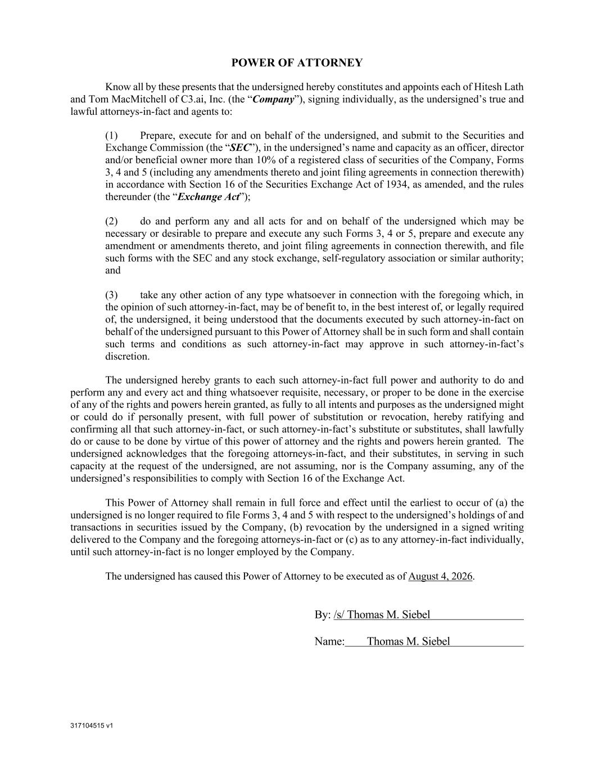
317104515 v1 POWER OF ATTORNEY Know all by these presents that the undersigned hereby constitutes and appoints each of Hitesh Lath and Tom MacMitchell of C3.ai, Inc. (the “Company”), signing individually, as the undersigned’s true and lawful attorneys-in-fact and agents to: (1) Prepare, execute for and on behalf of the undersigned, and submit to the Securities and Exchange Commission (the “SEC”), in the undersigned’s name and capacity as an officer, director and/or beneficial owner more than 10% of a registered class of securities of the Company, Forms 3, 4 and 5 (including any amendments thereto and joint filing agreements in connection therewith) in accordance with Section 16 of the Securities Exchange Act of 1934, as amended, and the rules thereunder (the “Exchange Act”); (2) do and perform any and all acts for and on behalf of the undersigned which may be necessary or desirable to prepare and execute any such Forms 3, 4 or 5, prepare and execute any amendment or amendments thereto, and joint filing agreements in connection therewith, and file such forms with the SEC and any stock exchange, self-regulatory association or similar authority; and (3) take any other action of any type whatsoever in connection with the foregoing which, in the opinion of such attorney-in-fact, may be of benefit to, in the best interest of, or legally required of, the undersigned, it being understood that the documents executed by such attorney-in-fact on behalf of the undersigned pursuant to this Power of Attorney shall be in such form and shall contain such terms and conditions as such attorney-in-fact may approve in such attorney-in-fact’s discretion. The undersigned hereby grants to each such attorney-in-fact full power and authority to do and perform any and every act and thing whatsoever requisite, necessary, or proper to be done in the exercise of any of the rights and powers herein granted, as fully to all intents and purposes as the undersigned might or could do if personally present, with full power of substitution or revocation, hereby ratifying and confirming all that such attorney-in-fact, or such attorney-in-fact’s substitute or substitutes, shall lawfully do or cause to be done by virtue of this power of attorney and the rights and powers herein granted. The undersigned acknowledges that the foregoing attorneys-in-fact, and their substitutes, in serving in such capacity at the request of the undersigned, are not assuming, nor is the Company assuming, any of the undersigned’s responsibilities to comply with Section 16 of the Exchange Act. This Power of Attorney shall remain in full force and effect until the earliest to occur of (a) the undersigned is no longer required to file Forms 3, 4 and 5 with respect to the undersigned’s holdings of and transactions in securities issued by the Company, (b) revocation by the undersigned in a signed writing delivered to the Company and the foregoing attorneys-in-fact or (c) as to any attorney-in-fact individually, until such attorney-in-fact is no longer employed by the Company. The undersigned has caused this Power of Attorney to be executed as of August 4, 2026. By: /s/ Thomas M. Siebel Name: Thomas M. Siebel

